Payment Detail by Client Report

Payment Detail by Client Report – Input screen
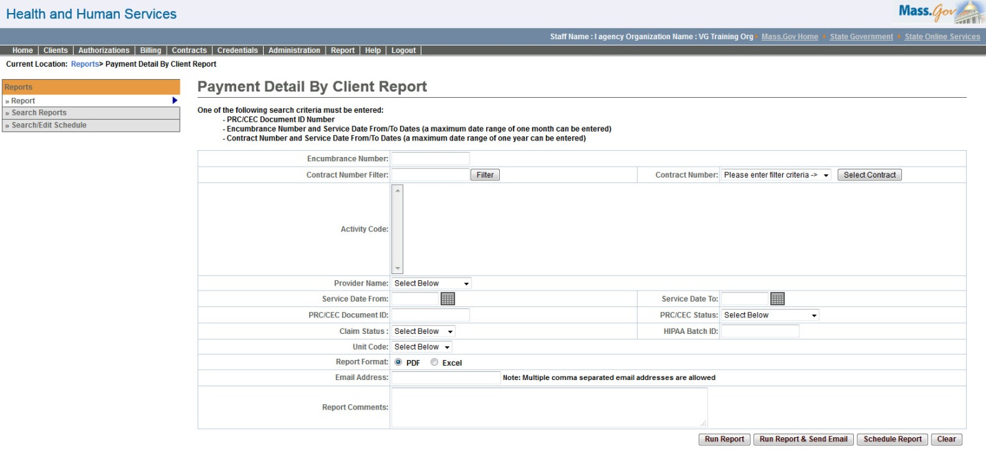

Payment Detail by Client Report – Output screen
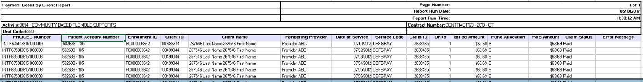
Report Description
Provides the list of clients that have been paid through a single Payment file along with their Billed/Paid amounts.

Report Benefit

This report allows a user to retrieve payment information per client based on either of the criteria's:

1. Each Payment file

2. Master contract and service dates

3. Vendor contract number and service dates

Hence the user can retrieve billed and paid amounts for each client based on the above mentioned criteria's

Required Parameters
- PRC/CEC Document ID Number
OR
- Encumbrance Number
- Service Date From/To Dates (a maximum date range of one month can be entered)
OR
- Contract Number
- Service Date From/To Dates (a maximum date range of one year can be entered)

Scheduling
Yes

Agency Roles
UR Reports

Provider Roles

UR Billing Centralized, UR Billing Decentralized, UR Release, UR Authorize, UR Review

Operation Roles
N/A
This information is provided by the Virtual Gateway within Health and Human Services.

