Payment Detail Report by Bed Days (DI)

Payment Detail Report by Bed Days (DI) – Input screen
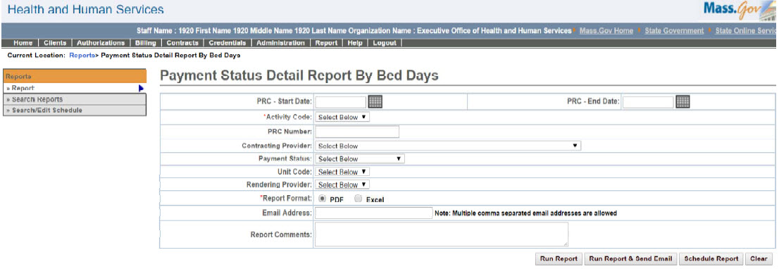

Payment Detail Report by Bed Days (DI) – Output screen
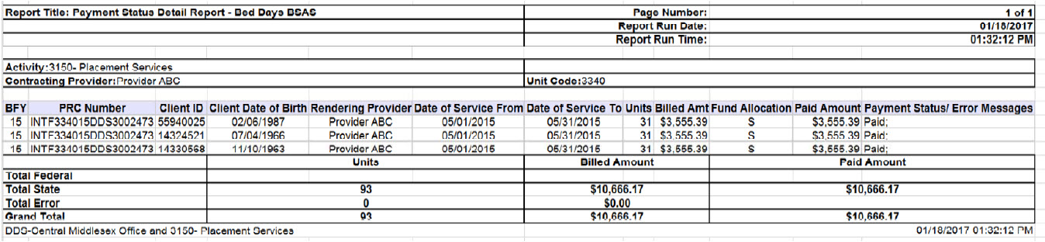
Report Description
N/A

Report Benefit
N/A

Required Parameters
- Activity Code
- PRC Number or PRC Start Date & End Date
- Report Format

Scheduling
Yes

Agency Roles
UR Reports DI

Provider Roles

N/A

Operation Roles
N/A
This information is provided by the Virtual Gateway within Health and Human Services.

