Payment Tracking Report

Payment Tracking Report – Input screen
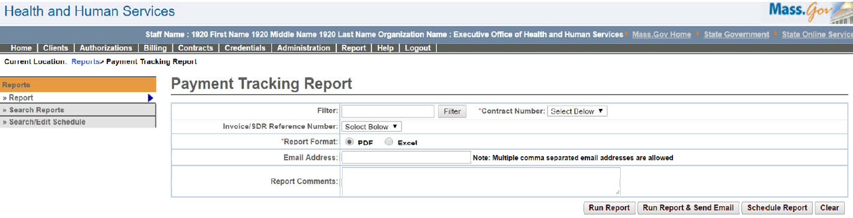

Payment Tracking Report – Output screen
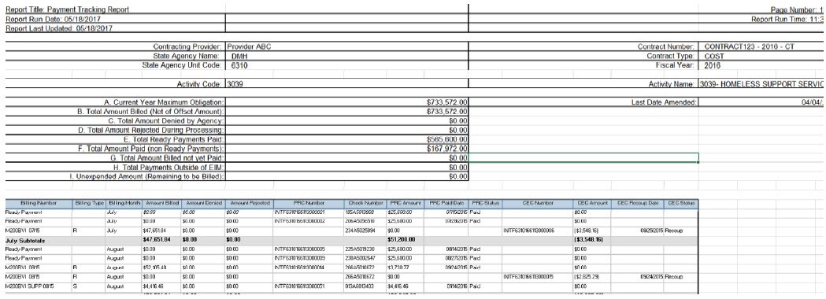
Report Description

Lists all the payments (PRC/CEC) information per month for a particular contract.

Report Benefit

Allows a user to retrieve payments associated to each contract. Also, the user has the option to choose a particular SDR/Invoice to filter down information in the report output.

Required Parameters

Contract Number

Report Format

Scheduling
Yes

Agency Roles
AR Accounting Payment Manager, AR Payment Reviewer, AR Program Payment Manager, Batch Interface Manager, Business Configuration Reviewer, Business Configuration Specialist, CR Reports, UR Reports

Provider Roles

AR Billing, Contract and Payment Reviewer, CR Billing, UR Billing Centralized, UR Billing Decentralized

Operation Roles
N/A
This information is provided by the Virtual Gateway within Health and Human Services.

