PRC/CEC Batch Report

PRC/CEC Batch Report – Input screen
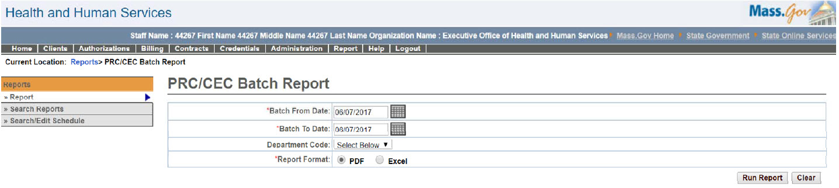

PRC/CEC Batch Report – Output screen
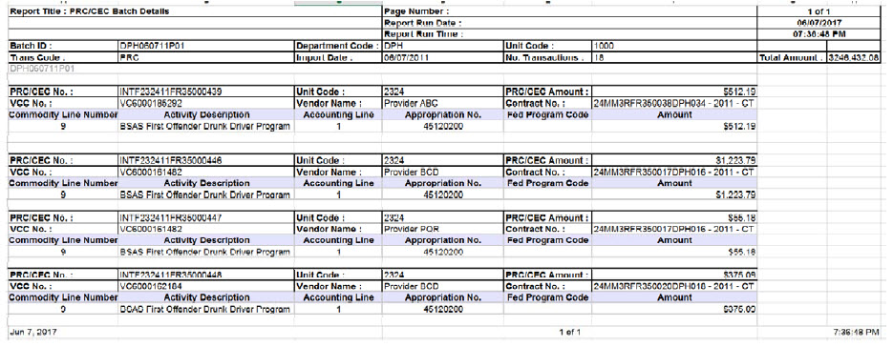
Report Description
Lists all the PRCs/CECs that were sent out from EIM/ESM to MMARS.

Report Benefit

Allows the user to view a list of PRCs/CECs grouped by Batch ID.

Required Parameters

Batch From Date

Batch To Date

Report Format

Scheduling
No

Agency Roles
Batch Interface Manager, Business Configuration Reviewer, Business Configuration Specialist

Provider Roles

N/A

Operation Roles
N/A
This information is provided by the Virtual Gateway within Health and Human Services.

