Ready Pay Contract Reconciliation Report

Ready Pay Contract Reconciliation Report – Input screen
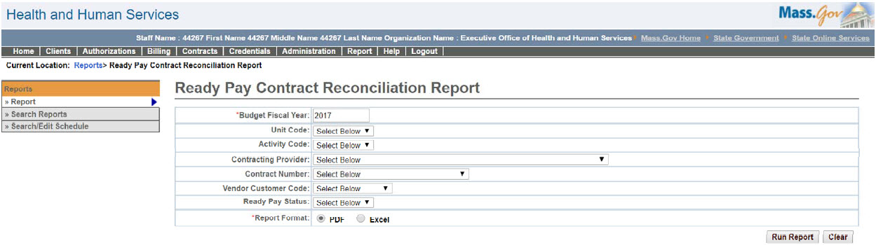

Ready Pay Contract Reconciliation Report – Output screen
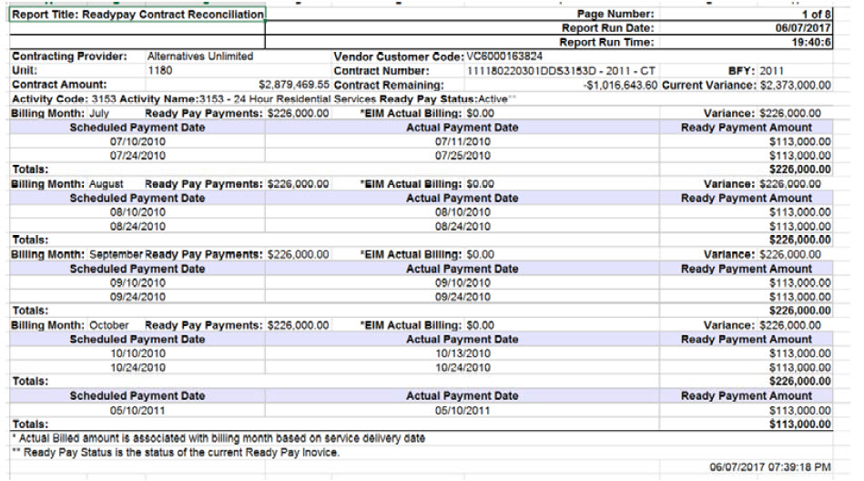
Report Description
Provides history of ready pay contract payments for the purpose of reconciling actual billings against ready pay.

Report Benefit

Allows the user to keep a track of ready pay payments that have/have not been reconciled.

Required Parameters

Budget Fiscal Year

Report Format

Scheduling
No

Agency Roles

CR Reports, UR Reports

Provider Roles

Contract and Payment Reviewer, CR Authorize, CR Review, CR Billing

Operation Roles
N/A
This information is provided by the Virtual Gateway within Health and Human Services.

