Service Delivery (DI) Report

Service Delivery Report (DI) – Input screen
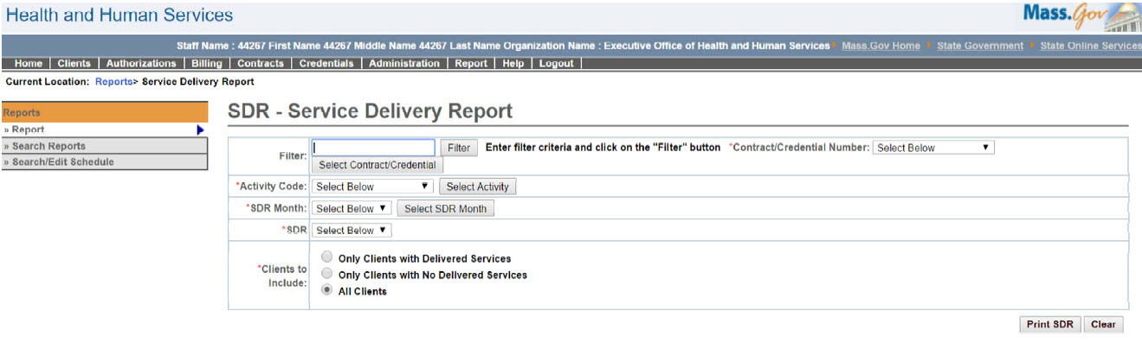

Service Delivery Report (DI) – Output screen
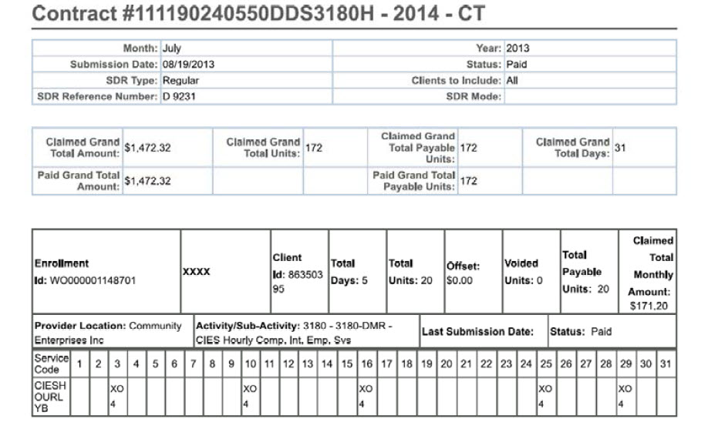
Report Description
Provides an SDR report without client names printed on it.

Report Benefit
Allows a user to have a hard copy of the SDR submitted in the system without client PII information.

Required Parameters
- Contract/Credential Number
- Activity Code
- SDR Month
- SDR
- Clients to Include

Scheduling
No

Agency Roles

UR Reports-DI, UR DI Accounting Payment Manager, UR DI Payment Reviewer, UR DI Program Payment Manager

Provider Roles
N/A

Operation Roles
N/A
This information is provided by the Virtual Gateway within Health and Human Services.

