Service Delivery Report

Service Delivery Report – Input screen
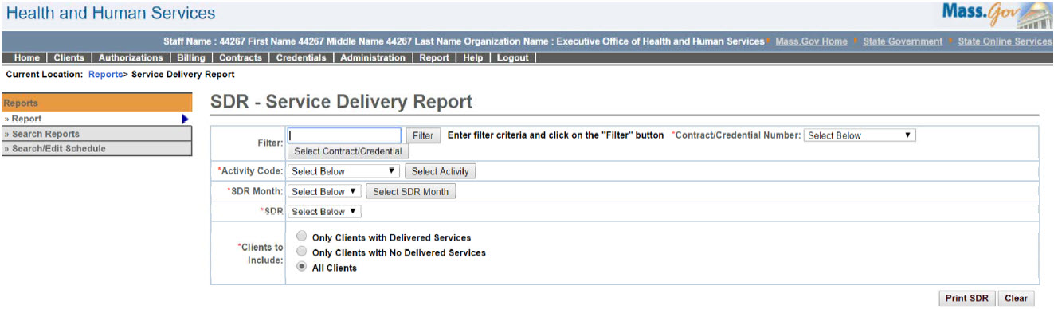

Service Delivery Report – Output screen
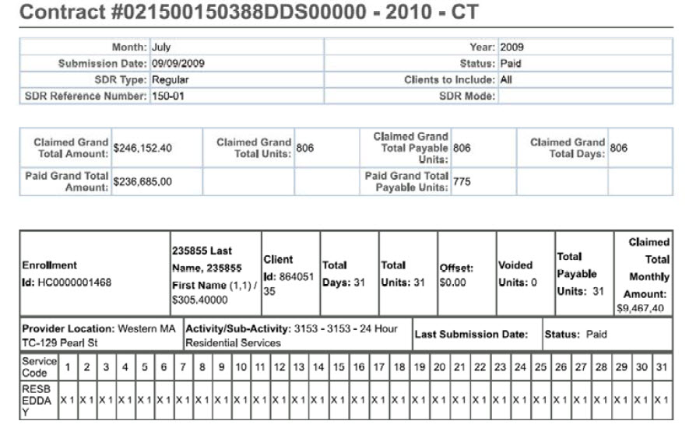
Report Description
Provides a means to print SDR documents.

Report Benefit
Allows a user to have a hard copy of the SDR submitted in the system.

Required Parameters
- Contract/Credential Number
- Activity Code
- SDR Month
- SDR
- Clients to Include

Scheduling
No

Agency Roles

UR Reports, UR Accounting Payment Manager, UR Payment Reviewer, UR Program Payment Manager

Provider Roles
UR Billing Centralized, UR Billing Decentralized, UR Release, UR Authorize, UR Review

Operation Roles
N/A
This information is provided by the Virtual Gateway within Health and Human Services.

