System Configuration and Reference – Activity Details Report

System Configuration and Reference – Activity Details – Input screen
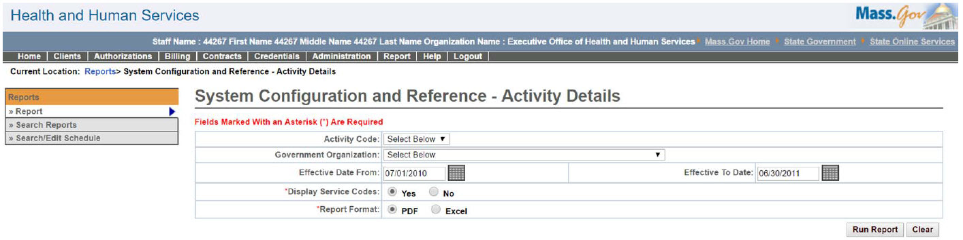

System Configuration and Reference – Activity Details – Output screen
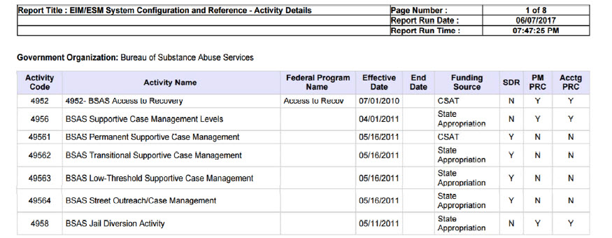
Report Description
Provides a list of activities for a system.

Report Benefit
Allows the user to view the activity information along with their funding sources.

Required Parameters
- Display Service Codes
- Report Format

Scheduling
No

Agency Roles
Business Configuration Reviewer, Business Configuration Specialist

Provider Roles
N/A

Operation Roles
N/A
This information is provided by the Virtual Gateway within Health and Human Services.

