System Configuration and Reference - Contracts Details Report

System Configuration and Reference - Contracts Details – Input screen
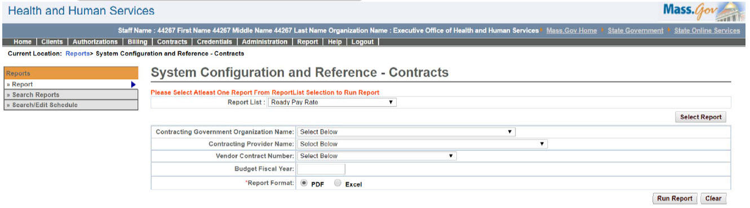

System Configuration and Reference - Contracts Details – Output screen
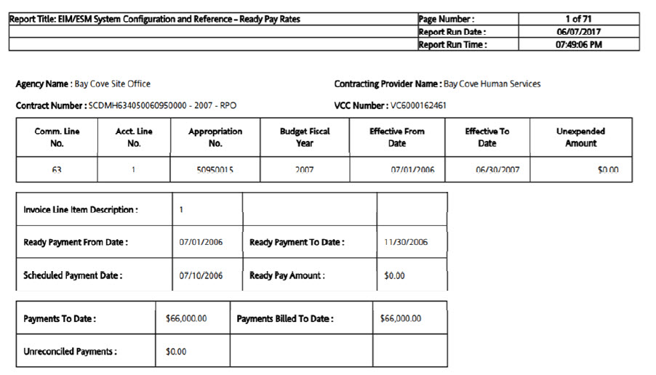
Report Description
Provides all the selected contract details.

Report Benefit
Allows the user to view the configurations for a particular contract.

Required Parameters
- Report List

Scheduling
No

Agency Roles
UR Reports

Provider Roles
N/A

Operation Roles
N/A
This information is provided by the Virtual Gateway within Health and Human Services.

