System Configuration and Reference –Credentials Details Report

System Configuration and Reference – Credentials Details – Input screen
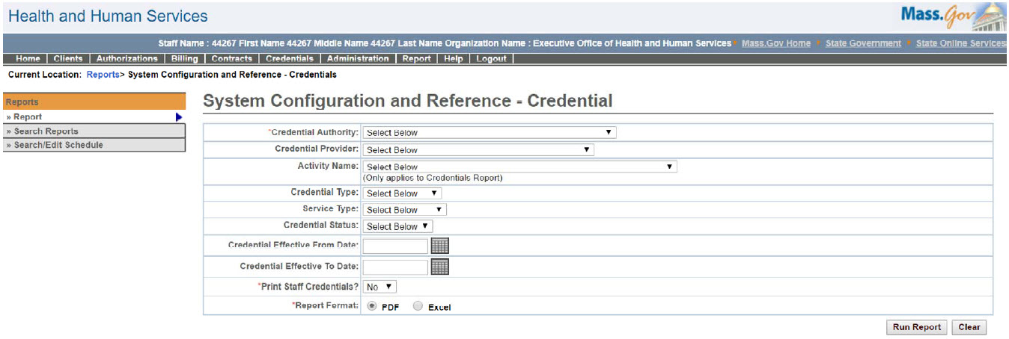

System Configuration and Reference – Credentials Details – Output screen
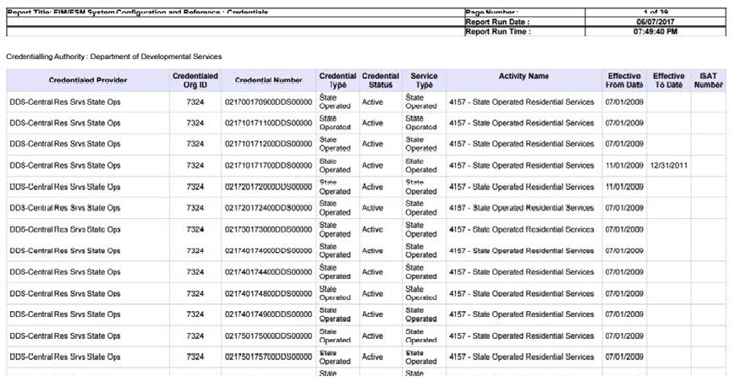
Report Description
Provides a list of Credentials based on the input parameters.

Report Benefit
Allows the user to view all the Credentials added for a particular Credentialing Authority.

Required Parameters
- Credential Authority
- Print Staff Credentials
- Report Format

Scheduling
No

Agency Roles
Business Configuration Reviewer, Business Configuration Specialist

Provider Roles
N/A

Operation Roles
N/A
This information is provided by the Virtual Gateway within Health and Human Services.

