System Configuration and Reference – Reference Table Report

System Configuration and Reference – Reference Table Report – Input screen
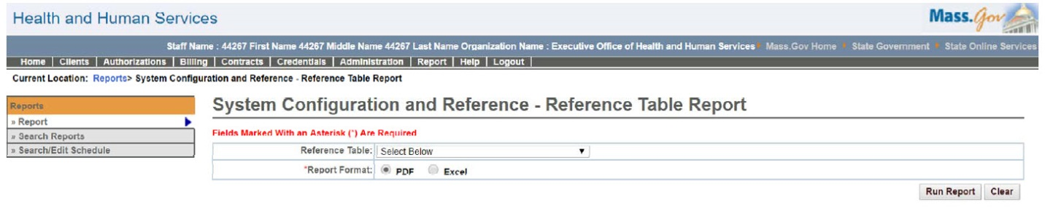

System Configuration and Reference – Reference Tables Report – Output screen
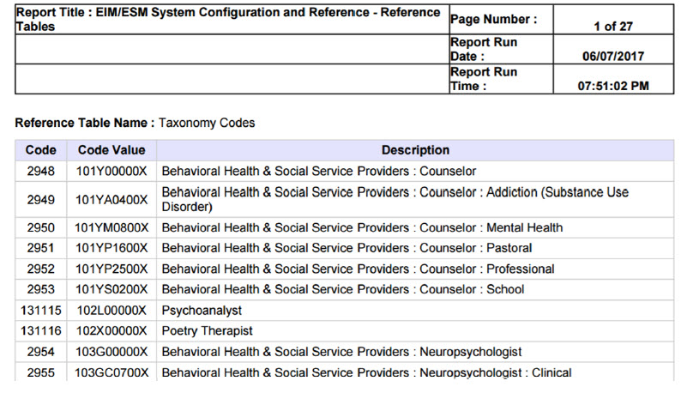
Report Description
Provides a list of reference code entries for the selected reference table.

Report Benefit
Allows the user to view all the reference code table values.

Required Parameters
- Reference Table (optional)
- Report Format

Scheduling
No

Agency Roles
Business Configuration Reviewer, Business Configuration Specialist

Provider Roles
N/A

Operation Roles
N/A
This information is provided by the Virtual Gateway within Health and Human Services.

