System Configuration and Reference – Remittance Reconciliation Report

System Configuration and Reference – Remittance Reconciliation Report – Input screen
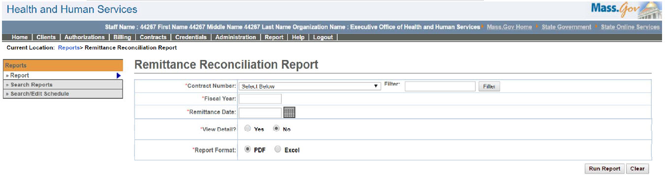

System Configuration and Reference – Remittance Reconciliation Report – Output screen
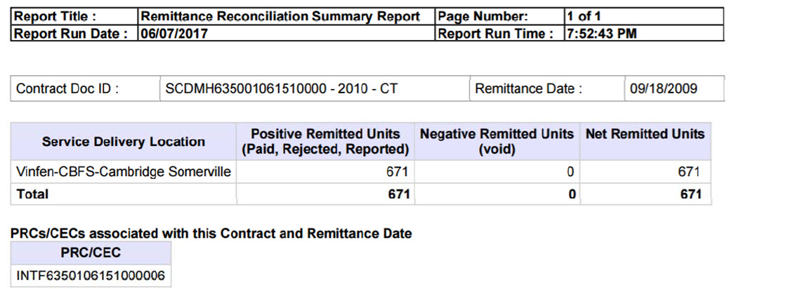
Report Description
Provides a list of positive and negative units for a particular contract that have been paid and remitted.

Report Benefit
Allows the user to view all the paid services that have been paid but not remitted.

Required Parameters
- Contract Number
- Fiscal Year
- View Detail
- Report Format

Scheduling
No

Agency Roles
UR Reports

Provider Roles
N/A

Operation Roles
N/A
This information is provided by the Virtual Gateway within Health and Human Services.

