Vendor Worksheet for Program Budget Amendment Details Report

Vendor Worksheet for Program Budget Amendment Details – Input screen
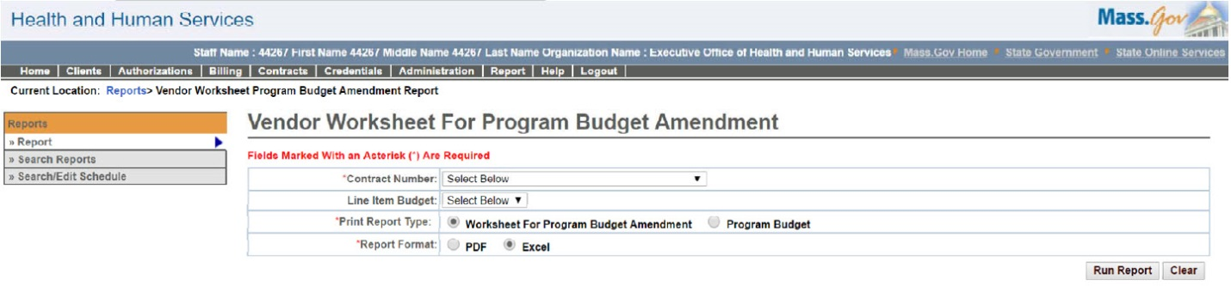

Vendor Worksheet for Program Budget Amendment Details – Output screen
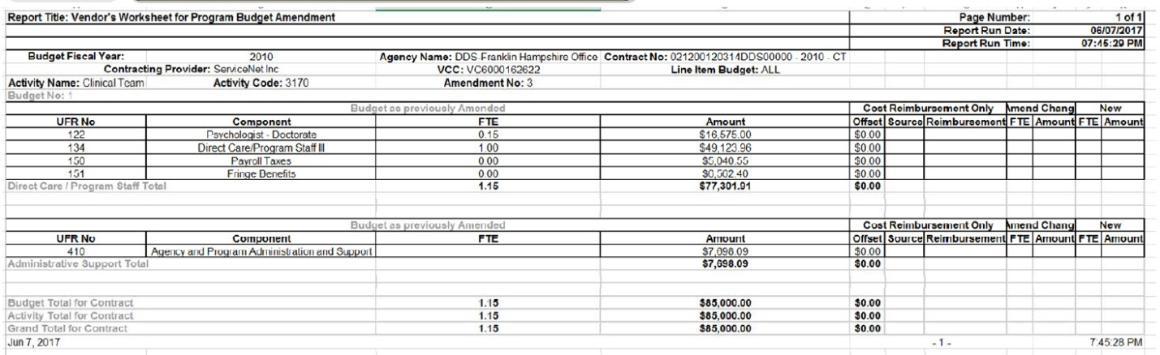
Report Description
Supports provider requests for line item budget amendments for CR contracts.

Report Benefit
Allows the user to view the list of amendment requests.

Required Parameters

Contract Number

Print Report Type

Report Format

Scheduling
No

Agency Roles
CR Reports

Provider Roles
Contract and Payment Reviewer

Operation Roles
N/A
This information is provided by the Virtual Gateway within Health and Human Services.

