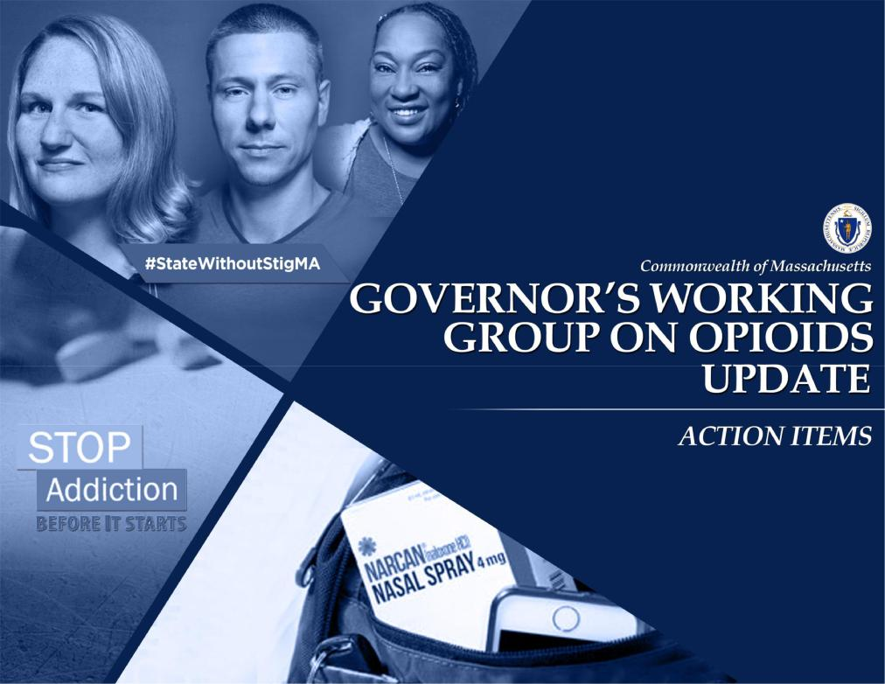

November 14, 2017

1

2017 Highlights...

While there are still far too many of our families, friends and neighbors suffering from an opioid use disorder – there are signs of early progress in our fight against opioid addiction
- The rate of overdose deaths has slowed, the first 9 months of 2017 showed a 10% decrease over 2016

- The presence of prescription opioids and heroin in toxicology of opioid-related deaths continues to decline, however, the presence of fentanyl in opioid-related deaths has been increasing significantly

- Prescribing clinicians have changed their practice and are using the prescription monitoring program
- The number of opioid prescriptions has decreased by 29% since 2015
- There continues to be an increase in the use of Naloxone as a result of expanded access

A few highlights include:
- Certified 162 Sober Homes, totaling 2,168 beds

- Added 680 substance use disorder and psychiatric treatment beds since January 2015
- Released Chapter 55 Opioid Overdose Data Brief in August 2017
- Expanded access to on-demand treatment at 3 Opioid Urgent Care Centers
- Implemented Screening, Brief Intervention and Referral to Treatment (SBIRT) in schools
- Received a 5-year $52 billion 1115 demonstration waiver that includes SUD expansion

2 ₂

Through the MassHealth 1115 Demonstration Waiver, over $150 million will be invested in expanding the substance use treatment system over 5 years

In FY 18, we will invest $30 million to expand residential recovery services; increase access to medication assisted treatments and fund new recovery coaches

Over the next 5 years, we will continue to invest in SUD treatment expansion, including:

Expansion of residential treatment capacity: Up to $21M per year

– Approximately 500 new beds will be added to care for individuals with a co-occurring substance use and mental health disorder

– Ensuring access to residential treatment and evidence based care for priority populations, including: pregnant and/or parenting women, as well as individuals with justice involvement, severe mental illness, and individuals who are homeless.

Expansion of access to Medication Assisted Treatment (MAT): Up to $14M per year

– We will increase the number prescribers offering MAT in the Primary Care setting

– We will provide technical assistance to primary care providers to increase provider comfort and clinical competency for treating OUD

Coverage of additional recovery support services: Up to $8M per year

– We will incorporate recovery support services (e.g., navigators/coaches) as a covered benefit for all MassHealth beneficiaries

Implementation of standardized ASAM assessment and care planning tool with SUD service providers: Up to $4M/year

– We will implement protocols across treatment settings for assessment, admission, and care planning based on ASAM dimensions

– We will develop a standardized SUD assessment process and tools in concert with providers

*American Society of Addiction Medicine

3 ₃

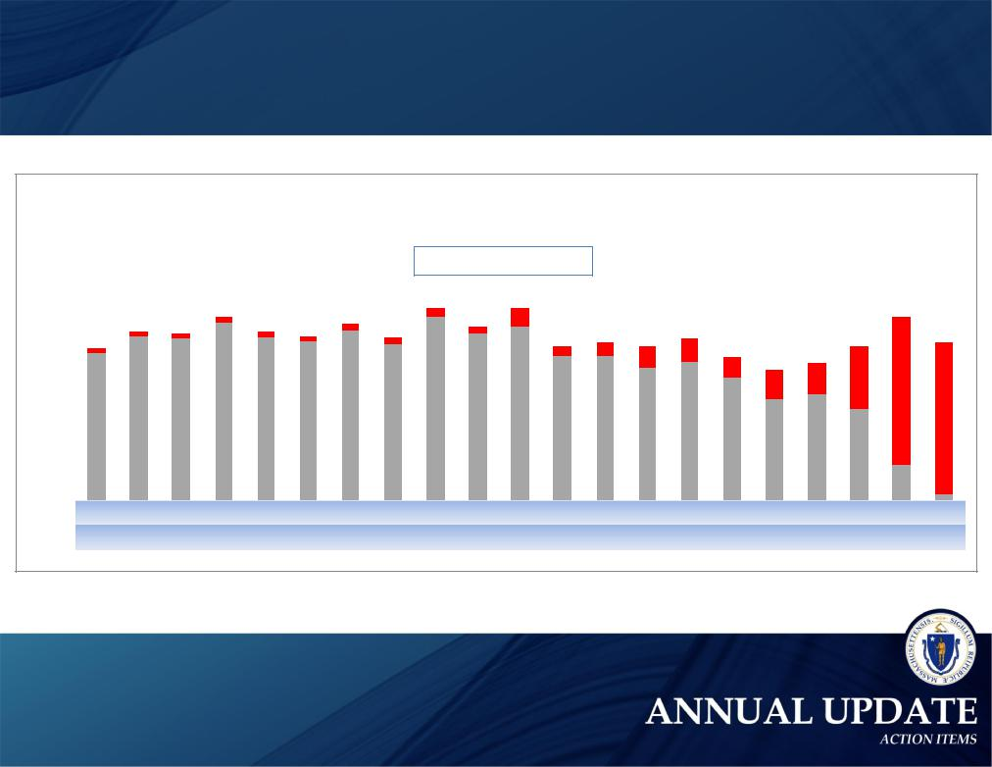
Opioid-related deaths in Massachusetts declined by 10%
in the first nine months of 2017, compared to 2016

Number of deaths

250
200 |  |  |  |  | 7 | 6
 |  | 4 | 5 | 6
150
100 |  | 157 | 175 | 172 | 189 | 174
50
0 |  | January February |  | March | April | May

Figure 1. Opioid¹-Related Deaths, All Intents by Month

Massachusetts Residents: January 2016 - September 2017

Confi rmed Estimated

 | 7 |  | 11 |  | 20
6 |  | 7 |  | 7 |  | 15 |  | 24 |  |  |  |  | 159
 |  |  |  |  | 10 |  | 23 |  |  |  |  |  |  | 163
 |  |  |  |  |  |  |  |  | 23
 |  |  |  |  |  |  |  |  |  |  | 32 | 67
 |  |  |  |  |  |  |  |  |  | 32
169 | 181 | 166 | 195 | 178 | 185
 |  |  |  |  | 153 | 153 | 141 | 148
 |  |  |  |  |  |  |  |  | 130 | 107 | 114
 |  |  |  |  |  |  |  |  |  |  |  | 97
 |  |  |  |  |  |  |  |  |  |  |  |  | 37 | 5
June | July | August September October |  |  | November December | January | February | March | April | May | June | July | August September
 | 2016 |  |  |  |  |  |  |  |  | 2017

4 ₄

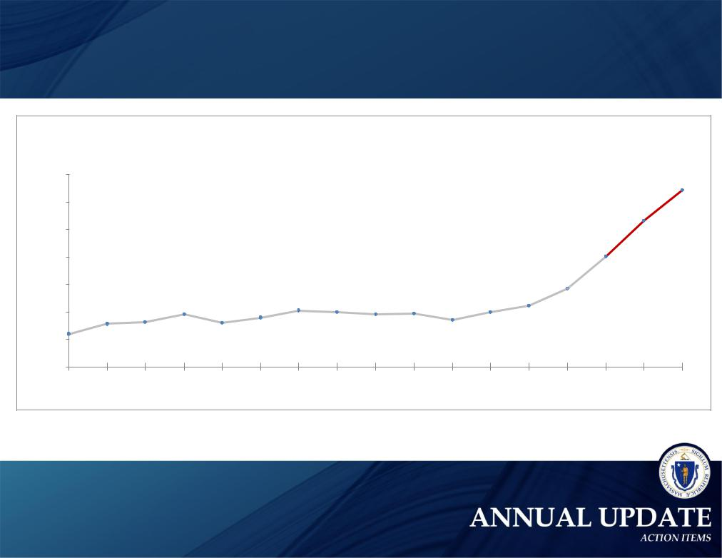
The increase in the estimated death rate has slowed year over year
In 2014, there was a 40% increase from the prior year; in 2015, a 32% increase from
the prior year; and in 2016, a 21% increase from the prior year

Residents

per 100,000 Rate

 |  |  |  |  | Figure 3. Rate of Opioid¹-Related Deaths, All Intents
 |  |  |  |  |  | Massachusetts Residents: 2000-2016
35
30 |  |  |  |  |  |  |  |  |  |  |  |  |  |  |  |  | 32.2
25 |  |  |  |  |  |  |  |  |  |  |  |  |  |  |  | 26.7
20 |  |  |  |  |  |  |  |  |  |  |  |  |  |  | 20.2
15
 |  |  |  | 9.6 |  |  | 10.3 | 10.0 |  | 9.7 |  |  | 11.2 | 14.4
10 |  | 7.9
 |  |  |  |  |  |  |  |  |  |  |  | 10.0
 |  |  |  |  |  | 8.9 |  |  | 9.6 |  | 8.0
 |  |  | 8.2 |  | 8.0
5
 | 6.0
0
2000 |  | 2001 | 2002 | 2003 | 2004 | 2005 | 2006 | 2007 | 2008 | 2009 | 2010 | 2011 | 2012 | 2013 | 2014 | 2015 | 2016

- Opioids include heroin, opioid-based prescription painkillers, and other unspecified opioids.

5 ₅

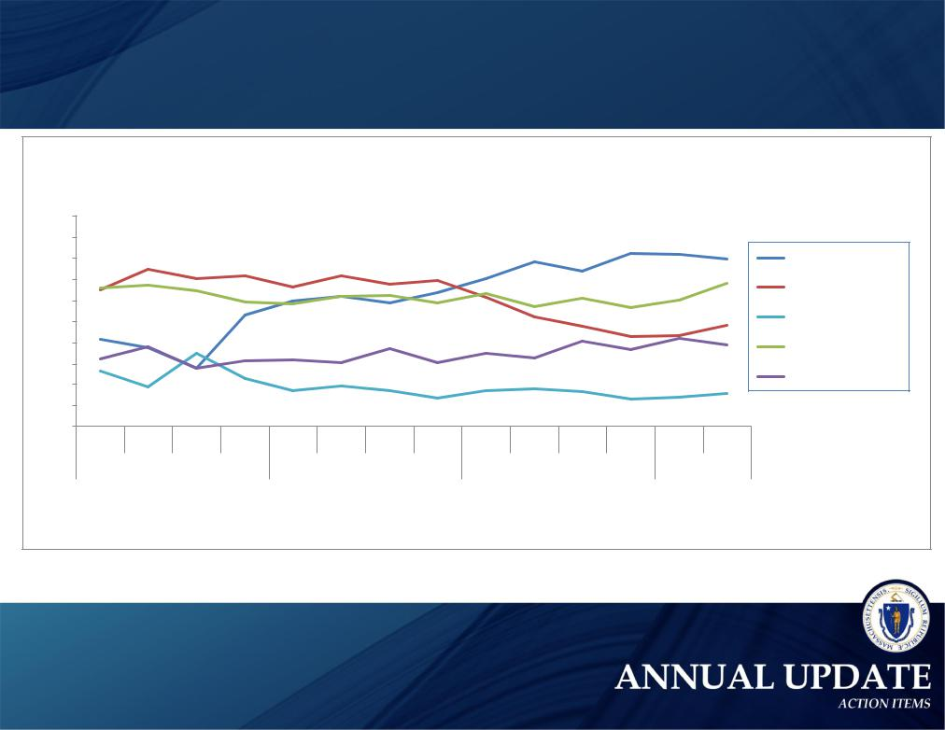
Prescription opioid deaths are decreasing;
Fentanyl is present in 81% of toxicology screens

Figure 4. Percent of Opioid Deaths with Specific Drugs Present
MA: 2014-2017

 | 100
 | 90
 | 80
 | 70
Percent | 60
 | 40
 | 50

30

20

10

0

1 | 2 | 3 | 4 | 1 | 2 | 3 | 4 | 1 | 2 | 3 | 4 | 1 | 2
 |  | 2014 |  |  |  | 2015 |  |  |  | 2016 |  |  | 2017

Year and Quarter

- This is most likely illicitly produced and sold, not prescription fentanyl
- Prescription opioids include: hydrocodone, hydromorphone, oxycodone, oxymorphone, and tramadol

Fentanyl¹

Likely Heroin

Prescription Opioid²

Benzodiazepine

Cocaine

6 ₆

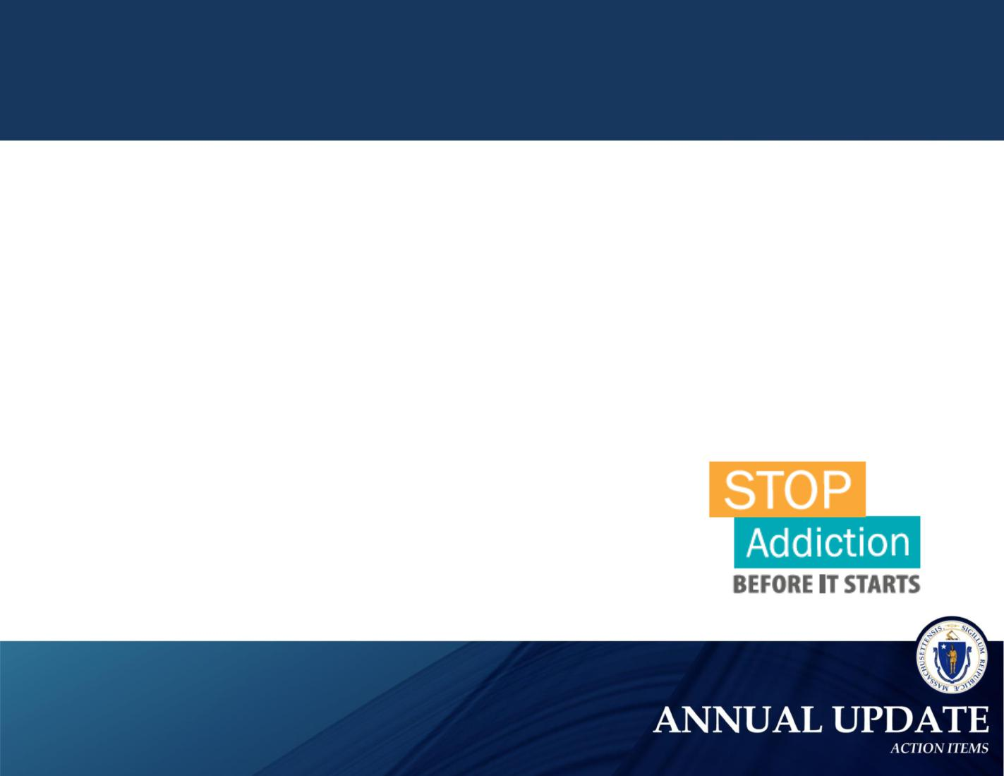
Protecting Our Youth

Screening, Brief Intervention, and Referral to Treatment (SBIRT)

– SBIRT is an evidence-based practice used to identify, reduce, and prevent problematic use of and dependence on alcohol and illicit drugs

– SBIRT screening in schools is mandatory for the first time this year (17-18 school year). Students must be screened in two different grade levels for a substance use disorder

– Last school year, 89 schools implemented SBIRT and submitted aggregate data to DPH

– Since January 2016, 4,263 professionals in 283 school districts have been trained by DPH to administer SBIRT in the required 6-hour Introductory Course

– 760 professionals from trained districts attended an additional 3-hour ‘SBIRT Essentials’ session

Stop Addiction Before It Starts Ad Campaign

– Public information campaign, launched in August 2017, encouraging parents of teens to speak to their kids about the dangers of pain medication

7 ₇

Ensuring Core Competencies for Our Clinicians in Training

Prescriber education core competencies for the Prevention and Management of
Prescription Drug Misuse have been established for:

– Medical Education, reaching 3,000 students each year

– Dental Education, reaching 2,380 students each year

– Advance Practice Nursing Education, reaching 2,000 students each year

– Physical Assistant Education, reaching 900 students each year

In Fall 2017, all nine Schools of Social Work in Massachusetts established a set of Core Principles for the Prevention and Management of Substance Misuse, reaching 4,300 social work students each year.

• | Boston College | • | Smith College
• | Boston University | • | Springfield College
• | Bridgewater State University | • | Westfield State University
• | Salem State University | • | Wheelock College
- Simmons College

8 ₈

Increasing access to naloxone, the life-saving overdose reversal drug

In FY17, DPH invested more than $3.87 million to improve access to naloxone throughout the Commonwealth

- $2.8 million to support the Overdose Education and Naloxone Distribution (OEND) program

– OEND has trained more than 64,000 individuals on how to administer naloxone since the program began in 2007

– Since 2007, nearly 12,800 overdose rescues have been reported. Over 8,600 since 2015 and 3,600 rescues in 2016 alone

- $578, 500 to support the First Responder Grant Program

– 5,600 overdose rescues have been reported by the 32 First Responder Naloxone Grant agencies since 2015

- $100,000 for Naloxone for Community Health Centers

– In June 2017, we provided $100,000 in naloxone (approximately 260 doses) to 10 community health centers, participating in the SUSTAIN (Substance Use Support & Technical Assistance in Communities) initiative, which supports efforts to prevent and treat substance use disorders in local communities

- $392,251 for state naloxone purchases through the bulk purchasing program

– Since 2016, 140 cities and towns have purchased over 12,000 doses of naloxone at a significant discount

9 ₉

Collecting and Leveraging Data to Identify At-Risk Populations

Chapter 55 of the Acts of 2015

– Chapter 55 permitted the first-in-the-nation linkage and analysis of government data sets to better understand the opioid epidemic and guide policy development

– First report was released in the Fall of 2016 and updated in Fall 2017

– In 2016, ten government data sets were linked and analyzed; In 2017, twenty government data sets were linked and analyzed

2017 Chapter 55 Opioid Data Brief

– Key findings:

  - Compared to the rest of the adult population the opioid-related overdose death rate is:

– 321 times higher for pregnant and postpartum mothers with opioid use disorder

– 120 times higher for persons released from Massachusetts prisons and jails

– Up to 30 times higher for homeless individuals

– 6 times higher for individuals with serious mental illness

  - Nearly 1 in 10 individuals die within 2 years after an initial nonfatal overdose

  - The average survival time for those who died of an opioid overdose was 36 Months

10
10

Massachusetts Prescription Monitoring Program (PMP)

Chapter 55 data found, those who received three months of prescribed opioids in 2011 were 4 times as likely to die from an overdose within 1 year, and 30 times as likely within 5 years

- As of October 15, 2017, all Prescribers of Schedule II-III prescriptions by LAW must check MassPAT before prescribing a Schedule II-III prescription

- More than 6.5 million searches have been completed since the creation of MassPAT

- 54,861 physicians and delegates are registered with MassPAT

- 95% of prescribers who prescribed at least one Schedule II or III opioid between January-March 2017 are registered with MassPAT, accounting for 97% of opioid Rx volume from October-December 2016

- MassPAT is connected with 29 states, including the full New England region, on the PMP

- As of September 2017, there has been a 29% decline in opioid prescriptions compared to 2015

11
11

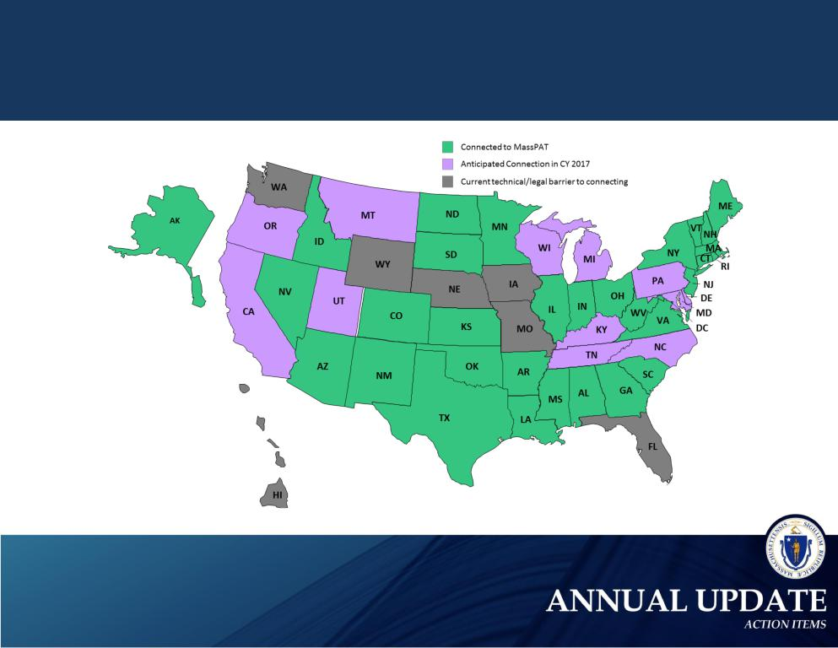
Massachusetts has connected with
29 states and the District of Columbia
to share patient prescription data

Massachusetts
Prescription Awareness
Tool (MassPAT)
Interconnectivity Map

Since January 2015, we have added more than 1,100 beds for
psychiatric and substance use services

 | Total Operational | Total Operational | Total Operational | Change Since
Program Type | Licensed Capacity as | Licensed Capacity as | Licensed Capacity as
 |  |  |  | January 1, 2015
 | of January 1, 2015 | of January 1, 2016 | of November 1, 2017
DPH Acute Treatment Services (ATS) (level 4.0 & 3.7), Adult | 846 beds | 902 beds | 1,073 beds | 227 beds
DPH Clinical Stabilization Services (CSS) | 297 beds | 340 beds | 671 beds | 374 beds
DPH Transitional Support Services (TSS) | 339 beds | 312 beds | 382 beds | 43 beds
DPH Adult Residential Recovery | 2,300 beds | 2,375 beds | 2,336 beds | 36 beds
DPH Youth Stabilization Beds | 48 beds | 48 beds | 48 beds | 0
DPH Second Offender Residential | 58 beds | 58 beds | 58 beds | 0
DPH Adolescent / Transitional Youth Residential Beds | 144 beds | 111 beds | 101 beds | -43 beds
DPH Family Residential | 110 families | 110 families | 110 families | 0
DMH Adult Psychiatric | 1,782 beds | 1,854 beds | 2,012 beds | 230 beds
DMH Geriatric Psychiatric | 399 beds | 399 beds | 457 beds | 58 beds
DMH Adolescent & Child Psychiatric | 252 beds | 266 beds | 263 beds | 11 beds
Section 35 Men's Beds | 258 beds | 308 beds | 359 beds | 101 beds
Section 35 Women's Beds | 90 beds | 90 beds | 167 beds | 77 beds
DPH Outpatient Treatment Program (OTP) - Medication | 39 programs | 41 programs | 44 programs | 5 programs
Assisted Treatment (MAT) Programs (Methadone)
DPH Outpatient Counseling and Outpatient Detox Programs | 190 programs | 190 programs | 218 programs | 28 programs
DPH Office-Based Outpatient Treatment (OBOT) | 14 programs | 17 programs | 42 programs | 28 programs
(buprenorphine) – MAT Sites funded by DPH
Sober Homes Certified by the Mass Association of Sober Houses | 0 | 0 | 162 homes | 162 homes
 |  |  | (2,168 beds) | (2,168 beds)

13
13

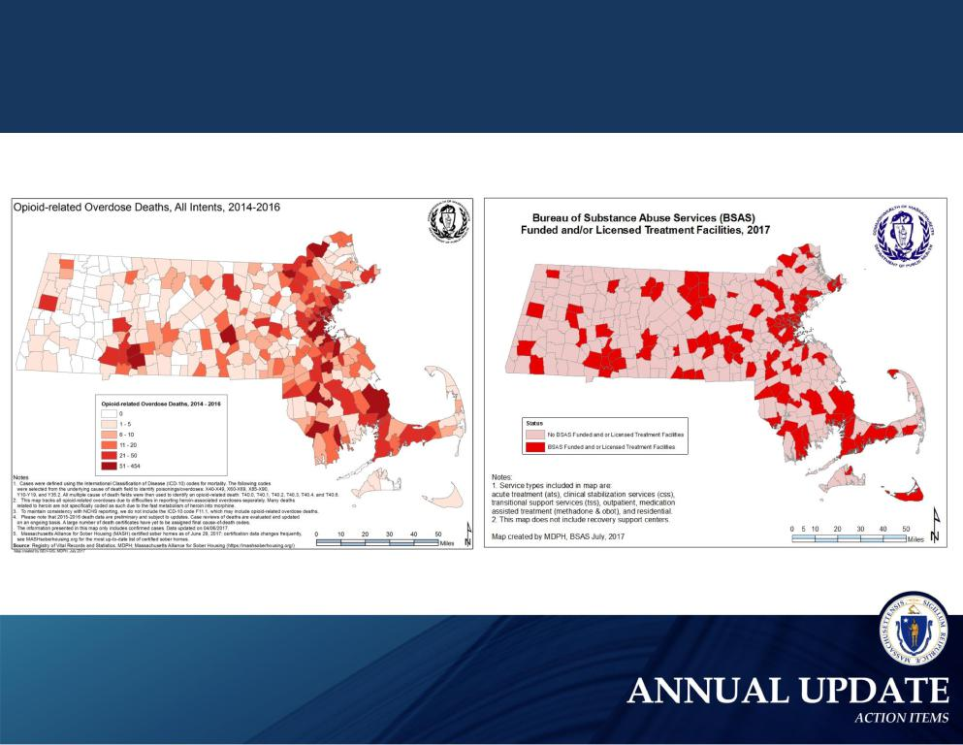
DPH is using opioid-related overdose death data to identify

high need areas for licensed treatment facilities

14
14

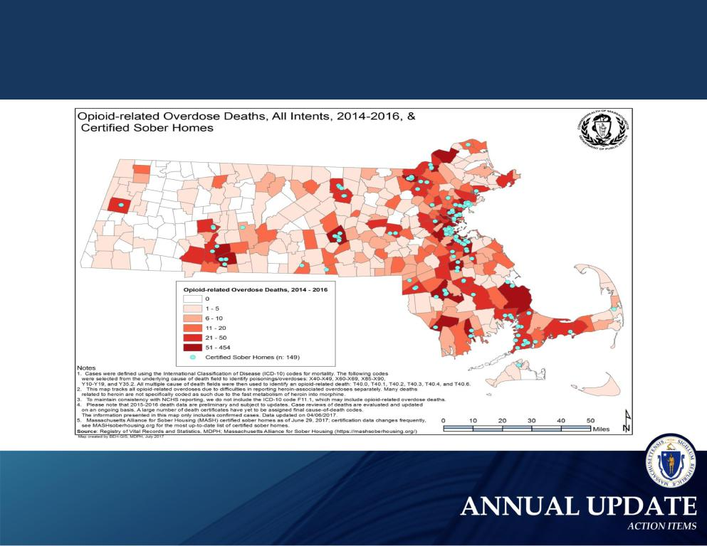
As of November 6, 2017, 162 Sober Homes (2,168 total beds) have been certified by the Massachusetts Association of Sober Houses

15
15

Opioid Urgent Care Centers are connecting individuals to services

- Three Opioid Urgent Care Centers were created as pilots, allowing for walk-in access to a trained clinician, in a community-based outpatient provider settings, who can provide an emergent/urgent addiction assessment and direct referral to the appropriate level of care

- As of September 2017, Opioid Urgent Care Centers served 13,000 individuals during 16,000 visits. Through June 2017, they successfully referred 7,303 individuals to services, with 1,280 receiving MAT

– Worcester – Community Healthlink (5,800 visits)

– Boston – Boston Medical Center (5,400 visits)

– Fall River – STARR Program (5,000 visits)

- Between April and June 2017, individuals enrolled in the 3 centers most frequently utilized: Medical Evaluation services (87.7% of enrollments), Overdose Education and Naloxone Rescue Kit (OEND) services (57.2% of enrollments), and Community Support Services (20.2% of enrollments).

16
16

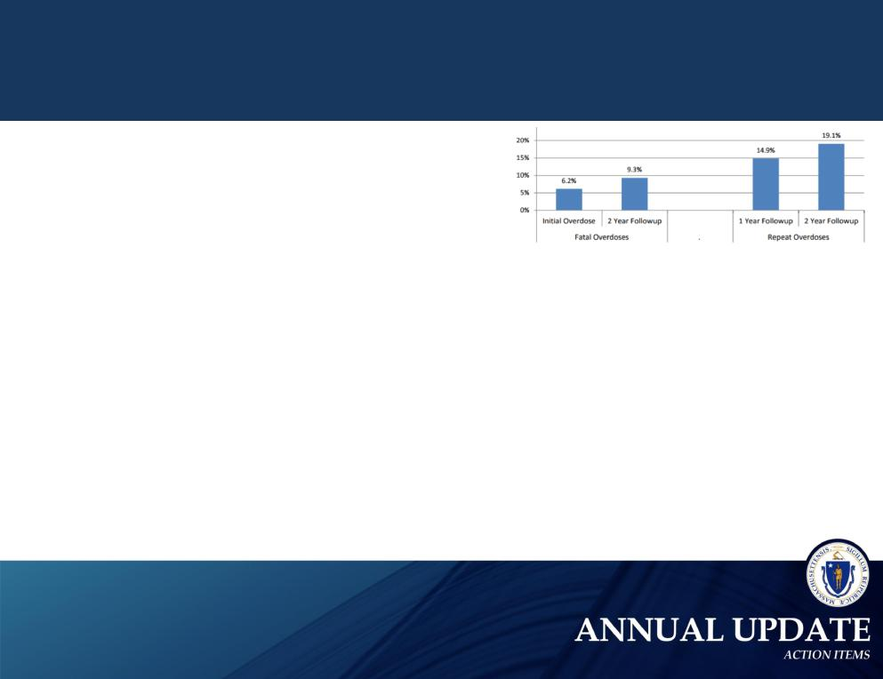
Intervening after an overdose is critical

Recovery Coaches in Emergency Departments

- Recovery coaches in 11 Emergency Departments are making referrals and connections to treatment and recovery support services in the community.

- As of September 2017, 2,758 calls requesting recovery coaches were received and 2,423 were served.

Nearly 1 in 10 individuals die within 2 years after an initial nonfatal overdose

- Participating agencies include Bay State Community Services, High Point Treatment Center, Child and Family Services, Lahey Behavioral Health, and Advocates Inc.

- Hospitals include: South Shore Hospital (Weymouth), Carney Hospital (Boston), Quincy Medical Center, Brockton Hosptial, Good Samaritan Hospital (Brockton), St. Luke’s Hospital

(New Bedford), Tobey Hospital (Wareham), Metrowest Hospital (Framingham), Umass Memorial (Marlborough), Beverly Hospital, Addison Gilbert Hospital (Gloucester)

“Post-Overdose Follow-Up Program”

- In November, DPH will award $500,000 for post-overdose follow-up programs . These programs partner addiction specialists with first responders to provide outreach, support and education to an individual after an overdose

17
17

Program Highlight:
Women’s Recovery from Addictions Program (WRAP) at Taunton

- The WRAP provides individual therapy, medical treatment, group therapy, family intervention, and aftercare support to individuals civilly committed for SUD treatment

- The WRAP offers aftercare services to clients for 6 months post discharge. Aftercare assists clients in their return to the community and ensures strong linkages to the next level of care/support

  - Between October 2016 and June 2017 98% of clients accepted aftercare services upon discharge from the WRAP. As a result readmission rates are low.

- WRAP utilizes 6 Medication Assisted Treatments:
  - Vivitrol (naltrexone – extended release injectable suspension)
  - Methadone Maintenance

  - Suboxone (Buprenorphine)
  - Naltrexone

  - Disulfiram

  - Acamprosate

Readmission Data

 | FY 17 | FY 18
Total Discharges | 365 | 154
Readmitted w/in 7 days | 3 | 1
Readmitted w/in 30 day | 10 | 4

3 month snapshot of patients discharged on MAT

 | JULY | AUG | SEPT
Number of patients | 30 | 44 | 43
Initiated on MAT | 61% | 34% | 63%
Admitted on MAT | 30% | 39% | 35%
Declined MAT | 22% | 24% | 8%
Discharged on MAT | 78% | 76% | 92%

18
18

Program Highlight:

HOC/DOC Medication-Assisted Treatment Re-Entry Initiative (MATRI)

Chapter 55 data found that nearly one of every 11 opioid-related deaths involved a person with a history of incarceration. The opioid death rate is 120 times higher for individuals with a history of incarceration.

- In August 2017, $500,000 in MATRI funding was awarded to five Houses of Correction (HOC). The HOC MATRI funding supports:

– Access to Medication Assisted Treatment (MAT);

– Case management services to facilitate a successful transition from a correctional services environment back into the community; and

– Linkages to community-based treatment and recovery support services for one year post release.

- Nationally recognized as a best practice, MATRI provides pre-release treatment and post-release referral for inmates in the MA Department of Corrections (DOC). Inmates receive a pre-release injection of Vivitrol and are connected to community-based clinics for aftercare treatment.

19
19

State Plan for the Coordination of Care and Services
for Families Impacted by Opioid Use

Chapter 55 data found that the opioid-related overdose death rate of mothers with OUD was

321 times higher than the rate among mothers without OUD. The opioid-related overdose death rate among
mothers delivering an infant with NAS was 27 times higher than the rate for all other mothers.

Interagency Task Force on Neonatal Abstinence Syndrome March 2017 Report provided:

– An inventory of 75+ existing services and programs for NAS/SEN affected families

– Over 60 recommendations that will support providing coordinated, high quality services across the continuum of care for NAS/SEN affected families

– A state plan on data collection and quality improvement, setting the Commonwealth on a course to collect, measure and report system performance

SAMHSA Policy Academy Focused on Improving Outcomes for Pregnant and Postpartum Women with Substance Use Disorders

– Massachusetts was selected as one of ten states to participate in the 2017 Policy Academy, which provided 6-months of technical assistance and the opportunity to work with other states and national experts

– The Policy Academy team has created an action plan, which includes development of a Plan of Safe Care for infants affected by all substance abuse, diagnosed with fetal alcohol syndrome, or withdrawal symptoms resulting from prenatal substance exposure. The team continues to build on existing cross-agency collaboration in order to operationalize the Interagency Task Force on NAS’ State Plan.

20
20

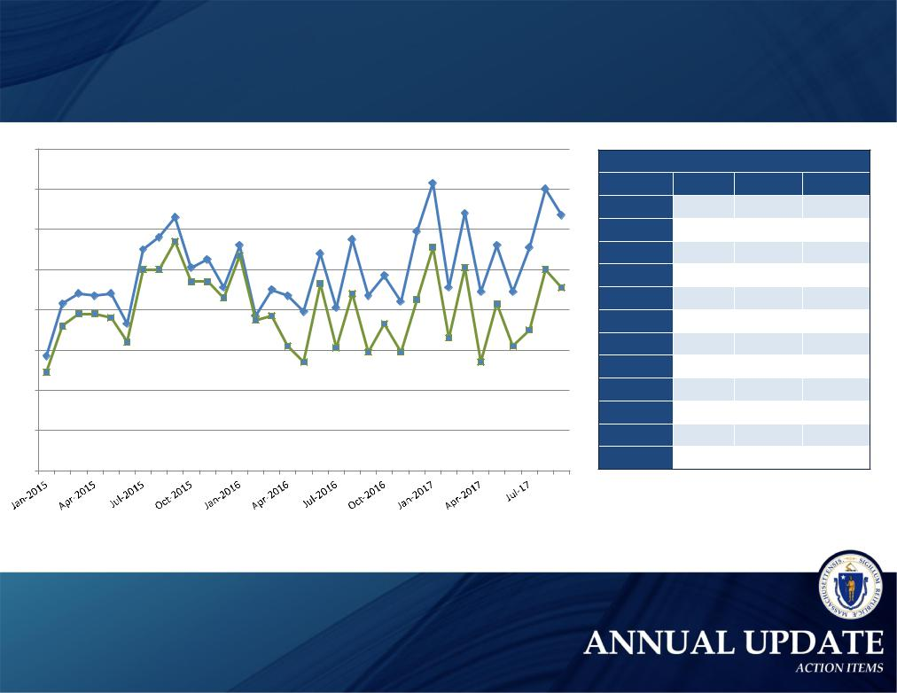
Number of Substance-Exposed Newborns (SEN) Reports to DCF (January 2015 to September 2017)

280
 |  |  |  |  |  |  |  |  |  | 263 |  |  |  | 260
260 |  |  |  |  |  |  |  |  |  |  | 248 |  |  | 247
 |  |  | 246
 |  |  | 236 |  |  |  | 235 |  | 239
240 |  |  |  | 232 |  |  |  |  |  |  |  | 232 |  | 231
 |  | 230 |  |  |  | 228
 |  |  | ₂₃₄221²²⁵
 |  |  |  |  |  |  |  | 217 |  | 231
220 |  |  | 211227
 | 208₂₀₇208 |  |  |  | ²¹⁰207 |  |  | 207 |  |  | 211 | 209 | 209
 |  | 220220 |  |  |  |  |  |  | 204
 | 203 |  |  |  |  | 199₂₁₃²⁰¹ |  |  |  |  | 221 |  |  | 220
200 | 193 |  | 214214 | 197 |  |  |  |  |  |  |  |  |  | 211
 |  |  | 206 |  |  |  | 208 |  | 205 |  |  | 203
 | 198198₁₉₆
 |  |  |  | 195¹⁹⁷ |  |  |  | 193
180 | 177192 |  |  |  |  |  |  |  |  |  |  |  |  | 190
 |  |  |  |  |  |  |  |  |  |  | 186
 | 184
 |  |  |  |  |  | 182 | 181 |  |  |  |  |  | 182
 |  |  |  |  |  |  |  | 179 | 179
 |  |  |  |  |  | 174 |  |  |  |  |  | 174
- ¹⁶⁹

120

Screen-In Totals

 | 2015 | 2016 | 2017
January | 169 | 227 | 231
February | 192 | 195 | 186
March | 198 | 197 | 221
April | 198 | 182 | 174
May | 196 | 174 | 203
June | 184 | 213 | 182
July | 220 | 181 | 190
August | 220 | 208 | 220
September | 234 | 179 | 211
October | 214 | 193
November | 214 | 179
December | 206 | 205

Total… Screen-In…

Source: DCF data

21
21

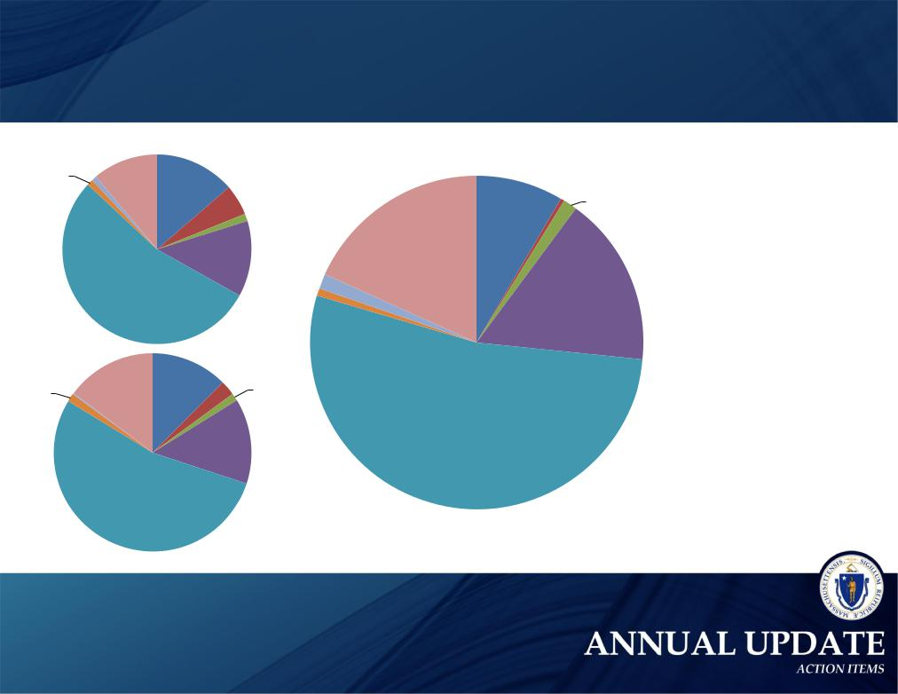
Opioid-Related Deaths in Massachusetts by Category of Insurance (CY2014-2016)

1% | 1% | 14%
 | 11%

2013
2014

54%

1% ^{0%} | 15% | 12%

2014
2015

54%

5% | 1% | 8% | ^{0%} 1%
 |  | 18%
13%
 |  | 2% | 17%
 |  | 1%
3% | 1% | 2015
 |  | 2016
14%

53%

Commercial insurance primary

Medicare only***

Medicare + HSN

Medicare + MassHealth & CommCare

MassHealth & CommCare only

Health Safety Net only

Other Public*

Other Unknown / Uninsured at time of death

Source: DPH, MassHealth, and CHIA data

22
22

Budget and Legislation

Signed 4 Budget Bills

- FY 2015 Supplemental Budget (Ch. 119 of the Acts of 2015): Appropriated $27.8 million to support prevention and treatment initiatives.

- FY 2016 Budget (Ch. 46 of the Acts of 2015): Appropriated $134 million for substance use treatment, prevention, intervention, and recovery efforts.

- FY 2017 Budget (Ch. 133 of the Acts of 2016): Appropriated $173 million for substance use treatment, prevention, intervention, and recovery efforts.

- FY 2018 Budget (Ch. 47 of the Acts of 2017): Appropriated $185.3 million for substance use treatment, prevention, intervention, and recovery efforts.

Criminalizing Fentanyl Trafficking (Ch. 136 of the Acts of 2015): Mandates that trafficking fentanyl is a felony and institutes mandatory minimums on the charge.

Ended the practice of civilly committing women under Section 35 to MCI-Framingham (Ch. 8 of the Acts of 2016): Ensures that women with a substance use disorder who are civilly committed will now receive substance use treatment at an appropriate facility.

STEP Act (Ch. 52 of the Acts of 2016): Limits a first-time opioid prescription to seven days; requires practitioners to check the PMP before prescribing opioids; requires student prevention education training during concussion safety training for athletes; increases prescriber education requirements; expands Good Samaritan protections by shielding individuals administering naloxone to a person during an opiate overdose from civil liability; and requires a substance use disorder evaluation for individuals presenting in the emergency room because of an apparent opiate overdose.

23
23

Prevention Initiatives

Public Awareness

- Create a public awareness campaign focused on reframing addiction as a medical disease

- Foster public-private partnerships to leverage public awareness activities

- Promote drug take-back days

- Partner with a chain pharmacy to pilot a drug-take-back program in the Commonwealth

Education – Parents and Students

- Educate parents, students, and faculty about the risks of opioid use and misuse during mandatory athletic meetings

- Provide state funding for evidence-based opioid prevention programs in schools

• Develop targeted educational materials for parents about the risks of opioid use and misuse

Prescriber Practices

- Mandate prescriber education as a condition of licensure by working with boards of registration to enforce continuing education requirements related to: effective pain management; identification of patients at high risk for a SUD; and counseling patients on the side effects, addictive nature, and proper storage and disposal of prescription medications

- Appoint an addiction specialist to the Board of Registration in Medicine, Board of Registration in Nursing, Board of Registration of Physician Assistants, and Board of Registration in Dentistry

- Appoint members to the drug formulary commission and commence the first meeting prior to August 1

- Outreach to prenatal and postpartum care providers to increase training about screening, intervention, and care for women with a substance use disorder (SUD)

• Increase and improve educational offerings about safe prescribing practices by engaging in private-public partnerships

- Encourage the American College of Graduate Medical Education to adopt requirements for pain management and substance use disorder education for all medical and residency programs, through a partnership with federal leaders

complete in progress not in progress

24
24

Intervention Initiatives

Prescription Monitoring Program

- Improve the prescription monitoring program (PMP)

- Ensure data compatibility of the PMP with other states, Memorandum of understanding with other states required

- Require PMP data to be submitted within 24 hours by pharmacies, Legislation required

Data

- Require timely reporting of overdose death data to the public

- Amend Department of Public Health regulations to require that emergency medical service providers report opioid overdose data

- Utilize overdose reports to identify geographical hot spots for targeted intervention and alert law enforcement, public health entities, community coalitions, and the public

Other Intervention Action Items

- Develop and distribute educational materials for prescribers to increase co-prescribing of naloxone with opioid prescriptions

- Implement a training program about neonatal abstinence syndrome and addiction for Department of Children and Families’ staff

- Promote the Good Samaritan law

- Amend the civil commitment statute, section 12 of chapter 123 of the General Laws, to allow for the involuntary transport and assessment of an individual with a substance use disorder (SUD), Legislation required

- Improve affordability of naloxone through bulk purchasing, Legislation required

complete in progress not in progress

25
25

Treatment Initiatives

MassHealth

- Develop a statewide database of available treatment services, accessible by phone and internet

• Expand mobile emergency service programs to support individuals with a substance use disorder (SUD) in crisis

- Provide case management services to MassHealth fee-for-service members who have a SUD

- Remove fail-first requirements for medication-assisted treatment and ensure naltrexone is categorized as a pharmacy benefit within all MassHealth plans

- Review SUD treatment prior authorization policies across MassHealth to ensure consistency and remove barriers to treatment

- Enroll uninsured patients receiving acute treatment services or clinical stabilization services in MassHealth or other insurance

Department of Public Health

- (Pilot) Create walk-in access to a trained clinician in community-based outpatient provider settings who can provide an emergent/urgent addiction assessment and direct referral to the appropriate level of care

- (Pilot) Make recovery coaches available in emergency departments and hot spots

- Increase the number of office-based opioid treatment programs in community health centers

- Integrate medication-assisted treatment into the clinical stabilization services (CSS) care setting

- Add 100 new treatment beds by July 2016 and expand access to patient navigators

complete in progress not in progress

26
26

Treatment Initiatives

Department of Corrections

- Bulk purchase opioid agonist and naltrexone therapies for correctional facilities

- Improve SUD treatment services for men and women committed under section 35 of chapter 123 of the General Laws:

  - Transfer women from the correctional facility at MCI-Framingham to a new facility run by the Executive Office of Health and Human Services (EOHHS)

  - Develop a feasibility plan to transfer responsibility for the Massachusetts Alcohol and Substance Abuse Center at Bridgewater
to EOHHS, Legislation required

- Increase treatment beds and ensure a continuum of care for patients who are civilly committed under section 35

Division of Insurance

• Review existing Division of Insurance bulletins regarding parity oversight and enforcement

- Issue guidance on the implementation of the substance use disorder recovery law before October 1, 2015

Group Insurance Commission

- Ensure that all Group Insurance Commission (GIC) plans provide coverage for naltrexone, naloxone, buprenorphine, and methadone

- Review GIC insurance plans, removing fail-first policies and prior authorization protocols that may impede access to treatment

Partnering with Federal Leaders

- Change Drug Enforcement Agency (DEA) rules to permit medical residents to prescribe buprenorphine under an institutional DEA registration number, through a partnership with federal leaders

- Change federal law and regulations to increase access to buprenorphine by: increasing the cap - the number of patients a physician can treat with buprenorphine - or removing it entirely; and permitting nurse practitioners and physician assistants to prescribe buprenorphine, through a partnership with federal leaders

complete in progress not in progress

27
27

Recovery Support Initiatives

Department of Public Health

•Enforce and strengthen the requirement that all licensed addiction treatment programs accept patients who are on methadone or buprenorphine medication

•Implement a process to certify alcohol and drug-free housing to increase accountability and credibility •Establish revised rates for residential recovery homes, effective July 1, 2015 •Leverage community coalitions to address the opioid epidemic •Open Recovery High School in Worcester

Executive Office of Health and Human Services

- Create a consistent public behavioral health policy through a review of all DPH and DMH licensing regulations for outpatient
primary care clinics, outpatient mental health clinics, and BSAS programs removing all barriers to integration

• Ensure MassHealth coverage is reinstated on an accelerated basis for individuals upon release from incarceration

- Establish a single point of accountability for addiction and recovery policy within the Executive Office of Health and Human Services

- Amend the composition of the Interagency Council on Substance Abuse, Legislation required

- Report publicly on the progress and challenges of implementing the working group’s recommendations

- Increase federal support for substance use prevention, intervention, treatment, and recovery efforts uniquely tailored for our Veterans, through a partnership with federal leaders

complete in progress not in progress

28
28

