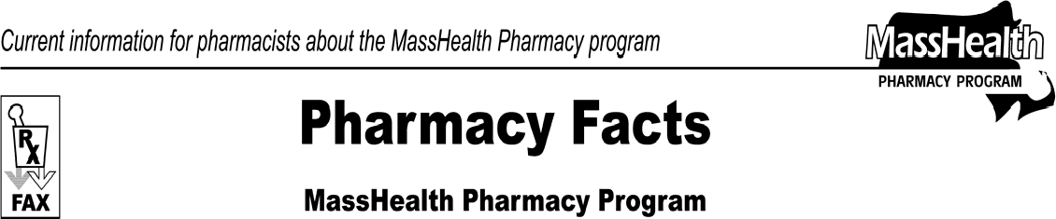www.mass.gov/masshealth/pharmacy
Number 33
January 23, 2008
- Editor: Vic Vangel • Contributors: Chris Burke, Gary Gilmore, Paul Jeffrey, James Monahan, Chuck Young •
MHDL Update  The prior-authorization (PA) requirements for the proton pump inhibitors are changing. Effective February 1, 2008, Prilosec OTC will be removed from the Nonlegend (OTC) Drug List and will no longer be covered. Please see Table 3 for a complete list of PA requirements for the proton pump inhibitors. Omeprazole will no longer require prior authorization.  In addition, the following drugs will no longer require prior authorization.  Estrasorb (estradiol) EstroGel (estradiol) Femring (estradiol)  Claims-Processing Reminders  - B3 Transactions  MassHealth has a 90-day timely filing limit for the submission of claims. If a claim was filed on a timely basis but requires an adjustment after the 90-day time period has elapsed, pharmacies should use the B3 rebill transaction. The B3 rebill transaction is a reversal and resubmission of a claim in one step. For more information on how to perform a B3 transaction please contact your software helpdesk.  - Medicare-D Copay Assistance  MassHealth continues to provide assistance with Part D plan copayments. The pharmacy should collect the same copayment that the member would pay under MassHealth ($0 to $3) and send a claim to MassHealth for the balance, using other-coverage code 2, 4, or 8. A dual-eligible member is never responsible for copayments greater than the standard MassHealth copayments.  - Emergency Fill  MassHealth Pharmacy regulations at 130 CMR 406.411(B) allow a pharmacist to dispense an appropriate emergency supply of selected drugs when denied for coverage after normal business hours and prior authorization cannot be obtained from the UMASS DUR Unit. The pharmacy must indicate a level-of- service value of “3” (emergency service) in field 418.  When the pharmacist determines that an emergency exists, the MassHealth agency will pay the pharmacy for at least a 72-hour, nonrefillable supply of the drug, in compliance with state and federal regulations. | After the prescription is adjudicated, the pharmacy should remove the “3” from the level-of-service field before the next fill. The DUR Unit at UMass must be contacted during normal business hours to obtain PA for additional refills.  4. Claim Submission When MassHealth Is Secondary Insurer  Listed below are valid other-coverage codes (NCPDP field 308) that may be used.  02-Other coverage exists-payment collected 03-Other coverage exists-claim not covered  04-Other coverage exists-payment not collected 07-Other coverage exists-not in effect on Date of  Service  08-Claim is billing for copay  Remember that claims submitted with other -coverage code 04 will be automatically reversed in 90 days (except for Medicare-D copayment assistance claims). This code is to be used only when online adjudication from the primary insurance is not available. When a pharmacist is notified of the claim status from the primary insurer, the pharmacist should reverse and resubmit the claim with the correct other-coverage code.  A pharmacy should use other-coverage code 08 when billing 100% of the copay from a paid claim to MassHealth. For example, when a member has a $10 copay with their primary insurer and the member receives a prescription with a total cost of $7, the pharmacy would bill MassHealth for the full $7 using code 08. If the primary insurer has made any payment toward the claim, code 02 should be used.
Please direct any questions or comments (or to be taken off of this fax distribution) to
Victor Moquin of ACS at 617-423-9830.

