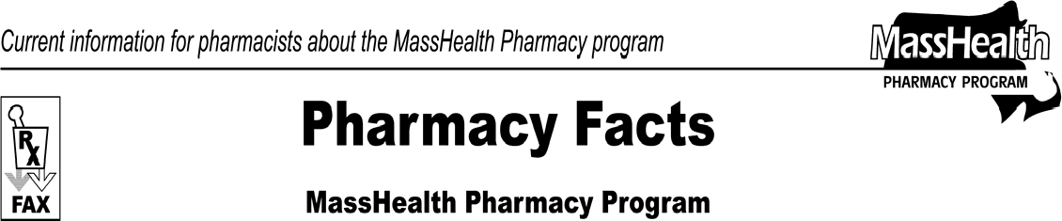www.mass.gov/masshealth/pharmacy
Number 36
April 2, 2008
- Editor: Vic Vangel • Contributors: Chris Burke, Gary Gilmore, Paul Jeffrey, James Monahan, Chuck Young •
Claims Processing Update  - Family Planning Products for MCO Members  MassHealth will notify pharmacies when the pharmacy submits a claim for a family planning product to MassHealth for a member who is enrolled in one of the four MassHealth Managed Care Organizations (MCO). MassHealth will pay the claim for a family planning product. Alternatively, if the member has coverage through one of the MCOs, the pharmacy may bill the MCO instead. The message you will see is:  You may bill MCO (name), #######, directly, (Phone #), but are not required to do so. Bill only one payer for each family planning service provided.  - Member Date of Birth  MassHealth will soon begin sending messages back to pharmacies if the member date of birth submitted on a pharmacy claim does not match what MassHealth has on record in the member file. MassHealth has noted an increase in the number of claims where a prescription claim is being submitted with a child’s RID # instead of a parent’s RID # or vice versa because of similar names on a MassHealth card. The message you will see is:  The date of birth entered does not match the date of birth on file with MassHealth.  When you see this message we ask that you verify the member RID # and date of birth and reprocess the claim with correct information, if necessary. | - Prescriptions from Mid-Level Practitioner Reminder  The law stipulates that any prescription issued by a nurse practitioner (See M.G.L. c. 112, section 80(E)), or physician assistant (See M.G.L. c. 112, section 9(E)) must include the name of the supervising physician.  - Prescription Origin Codes  Every claim submitted to MassHealth needs to contain a valid prescription origin code in NCPD field 419-DJ. These values are:  1-Written  2-Telephone 3-Electronic 4-Facsimile  If a pharmacy receives a prescription that is not tamper resistant and the pharmacist telephones the prescriber to verify authenticity, the pharmacist may use a prescription origin code of 1. The pharmacist must document this call on the prescription.

Please direct any questions or comments (or to be taken off of this fax distribution) to
Victor Moquin of ACS at 617-423-9830.

