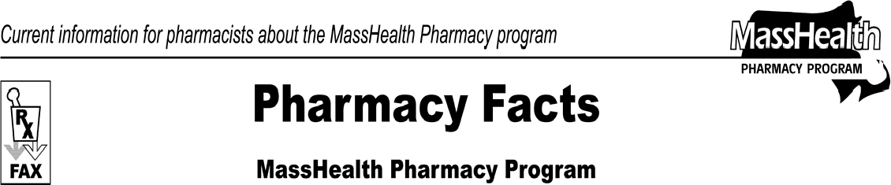www.mass.gov/masshealth/pharmacy
Number 38
April 25, 2008
- Editor: Vic Vangel • Contributors: Chris Burke, Gary Gilmore, Paul Jeffrey, James Monahan, Nancy Schiff, Chuck Young •
Summary of MassHealth All Provider Bulletin 172  MassHealth recently sent out All Provider Bulletin 172, which contains information crucial to pharmacies and your use of the Pharmacy Online Processing System (POPS). This bulletin, NewMMIS Key Concepts and Provider Preparation Guidelines, can be found on the MassHealth Web site at www.mass.gov/masshealth. Go to MassHealth Regulations and Other Publications. Click on the link for Provider Library, and then for Provider Bulletins. The current Medicaid Management Information System (MMIS) processes and pays pharmacy claims that are adjudicated in POPS. MMIS interacts daily with POPS concerning claims, member files, provider enrollment, and payment information.  The “NewMMIS” will interact with POPS in many of the same ways.  Training Sessions for Pharmacies  MassHealth is hosting training to prepare all providers for the implementation of NewMMIS. The new system will go live on September 29, 2008. You need to be aware of the changes ahead of time so that you can plan for the impact of NewMMIS. Provider training will focus on details needed for member eligibility verification, DME prior authorization, and claim- submission changes in POPS and non-POPS transactions. Information, registration for provider training sessions, and all announcements about NewMMIS will be posted on the Web site at www.mass.gov/masshealth/newmmis.  New Provider ID Numbers  All current MassHealth provider numbers will be replaced with a new 10-character provider ID consisting of nine numbers and a letter to denote the provider’s service location. This impacts a claim that a pharmacy may submit to MassHealth for DME services. Providers will need this number to access the Provider Online Service Center, and is used on the remittance advice. NewMMIS provider IDs will be sent to providers 45 to 60 days before the NewMMIS implementation. | New Member ID Numbers  Each MassHealth member will receive a new 12-digit MassHealth ID number and a MassHealth ID card before the implementation of NewMMIS. The new ID numbers will not be based on the member’s social security number and each MassHealth member will receive their own card. Multiple members will not be listed on the same card.  Consolidation of Services  With NewMMIS, MassHealth will launch a new Provider Online Service Center that will consolidate Web services available to providers. The APAS (Automated Prior Authorization System for DME) and REVS (Recipient Eligibility Verification System) services will be retired, and these and other functions will be consolidated into NewMMIS.  Industry-Standard Claims  MassHealth will adopt industry-standard claim- processing rules in NewMMIS. For pharmacies, MassHealth will continue to accept the POPS NCPDP  5.1 transaction, but for DME, the CMS-1500 claim form will replace the MassHealth claim form no. 9.  835 Changes for Pharmacy  The 835 remittance advice will also change under NewMMIS, though it was not mentioned in All Provider Bulletin 172. The 835 Pharmacy Companion Guide will be replaced by the 835 Companion Guide on September 29, 2008. This new 835 will be created for pharmacy providers. Changes in these procedures are announced on the NewMMIS site (see above).  TCN (Transaction Control Number)  NewMMIS will replace the current transaction control number (TCN) with a 13-digit NewMMIS interchange control number (ICN).  Questions  If you have any questions about this information, or DME claims, contact MassHealth Customer Service at 1-800-841-2900. For information about POPS claims, contact the ACS Pharmacy Technical Help Desk at  1-866-246-8503.

Please direct any questions or comments (or to be taken off of this fax distribution) to
Victor Moquin of ACS at 617-423-9830.

