Sentinel Provider Surveillance: Influenza-like illness activity
Week 20 Activity (representing geographic distribution): Local
Week 20 ILI Activity (representing intensity of ILI activity): 1 (Minimal)
Provider offices across the US report the amount of influenza-like illness (ILI) they see in their patients each week during regular flu season. These outpatient providers’ offices, which include doctors' offices, school health services, and community health centers, are called 'sentinel sites.’ Here we present Massachusetts sentinel site data. Please note that the data represent not only confirmed influenza cases, but also those just with ILI, which may be caused by other viruses. ILI is defined as fever above 100.0¹ in addition to either cough or sore throat. ILI is a marker of influenza and is used throughout the regular influenza season to monitor influenza since most people are not tested for influenza. Figure 1 shows that ILI activity is low, consistent with activity levels normally seen at this time of year. For more information, see CDC’s influenza surveillance website at www.cdc.gov/flu/weekly/fluactivitysurv.htm.

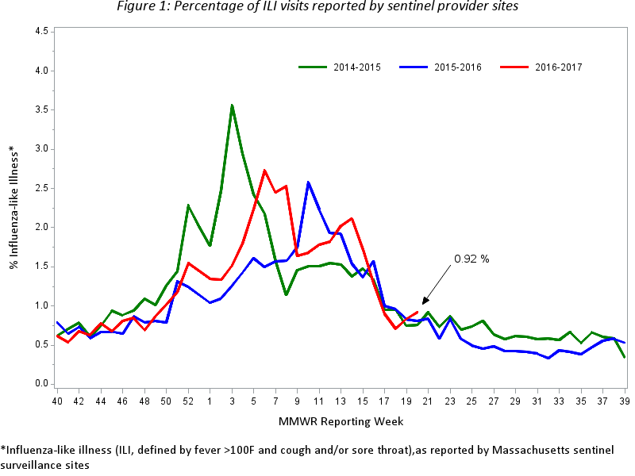
Figure 2 below shows a geographical distribution of reported ILI in Massachusetts. Figure 2 shows that sentinel sites in one region of the state are experiencing elevated ILI activity.

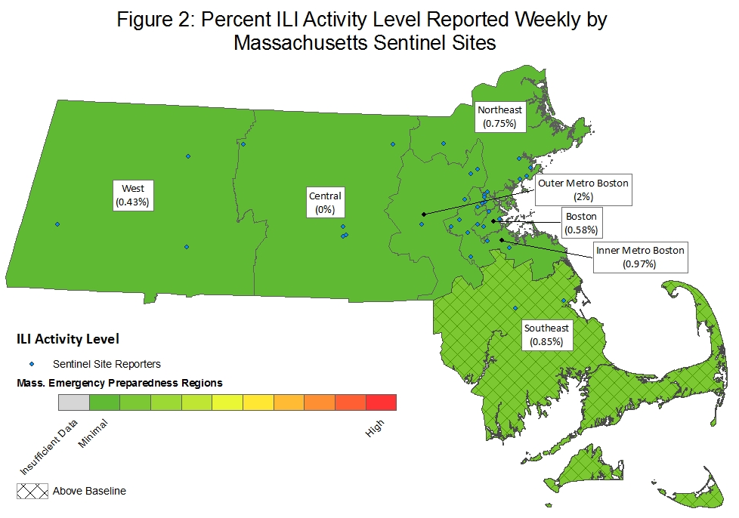

Laboratory testing for influenza
Laboratories in Massachusetts report all positive influenza laboratory tests to MDPH, including viral culture, polymerase chain reaction (PCR) and rapid influenza diagnostic tests. Because the majority of cases are not tested, the number of 'confirmed' cases does not reflect the overall incidence of influenza; however, this information is essential to track the types of influenza circulating in Massachusetts and can be a useful indicator of the presence and distribution of influenza in the state. Table 1 reflects the number of influenza cases confirmed via viral culture or PCR test by region and influenza type. Figure 3 illustrates the number of laboratory confirmed cases in Massachusetts by week, shown along with Massachusetts ILI.

Table 1: Laboratory-confirmed Influenza by Region – 2016-2017 and 2015-2016 Influenza Seasons
 | 2016-2017 |  |  |  |  |  | 2015-2016
 | A |  | B |  | Untyped |  | A |  | B |  | Untyped
Region | Week | YTD | Week | YTD | Week | YTD | Week | YTD | Week | YTD | Week | YTD
Boston | 2 | 1,120 | 4 | 469 | 0 | 0 | 4 | 801 | 8 | 170 | 0 | 0
Central | 0 | 372 | 2 | 145 | 0 | 0 | 0 | 101 | 1 | 10 | 0 | 0
Inner Metro Boston | 0 | 605 | 4 | 209 | 0 | 0 | 5 | 468 | 5 | 117 | 0 | 0
Northeast | 2 | 1,056 | 5 | 462 | 0 | 0 | 1 | 524 | 5 | 191 | 0 | 0
Outer Metro Boston | 0 | 419 | 6 | 175 | 0 | 0 | 0 | 264 | 3 | 59 | 0 | 0
Southeast | 0 | 227 | 0 | 107 | 0 | 0 | 0 | 136 | 0 | 30 | 0 | 0
Unknown | 1 | 120 | 0 | 31 | 0 | 0 | 2 | 120 | 0 | 28 | 0 | 0
West | 5 | 2,362 | 17 | 1,222 | 0 | 0 | 2 | 1,364 | 29 | 337 | 0 | 0
Total | 10 | 6,281 | 38 | 2,820 | 0 | 0 | 14 | 3,778 | 51 | 942 | 0 | 0
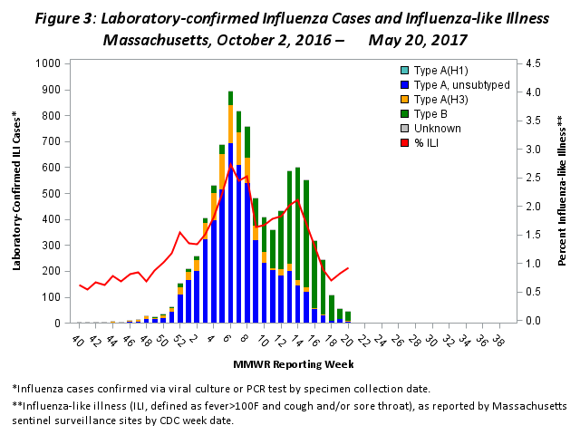
Influenza-Associated Hospitalizations
In 2010, MDPH began to request voluntary reporting of all laboratory-confirmed influenza hospitalizations from hospitals in Massachusetts. As many as 50 acute care hospitals from across the state report these data to MDPH on a weekly basis during flu season. The graph below shows the number of laboratory-confirmed hospitalizations per 1,000 licensed beds represented by reporting hospitals for the current season and two previous seasons.

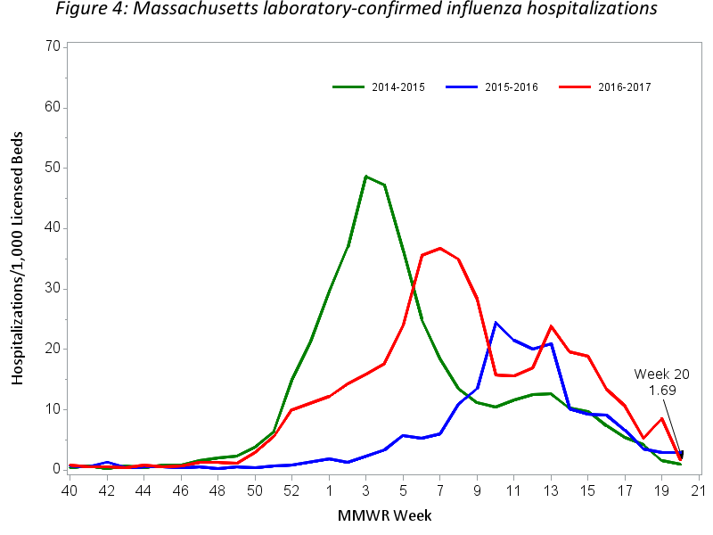

Testing at the State Public Health Laboratory
As part of a more comprehensive respiratory surveillance initiative, MDPH’s Bureau of Infectious Disease and Laboratory Sciences (MDPH-BIDLS) performs testing to confirm typing and subtyping of circulating influenza viruses followed by testing of influenza-negative samples for the evidence of adenovirus, respiratory syncytial virus (RSV) A/B, parainfluenza virus (PIV) types 1-4 , coronavirus (HCoV) HKU1, OC43, NL63, 229E, human metapneumovirus (HMPV), and rhinovirus/enterovirus (RHV/ENT) using a multiplex PCR respiratory viral panel. Samples are submitted by ~60 outpatient healthcare providers (ILINet) and include early influenza positives, as well as specimens and isolates from clinical hospital diagnostic laboratories across Massachusetts. For the 2016-2017 season, Figure 5 and Tables 2 and 3 summarize virologic surveillance testing conducted by MDPH-BIDLS beginning MMWR week 40 (week ending October 2, 2016). MDPH-BIDLS performs influenza surveillance testing year round. For the 2016-2017 season to date, 298 cases of A/H3N2 influenza, five cases of A/2009 H1N1, 82 cases of B/Yamagata and 42 cases of B/Victoria have been confirmed in 567 cases tested.

Figure 5: Influenza positive tests reported to CDC by MDPH-BIDLS, October 2, 2016 – May 20, 2017

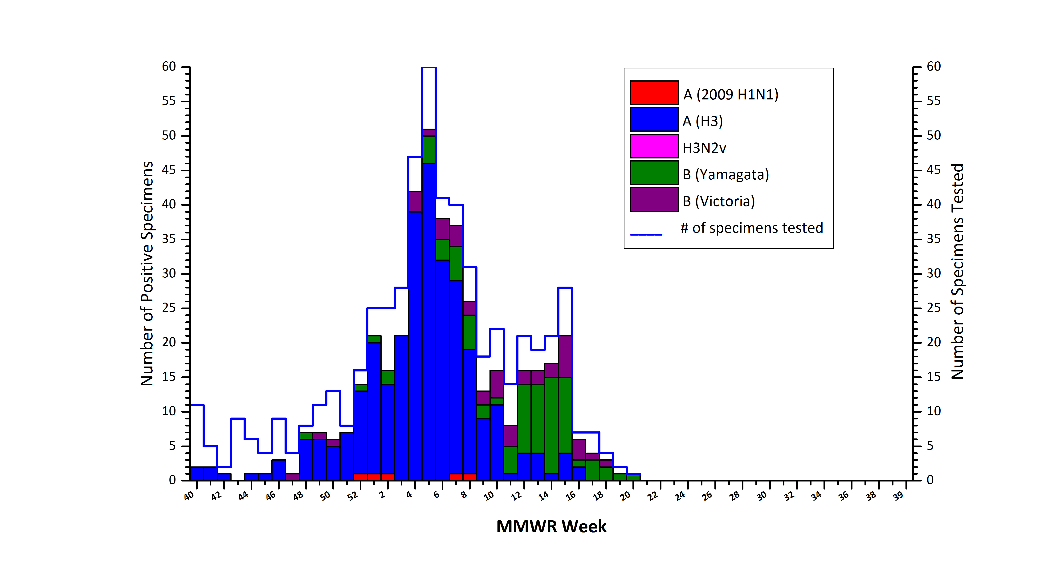

Table 2: Weekly Summary of MDPH-BIDLS Influenza Surveillance Test Results
2016-2017 Season: Influenza Surveillance
MA Department of Public Health’s Bureau of Infectious Disease and Laboratory Sciences (MDPH-BIDLS)
MMWR Week:  (Specimen Collected) | 2009 H1N1 | seasonal A/H3N2 | H3N2v | B Yam | B Vic | No. Flu Pos (%) | Unsat | Total Tested | Total  Rec’d
17 (04/23 – 04/29/2017) | 0 | 0 | 0 | 3 | 1 | 4(57%) | 0 | 7 | 7
18 (04/30 – 05/06/2017) | 0 | 0 | 0 | 2 | 1 | 3(75%) | 0 | 4 | 4
19 (05/07 – 05/13/2017) | 0 | 0 | 0 | 1 | 0 | 1(50%) | 0 | 2 | 2
20 (05/14 – 05/20/2017) | 0 | 0 | 0 | 1 | 0 | 1(100%) | 0 | 1 | 1
Prior 4 wk Total | 0 | 0 | 0 | 7 | 2 | 9(64%) | 0 | 14 | 14
Cumulative Season total | 5 | 298 | 0 | 82 | 42 | 427(75%) | 16 | 567 | 583
All data are subject to change as test results become finalized. The 2016 -2017 influenza season began MMWR 40 (10/02- 10/08/2016).
Table 3: Weekly Summary of MDPH-BIDLS non-Influenza Respiratory Surveillance Test Results
2016-2017 Season: Influenza Like Illness Surveillance
MA Department of Public Health’s Bureau of Infectious Disease and Laboratory Sciences (MDPH-BIDLS)
MMWR Week:  (Specimen Collected) | RSV | RHV/ENT | PIV | HMPV | HCV | ADV | # Co-Infection | No. Pos (%) | Unsat | Total Tested | Total  Rec’d
17 (04/23 - 04/29/2017) | 0 | 0 | 0 | 0 | 0 | 0 | 0 | 0(0%) | 0 | 2 | 2
18 (04/30 - 05/06/2017) | 0 | 0 | 0 | 1 | 0 | 0 | 0 | 1(100%) | 0 | 1 | 1
19 (05/07 - 05/13/2017) | 0 | 0 | 1 | 0 | 0 | 1 | 1 | 1(100%) | 0 | 1 | 1
20 (05/14 - 05/20/2017) | 0 | 0 | 0 | 0 | 0 | 0 | 0 | 0(0%) | 0 | 0 | 0
Prior 4 wk Total | 0 | 0 | 1 | 1 | 0 | 1 | 1 | 2(50%) | 0 | 4 | 4
Cumulative Season total | 4 | 18 | 11 | 8 | 17 | 9 | 6 | 60(47%) | 0 | 128 | 128
All data are subject to change as test results become finalized. The 2016-2017 influenza season began MMWR 40 (10/02- 10/08/2016).

For the 2016-2017 season, two original specimens positive for each influenza virus A(H3N2), influenza virus A(H1N1)pdm09, and influenza virus B (with one sample from each Victoria and Yamagata lineage, if possible) will be sent every two weeks by MDPH-BIDLS to a CDC contract laboratory performing National Influenza Virus Surveillance standardized test methods. Antigenic characterization of these submitted specimens include: hemagglutination inhibition (HI), genetic analysis (sequencing) and sensitivity to FDA-approved drugs for identification of resistance. Selection criteria for submitting influenza positive specimens will be based on a Ct value (<30) for Inf A and Inf B tests using the CDC Flu rRT-PCR Dx Panel. See Figure 6 for a summary of specimens characterized in the 2016-2017 season to date.

Figure 6: Summary of 2016-2017 CDC Contract Laboratory Specimen Characterization
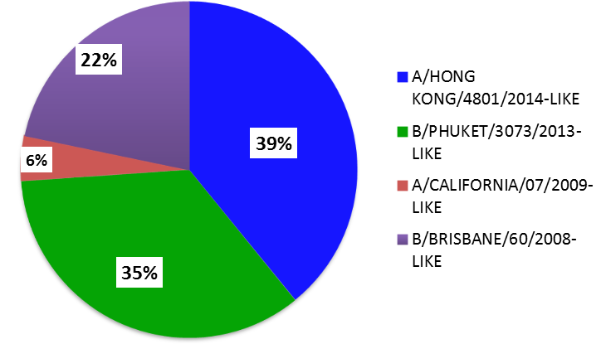

INFLUENZA VIRUS TYPE | CHARACTERIZED TOTAL
A/HONG KONG/4801/2014-LIKE | 9
B/PHUKET/3073/2013-LIKE | 8
A/CALIFORNIA/07/2009-LIKE | 1
B/BRISBANE/60/2008-LIKE | 5

The CDC Flu rRT-PCR Dx Panel for Influenza A subtyping for the 2016-2017 season has been updated. The oligonucleotide primers and probe have been improved to ensure detection of currently circulating influenza A(H1N1)pdm09 viruses. The “seasonal” H1 target from Influenza A(H1N1) viruses that caused seasonal epidemics in humans prior to 2009 no longer circulates in humans and this target within the assay has been discontinued.

As samples are received, MDPH-BIDLS will screen additional samples every two weeks to detect point mutations within the neuraminidase gene of influenza A/H3N2 viruses (E119, R292, and N294) and influenza A/2009 H1N1 viruses (H275 and I223) to assess resistance trends using the current CDC pyrosequencing method. This information will be reported locally and captured nationally in FluView (http://www.cdc.gov/flu/weekly/). For the 2015-2016 season, one A/2009 H1N1 isolate with a mutation conferring oseltamivir-resistance (H275H/Y) was detected.

Table 4: DPH-BIDLS Influenza Antiviral Resistance Screening: 2016-2017 Season
Virus Collection Period: October 2, 2016- ongoing
 | Oseltamivir |  | Zanamivir
 | Samples Tested | Resistant Viruses, Number (%) | Samples Tested | Resistant Viruses,  Number (%)
Influenza A (H3N2) ^{i} | 215 | 0 (0) | 215 | 0 (0)
Influenza A (H1N1)pdm09 ^{ii} | 3 | 0 (0) | 0 | 0 (0)
^{i} Samples tested by pyrosequencing at position E119, R292, and N294 within the neuraminidase (NA) gene.
^{ii} Samples tested by pyrosequencing at position H275 and I223 within the NA gene.

Additional information on national antiviral resistance testing including recommendations for antiviral treatment and chemoprophylaxis of influenza virus infection can be found at http://www.cdc.gov/flu/weekly/.

CDC activity indicator – indicates how widespread influenza activity level is in the state.
CDC ILI activity indicator – more quantitative indicator of the level of ILI activity across the state.

