Influenza Vaccination of Healthcare Facility Employees

DPH 2017 – 2018 Seasonal Influenza Vaccination of Employees at Massachusetts Adult Day Health Centers, Clinics*, Nursing Homes and Rest Homes.

*This guidance applies to all clinics except for ambulatory surgical centers

Please note all licensed acute care hospitals, ambulatory surgical centers, dialysis centers, and long term acute care hospitals are required to report influenza healthcare worker vaccination data to the Centers for Disease Control and Prevention’s National Healthcare Safety Network (NHSN.)

NEW for the 2017-2018 influenza season:

- To improve the accuracy, completeness and timeliness of reporting, DPH has transitioned from a paper-based system to an electronic web-based system.
- Beginning with the 2017-2018 influenza season, only reports submitted through the web-based application, SurveyMonkey® will be accepted.

Background
Healthcare personnel are an important source of transmission of the influenza virus in the healthcare setting and annual influenza vaccination is an effective method of preventing influenza virus infection and its potentially serious complications.

As a condition of licensure, Massachusetts Department of Public Health (DPH) regulations mandate all licensed healthcare facilities to offer, free of charge, annual influenza vaccine to all personnel (regular employees, contracted employees, volunteers, house staff and students); document all personnel’s receipt of influenza vaccine administered within and outside the facility; or document the declination of immunization.

DPH has established an overall minimum performance goal for all licensed healthcare facilities. Statewide, the DPH expects that a 90% influenza vaccination coverage rate will be reached for all licensed healthcare facilities.

Reporting Instructions
While all personnel, including non-employee personnel, must be offered influenza vaccine, the reportable measure of effectiveness is based on employees, as defined by the payroll.
For the purposes of the vaccination program, employee is defined as:
- Individuals, both full-time and part-time, who worked at this healthcare facility for at least 1 day between October 1, 2017 and March 31, 2018.
- This includes, but is not limited to: physicians; nurses; interns/residents; fellows; physician assistants; physical, occupational, respiratory and speech therapists; laboratory and operating room technicians; central supply staff; pharmacists; maintenance/environmental services staff; dietary staff; attendants/orderlies, secretarial and administrative staff; contract staff, whether or not such individuals provide direct patient care.
- Employees, such as contractors performing administrative functions, who do not work at or come to the licensed healthcare facility, are not required to be vaccinated.
Please see the following instructions for the three page “Influenza Vaccination of Healthcare Personnel in Massachusetts (2017-2018)” SurveyMonkey®. All questions are required. You will not be able to move to the next page or complete the survey until all questioned are completed.
Start by clicking on the link to the “Influenza Vaccination of Healthcare Personnel in Massachusetts (2017-2018)” SurveyMonkey® available at the following link:
https://www.surveymonkey.com/r/2017-18HCPvaccination.

Long term care facilities that have both a nursing home and an adult day health center must report each licensed facility separately. If a HCP works in or is affiliated with both agencies, this individual must be counted in both reports.

Questions 1-4: Facility Information

If you are unsure of your facility's name, type or ID number, please refer to the "Massachusetts Licensed or Certified Health Care Facility/Agency Listing“ link provided in the survey: http://www.mass.gov/eohhs/docs/dph/quality/healthcare/healthcare-facilities.xlsx.

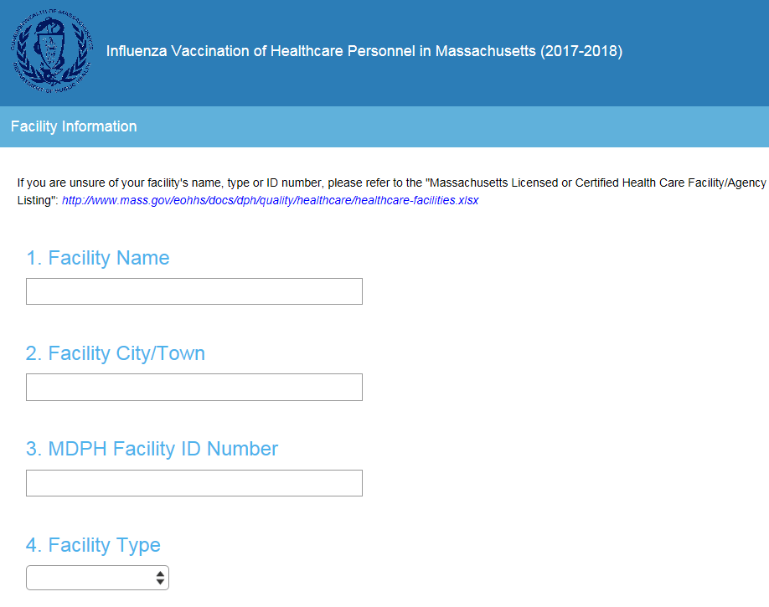

Questions 5-8: Contact Information

Please enter the complete name, position/title, phone number and email address of the person at your healthcare facility whom DPH should contact if there are questions about influenza data submission.

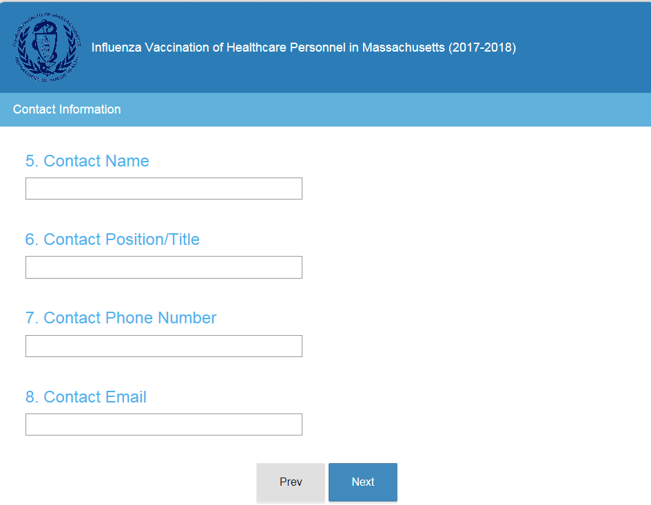

Questions 9-10: Influenza Vaccination Summary

Question 9: Please enter the number of healthcare facility employees who worked at this healthcare facility for at least 1 day between October 1, 2017 and March 31, 2018.

Question 10: Please enter the number of healthcare facility employees who received an influenza vaccine at this facility since influenza vaccine became available this season (August 1, 2017). Do not include doses administered after 3/31/18.

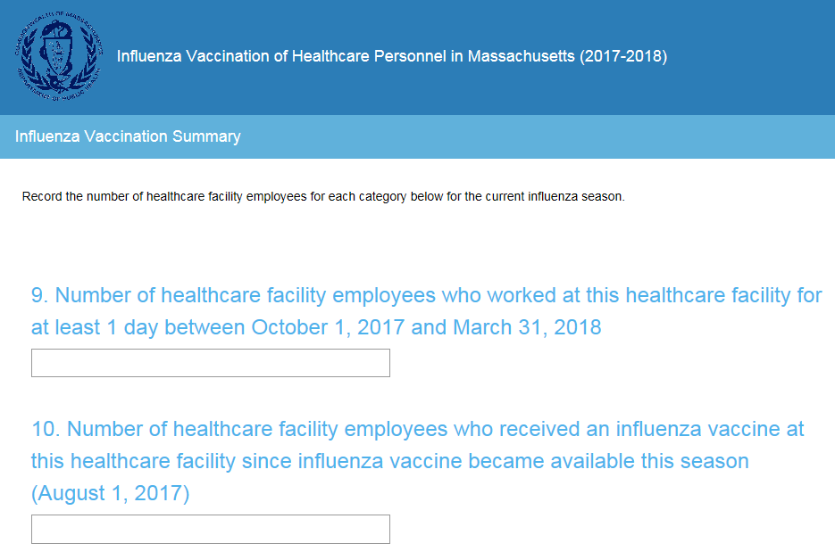

Questions 11-14: Influenza Vaccination Summary (Cont.)

Question 11: Please enter the number of healthcare facility employees who received seasonal influenza vaccination OUTSIDE the healthcare facility (for example from private physician’s office, community health center, clinic, etc.). Do not include doses administered after 3/31/18.

Individuals must report in writing (paper or electronic) or provide documentation that influenza vaccination was received elsewhere. Each healthcare facility must maintain written documentation of influenza vaccination received elsewhere.

Question 12: Please enter the number of healthcare facility employees who have a medical contraindication to the influenza vaccine.

Question 13: Please enter the number of healthcare facility employees who declined to receive the influenza vaccine.

Question 14: Please enter the number of healthcare facility employees with unknown vaccination status (or criteria not met for questions 10-13 above).

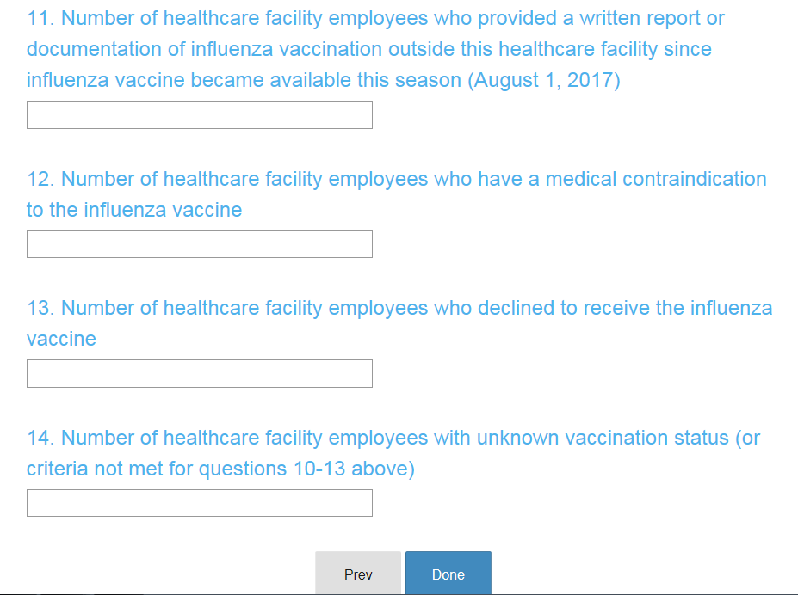

Data submission must be completed by 5:00 pm, April 15, 2018.
.
Remember to keep a copy of your facility’s submitted data. Healthcare facilities must retain copies of all data submitted in a secure file for a minimum of three years.

State and healthcare facility specific information will be publicly reported.

Requests for assistance with data submission and related questions may be directed to
dhcq.fludata@state.ma.us.

Influenza Data Submission Deadline: April 15, 2018

105 CMR 130.325, 105 CMR 140.150, 105 CMR 150.002(D)(8), 105 CMR 158.004 available at http://www.mass.gov/dph/dhcq

