Competitive Integrated Employment Services (CIES) SFY2017
Program Description
Program Design
The CIES program is made up of six component services that assist consumers in achieving competitive employment. Consumers enter or exit component services based on need. The key measures of success for the program are the number of consumers placed in jobs for 30 days or more, called Job Placements, and the number of consumers employed beyond 90 days, called Successful Employment Outcomes (SEOs).

The State contracts with Qualified Community Rehabilitation Providers (CRPs) to deliver the CIES services. Providers are paid on a performance basis during the initiation and completion phases of services. Using a data management and billing system called EIM (Enterprise Invoice Management), the MRC CIES team tracks enrollment, expenditure, and outcomes. Data from the EIM system allows detailed analysis of provider performance and program results.

High Level Results
MRC CIES providers have consistently expended about 60% of resources on the Job Development and Placement component. A total of 1,164 consumers placed in a job as a percentage of all consumers served has steadily increased in recent years. In SFY 2017, 84% of all CIES placements, or 928 individuals, reached successful employment outcomes. These consumers achieved combined annual earnings of approximately $10 million
The MRC Competitive Integrated Employment Services (CIES) program provides assessment, skills training, job placement, initial supports, interim supports, and ongoing support services to assist consumers in their efforts to choose, obtain, and maintain competitive employment in an integrated work setting. Through the six CIES service components, consumers are able to receive the individualized services and supports they need to achieve and maintain successful employment opportunities throughout the Commonwealth of Massachusetts. CIES services may carry over from year to year.

CIES Components

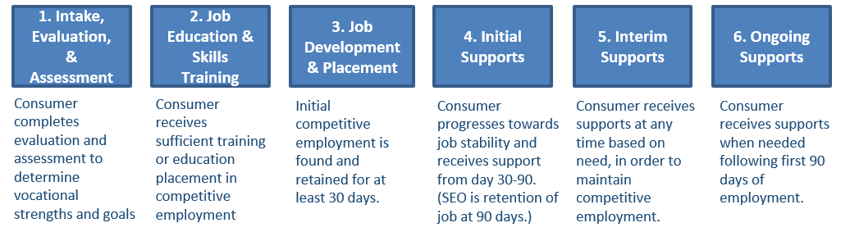

CIES Placements and Successful Employment Outcomes (SEOs)

Outcome | SFY 2014 | SFY 2015 | SFY 2016 | SFY 2017
Total Served | 3,179 | 3,618 | 3,444 | 3,722
Placements | 951 | 1,161 | 1,164 | 1,106
SEOs as % of Placements | 81% | 77% | 91% | 84%

The percentage of placements and successful employment outcomes (SEOs) as a percentage of the total number of consumers served has increased overall, demonstrating performance gains. Between FY2014 and 2017 there was a 16% increase in consumer placements which resulted in successful employment outcomes. MRC also saw a 21% increase in successful employment outcomes between FY2014 and FY2017.

SFY 2017 CIES Budget
SFY 2017 CIES Budget (total obligated) | $9.29 million
SFY 2017 CIES State Funded Ongoing Supports | $1.67 million

CIES Job Placements by the North American Industry Classification System (NAICS)

CIES consumers are placed in a wide variety of occupations across Massachusetts. Retail Trade, followed by Accommodation & Food Services, and Health Care topped the list of industries/occupations where CIES consumers were placed.

CIES Wage Outcomes (SFY 2017)

# of Consumers  w/ 30+ Day  Job Placement | Total Hourly Wage Range | Average # of Hours | Range of Avg. # of Hours Across Districts | # Retaining Job for 90+ days | % of Placements  to SEOs | Cost per SEO
1,106 | $11.00 - $45.00 | 21.1 | 18-24 | 928 | 84% | $9,186

CIES Service Component Rates SFY2017

Rate Category | Component 1:  Assessment | Component 2:  Training | Component 3:  Placement | Component 4:  Initial Supports | Component 5:  Interim Supports | Component6:  Ongoing Supports
Initiation Phase | $165 | $903 | $ 1,821 | $650 | $37.20 / hour | $37.20 / hour
Completion Phase | $662 | $1,355 | $ 2,731 | $976
Total | $827 | $2,258 | $4,552 | $1,626
(By law, all established rates are multiplied by 1.07% in Dukes and Nantucket Counties)

CIES Benefits
- In SFY2017, 1,106 CIES consumers were placed in employment for 30 days or more and 928 achieved successful employment outcomes.
- A high percentage of placed individuals (over 80%) achieve successful employment outcomes in CIES
- CIES consumers work in a wide variety of competitive occupations throughout Massachusetts
- Providers are paid on a timely basis and are assisting consumers in finding competitive employment
- Over 900 individuals in need of ongoing supports to maintain employment remained competitively employed through CIES services.

CIES Performance Summary
The MRC CIES management team continuously monitors and evaluates performance quality to ensure the best possible consumer employment outcomes, using tools such as site visits, monthly data analysis and reporting, quarterly management team meetings, and annual provider and consumer surveys. The percentage of consumers placed who achieved a successful employment outcome increased by 3% over the four period from SFY2014 to SFY2017 and the number of successful outcomes increased by 21% over the same four year period. The CIES program continues to achieve high performance and to positively impact consumer employment outcomes.

