FY17 Legislative Report
For The DDS
Turning 22 Program

December 23, 2016

December 23, 2016

The Honorable Karen E. Spilka, Chair
Senate Committee on Ways and Means
State House, Room 212
Boston, MA 02133

The Honorable Brian S. Dempsey, Chair
House Committee on Ways and Means
State House, Room 243
Boston, MA 02133

Dear Chairwoman Spilka and Chairman Dempsey:

Line item 5920-5000 of Chapter 133 of the Acts of 2016 requires the Department of Developmental Services (DDS) to submit an annual report to the House and Senate Committees on Ways and Means on the projected use of funds encumbered or expended for the “Turning 22” program.

Chapter 688 (better known as the “Turning 22” law) was enacted in 1984 to provide a planning process for young adults with severe disabilities as they leave special education and transition into the adult service system. Each year, DDS transitions hundreds of young people into the Department’s adult service system. One of the Department’s most significant challenges is to continually meet the needs of these young people coming to DDS from Special Education when their school entitlement services end.

Figure 1 displays the number of individuals leaving Special Education and entering DDS services since Fiscal Year (FY) 1998. As noted in the chart, there have been steady increases in the number of “graduates” each year. In addition, the Department is experiencing a higher number of individuals with complex clinical profiles who have intensive support needs due to medical or behavioral challenges.

Figure 1
DDS Turning 22 Census by Fiscal Year

Figure 2 displays the annualized legislative appropriation for the 855 cohort of students who entered the DDS system during FY16.

Figure 2
Legislative Annual Appropriation for the FY16 Class

Figure 3 represents spending from FY10 and onward for the first year of funding for services for some of the individuals of the Turning 22 class. The FY17 appropriation for line-item 5920-5000 is $7.5 million.
Figure 3
5920-5000 Legislative 1st Year Appropriation

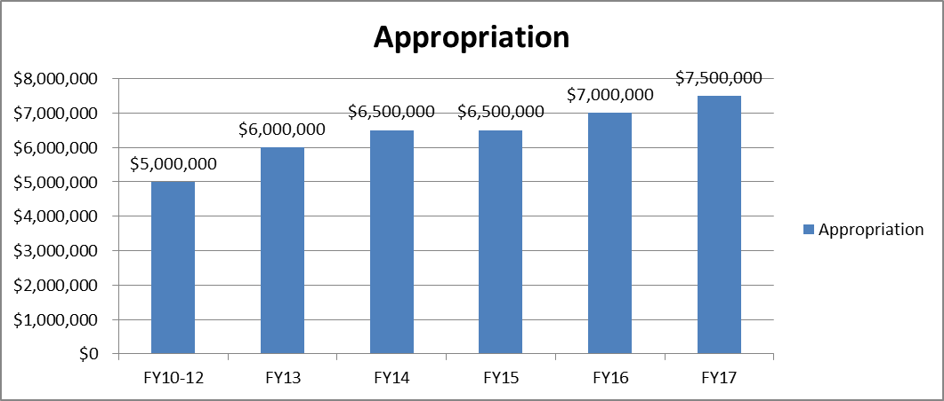

For FY17, DDS has identified 927 young people eligible for Turning 22 services. Line-item 5920-5000, the Turning 22 account, supplements the cost to serve 270 young people who were identified as needing some Community Based Residential Supports as they leave special education gradually over the course of this fiscal year. This appropriation helps to fund in part their first year residential supports in a wide range of living arrangements in their community including small individual settings and group living situations. State and private vendors are contracted with the Commonwealth to manage these services. Appropriate vocational and transportation services are also arranged for this group.

Figure 4 presents the number of those individuals receiving Community Based Residential Services by region.

Figure 4
DDS 5920-5000 FY17 Residential Census
REGION | Central/West | Metro Boston | Northeast | Southeast | TOTAL
# | 80 | 56 | 70 | 64 | 270

As for the remaining 657 students, Figure 5 represents the remaining number of FY17 Turning 22 students by DDS region who live at home with families and require day and/or employment and transportation services.
Figure 5
REGION | Central/West | Metro Boston | Northeast | Southeast | TOTAL
# | 219 | 143 | 152 | 143 | 657

