The Commonwealth of Massachusetts
Executive Office of Health and Human Services
Department of Public Health
Bureau of Health Care Safety and Quality
99 Chauncy St., 11th Floor
Boston, MA 02111

CHARLES D. BAKER
Governor
KARYN E. POLITO
Lieutenant Governor

MARYLOU SUDDERS
Secretary
MONICA BHAREL, MD, MPH Commissioner

Tel: 617-624-6000
www.mass.gov/dph

Circular Letter: DHCQ 17-12-676

TO: Adult Day Health Program Administrators
Clinic Chief Executive Officers or Practice Managers
Nursing Home Administrators
Rest Home Administrators

FROM: Eric Sheehan, JD

Director, Bureau of Health Care Safety and Quality

DATE: December 27, 2017

RE: Important Change in Process to Report Seasonal Influenza Vaccination of Healthcare Personnel (HCP) at Massachusetts Adult Day Health Programs, Non-Ambulatory Surgical Center Clinics, Nursing Homes and Rest Homes for the 2017-2018 Influenza Season

The purpose of this circular letter is to inform Massachusetts Adult Day Health Programs, Clinics, Nursing Homes and Rest Homes of changes in the process to report mandatory HCP influenza data and to provide guidance for facilities to fulfill the Massachusetts Department of Public Health (DPH) requirement for submission of annual HCP influenza data to the Department by April 15, 2018.

Background
As a condition of licensure, DPH regulations require all licensed healthcare facilities to:

- Offer free-of-charge, annual influenza vaccine to all personnel (full and part-time employees, contracted employees, volunteers, house staff and students);
- Document receipt of influenza vaccine administered within and outside the facility or document the declination of immunization; and
- Report information to DPH, documenting compliance with the vaccination requirement, in accordance with reporting and data collection guidelines of the Commissioner (105 CMR 140.150(I)).

DPH has established an overall minimum performance goal for all licensed facility HCP vaccination rates. Statewide, DPH expects that a minimum 90% influenza vaccination coverage rate will be reached for all HCP. This performance goal is intended to advance patient and HCP health and safety by ensuring optimal HCP influenza vaccination coverage, and is in alignment with the National Healthy People 2020 target of 90% influenza coverage of HCP.

Figure 1 depicts trends in influenza vaccination rates in Clinics, Nursing Homes, Rest Homes and Adult Day Health Programs in Massachusetts from the 2012-2013 influenza season through the 2016-2017 season. The 2015-2016 season was the second year adult day health programs were required to report their data. No facility type reached the 90% coverage goal during the 2016-2017 influenza season.

Figure 1.†

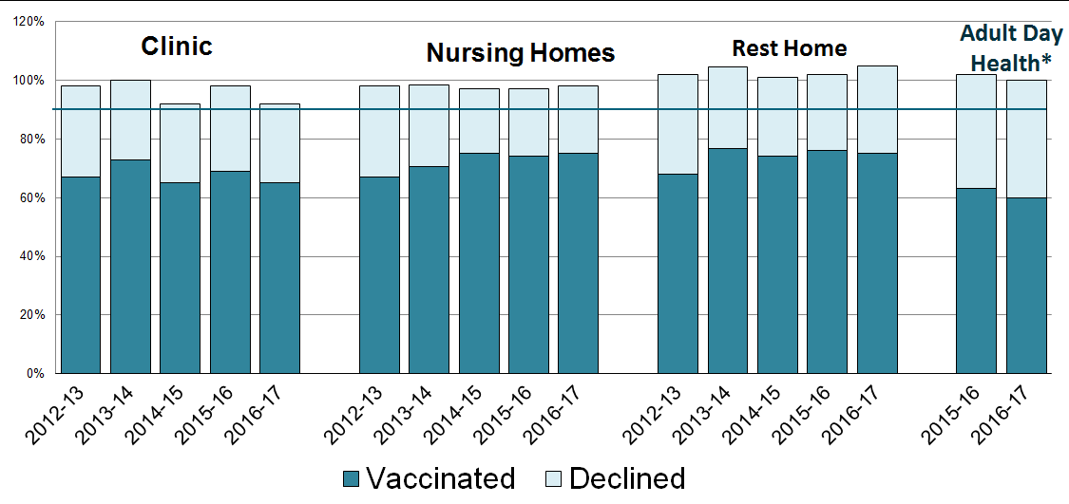

*Licensed Adult Day Health Programs began reporting in 2015-2016 influenza season.

†Vaccination of staff hired after December 31may result in rates higher than 100%.

Important Reporting Changes for the 2017-2018 Influenza Season

- To improve the accuracy, completeness and timeliness of reporting, DPH has transitioned from a paper-based system to an electronic web-based system.
- Beginning with the 2017-2018 influenza season, only reports submitted through the web-based application, SurveyMonkey® will be accepted.
- The required metrics have been updated to better align with federal reporting categories established by the Centers for Disease Control and Prevention (CDC). Each licensed Adult Day Health Program, Non-Ambulatory Surgical Center Clinic, Nursing Home, and Rest Home is required to report the following:

  - Complete demographic and facility contact information
  - Number of healthcare facility employees who worked in the healthcare facility for at least 1 day between October 1, 2017 and March 31, 2018
  - Number of healthcare facility employees who received an influenza vaccine at the healthcare facility since the influenza vaccine became available this season (August 1, 2017)
  - Number of healthcare facility employees who provided a written report or documentation of influenza vaccination outside the healthcare facility since influenza vaccine became available this season (August 1, 2017)
  - Number of healthcare facility employees who have a medical contraindication to the influenza vaccine
  - Number of healthcare facility employees not captured in the three categories above.

Please see Attachment I for a list of resources to assist healthcare facilities develop influenza campaigns and identify best practices for increasing HCP vaccination rates.

Please see Attachment II for detailed instructions necessary to complete the 2017-2018 reporting requirement.

The deadline for data submission is April 15, 2018 at 5:00 pm. To access the online survey, please click on the following link: https://www.surveymonkey.com/r/2017-18HCPvaccination.

It is your responsibility to ensure that this circular letter is forwarded to all persons in your healthcare facility responsible for infection prevention, employee health, and quality management reporting including but not limited to: Infection Preventionists, Occupational Health Professionals, Nursing and Medical Directors, Directors of Quality Improvement, and Directors of Human Resources.

Annual vaccination is the most important measure to prevent seasonal influenza infection. DPH is dedicated to working with you to ensure that patients and personnel are protected. Thank you for your ongoing participation in this important initiative. Please submit questions concerning the reporting and
data submission requirements to the Bureau of Health Care Safety and Quality at
dhcq.fludata@state.ma.us.

Attachment I
References and Resources

Many resources are available to help healthcare facilities develop influenza campaigns and identify best practices for increasing HCP vaccination rates. The following is a non-inclusive list of resources:

Seasonal Influenza (Flu)
www.cdc.gov/flu/

Seasonal Influenza: Flu Basics
www.cdc.gov/flu/about/disease/index.htm

Information for Health Professionals
www.cdc.gov/flu/professionals/index.htm

MMWR - Prevention and Control of Seasonal Influenza with Vaccines: Recommendations of the Advisory Committee on Immunization Practices — United States, 2017–18 Influenza Season
https://www.cdc.gov/mmwr/volumes/66/rr/rr6602a1.htm

A Toolkit for Long-Term Care Employers
Increasing Influenza Vaccination among Health Care Personnel in Long-term Care Settings
https://www.cdc.gov/flu/toolkit/long-term-care/index.htm

Influenza Infection Control in Health Care Facilities
www.cdc.gov/flu/professionals/infectioncontrol/index.htm

Seasonal Influenza (Flu)-Free Resources
www.cdc.gov/flu/freeresources/index.htm

Seasonal Influenza (Flu)-Information for Businesses & Employers
www.cdc.gov/flu/business/

Influenza Vaccination of Health-Care Personnel
www.cdc.gov/mmwr/preview/mmwrhtml/rr5502a1.htm

Providing a Safer Environment for Health Care Personnel and Patients through Influenza Vaccination-Strategies from Research and Practice
www.jointcommission.org/assets/1/18/flu_monograph.pdf

Strategies for Improving Health Care Personnel Influenza Vaccination Rates
www.jointcommission.org/topics/hai_influenza.aspx

HHS Prevention Strategies-Health Care-Associated Infections
www.health.gov/hai/prevent_hai.asp

The Massachusetts Department of Public Health website provides information, clinical advisories and guidance for healthcare professionals on the prevention and treatment of influenza. http://www.mass.gov/eohhs/provider/guidelines-resources/services-planning/diseases-conditions/influenza/information-for-healthcare-and-public-health.html

Attachment II

Data Submission Instructions: 2017-2018 Seasonal Influenza Vaccination of Healthcare Personnel (HCP) at Massachusetts Adult Day Health Centers, Clinics, Nursing Homes and Rest Homes

Please see the following instructions for the “Influenza Vaccination of Healthcare Personnel in Massachusetts (2017-2018)” SurveyMonkey®. All questions are required. You will not be able to proceed to the next page or complete the survey until all questions are completed.
Please review data for accuracy and completeness as changes will not be possible following submission.

Remember to keep a copy of your facility’s submitted data. Healthcare facilities must retain copies of all data submitted in a secure file for a minimum of three years.

State and healthcare facility-specific information will be publicly reported.
Long term care facilities that have both a nursing home and an adult day health center must report each licensed facility separately. If a HCP works in or is affiliated with both agencies, this individual must be counted in both reports.
Requests for assistance with data submission and related questions may be directed to
dhcq.fludata@state.ma.us.

Reporting Instructions:
While all personnel, including non-employee personnel, must be offered influenza vaccine, the reportable measure of effectiveness is based on employees, as defined by the payroll.
For the purposes of the vaccination program, employee is defined as:
- Individuals, both full-time and part-time, who worked at this healthcare facility for at least 1 day between October 1, 2017 and March 31, 2018.
- This includes, but is not limited to: physicians; nurses; interns/residents; fellows; physician assistants; physical, occupational, respiratory and speech therapists; laboratory and operating room technicians; central supply staff; pharmacists; maintenance/environmental services staff; dietary staff; attendants/orderlies, secretarial and administrative staff; contract staff, whether or not such individuals provide direct patient care.
- Employees, such as contractors performing administrative functions, who do not work at or come to the licensed healthcare facility, are not required to be vaccinated. Start by clicking on the link to the “Influenza Vaccination of Healthcare Personnel in Massachusetts (2017-2018)” SurveyMonkey® available at the following link:

https://www.surveymonkey.com/r/2017-18HCPvaccination.

Questions 1-4: Facility Information

If you are unsure of your facility's name, type or DPH Facility ID Number, please refer to the "Massachusetts Licensed or Certified Health Care Facility/Agency Listing“ link provided in the survey available at: https://www.mass.gov/service-details/find-information-about-licensed-or-certified-health-care-facilities.

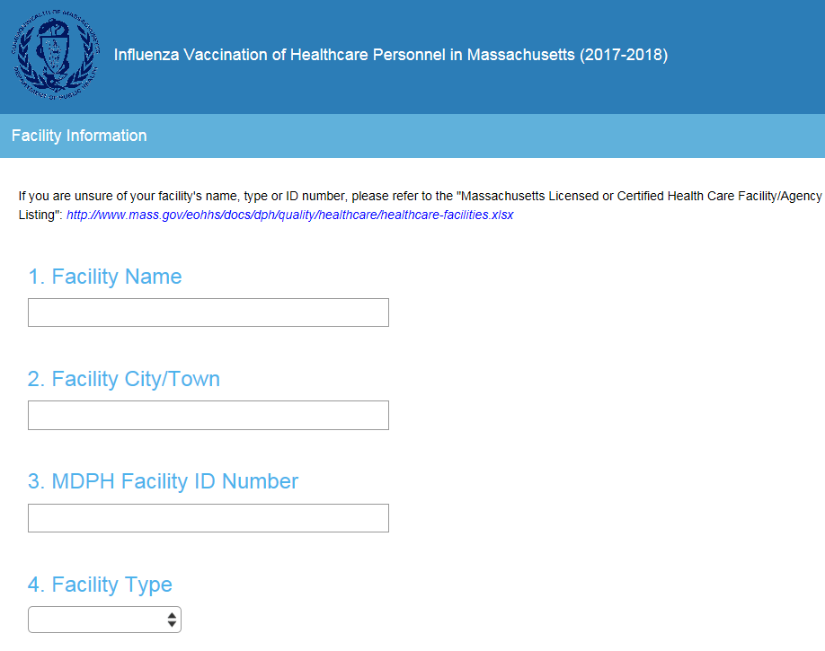

Questions 5-8: Contact Information

Please enter the complete name, position/title, phone number and email address of the person at your healthcare facility whom DPH should contact if there are questions about influenza data submission.

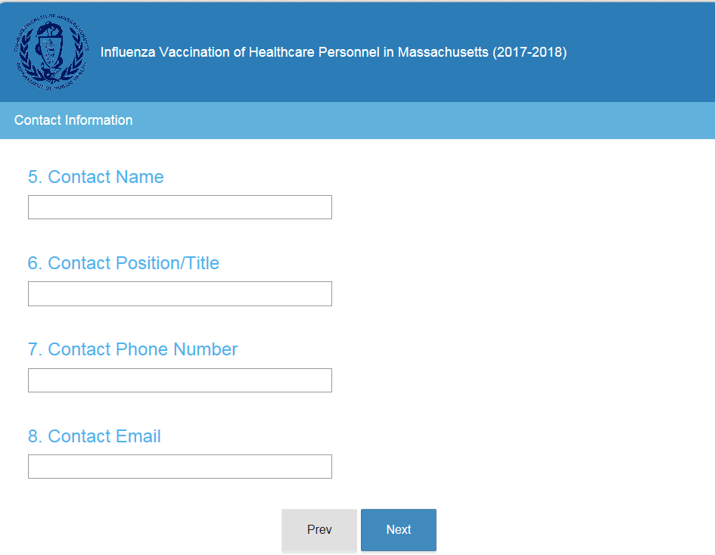

Questions 9-10: Influenza Vaccination Summary

Question 9: Please enter the number of healthcare facility employees who worked at this healthcare facility for at least 1 day between October 1, 2017 and March 31, 2018.

Question 10: Please enter the number of healthcare facility employees who received an influenza vaccine at this facility since influenza vaccine became available this season (August 1, 2017). Do not include doses administered after 3/31/18.

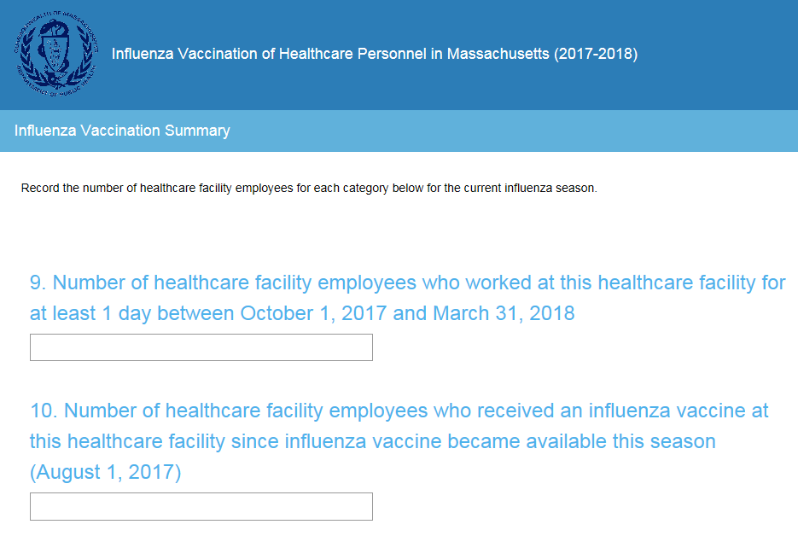

Questions 11-14: Influenza Vaccination Summary (Cont.)

Question 11: Please enter the number of healthcare facility employees who received seasonal influenza vaccination OUTSIDE the healthcare facility (for example from private physician’s office, community health center, clinic, etc.). Do not include doses administered after 3/31/18.

Individuals must report in writing (paper or electronic) or provide documentation that influenza vaccination was received elsewhere. Each healthcare facility must maintain written documentation of influenza vaccination received elsewhere.

Question 12: Please enter the number of healthcare facility employees who have a medical contraindication to the influenza vaccine.

Question 13: Please enter the number of healthcare facility employees who declined to receive the influenza vaccine.

Question 14: Please enter the number of healthcare facility employees with unknown vaccination status (or criteria not met for questions 10-13 above).

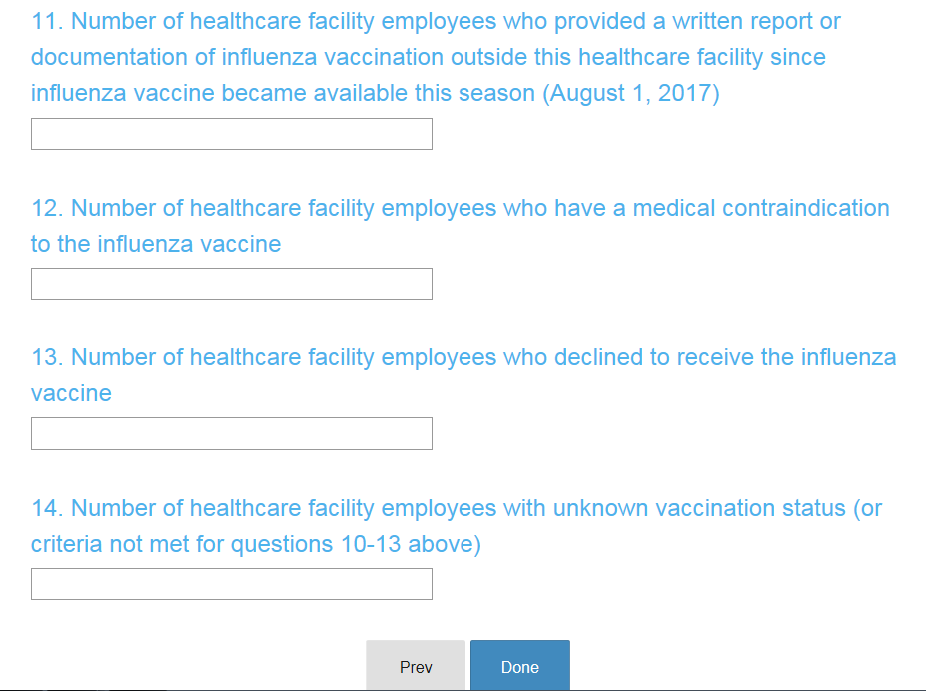

Influenza Data Submission Deadline: April 15, 2018 at 5:00 pm

This guidance applies to all clinics except for ambulatory surgical centers. Ambulatory surgical centers are required to report influenza HCP vaccination data to the Centers for Disease Control and Prevention’s National Healthcare Safety Network (NHSN).
105 CMR 140.150, 105 CMR 150.002(D)(8), 105 CMR 158.030(L)(8). Please note that DPH regulations do not allow for reporting unknown vaccine status. See 105 CMR 140.150(H)(1).
https://www.healthypeople.gov/node/4668/data_details
http://www.cdc.gov/flu/professionals/infectioncontrol/healthcaresettings.htm
This guidance applies to all clinics except for ambulatory surgical centers. Ambulatory surgical centers are required to report influenza HCP vaccination data to the Centers for Disease Control and Prevention’s National Healthcare Safety Network (NHSN).

