|  |  |
| --- | --- |
|  | ***Commonwealth of Massachusetts***  ***Executive Office of Health and Human Services*** Office of Medicaid *www.mass.gov/masshealth* |

MassHealth

Transmittal Letter AOH-42

December 2017

**TO:** Acute Outpatient Hospitals Participating in MassHealth

**FROM:** Daniel Tsai, Assistant Secretary for MassHealth 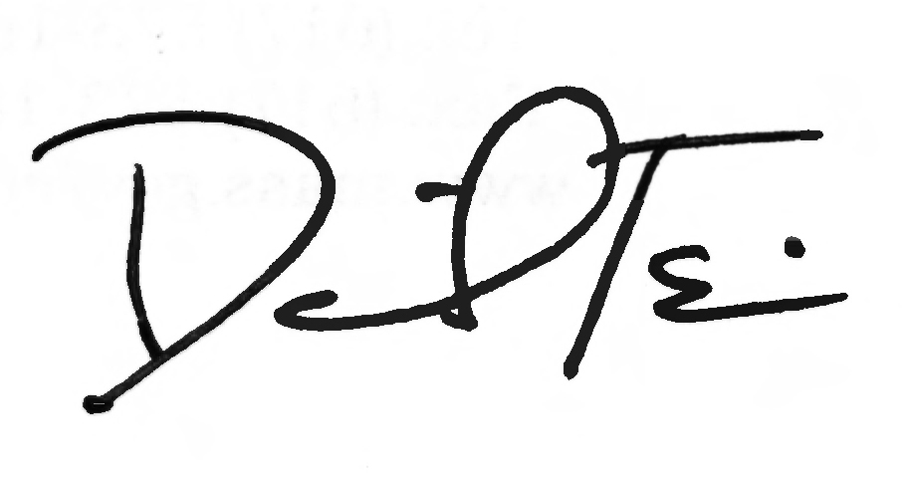

**RE:** *Acute Outpatient Hospital Manual* (Revised Subchapter 6: Additional Behavioral- Health Screening Tools and Revised Coding for Postpartum Depression Screening)

This letter transmits updates to Subchapter 6 of the *Acute Outpatient Hospital Manual* to incorporate changes for the modifiers and codes to be used for claiming postpartum depression screening performed by an infant’s physician. These changes conform to updates announced in Transmittal Letter ALL-219 (March 2017) to Appendix W of all provider manuals, including updates to MassHealth’s list of approved, standardized, behavioral-health screening tools for children younger than 21 years of age.

The revisions to Subchapter 6 became effective for dates of service on or after April 17, 2017.

**Developmental and Behavioral Health Screens**

MassHealth includes developmental and behavioral health (mental health and substance use disorder) screens in its list of Early Periodic Screening, Diagnosis and Treatment (EPSDT) services and Preventive Pediatric Healthcare Screening and Diagnosis (PPHSD) services, in accordance with 130 CMR 450.140 through 450.150.

The revised Appendix W (EPSDT/PPHSD Periodicity Schedule) requires providers to choose a clinically appropriate, behavioral-health screening tool from a menu of approved, standardized tools when conducting a behavioral-health screen at a periodic or interperiodic visit.

MassHealth has added three more tools to its list of approved, standardized, behavioral-health screening tools for children younger than age 21. These tools are the

* Pediatric Symptom Checklist, 17-question version (PSC-17);
* Modified Checklist for Autism in Toddlers, Revised (M-CHAT-R); and
* Edinburgh Postnatal Depression Scale (EPDS).

Instructions for acute outpatient-hospital (AOH) providers to use when claiming for the administration of the Edinburgh Postnatal Depression Scale (EPDS) are listed below.

**Claims for Postpartum Depression Screening by an Infant’s Physician**

Subchapter 6 of the *Acute Outpatient Hospital* *Manual* has been updated to reflect changes to the modifiers and codes that AOHs must use for claiming for professional services for postpartum depression screening performed by an infant’s physician who is employed or contracted by the AOH.

**Claims for Postpartum Depression Screening by an Infant’s Physician** *(cont.)*

MassHealth AOH providers may only claim payment for the professional component of physician, podiatrist, or dentist services, and then only when the physician, podiatrist, or dentist is employed or contracted by the hospital. MassHealth AOH providers may not claim separate payment for the professional fees for any other practitioners.

Effective for dates of service on or after April 17, 2017, AOHs that submit claims for the EPDS administered by infants’ physicians employed or contracted by the AOH must use CPT code 96110 with the appropriate modifiers identifying whether or not a behavioral health need is identified (U1 or U2).

If the EPDS is the behavioral health screen administered, the AOH must also include an additional, second modifier (UD) signifying that the EPDS is the screen administered. Section 604 of Subchapter 6 has been updated to include this new modifier, UD.

For a single date of service, AOHs may file only one claim for CPT code 96110.

Effective for dates of service on or after April 17, 2017, AOHs may no longer use code S3005 for postpartum depression screens administered to caregivers of infants younger than six months by an infant’s physician.

**No Code Change for Perinatal Depression Screens by an Infant’s Caregiver’s Physician**

There is ***no change*** for the code used by AOHs to bill for ***perinatal*** (prenatal and postpartum) depression screens administered to an infant’s caregiver ***by the caregiver’s physician*** who is employed or contracted by the AOH. For such perinatal depression screens, AOHs should continue to use CPT code S3005. The modifiers for S3005 applicable to screens performed by a caregiver’s physician, U1 and U2, are not changed. Modifiers previously applicable to screens performed by an infant’s physician (U3 and U4) are discontinued, effective for dates of service on or after April 17, 2017.

**MassHealth Website**

This transmittal letter and attached pages are available on the MassHealth website at [www.mass.gov/masshealth.](http://www.mass.gov/masshealth)

For more information about the standardized behavioral-health screening tools, visit [www.mass.gov/masshealth/cbhi](http://www.mass.gov/masshealth/cbhi%20) and click on “Screening for Behavioral Health Conditions.”

**Questions**

If you have any questions about the information in this transmittal letter, please contact the MassHealth Customer Service Center at 1-800-841-2900, email your inquiry to [providersupport@mahealth.net,](mailto:providersupport@mahealth.net,%20%20%20) or fax your inquiry to 617-988-8974.

NEW MATERIAL

(The pages listed here contain new or revised language.)

*Acute Outpatient Hospital Manual*

Pages 6-15 and 6-16

OBSOLETE MATERIAL

(The pages listed here are no longer in effect.)

*Acute Outpatient Hospital Manual*

Pages 6-15 and 6-16 — transmitted by Transmittal Letter AOH-41

U7 Medicaid level of care 7, as defined by each state

U8 Medicaid level of care 8, as defined by each state

U9 Medicaid level of care 9, as defined by each state

XE Separate Encounter: a service that is distinct because it occurred during a separate encounter

XP Separate Practitioner: a service that is distinct because it was performed by a different practitioner

XS Separate Structure: a service that is distinct because it was performed on a separate organ/structure

XU Unusual Non-Overlapping Service: the use of a service that is distinct because it does not overlap usual components of the main service

Modifiers for Behavioral Health Screening, Including Postnatal Depression Screening

The administration and scoring of standardized behavioral health screening tools selected from the approved menu of tools found in Appendix W of your MassHealth provider manual is covered for members (except MassHealth Limited) younger than 21 years of age. **Service Code 96110** must be accompanied by one of the modifiers listed below to indicate whether a behavioral health need was identified. “Behavioral health need identified” means the provider administering the screening tool, in

her or his professional judgment, identified a child with a potential behavioral health services need.

U1 Completed behavioral health screening using a standardized behavioral health screening tool selected from the approved menu of tools found in Appendix W of your MassHealth provider manual with no behavioral health need identified.

U2 Completed behavioral health screening using a standardized behavioral health screening tool selected from the approved menu of tools found in Appendix W of your MassHealth provider manual and behavioral health need identified.

UD Completed behavioral health screening for members birth through 6 months, for the administration and scoring of the Edinburgh Postnatal Depression Scale. UD must be used together with one of the above modifiers, U1 or U2.

Modifiers for Perinatal (Prenatal and Postpartum) Depression Screening

**Service Code S3005** must be used by acute outpatient hospitals when billing MassHealth for the administration and scoring of a MassHealth-approved, standardized, perinatal depression screening tool. Code S3005 must be accompanied by one of the modifiers listed below.

U1 Perinatal care provider completed prenatal or postpartum depression screening and behavioral health need identified (positive screen)

U2 Perinatal care provider completed prenatal or postpartum depression screening with no behavioral health need identified (negative screen)

Please refer to the Massachusetts Department of Public Health’s (DPH) postpartum depression (PPD) screening tool grid for any revisions to the list of MassHealth-approved screening tools:

[www.mass.gov/eohhs/gov/departments/dph/programs/family-health/postpartum-depression/postpartum-depression-tools.html](http://www.mass.gov/eohhs/gov/departments/dph/programs/family-health/postpartum-depression/postpartum-depression-tools.html).

Modifiers for Tobacco-Use Cessation Services

The following modifiers are used in combination with Service Code 99407 to report tobacco-use cessation counseling. Service Code 99407 (Smoking- and tobacco use-cessation counseling visit; intensive, greater than 10 minutes) may also be billed without a modifier to report an individual smoking- and tobacco-cessation counseling visit of at least 30 minutes.

HQ Group counseling, at least 60-90 minutes

TF Intermediate level of care, at least 45 minutes

Modifier for Child and Adolescent Needs and Strengths (CANS)

HA Service Code 90791 must be accompanied by this modifier to indicate that the Child and Adolescent Needs and Strengths is included in the assessment. This modifier may be billed only by psychiatrists.

Modifiers for Provider Preventable Conditions That Are National Coverage Determinations

PA Surgical or other invasive procedure on wrong body part

PB Surgical or other invasive procedure on wrong patient

PC Wrong surgery or other invasive procedure on patient

For more information on the use of these modifiers, see Appendix V of your provider manual.