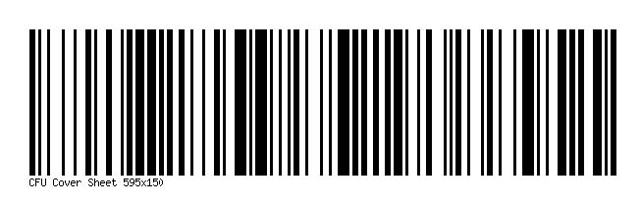

Department of Transitional Assistance (DTA) Electronic Document Management (EDM) Mail/Fax Cover Sheet

Please print clearly. Use this cover sheet when mailing or faxing documents to DTA.

Head of Household Information
Name: ___________________________________
Sender
Name: __________________________________
Last 4 digits of Soc. Sec. No: _________________
Date of birth: ______________________________
AP ID (if applicable): ________________________
No. of pages (including cover sheet): ___________
Date: ____________________________________
Phone No: ________________________________
Name of Agency (if applicable): _________________________________________

Important Message

Do NOT photocopy cover sheets. Cover sheets must be originals, not copies. Use one cover sheet for each household. Do NOT use the same cover sheet to send items for more than one household.

Fax or Mail Information

Documents should be sent to the address below (mail or fax) to avoid a delay in processing.

DTA Document Processing Center
PO Box 4406
Taunton, MA 02780-0420
Fax: 617-887-8765

This facsimile transmittal may contain information that is privileged, confidential, or exempt from disclosure under applicable law is intended for the use of only the individual or department to which it is addressed. If you are not the recipient, or the employee or the agent responsible for the delivery of this transmittal to the intended recipient, please notify the sender by telephone at the above number and destroy the attached documents. Anyone other than the intended recipient is hereby notified that any dissemination, distribution, or copying of this communication is strictly prohibited.

