Earn More SNAP Dollars
with the Healthy Incentives Program!

Spend your SNAP dollars on farm-fresh fruits and vegetables at participating Healthy Incentives Program (HIP) retailers and have the amount of your purchase instantly added back to your EBT card!

Fresh. Canned. Dried. Frozen.
H
It’s to be healthy!

Farmers Markets
Look for participating farmers at regularly scheduled markets in your town or nearby, selling fresh fruits and vegetables.

Farm Stands
On-farm stores where you can buy fresh fruits and vegetables, right from the hands that picked them.

Mobile Markets
Markets that bring farm-fresh produce right to your community.
CSA Farm Shares Membership-based service that provides your family with fresh fruits and vegetables every week.

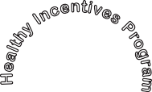

Look at what you can earn each month! (based on household size)
$40 1-2 PEOPLE $60 3-5 PEOPLE $80 6+ PEOPLE

FIND A HIP LOCATION NEAR YOU
Visit www.mass.gov/hip for a directory, call Project Bread’s FoodSource Hotline at 1-800-645-8333, or look for the HIP logo.

How does HIP work?

HIP RETAILERS

1
2
3
4

You are already enrolled! Use your SNAP dollars to buy farm-fresh fruits and vegetables at a HIP retailer.
An equal amount of money, up to your monthly limit, is instantly added back to your EBT card.
Your receipt will show the amount of additional SNAP dollars you’ve earned.
Spend your earned benefits anywhere that accepts SNAP.

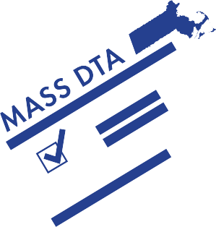

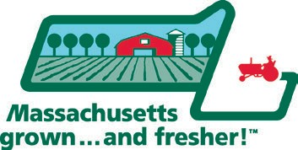
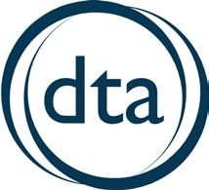
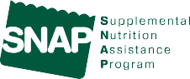Supported by USDA FINI and the Commonwealth of Massachusetts.

