HMO Self-Assessment Form - Year 1
Note: This form is to be completed in the Fiscal Year in which the HMO completed its triennial Community Health Needs Assessment

I. Community Benefits Process:
- Community Benefits in the Context of the Organization’s Overall Mission:
- Are Community Benefits planning and investments part of your HMO’s strategic plan? ☐ Yes ☐ No
  - If yes, please provide a description of how Community Benefits planning fits into your HMO’s strategic plan. If no, please explain why not.
  - Click or tap here to enter text.

- Community Benefits Advisory Committee (CBAC)/Committee responsible for oversight of Community Benefits programs:
- Members (and titles):
Click or tap here to enter text.

- Leadership:
Click or tap here to enter text.

- Frequency of meetings:
Click or tap here to enter text.

- Involvement of HMO’s Leadership in Community Benefits:
Place a checkmark next to each leadership group if it is involved in the specified aspect of your Community Benefits process:
 | Review Community Health Needs Assessment | Review Implementation Strategy | Review Community Benefits Report
Senior leadership (at HMO and/or foundation, as applicable) | ☐ | ☐ | ☐
Board (HMO and/or foundation, as applicable) | ☐ | ☐ | ☐
Staff-level managers | ☐ | ☐ | ☐
Community representatives on committee responsible for Community Benefits oversight | ☐ | ☐ | ☐

For any check above, please list the titles of those involved and describe their specific role:
Click or tap here to enter text.

- HMO Approach to Assessing and Addressing Social Determinants of Health
- What social determinants of health does the HMO consider when assessing community needs and why? (150-word limit)
Click or tap here to enter text.

- How does the HMO incorporate health equity in its approach to Community Benefits? (150-word limit)
Click or tap here to enter text.

- How does the HMO approach allocating resources to Total Population or Community-Wide Interventions? (150-word limit)
Click or tap here to enter text.

II. Community Engagement:
- Organizations Engaged in Community Benefits Process
Use the table below to list any organizations with whom the HMO collaborated on Community Benefits and provide a brief description of collaborative activities with each partner. Note that the HMO is not obligated to list every group, but rather should focus on groups that have been significantly involved. Please feel free to add rows as needed.

Organization | Name and Title of Key Contact | Brief Description of Engagement
Click or tap here to enter text. | Click or tap here to enter text. | Click or tap here to enter text.
Click or tap here to enter text. | Click or tap here to enter text. | Click or tap here to enter text.
Click or tap here to enter text. | Click or tap here to enter text. | Click or tap here to enter text.
Click or tap here to enter text. | Click or tap here to enter text. | Click or tap here to enter text.

- Level of Engagement in Assessing Needs and Implementing Priorities
Please use the spectrum below from the Massachusetts Department of Public Health to assess the HMO’s level of engagement with the community.
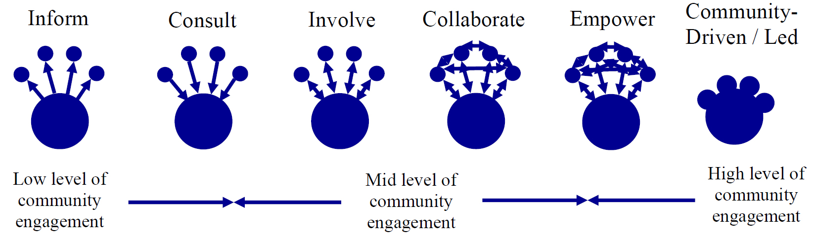

For a full description of the community engagement spectrum, see page 10 of the Attorney General’s Community Benefits Guidelines for Health Maintenance Organizations.
- Assessing Community Needs
Please assess the HMO’s level of engagement in assessing community health needs and the effectiveness of its community engagement process.

Category | Level of Engagement | Did Engagement Meet HMO’s Goals? | Goal(s) for Engagement in Upcoming Year(s)
Overall engagement in assessing community health needs | Choose an item. | Click or tap here to enter text. | Choose an item.
Collecting data | Choose an item. | Click or tap here to enter text. | Choose an item.
Defining the community to be served | Choose an item. | Click or tap here to enter text. | Choose an item.
Establishing priorities | Choose an item. | Click or tap here to enter text. | Choose an item.

- For categories where community engagement did not meet the HMO’s goal(s), please provide specific examples of planned improvement for next year:
Click or tap here to enter text.
- Implementation Strategy:
Please assess the HMO’s level of engagement in developing and implementing its plan to address documented health needs and the effectiveness of its community engagement process.

Category | Level of Engagement | Did Engagement Meet HMO’s Goals? | Goal(s) for Engagement in Upcoming Year(s)
Overall engagement in developing and implementing filer’s plan to address significant documented needs | Choose an item. | Click or tap here to enter text. | Choose an item.
Determining allocation of HMO Community Benefits resources/selecting Community Benefits programs | Choose an item. | Click or tap here to enter text. | Choose an item.
Implementing Community Benefits programs | Choose an item. | Click or tap here to enter text. | Choose an item.
Evaluating progress in executing Implementation Strategy | Choose an item. | Click or tap here to enter text. | Choose an item.

- For categories where community engagement did not meet the HMO’s goal(s), please provide specific examples of planned improvement for next year:
Click or tap here to enter text.
- Opportunity for Public Feedback
Did the HMO hold a meeting open to the public (either independently or in conjunction with its CBAC or a community partner) at least once in the last year to solicit community feedback on its Community Benefits programs? If so, please provide the date and location of the event. If not, please explain why not.
Click or tap here to enter text.

- Best Practices/Lessons Learned
The AGO seeks to continually improve the quality of community engagement.
- What community engagement practices are you most proud of? (150-word limit)
Click or tap here to enter text.

- What lessons have you learned from your community engagement experience? (150-word limit)
Click or tap here to enter text.
III. Collaboration:
- Is the HMO part of a larger community health improvement planning process?
☐ Yes ☐ No
  - If so, briefly describe it. If not, why?
Click or tap here to enter text.

“Community Engagement Standards for Community Health Planning Guideline,” Massachusetts Department of Public Health, available at: http://www.mass.gov/eohhs/docs/dph/quality/don/guidelines-community-engagement.pdf.

