Hospital Self-Assessment Form - Year 1
Note: This form is to be completed in the Fiscal Year in which the hospital completed its triennial Community Health Needs Assessment

I. Community Benefits Process:
- Community Benefits in the Context of the Organization’s Overall Mission:
- Are Community Benefits planning and investments part of your hospital’s strategic plan? ☐ Yes ☐ No
  - If yes, please provide a description of how Community Benefits planning fits into your hospital’s strategic plan. If no, please explain why not.
  - Click or tap here to enter text.

- Community Benefits Advisory Committee (CBAC):
- Members (and titles):
Click or tap here to enter text.

- Leadership:
Click or tap here to enter text.

- Frequency of meetings:
Click or tap here to enter text.

- Involvement of Hospital’s Leadership in Community Benefits:
Place a checkmark next to each leadership group if it is involved in the specified aspect of your Community Benefits process:
 | Review Community Health Needs Assessment | Review Implementation Strategy | Review Community Benefits Report
Senior leadership | ☐ | ☐ | ☐
Hospital board | ☐ | ☐ | ☐
Staff-level managers | ☐ | ☐ | ☐
Community Representatives on CBAC | ☐ | ☐ | ☐

For any check above, please list the titles of those involved and describe their specific role:
Click or tap here to enter text.

- Hospital Approach to Assessing and Addressing Social Determinants of Health
- How does the hospital approach assessing community needs relating to social determinants of health? (150-word limit)
Click or tap here to enter text.

- How does the hospital incorporate health equity in its approach to Community Benefits? (150-word limit)
Click or tap here to enter text.

- How does the hospital approach allocating resources to Total Population or Community-Wide Interventions? (150-word limit)
Click or tap here to enter text.

II. Community Engagement:
- Organizations Engaged in CHNA and/or Implementation Strategy
Use the table below to list the key partners with whom the hospital collaborated in assessing community health needs and/or implementing its plan to address those needs and provide a brief description of collaborative activities with each partner. Note that the hospital is not obligated to list every group involved in its Community Benefits process, but rather should focus on groups that have been significantly involved. Please feel free to add rows as needed.

Organization | Name and Title of Key Contact | Organization Focus Area | Brief Description of Engagement  (including any decision-making power given to organization)
Click or tap here to enter text. | Click or tap here to enter text. | Choose an item. | Click or tap here to enter text.
Click or tap here to enter text. | Click or tap here to enter text. | Choose an item. | Click or tap here to enter text.
Click or tap here to enter text. | Click or tap here to enter text. | Choose an item. | Click or tap here to enter text.
Click or tap here to enter text. | Click or tap here to enter text. | Choose an item. | Click or tap here to enter text.

- Level of Engagement Across CHNA and Implementation Strategy
Please use the spectrum below from the Massachusetts Department of Public Health to assess the hospital’s level of engagement with the community.
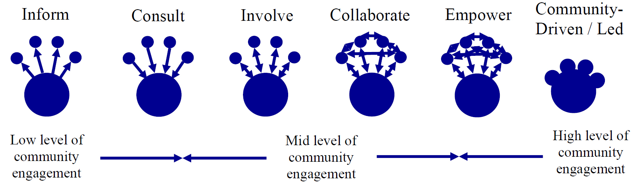

For a full description of the community engagement spectrum, see page 11 of the Attorney General’s Community Benefits Guidelines for Non-Profit Hospitals.
- Community Health Needs Assessment
Please assess the hospital’s level of engagement in developing its CHNA and the effectiveness of its community engagement process.

Category | Level of Engagement | Did Engagement Meet Hospital’s Goals? | Goal(s) for Engagement in Upcoming Year(s)
Overall engagement in assessing community health needs | Choose an item. | Click or tap here to enter text. | Choose an item.
Collecting data | Choose an item. | Click or tap here to enter text. | Choose an item.
Defining the community to be served | Choose an item. | Click or tap here to enter text. | Choose an item.
Establishing priorities | Choose an item. | Click or tap here to enter text. | Choose an item.

- For categories where community engagement did not meet the hospital’s goal(s), please provide specific examples of planned improvement for next year:
Click or tap here to enter text.
- Implementation Strategy:
Please assess the hospital’s level of engagement in developing and implementing its plan to address the significant needs documented in its CHNA and the effectiveness of its community engagement process.

Category | Level of Engagement | Did Engagement Meet Hospital’s Goals? | Goal(s) for Engagement in Upcoming Year(s)
Overall engagement in developing and implementing filer’s plan to address significant needs documented in CHNA | Choose an item. | Click or tap here to enter text. | Choose an item.
Determining allocation of hospital Community Benefits resources/selecting Community Benefits programs | Choose an item. | Click or tap here to enter text. | Choose an item.
Implementing Community Benefits programs | Choose an item. | Click or tap here to enter text. | Choose an item.
Evaluating progress in executing Implementation Strategy | Choose an item. | Click or tap here to enter text. | Choose an item.
Updating Implementation Strategy annually | Choose an item. | Click or tap here to enter text. | Choose an item.

- For categories where community engagement did not meet the hospital’s goal(s), please provide specific examples of planned improvement for next year:
Click or tap here to enter text.
- Opportunity for Public Feedback
Did the hospital hold a meeting open to the public (either independently or in conjunction with its CBAC or a community partner) at least once in the last year to solicit community feedback on its Community Benefits programs? If so, please provide the date and location of the event. If not, please explain why not.
Click or tap here to enter text.

- Best Practices/Lessons Learned
The AGO seeks to continually improve the quality of community engagement.
- What community engagement practices are you most proud of? (150-word limit)
Click or tap here to enter text.

- What lessons have you learned from your community engagement experience? (150-word limit)
Click or tap here to enter text.
III. Regional Collaboration:
- Is the hospital part of a larger community health improvement planning process?
☐ Yes ☐ No
  - If so, briefly describe it. If not, why?
Click or tap here to enter text.
- If the hospital collaborates with any other filer(s) in conducting its CHNA, Implementation Strategy, or other component of its Community Benefits process (e.g., as part of a regional collaboration), please provide information about the collaboration below.
- Collaboration:
Click or tap here to enter text.

- Institutions involved:
Click or tap here to enter text.

- Brief description of goals of the collaboration:
Click or tap here to enter text.

- Key communities engaged through collaboration:
Click or tap here to enter text.

- If you did not participate in a collaboration, please explain why not:
Click or tap here to enter text.

“Community Engagement Standards for Community Health Planning Guideline,” Massachusetts Department of Public Health, available at: http://www.mass.gov/eohhs/docs/dph/quality/don/guidelines-community-engagement.pdf.

