Commonwealth of Massachusetts
Executive Office of Health and Human Services

Office of Medicaid
www.mass.gov/masshealth

MassHealth
Acute Inpatient Hospital Bulletin 161
February 2018

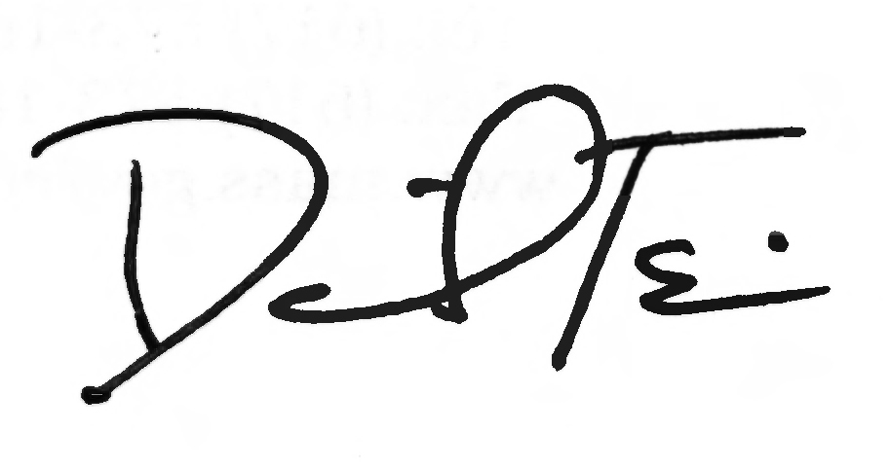
TO: Acute Inpatient Hospitals Participating in MassHealth

FROM: Daniel Tsai, Assistant Secretary for MassHealth

RE: Changes to Notification of Birth (NOB-1) Form and Filing Process

Summary

Starting March 1, 2018, MassHealth will require acute inpatient hospitals to use an updated Notification of Birth (NOB-1) form. This form, which is available at https://www.mass.gov/lists/masshealth-provider-forms-by-provider-type-h-l, will include streamlined submission instructions that simplify the process for providers.

Changes to the NOB-1 Form

In the form’s Section 1: Mother’s Information box (Figure 1), fields have been added for the newborn’s “Primary Insurer or Guardian … ” along with the mother’s or the primary insurer’s “Primary Commercial Insurance” plan. Instructions on the back of the form provide guidance on how to complete these new fields. Also, the “Mother’s Plan” box has been removed.

Figure 1:

Section I: Mother’s Information
Mother’s MassHealth Member ID | Mother’s Name
Mother’s Address
Mother’s Date of Birth | Mother’s Telephone No.
Primary Insurer or Guardian & Relationship to Newborn
Primary Commercial Insurance

In the form’s Section 2: Child’s Information box, the “Child’s Birth Weight,” Gestational Age,” and “Race Code” fields have been removed.

MassHealth
Acute Inpatient Hospital Bulletin 161

February 2018

Page 2

Changes to the NOB-1 Submission Process

There are several changes regarding submission of the NOB-1 form. Effective March 1, 2018, (or sooner if the provider is ready to do so), NOB-1 forms must be submitted via fax. This is the fastest and most complete way to get information on newborns to us. It allows us to add newborn information into our systems and to track and archive the request.

We will not accept NOB-1 forms via mail, and providers should not mail forms that they have already faxed to MassHealth. We hope to eliminate confusion and save providers time and postage by eliminating this mailing step.

Please note, we will not mail eligibility or enrollment information to providers. Providers should check the Eligibility Verification System (EVS) in the Provider Online Service Center (POSC) for this information.

Providers should also complete the NOB-1 form with the newborn’s birth name. Please avoid using “BABY GIRL” or “BABY BOY” as the newborn’s name, and use these terms ONLY as a last resort. If you enter “BABY GIRL” or “BABY BOY” on this form, it will take us longer to process it.

Processing NOB-1 forms is a top priority for MassHealth. Once a completed form is received, the eligibility information is typically loaded into the MassHealth eligibility system in one business day. Managed care organization (MCO) enrollment information is typically loaded into the MassHealth system within two to three business days once eligibility is established. Providers should only call in newborn information when the newborn’s enrollment is an emergency.

As a reminder, the NewbornAdd@state.ma.us email address is only for urgent newborn enrollment issues, such as neonatal babies, babies who need immediate services, or any other medical emergency that may arise after the baby is born. Please use the EVS or call the MassHealth Customer Service Center at 1-800-841-2900 for any other issues.

Claims Impact

In September 2017, MassHealth began suspending acute inpatient hospital claims for newborn members to ensure that claims are processed under the correct benefit plan, including MCOs. These claims are manually reviewed and adjudicated within 30 days of receipt so that the processing time for the claims will not be affected. This change reduces the administrative burden on providers by ensuring that the correct payer reimburses hospitals for services.

Questions

If you have questions about the information in this bulletin, please contact the MassHealth Customer Service Center at 1-800-841-2900, email your inquiry to providersupport@mahealth.net, or fax your inquiry to 617-988-8974.

