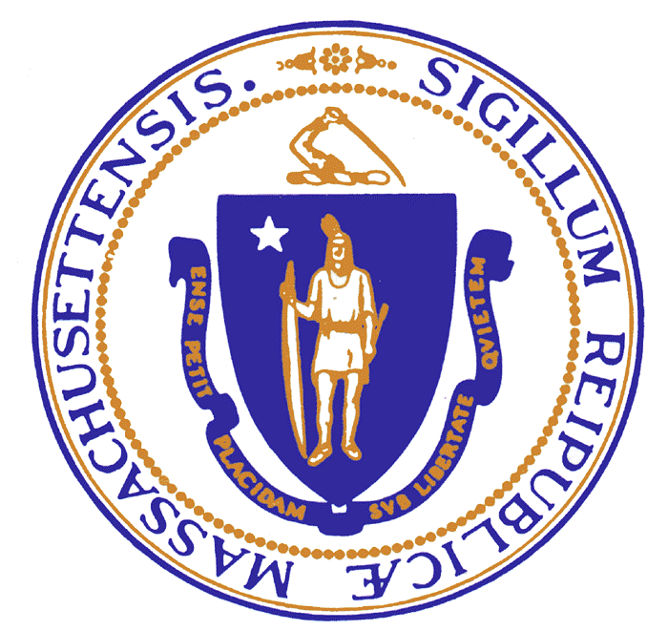  Charles D. Baker  Governor  Karyn E. Polito  Lieutenant Governor | The Commonwealth of Massachusetts  Executive Office of Public Safety & Security  Office of Grants & Research  Ten Park Plaza, Suite 3720  Boston, Massachusetts 02116  Tel: 617-725-3301  Fax: 617-725-0260  617-725-0267  www.mass.gov/eops | Daniel Bennett  Secretary  Angela F.F. Davis  Executive Director

TO: Secretary of State’s Office, Regulations Division & Executive Office of
Administration Office and Finance

FROM: Brook Chipman, Office of Grants & Research/Highway Safety Division

DATE: February 27, 2018

RE: Notice of Open Meeting

Under the provisions of M.G.L. c. 30A, the Executive Office of Public Safety and Security/Office of Grants & Research/Highway Safety Division will conduct a meeting of the Working-level Traffic Records Coordinating Committee at 10:30 am on March 5, 2018. The meeting will be held in the Gnazzo Conference Room (third floor), Registry of Motor Vehicles, 25 Newport Ave. Extension, Quincy, MA.

Agenda items include: review/approval of prior meeting minutes; follow-up to Crash Data Audit Report recommendations; RMV report on MMUCC 5th version technical assistance; RMV report on federal mandated elements to add to MA crash report form by April 2019; updates on current TRCC-funded projects; Highway Safety Division update on FFY 2019 405-c funded Traffic Safety Information Systems Improvement Grant process; unforeseen business/upcoming event announcements/next meeting.

In addition to being posted on the EOPSS/OGR website, this notice was e-mailed to the following entities:

Secretary of State’s Office
Regulations Division
1 Ashburton Place, Rm. 1613
Boston, MA 02108
regs@sec.state.ma.us

Executive Office of Administration and Finance
State House, Room 373
Boston, MA 02133
melissa.andrade@state.ma.us

Direct any questions regarding this meeting to Mr. Brook Chipman at brook.chipman@state.ma.us or 617-725-3355.

