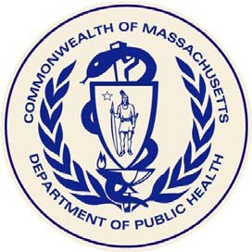

Massachusetts Department of Public Health
Fish Consumption Advisory
for Marine and Fresh Water Bodies

MDPH guidelines for pregnant women, women who may become pregnant, nursing mothers, and children under 12 years old:

Do Not Eat: Freshwater fish caught in streams, rivers, lakes, and ponds in Massachusetts*

Safe To Eat: Fish that are stocked in streams, rivers, lakes, and ponds in Massachusetts

Do Not Eat: Bluefish caught off the Massachusetts coast

Do Not Eat: Lobsters, flounder, soft-shell clams and bivalves from Boston Harbor

MDPH guidelines for everyone, including the groups listed above:

Do Not Eat: • Fish, shellfish, or lobsters from Area I of New Bedford Harbor
- Lobsters or bottom feeding fish from Area II of New Bedford Harbor
- Lobsters from Area III of New Bedford Harbor

Do Not Eat: Lobster tomalley

A varied diet, including safe fish, will lead to good nutrition and better health.

In 2017, the federal government issued additional advice about safe fish consumption. Please visit:

www.fda.gov/fishadvice and www.epa.gov/fishadvice

*More specific consumption advice is available for certain freshwater bodies that have been tested at: http://www.mass.gov/dph/fishadvisories or by calling the Massachusetts Department of Public Health, Bureau of Environmental Health at 617-624-5757.

Revised 2017

