Data Brief:
Trends in Cancer Incidence (2003-2013) and Mortality (2003-2014) for Four Major Cancers
Massachusetts Department of Public Health, Massachusetts Cancer Registry NOVEMBER 2015

The death rate for the four leading cancers (prostate, female breast, bronchus and lung, and colorectal) have all dropped in Massachusetts since 2003. In many cases, the incidence of these cancers has also dropped. The underlying causes of this positive news point to improved care, better screening, new recommendations for screening, and healthier lifestyles. This brief will present the latest trends for cancer incidence and deaths. Also included will be information about health disparities, screening procedures, cancer-related behaviors, and the activities of the Department of Public Health and its partners to reduce the incidence and the likelihood of deaths associated with these cancers.

This work is a collaborative effort between the Massachusetts Cancer Registry (MCR), the Behavioral Risk Factor Surveillance System (BRFSS), the Massachusetts Comprehensive Cancer Prevention and Control Network (MCCPCN), the Women’s Health Network Care Coordination Program (WHNCCP), and the Massachusetts Tobacco Cessation and Prevention Program (MTCPP) of the Massachusetts Department of Public Health (MDPH). The purpose is to compile into a single source the most recent readily available data on trends and program information for the following four major types of cancer: prostate, female breast, bronchus and lung, and colorectal.

The time periods presented in this report will vary by type of data. Data collection and quality assurance processes take longer for some datasets than others. This report presents the most recent data for each dataset that was available at the time of publication. Accordingly, the data presented include: cancer incidence for 2003-2013, cancer mortality for 2003-2014, and BRFSS cancer screening for breast 2000-2012, prostate 2000-2013, colorectal 2000-2013, and smoking information for lung cancer 1990-2013. Cancer incidence data for 2013 and cancer mortality data for 2014 presented in this brief are preliminary so must be interpreted with caution.

SOURCES OF DATA AND PROGRAM INFORMATION

Massachusetts Cancer Registry (MCR) – provided all of the incidence data. The MCR is a population-based cancer registry and is a part of the Massachusetts Department of Public Health. It began collecting reports of newly diagnosed cancer cases in 1982. Learn more about the Massachusetts Cancer Registry here: www.mass.gov/dph/mcr

Massachusetts Registry of Vital Records and Statistics (MRVRS) – provided all of the death data. The MRVRS has the legal responsibility for collecting reports of deaths of Massachusetts residents. Learn more about the Massachusetts Registry of Vital Records and Statistics here: www.mass.gov/dph/rvrs

Behavioral Risk Factor Surveillance System (BRFSS) – provided all of the screening and smoking prevalence data. The BRFSS is an ongoing random-digit-dial telephone survey of adults ages 18 and older that is conducted in all states in collaboration with federal Centers for Disease Control and Prevention (CDC). The survey has been conducted in Massachusetts since 1986. The BRFSS collects data on a variety of health risk factors, preventive behaviors, chronic conditions and emerging public health issues. Learn more about the Massachusetts Behavioral Risk Factor Surveillance System here: http://www.mass.gov/eohhs/gov/departments/dph/programs/admin/dmoa/health-survey/brfss/

Massachusetts Comprehensive Cancer Prevention and Control Network (MCCPCN) – provided information on the current initiatives of the Massachusetts Department of Public Health aimed at reducing the burden of cancer in Massachusetts. Current areas of focus include: Disparities and Health Equity, Advocacy and Community Engagement, Prevention and Early Detection, Survivorship, Treatment, Palliative Care and End of Life Care. Learn more about the Massachusetts Comprehensive Cancer Prevention and Control Network here: www.mass.gov/compcancer

Massachusetts Tobacco Cessation & Prevention Program (MTCPP) – provided information to prevent tobacco use and to support smokers to stay quit for good. Learn more about the programs offered here:
http://www.mass.gov/eohhs/gov/departments/dph/programs/mtcp/about-mtcp.html

National Center for Health Statistics (NCHS) – provided population estimates used for rate calculations used in this report. The NCHS produces the estimates in collaboration with the U.S. Census Bureau’s Population Estimation Program.

FORMAT

This report is organized by type of cancer (prostate, female breast, lung, and colorectal), and follows the following format:

- Incidence and mortality trends
- Screening or smoking trends (depending on cancer type)
- MDPH cancer control initiatives.

TECHNICAL NOTES

Age-adjusted rate – a weighted average of the age-specific rates, where the weights are the proportions of persons in the corresponding age groups of a standard population. The potential confounding effect of age is eliminated when comparing age-adjusted rates for populations with different age structures. The 2000 U.S. Census Bureau population distribution was used as the standard. Rates were age-adjusted using eighteen 5-year age groups. Age-adjusted rates can only be compared if they are adjusted to the same standard population.

Annual percent change (APC) – The APC is a statistical method for trend analysis. It shows how much a cancer rate has increased or decreased over the observed period of time. This estimation assumes that the change in incidence or mortality rates is constant during the observed time period. Trends in the age-standardized incidence and mortality rates in this report were analyzed using joinpoint regression, which involves fitting a series of joined straight lines on a logarithmic scale to the trends in the annual age-standardized rates with at least three data points between changes in joinpoints.

Prevalence - the proportion of a population found to have some factor of interest (such as screening or smoking). It is calculated by dividing the number of people with the factor of interest by the total number of people studies and is expressed as a percentage.

Prostate Cancer

Prostate cancer was the most common type of cancer diagnosed in Massachusetts men from 2003 through 2013. Prostate cancer comprised approximately 27% of all cancers diagnosed in men. During this period, a total of 52,990 new cases of prostate cancer were diagnosed, an average of 4,817 annually. There were 7,597 deaths with prostate cancer as the underlying cause of death from 2003 to 2014, an average of 633 deaths annually. Incidence rates of prostate cancer are markedly lower than in 2003 with the most dramatic decrease beginning in 2010.

Incidence and Mortality

- The incidence rate for prostate cancer dropped, non-significantly, from 164.7 per 100,000 in 2003 to 140.6 per 100,000 in 2010 (APC = -1.6%). A steeper and statistically significant decline (APC = -15.2%) was observed from 2010 to 2013 (140.6 to 92.7 per 100,000, respectively), but additional years of data are recommended before declaring this to be a continuing trend. While the incidence rate for white, non-Hispanic (NH) males began to significantly decline in 2007, the incidence rate for black, NH males did not begin to decline significantly until 2010. Incidence for black, NH males has remained higher than for white, NH males throughout the time period examined.

- The overall mortality rate for prostate cancer decreased significantly by 2.7% annually from 22.0 per 100,000 in 2003 to 19.1 per 100,000 in 2014. While the mortality rates for both black, NH and white, NH men decreased from 2003 to 2014, the APC among white, NH men decreased significantly (APC = -3.0%) whereas the APC among black, NH men did not (APC = -2.7%). These small differences are not considered statistically meaningful.
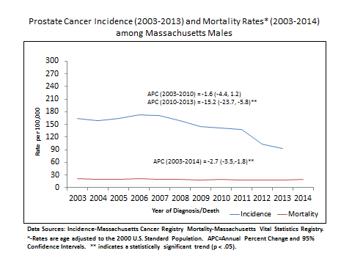
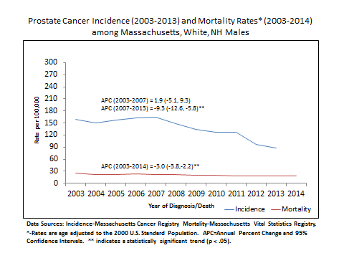
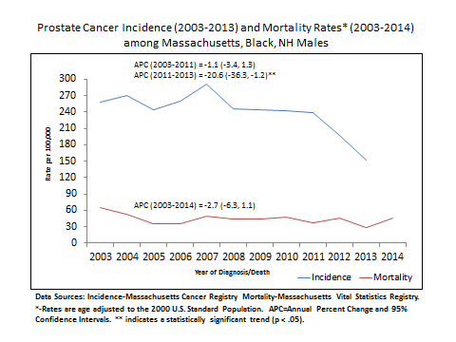

Screening

The prostate specific antigen (PSA) test has been widely used to screen men for prostate cancer. It is also used to monitor men who have been diagnosed with prostate cancer to see if their cancer has recurred (come back) after initial treatment or is responding to therapy. Some advisory groups now recommend against the use of the PSA test to screen for prostate cancer because the benefits, if any, are small and the harms can be substantial. None recommend its use without a detailed discussion of the pros and cons of using the test.

- The percentage of men ages 50 years and older who reported having a PSA test within the previous year decreased from 59.2% in 2000 to 44% in 2010 - a decreasing trend of 3% per year.

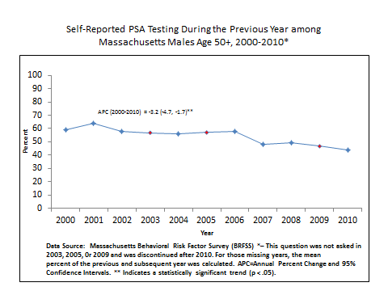

Massachusetts Comprehensive Cancer Prevention and Control Network Initiatives

In 2012, the University of Massachusetts Medical School received a grant from the Patient Centered Outcomes Research Institute (PCORI) to develop Massachusetts prostate cancer screening guidelines. The Massachusetts Prostate Cancer Screening Guidelines Panel, which included representatives from the Massachusetts Department of Public Health, developed these screening guidelines. The Adult Guideline Committee of the Massachusetts Health Quality Partners (MHQP) approved the recommended guidelines as part of the 2015 Adult Routine Preventive Care Guidelines. The guidelines are below:

- For average risk men ages 50-69 and high risk men [black men or men with a family history of prostate cancer (brother or father)] starting at age 45:
  - Screening for prostate cancer with the PSA should not be performed or offered routinely without patient education and informed consent.
  - PSA screening may be offered to men who express a clear preference for screening after demonstrating an understanding of the harms and benefits (e.g. through a shared decision-making process) and who have a life expectancy >10 years.
  - For men who express a clear preference for screening after shared decision-making:
    - Screen with PSA every 2 years.
    - For confirmed PSA>4.0 assess/refer for possible prostate biopsy.
In June 2013, the Massachusetts Comprehensive Cancer Prevention and Control Network convened its first meeting of the Prostate Cancer Workgroup. The major goal of the workgroup was to address strategies for dissemination and adoption of the new Massachusetts prostate cancer screening guidelines. Decision aids developed included:

- a decision aid to be used in the provider’s office;
- a decision aid that men would take home or be used as a stand along tool in a community setting; and
- an online widget that provides in-depth information about the risks and benefits of screening.

The decision aid has been pilot tested and revised. Next steps include dissemination of the decision aid and education of providers.

Summary

Prostate cancer was the most common cancer in Massachusetts men from 2003 to 2013. A steep decline in prostate cancer incidence was observed between 2010 through 2013. Mortality has also been decreasing but not as dramatically as incidence. The percentage of men age 50+ who reported having a PSA test within the previous year has also been decreasing. Massachusetts guidelines for prostate cancer screening have changed with recommendations that focus on patient and provider education and shared decision-making. Given the recent steep decline in prostate cancer incidence and the coincident change in the screening recommendations, it is likely that the decline in incidence is related.

Invasive Breast Cancer

Invasive breast cancer was the most common type of cancer diagnosed in Massachusetts women from 2003 through 2013, comprising approximately 29% of all cancers diagnosed in women. During this period, a total of 58,354 new cases of breast cancer were diagnosed, an average of 5,304 annually. There were 10,708 deaths with breast cancer as the underlying cause of death from 2003 to 2014, an average of 892 deaths annually. While incidence of invasive breast cancer has been steady in recent years, mortality has decreased.

Incidence and Mortality

- While the incidence rate for invasive breast cancer for all women did not change significantly from 2003 to 2013, it increased at a small but significant annual percentage change (APC = 0.5%) for white NH women, but remained stable for black, NH women. In 2013 the incidence rate for white, NH women was 141.0 per 100,000 compared to a rate of 123.0 per 100,000 in black, NH women.

- The breast cancer mortality rate for all women dropped significantly by 2.9% per year from 24.3 per 100,000 in 2003 to 18.7 per 100,000 in 2014. Significant decreases were also seen among white and black, NH women.

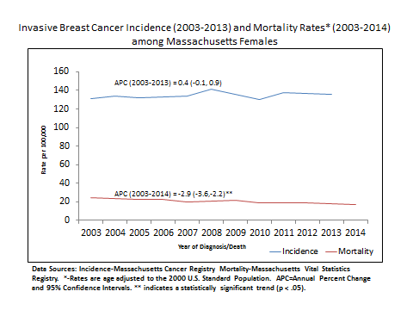

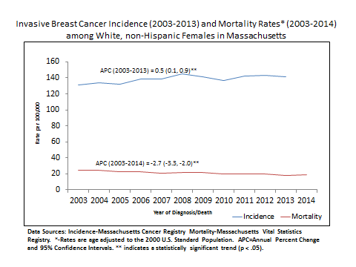

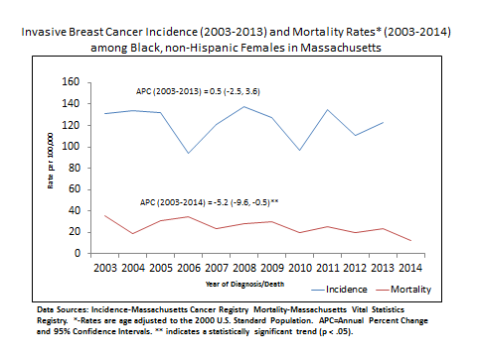

Screening

- The percentage of women, age 50 and older who reported having a mammogram during the previous two years increased from 86.1% in 2000 to 87.1% in 2012 – a significantly increasing trend of 0.2% per year. The screening rate in Massachusetts for women, age 50 and older is 13% higher than the rate nationally (CDC,BRFSS, 2012, accessed August 10, 2015; http://www.cdc.gov/brfss/brfssprevalence/index.html).

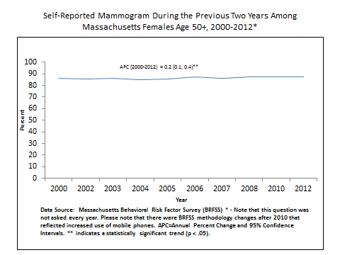

Massachusetts Department of Public Health Program Initiatives

The following programs were implemented by the Women’s Health Network Care Coordination Program (WHNCCP):

- Funded 11 clinical sites in community health centers since 2009 to provide education and patient navigation services to help men and women in Massachusetts get screened for breast, cervical and colorectal cancers. The WHNCCP also provides breast, cervical and colorectal cancer screening and diagnostic services at no cost to women and men who do not have health insurance.

- Developed and promoted the Can We Talk? materials (poster, postcards) to help empower women to feel more comfortable discussing breast and cervical cancer screening with their healthcare providers and remind healthcare providers of the critical role they play in helping their patients stay healthy by discussing appropriate screenings. Materials encourage women to talk with their doctors about screening and what’s right for them, and direct the audience to additional information online. Available at the MA Clearinghouse - http://massclearinghouse.ehs.state.ma.us/category/CANCER.html. Also created the www.mass.gov/cancerscreenings as a landing page for the Can We Talk materials and campaign.

- Conducted a breast and cervical cancer screening media campaign (modeled after the Can We Talk materials) targeting areas within the state with low cancer screening rates and low socio-economic status. The campaign encouraged women to talk to their doctors about the screenings that were right for them.

- Collaborated with the Massachusetts Medical Society to provide Continuing Medical Education modules (CMEs) that address the confusion related to current screening guidelines for primary care providers. The CME module on guidelines for breast cancer (www.massmed.org/cme/dphbreastscreening) is currently available online.

- Implemented the Community Based Organization Outreach, Education and Linkage project to reach those most in need of education and link them to a medical home and breast, cervical and colorectal cancer screening services. Nine hundred sixty-eight clients were educated using the Helping You Take Care of Yourself curriculum in FY 14 and this included a large percentage of new immigrants, non-English speakers and the uninsured.

Summary

Invasive breast cancer was the most common cancer in Massachusetts women from 2003 to 2013. Invasive breast cancer incidence had a small but statistically significant increase for white, NH females but remained stable for black, NH females between 2003 and 2013. Breast cancer mortality dropped significantly for white and black, NH women. The percentage of women, age 50 and older who reported having a mammogram during the past two years demonstrated a small but significant increase. The Women’s Health Network Care Coordination Program implemented initiatives which focused on education, patient navigation, and screening services for those in need. The Institute for Healthcare Improvement (IHI) has reported to DPH that Massachusetts has made greater progress than all other states in reducing the age-adjusted black/white disparity in deaths.

Lung Cancer

Lung cancer was the second most common type of cancer diagnosed in both Massachusetts men and women from 2003 through 2013, comprising 13.6% and 14.7%, respectively, of all cancers diagnosed. It also has a high fatality rate. In individual years the number of deaths is approximately 70% to 75% of the incidence of new cases of lung cancer. During this period, a total of 26,821 new cases of lung cancer among males and 28,261 new cases among females were diagnosed, an annual average of 2,438 and 2,569 cases respectively. There were 21,721 deaths among males and 20,663 deaths among females with lung cancer as the underlying cause of death from 2003 to 2014, comprising 27.6% and 26.6%, respectively, of all cancer deaths and average annual deaths of 1,810 and 1,722 among males and females, respectively.

Incidence and Mortality

- The incidence rate for lung cancer among males declined significantly from 83.8 per 100,000 in 2003 to 70.7 in 2012 (APC = -2.1%). There was an even larger decrease from 70.7 in 2012 to 60.9 in 2013, but there are too few years to determine whether this drop in the rate represents the beginning of a significant trend. While the lung cancer mortality rate among males did not decrease significantly from 2003 to 2006, it did decrease significantly from 65.2 per 100,000 in 2006 to 46.7 in 2014 (APC = -3.9%).

The incidence rate for lung cancer among females did not change from 2003 to 2008, but it decreased significantly from 66.4 per 100,000 in 2008 to 57.6 in 2013 (APC= -2.6%). The mortality rate decreased significantly from 41.2 per 100,000 in 2003 to 35.1 in 2013 (APC =-2.1%).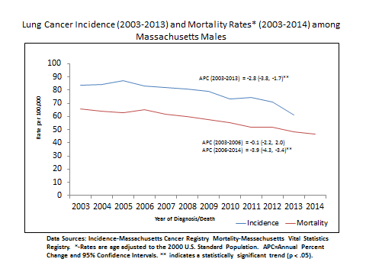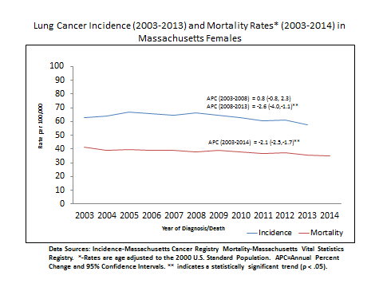

Cigarette Smoking

- Cigarette smoking is the number one risk factor for lung cancer. The CDC estimates that, “People who smoke cigarettes are 15 to 30 times more likely to get lung cancer or die from lung cancer than people who do not smoke.” Fortunately, progress is being made in Massachusetts. According to BRFSS data, cigarette smoking among men in Massachusetts decreased significantly from 26.7% in 1990 to 14.8% in 2010 (APC = -2.2%). Cigarette smoking among women decreased significantly from 21.8% in 1990 to 17.9% in 2005 (APC = -1.7%) and even more significantly from 17.9% in 2005 to 13.4% in 2010 (APC = -5.4%).

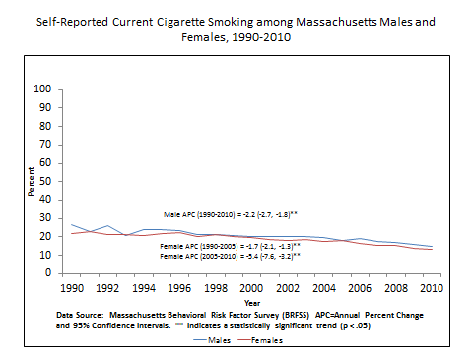

Massachusetts Tobacco Cessation & Prevention Program (MTCPP) Initiatives

- Developed the “Massachusetts Smokers’ Helpline” or the state tobacco quitline. Smokers, residents, healthcare providers and others may call this line for information and/or treatment from 7am-1am, seven days a week (except holidays). Counseling and medicines are dispensed for free. (See http://makesmokinghistory.org/quit-now/what-is-the-helpline/)

- Funds “health systems tobacco assessment and improvement” efforts, specific to tobacco screening and cessation, through a technical assistance (TA) vendor for all interested health care delivery systems. The TA vendor is the University of Massachusetts Medical School.

- Funds “behavioral health systems tobacco assessment and improvement” efforts, specific to tobacco screening and cessation, through a technical assistance vendor for all interested behavioral health care delivery systems. The TA vendor is the Institute of Health and Recovery.

- MTCPP provides technical assistance to landlords, property owners and housing authorities to promote and assist in adopting smoke-free housing policies. Our local community partnership programs provide resident education and resources to assist smokers. Information and tools to assist landlords is located on www.makesmokinghistory.org/smoke-free-environments. Also provide assistance through the Massachusetts Smoke-free Housing Project’s toll-free information line at 877-830-8795.

- MTCPP’s Tobacco-Free Community Partnership programs provide education and prevention strategies to communities to address youth initiation of tobacco use and help smokers to quit. These programs are the resource connectors on the community level and work with local coalitions, health centers, schools, and municipal government to assist communities in addressing tobacco use.

- MTCPP provides technical assistance to municipalities regarding tobacco laws and regulations. MTCP funds 184 municipalities to conduct enforcement of tobacco laws and regulation regarding smoke-free environments and youth access to tobacco in the retail environment. Municipal boards of health can access signage to assist with compliance of these laws at http://massclearinghouse.ehs.state.ma.us/category/TOB.html

- The 84 Movement is a program of youth activists working to educate their peers and their communities about the dangers of tobacco use. The 84 represents the 84% of Massachusetts youth who did not smoke when the movement began. Youth groups across the state have established Chapters of the 84. Chapters are provided training and tools to conduct surveys in their communities and educate decision makers about how tobacco is impacting their neighborhoods.

- More info can be found on www.the84.org

Summary

Lung cancer was the second most common cancer in Massachusetts men and women from 2003 to 2013. There were significant decreases for both males and females for incidence and mortality. Self-reported cigarette smoking has decreased significantly for both males and females. This long-term reduction in smoking is almost certainly related to the reduction in lung cancer deaths. The MDPH funds numerous programs which focus on helping individuals quit smoking. It also funds tobacco assessment and improvement efforts programs through a technical assistance vendor which is available to health care delivery systems.

Colorectal Cancer

Colorectal cancer was the third most common type of cancer diagnosed in both Massachusetts men and women from 2003 through 2013, comprising 8.9% and 9.2%, respectively, of all cancers diagnosed. During this period, a total of 22,442 new cases of colorectal cancer among males and 22,987 new cases among females were diagnosed, an annual average of 2,040 and 2,089 cases, respectively. There were 10,708 deaths with colorectal cancer as the underlying cause of death from 2003 to 2014, an average of 892 deaths annually. Both incidence and total deaths due to colorectal cancer have decreased. The decrease in incidence has occurred at a more rapid rate especially for men.

Incidence and Mortality

- The incidence rate of colorectal cancer among males decreased significantly by 5.4% annually from 68.4 per 100,000 in 2003 to 39.1 per 100,000 in 2013. The mortality rate also decreased significantly by 3.8% annually from 23.1 per 100,000 in 2003 to 15.4 per 100,000 in 2014.
- The incidence rate of colorectal cancer among females decreased significantly by 4.0% annually from 48.2 per 100,000 in 2003 to 32.0 per 100,000 in 2013. The mortality rate also decreased significantly by 3.4% annually from 15.3 per 100,000 in 2003 to 10.4 per 100,000 in 2014.
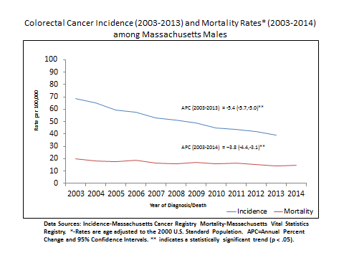

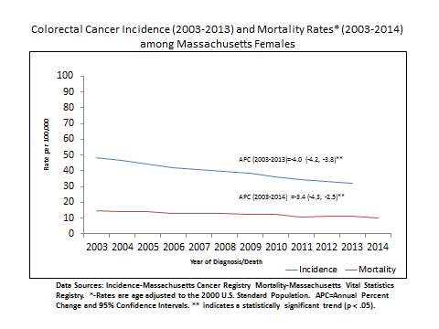
Screening

- The percentage of adults ages 50 years and older who reported having either a fecal occult blood test (FOBT) during the previous two years or a sigmoidoscopy/colonoscopy during the previous five years increased significantly from 56% in 2000 to 71% in 2007, representing a 2.7% annual increase during this period. The percentage then decreased non-significantly by 1.1% annually from 71% in 2007 to 66% in 2013.
- Although there was a significant increase in overall colorectal cancer screening for adults aged 50 years and older during 2000 through 2007 and then a stabilization from 2007 to 2013, the trends differed by method of screening:
- Between 2000 and 2007, those reporting having had a sigmoidoscopy or colonoscopy during the previous 5 years increased significantly by 6.6% per year, from 39% in 2000 to 64% in 2007, after which the trend stabilized through 2013.
- For screening by fecal occult blood test during the previous two years, the trend decreased significantly 7.5% per year from 2000 to 2013.

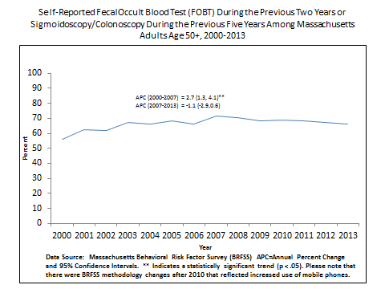
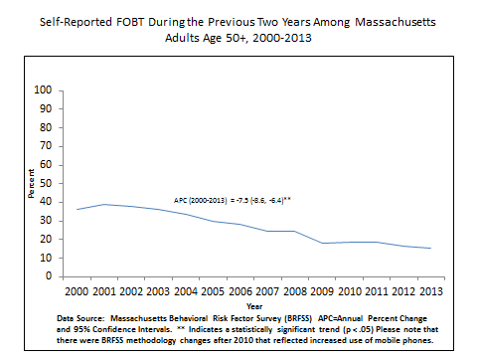

Massachusetts Department of Public Health Program Initiatives

The following programs were implemented by the Women’s Health Network Care Coordination Program:

- Supported and participated in the Annual Free Colonoscopy Day sponsored by CDC and AGA from FY 2010 - 2013.

- Developed and promoted A Guide to Colon Cancer Screening booklet to educate men and women over 50 and their families about colon cancer, how it grows and the importance of and options for being tested. The guide helps people make choices about getting tested and understand which test will work best for them. Available through the MA Health Promotions Clearinghouse - http://massclearinghouse.ehs.state.ma.us/CANCER/CA1373kit.html

- Collaborating with the Mass League of Community Health Centers to provide technical assistance with quality and process improvement efforts to increase cancer screenings in community health centers throughout the Commonwealth.

- Collaborating with the Massachusetts Medical Society to provide CME modules that address the confusion related to current screening guidelines for primary care providers. The CME module on guidelines for colorectal cancer (www.massmed.org/cme/dphcolorectalscreening) is currently available online.

- Developed and promoted the Test Yourself for Colon Cancer at Home brochure and poster encouraging use of FOBT/FIT as a colorectal cancer screening option.

- Conducted the Test Yourself for Colon Cancer at Home transit campaign, encouraging use of FOBT/FIT as a colorectal cancer screening option and added a colorectal cancer screening landing page on www.mass.gov/cancerscreenings.

- Currently developing a 2 minute animated video to accompany the Test Yourself for Colon Cancer at Home materials to explain the benefits of FOBT/FIT and explain how the test is used. Also developing a 30-second spot with CBS about the benefits of FOBT/FIT.

Summary

Invasive colorectal cancer was the most third most common cancer in Massachusetts men and women from 2003 to 2013. There were significant decreases for both males and females in incidence and mortality. The decline in colorectal cancer may be related to the elimination of pre-cancerous lesions which are identified as a result of colonoscopy screening. Overall screening for colorectal cancer increased significantly, though FOBT screening decreased while sigmoidoscopy/colonoscopy screening increased. During this time period, the Women’s Health Network Care Coordination Program implemented initiatives focused on increasing education about colon cancer and options for screening, increasing availability of screening in community health centers, and providing education on current screening guidelines for primary care providers.

