Performance Recognition Program (PRP) Information System

Instructions: Entering Carballo Nominee Information
- Enter your Carballo nominee’s Citation winner information and check the Carballo nominee box (Instructions on how to enter a Citation winner). To proceed entering the Carballo nominee information select ‘Enter Carballo Nominee.’ If you prefer to continue entering Citation winner information, select ‘Save.’
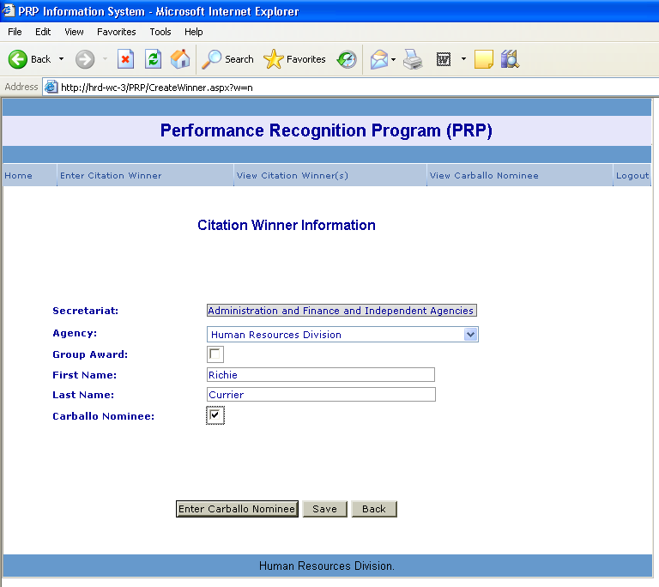

- For an individual Carballo nominee, please enter the nominee’s Title, Work Location, and Home Address. Select Job Category, Gender, and Ethnicity. Hit ‘Save.’
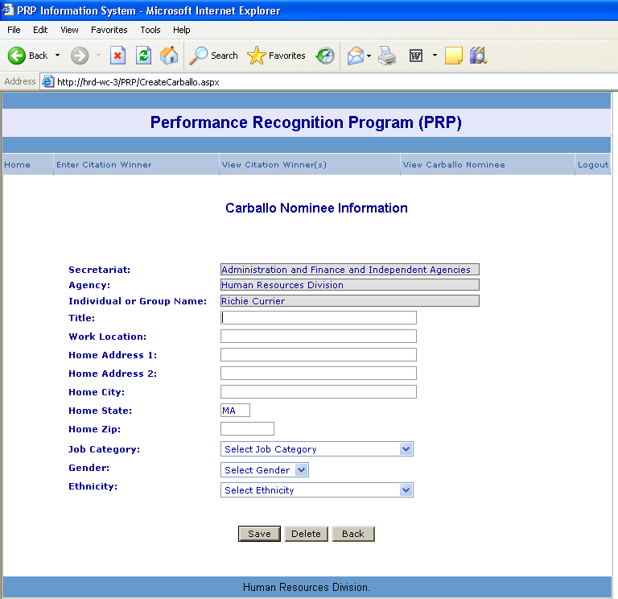

- For a group Carballo nominee, please enter the Work Location and Work Address of the group.
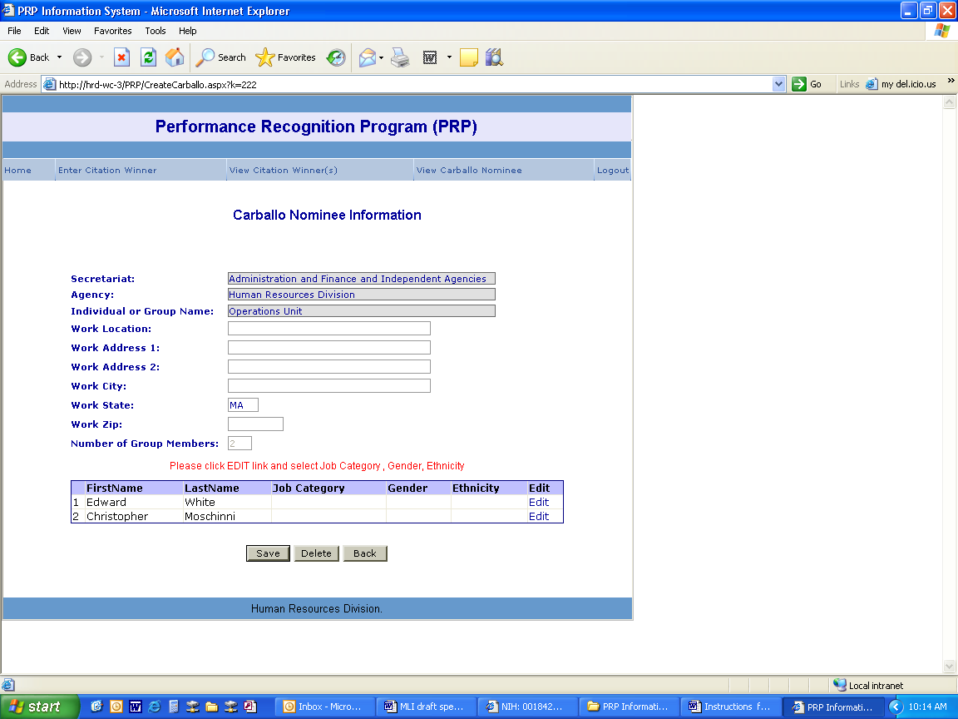
4. Next, select ‘Edit’ next to each group member’s name. Select a Job Category, Gender and Ethnicity. Hit ‘Update’ to save your selections. Repeat until finished. Hit ‘Save.’
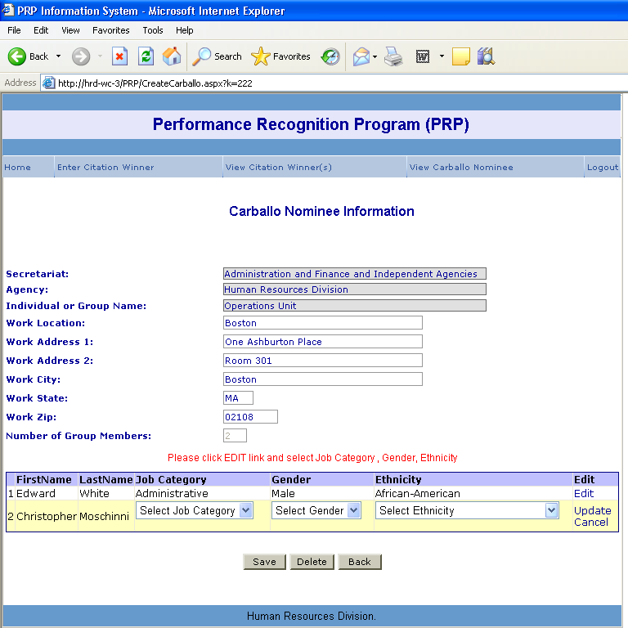

Instructions: Editing and Deleting Carballo Nominee Information
- If you would like to edit or delete a Carballo nominee, select the ‘View Carballo Nominee.’
- Select the name or group name of the Carballo nominee. This will bring you into the Carballo Nominee Information screen.
- For an individual Carballo nominee, you can edit Title, Work Location, Home Address, Job Category, Gender, and Ethnicity. Once your edits are complete, click ‘Update’ to save your changes.
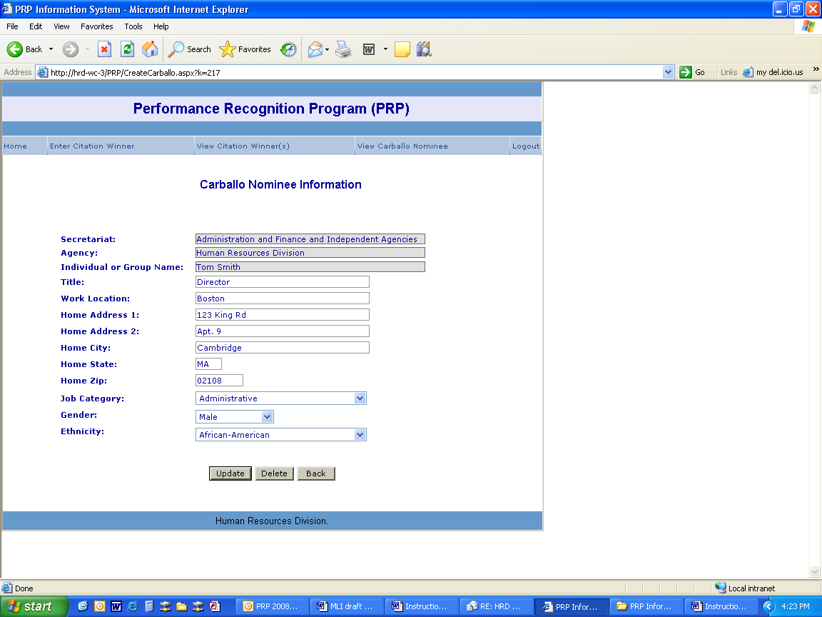
- For a group Carballo nominee, to edit Work Location and Work Address, make your edits and click ‘Update’ to save your changes.
- To edit Job Category, Gender, or Ethnicity for group members hit ‘Edit’ next to the name of the member you would like to edit, make your edits and hit ‘Update’ to save. To undue your edits hit ‘Cancel.’ Please note- if you would like to add group members they need to be added to the Citation Winner Information panel.
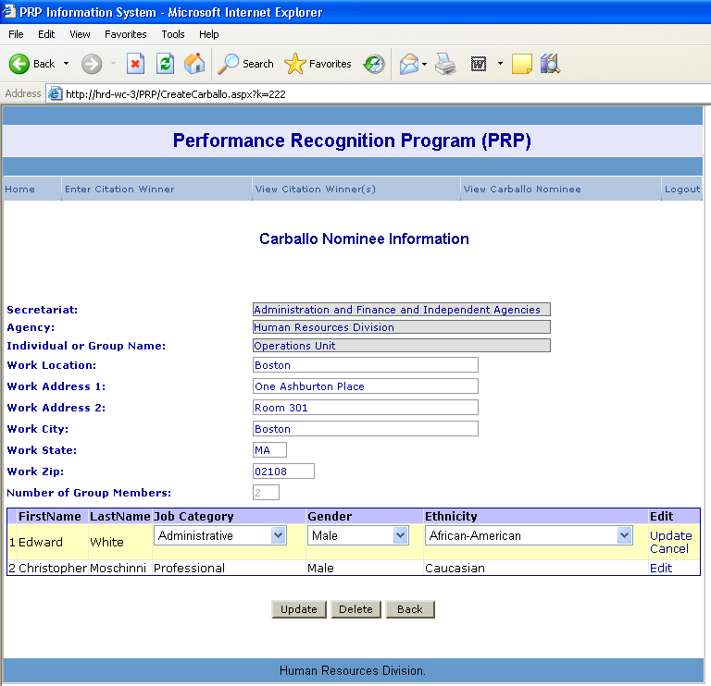
- To delete the entire record, select ‘Delete.’ A pop-up will appear asking if you are sure you want to delete this record. If yes, hit ‘Okay.’ If not, hit ‘Cancel.’ Please note- deleting Carballo Nominee Information will NOT delete the Citation Winner Information.

