Performance Recognition Program (PRP)
Information System
Welcome to the Performance Recognition Program (PRP) Information System instruction page. HRD is excited to announce this new feature, which will allow Agency PRP Coordinators to enter their Citation winner and Carballo nominee’s information directly into our database.
Here you will find the instructions on how to register and enter your agency’s Citation winners on the PRP Information System. Please keep in mind, how you enter your agency’s Citation winners is how they will appear on the printed Citation. Please make sure all spelling is correct, and the name reads how you would like it to appear on the Citation.
Instructions: Registering for First Time Users
- Click on the PRP Information System link (or find the system link on the PRP website).
- Select ‘New User?’
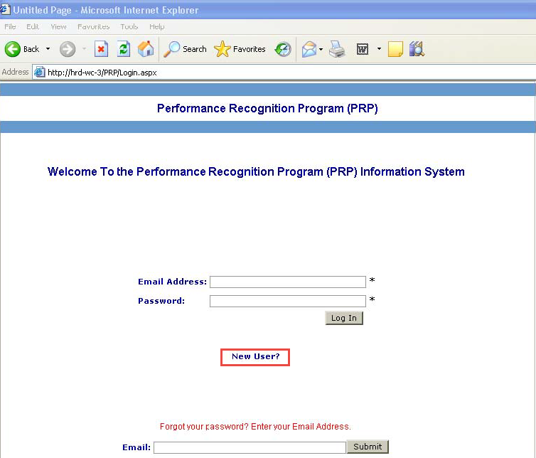

- Enter your first name, last name, email, phone number, and select your secretariat. Once your secretariat is selected, an agency list will pop up. Please select your agency. If you are the PRP Coordinator for multiple agencies, please check all agencies that apply. Enter and re-enter your password.
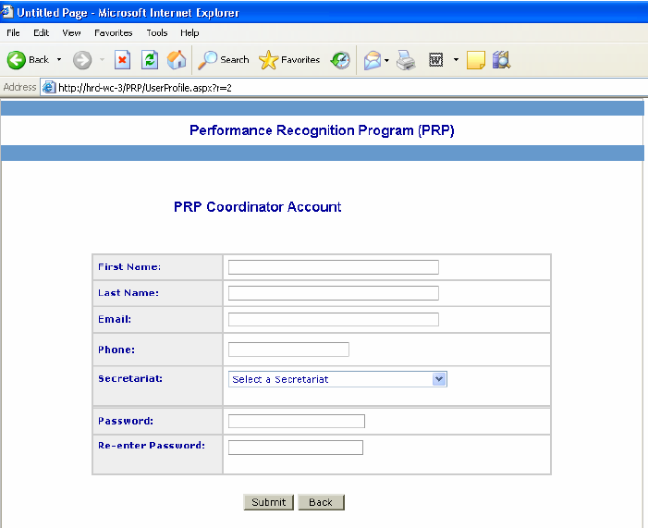
- Hit ‘submit.’ You will automatically be brought back to the initial login page. An email will be generated confirming that your information has been submitted. Once your account is approved you will receive an email confirmation and will be able to login and enter your agency’s Citation winners.
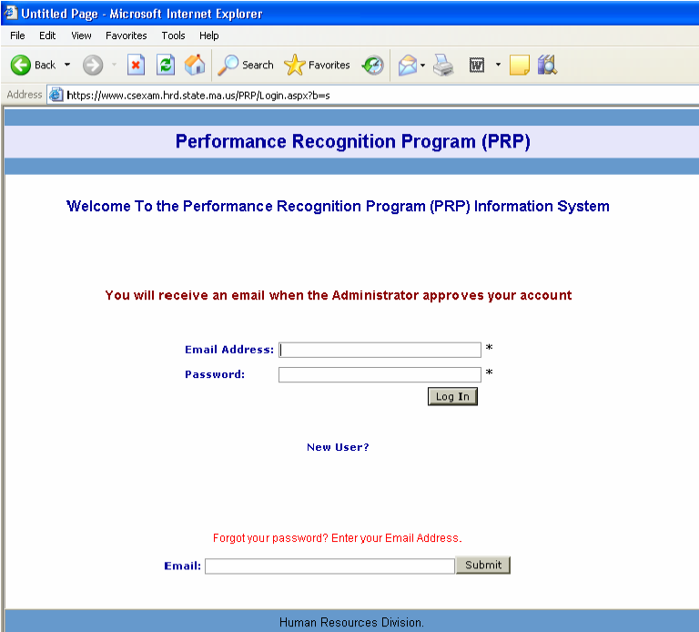

Instructions: Entering your Agency’s Citation Winner(s)
- After you login, you will see the PRP main screen.
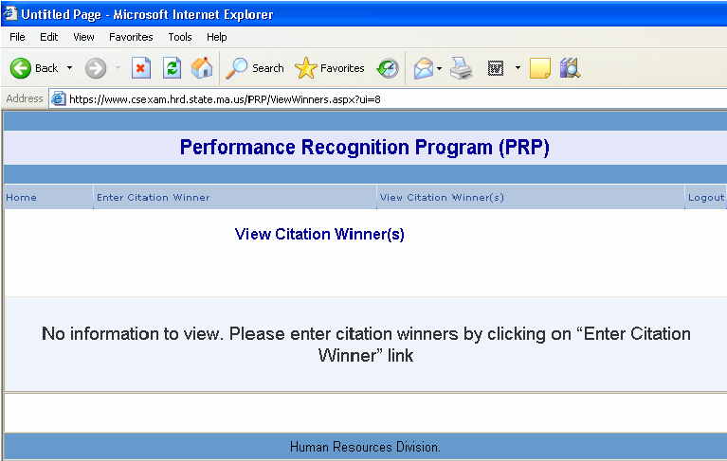
- Navigate to the ‘Enter Citation Winner’ tab to begin entering you Citation winners.
- For Individual Citations, enter the First Name and Last Name. If your Citation winner is also a Carballo nominee, please check the Carballo nominee box. Hit ‘Save.’
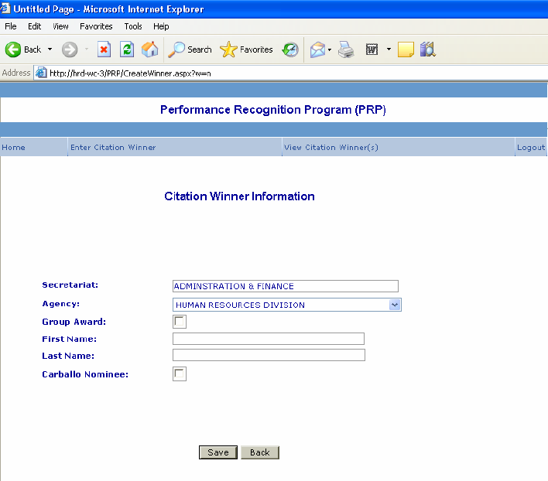

- For Group Citations check the Group Award box and enter the total number of group members. Hit the ‘Enter Member Names’ button.
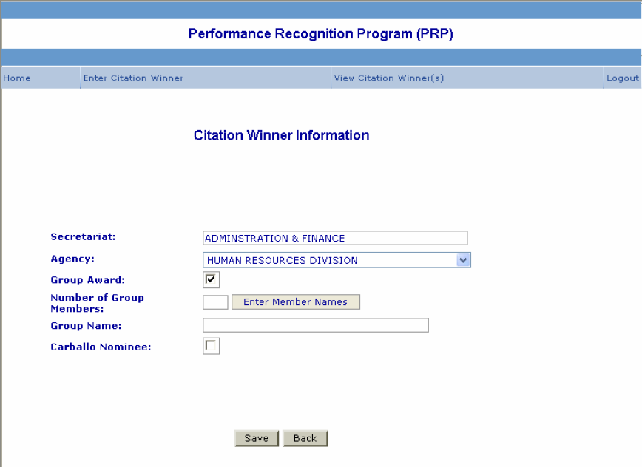
- Enter the group name and the members’ first and last name and hit ‘Save.’
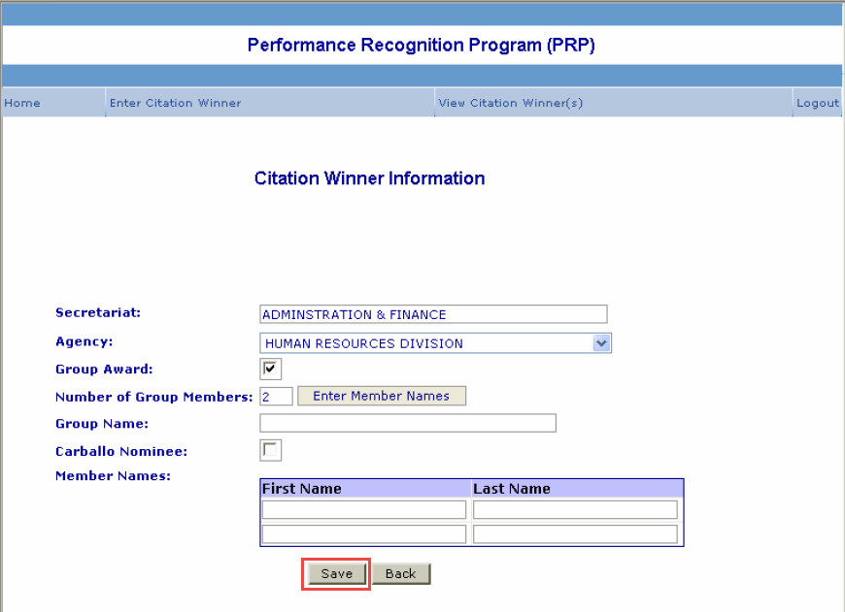
- Continue steps 2-5 until all your Citation winners are entered.

Instructions: Editing and Deleting Citation Winners
- If you would like to edit or delete a Citation winner, select ‘View Citation Winner(s).’
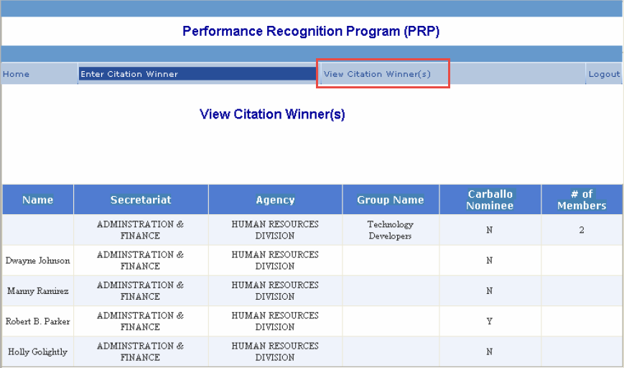
- Select the name or group name of the Citation you would like to edit or delete. This will bring you into the Citation Winner Information screen.
- For individual Citation winners:
  - To edit the Citation winner’s name, enter the change and hit ‘Update.’
  - To select them as a Carballo nominee, check the Carballo nominee box and hit ‘Update.’
  - To delete the entire record, click ‘Delete.’ A pop-up will appear asking if you are sure you want to delete this record. If yes, hit ‘Okay.’ If not, hit ‘Cancel.’ Once you delete a record, you cannot retrieve it.
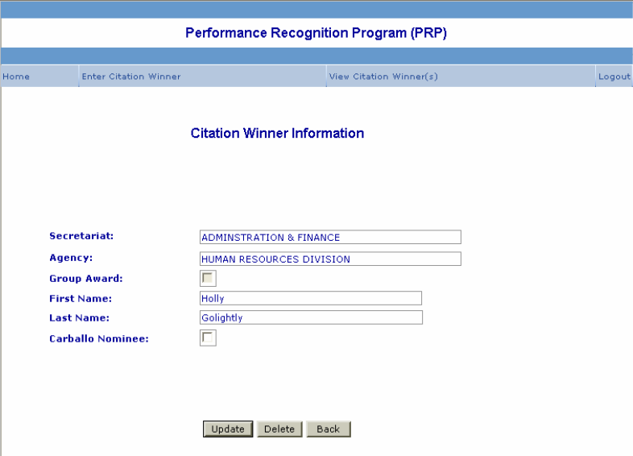

- For group Citation winners:
  - To edit the group name, enter the new group name and hit ‘Update.’
  - To add group members, enter the new member in the space provided and hit ‘Add New’ to save. Repeat this step until all new group members are added.
  - To delete a group member, click ‘Delete’ next to their name.
  - To edit a member name, click ‘Edit” and enter your corrections. Once corrected hit ‘Update.’ If you would like to undue your change, hit ‘Cancel.’
  - To delete the entire record, click ‘Delete.’ A pop-up will appear asking if you are sure you want to delete this record. If yes, hit ‘Okay.’ If not, hit ‘Cancel.’ Once you delete a record, you cannot retrieve it.
  - Once you are finished with your corrections, select the ‘Update’ or ‘Back’ buttons to return to the View Citation Winner(s) screen.

