STAY AWAY FROM STRAYS

Stray pets and wild animals can give you rabies.

A Rabies Education Packet for 3rd, 4th and 5th Grade Students

Materials for Teachers

How to Use This Curriculum Rabies Q&A for Teachers Introducing the Topic of Rabies to Students
Materials for Kids

Rabies Reminders (to take home) What Should You Do If...
Additional Activities Rabies Review Quiz Rabies Vocabulary Words Rabies Maze
Where’s the Risk?
Word Search

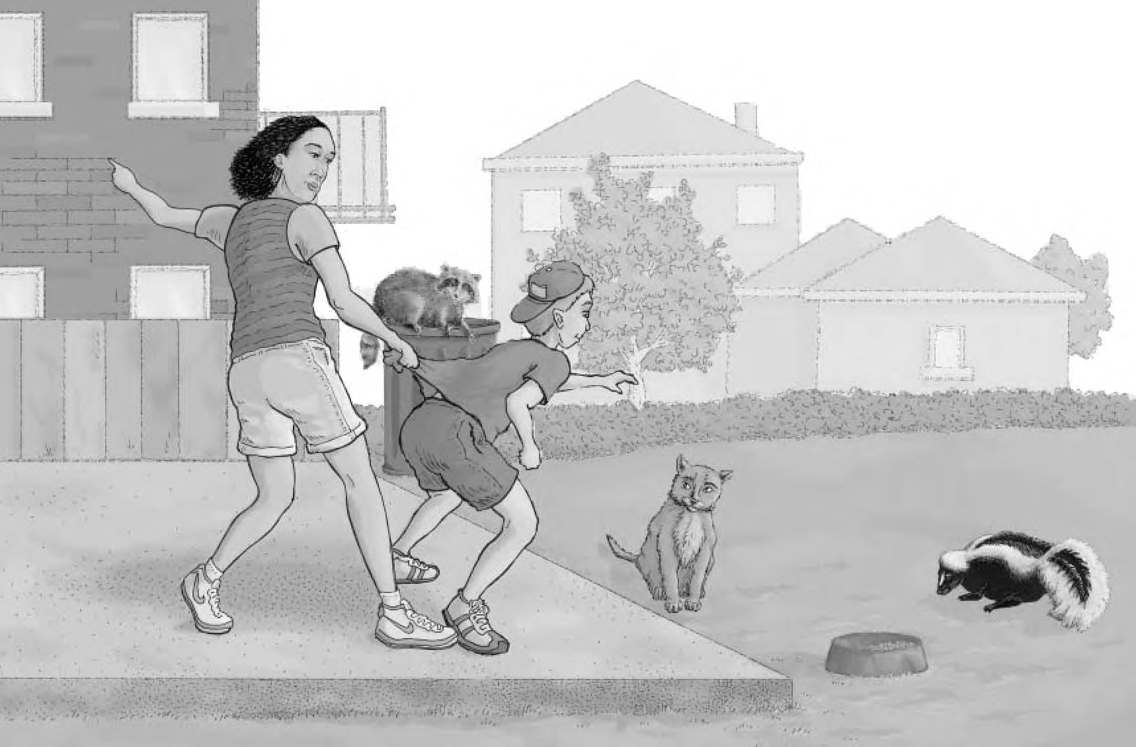Massachusetts Department of Public Health Division of Epidemiology and Immunization

March 2002

How to use the
STAY AWAY FROM STRAYS Curriculum
STAY AWAY FROM STRAYS includes suggested remarks for the teacher to begin the program, student activities, and materials to take home. The program can normally be completed during a regular class period, although teachers have the option of expanding the program to more than one class period. A list of optional activities has been included in this guide as a supplement to the basic program. You may use this curriculum in its entirety or modify it to meet your needs and those of the students or school.

The following approach is recommended for presenting the STAY AWAY FROM STRAYS program:
- Review the “Rabies Q & A for Teachers” and other materials to familiarize yourself with the subject matter.

- Use the “Introduction to Rabies” to begin the program.

- Review the “Rabies Vocabulary Words” with students. Discuss any unfamiliar terms.

- Discuss rabies, how it can be prevented, and what a child should do if bitten or scratched by an animal.

- Engage in any or all of the rabies-related activities described in the packet.

- Distribute Certificates of Participation to students.

Students completing the STAY AWAY FROM STRAYS program will have a better understanding of rabies and its prevention. At the completion of the program students should be able to:
- Describe rabies and why it is an important health concern;

- Identify wildlife that are most at risk for rabies;

- Identify pets and other domestic animals that are most at risk of being exposed to or infected with rabies;

- Describe the common symptoms of rabies infection in animals;

- Describe how to protect themselves and their pets from rabies; and

- Describe the steps to take if bitten or exposed to an animal.

This curriculum was created by the Massachusetts Department of Public Health, Division of Epidemiology and Immunization. It was adapted from the New Jersey Department of Health and Senior Services "Take the Bite Out of Rabies" curriculum.

Rabies Questions and Answers
for Teachers
The following is provided as background information for teachers presenting STAY AWAY FROM STRAYS. It is intended to familiarize teachers/instructors with rabies and common measures for controlling rabies and preventing unnecessary exposures to the disease.

“Rabies causes an inflammation of the brain and is fatal once symptoms develop.”

What is Rabies?
Rabies is a fatal disease that is caused by a virus. The rabies virus is present predominantly in the saliva and nervous tissue (brain and nerve cells) of infected animals and is transmitted most often by a bite. Rabies causes an inflammation of the brain and is fatal once symptoms develop. Each year, over 6,000 cases of animal rabies are confirmed in the United States and more than 20,000 people receive anti-rabies immunizations after being exposed to a rabid or a suspected rabid animal.

A serious outbreak of raccoon-strain rabies entered Massachusetts in 1992 and subsequently spread to Vermont, New Hampshire, and Maine. The magnitude of the problem is demonstrated by the fact that over 3,000 animals have tested positive for rabies in Massachusetts since 1992. However, thanks to prompt and careful case-by-case implementation of rabies prevention guidelines by state and local public health officials and healthcare providers, in Massachusetts there have been no cases of human rabies associated with the outbreak.

In 1996, there was one human case of rabies in New Hampshire in a person who had been exposed to a rabid animal while traveling overseas. The last case of domestically acquired human rabies in New England was in Connecticut in 1995, when a person died of bat-strain rabies.

In other parts of the world where medical treatment is not readily available and where animal vaccination campaigns are not in place, some 40,000 — 70,000 persons die from rabies annually.

What signs does an animal with rabies exhibit?
Animals infected with rabies may be aggressive and attack without fear or provocation (“furious” rabies) or may act stuporous and have difficulty walking because of partial or total paralysis (“dumb” or “paralytic” rabies). Animals that are usually only out at night may be seen during the daylight and may approach people or other animals they would normally avoid. Drooling, or what has become known as “foaming at the mouth,” may or may not be present. It is very difficult to know if an animal has rabies just by the way it acts or appears. The only sure way to know if an animal has rabies is to euthanize it and have its brain tested.

Which animals are most likely to be infected?
Mammals, particularly raccoons, skunks, foxes, and bats are most commonly infected. Other mammals can be infected through bites from these animals, including pets and livestock. Small terrestrial rodents (such as squirrels, rats, mice, hamsters, gerbils, chinchillas) and rabbits are rarely found to have rabies. Reptiles, amphibians, fish, birds, and insects do not carry rabies.

Through the distribution of an oral rabies vaccine for raccoons along the northern side of the Cape Cod Canal, the spread of raccoon rabies to Cape Cod and the islands of Nantucket and Martha’s Vineyard has been prevented.

How do people get rabies?
Rabies infection in a person is usually the result of a bite or scratch from a rabid animal. Infection can also occur when saliva from a rabid animal comes in contact with a fresh, open wound or with the eyes or other mucous membranes. Getting saliva on the surface of intact skin does not cause rabies. Nor can you get rabies simply by petting an animal.

Human rabies may develop weeks to months, and on occasion, years after a person is bitten or scratched by a rabid animal, if the person is not treated. Once symptoms develop, rabies is fatal.

What is the treatment for people exposed to rabies?
Animal bites and scratches should be immediately and thoroughly washed with soap and water. Medical advice should then be sought to ensure that the appropriate treatment is provided. This could include evaluating the risk of wound infection and offering rabies vaccination.

Before the decision is made to treat an exposed person, the exposing animal, if available, is evaluated to determine if it has rabies. Wild animals must be euthanized and their brains tested for rabies virus. Dogs and cats are usually confined and observed for signs of rabies infection. If the animal is not available for testing, the decision to treat the exposed person(s) is based on the assumption that the animal could have had rabies.

Rabies can be prevented by immunization, if administered shortly after exposure. The treatment for people exposed to rabies involves two medications. One, called rabies immune globulin (or RIG), contains preformed antibodies to fight the virus and is given once. The other medication is rabies vaccine, which ensures longer-lasting protection, and is given as five shots over the course of a month. (Rabies shots are no longer given in the stomach.) People who received the full series of rabies shots in the past need only two rabies vaccine shots. To work best, the medications should begin as soon as possible after the bite or scratch. However, if the animal has been caught and will be tested for rabies, you can wait for the test results to see if the shots are necessary.

“Rabies infection in a person is usually the result of a bite or scratch from a rabid animal.”

What would I have to do if my dog, cat, or ferret is bitten or exposed to rabies?
Depending on the circumstances of the exposure and whether the exposed cat, dog, or ferret was currently vaccinated, it would likely have to be observed for a specified period of time to be sure that it does not come down with rabies.
Vaccination is not 100% effective in preventing rabies in pets. Your local animal control officer and your veterinarian will be able to assist you. In addition, the Massachusetts Department of Food and Agriculture, Bureau of Animal Health is an excellent resource: (617) 626-1794.

How can exposure to rabies be prevented?

1. Vaccinate all cats, dogs and ferrets.

Unvaccinated domestic animals can be infected with rabies through contact with rabid animals and could then transmit rabies to people. Vaccinations must be kept current. The first vaccination a dog or cat receives is good for only a year. The second vaccination is then good for one or three years, depending on which vaccine is administered. Even if you consider your cat, dog, or ferret an indoor pet, wild animals (especially bats) often get indoors, or your pet could get outside when a door is opened. So, it is very important to vaccinate ALL cats, dogs, and ferrets. In certain situations it is also recommended to vaccinate livestock.

How can exposure to rabies be prevented?

- Vaccinate all cats, dogs and ferrets.

- Avoid any contact with wild animals.

- Secure your yard and home.

- Avoid contact with stray animals.

- If you are bitten or exposed to rabies, wash the wound thoroughly with lots of warm water & soap.

2. Avoid any contact with wild animals

Do not feed or touch wild animals. Do not try to rescue or help injured animals or touch their babies. You are likely to get bitten and could be exposed to rabies. Call Animal Control in your town for help.

Do not keep wild animals as pets. It is illegal in Massachusetts to keep wild animals as pets. There are no injectable vaccines approved for use in wildlife. Therefore, vaccination of individual wild animals is not considered safe or effective.

3. Secure your yard and home.

Keep garbage cans covered with tight-fitting lids. Do not leave pet food outdoors. Prevent animals from getting into your home by placing a cap (screened cover) on your chimney, keep garage doors closed, and eliminate places where animals can take up residence.

4. Avoid contact with stray animals.

Strays are more likely to come into contact with wildlife that could be infected with rabies. They may bite or scratch you and may not be vaccinated against rabies.

5. If you are bitten or possibly exposed to rabies:

Wash the wound thoroughly with lots of warm water and soap. Seek immediate medical attention from your doctor or local hospital emergency room.

Introducing the Topic of Rabies to
Students
Use this information to introduce the STAY AWAY FROM STRAYS program to students. If you are not the students’ regular classroom teacher, briefly introduce yourself. Inform the students that you will be discussing an important problem: RABIES. Ask students to answer the following questions so that you may gauge their understanding of the disease. Provide additional information, as needed.

What is rabies?
Rabies is a deadly disease caused by a virus (a germ so small you can’t see it). Rabid mammals can be found almost anywhere in the world. It is a disease, which makes mammals very sick. These animals will usually die, but before they die they will often infect other mammals.

How do animals get rabies?
The rabies virus is found in the saliva of infected mammals. When an infected animal bites a healthy animal, the healthy animal may get rabies, too.

How do animals act when they have rabies?
Animals that have rabies may act differently than they would normally. They may be more likely to attack or may look like they are sick or drunk. They do not always drool or “foam at the mouth”. Animals that are usually out only at night may be seen during the day. They may act aggressive or lose their fear of humans. Sometimes, however, animals may look normal and still have rabies.

What are the most common animals that get rabies?
Mammals such as raccoons, skunks, bats, cats, woodchucks, foxes, and dogs are the animals that are most commonly found to have rabies. These animals can bite other animals, even a pet dog or cat, and make them sick. It is important to protect our cats, dogs, and ferrets because if they are bitten and get rabies, they could get very sick and die. And they could give rabies to us. Livestock, such as cattle, horses, sheep, pigs, and goats can also get rabies if bitten or exposed to a rabid animal. Pets like gerbils and hamsters do not usually get rabies because they are kept in indoor cages. Squirrels, chipmunks, other rodents, and rabbits rarely get rabies and reptiles, amphibians, fish, birds, and insects never get rabies.

Can people get rabies?
If you are bitten or scratched by an animal that has rabies, you can get rabies, too. But you can protect yourself if you wash the wound with lots of warm water and soap, TELL AN ADULT, and see a doctor immediately.

How can we keep wild and stray animals away from our homes?
Keep garbage cans covered with tight fitting lids. Keep garage doors and shed doors closed. Put a cap or cover on the fireplace chimney. Do not leave pet food outside.

Why don’t wild animals make good pets?
Wild animals cannot be vaccinated against rabies and may bring the disease into your home. They are also difficult to train and will naturally bite. It is illegal to adopt a wild animal as a pet in Massachusetts.

How can we protect ourselves and our pets from rabies?
Make sure your cats, dogs, and ferrets have current rabies shots. Stay away from wild animals and animals you do not know. Be extra careful on field trips or whenever visiting an area where you may encounter wildlife or stray animals.

Rabies Reminders

(Post these on your refrigerator)

1. Have your pets vaccinated against rabies.
A rabies vaccination shot will help protect your dog, cat or ferret from rabies. Make sure your pets stay up to date on their vaccination shots.

2. Do not go near wild animals.
Raccoons, skunks, foxes, bats and other wild animals may be infected with rabies and should not be touched.

3. Stay away from stray animals.
Cats and dogs that roam outdoors are more likely to be infected with rabies and may bite you. Do not try to feed or pet them.

4. Make sure that your home and yard do not attract wild animals.
Keep garbage cans tightly covered. Do not leave pet food outdoors. Cap chimneys and seal places where animals can get in and hide.

5. If you are scratched or bitten by an animal…
- Wash the wound with lots of soap and water.

- TELL AN ADULT and have them call your doctor right away.

To report a wild or stray animal in your neighborhood, call Animal Control at
( ) -
Look up the number and write it here!

What should you do if...

Situation #1
You are walking through the woods with a friend and you come upon a young fox. Your friend wants to take the fox home. What do you do?

Situation #2
One afternoon you are sitting in your yard, reading. You hear noise! It is a raccoon, which has gotten into a trash can. What do you do?

Situation #3
Your cat came home with a bat in its mouth. What do you do?

Situation #4
Your little sister walks across the street to pet a stray cat which you have not seen around before. What do you do?

Situation #5
You are on your way home from school when you see a dog that appears to be gagging and choking. What do you do?

Situation #6
You are walking along with a group of friends. You reach out to pet a stray dog and it bites you. What do you do?

Situation #7
You look out the back window and see a drunk-looking skunk, wandering through your backyard. Its fur is straggly and it falls from time to time. What do you do?

Situation #8
You are at a friend’s house and his dog comes in from wandering in the woods. The dog is glad to see you and licks you both. You notice that the dog has no collar or tags. When you ask, your friend tells you that his family taken in a stray. What do you do?

Situation #9
You find a dead raccoon. You would like to examine it to find out why it died. What do you do?

Situation #10
Your dog comes indoors and you discover that it has been in a fight and has been bitten. What do you do?

What should you do if...

(Teacher’s Sheet)

Situation #1
You are walking through the woods with a friend and you come upon a young fox. Your friend wants to take the fox home. What do you do?

Stay away from the fox. Tell your friend not to touch it and explain why. Wild animals may have rabies. It is also against the law to have wild animals as a pet. Not only is it illegal, it is extremely unwise because wild animals remain wild, even after extended captivity. They are unpredictable and their behaviors are often destructive and dangerous.

Situation #2
One afternoon you are sitting in your yard, reading. You hear noise! It is a raccoon, which has gotten into a trash can. What do you do?

Leave and tell an adult! Trying to remove the raccoon could put you in danger of being bitten. Ignoring the animal is not a good idea either because if it is diseased it could attack you, and if you are reading you might not notice the animal approach until it is too late to escape. Once the raccoon is gone check your trash cans and perhaps even place them in the garage or shed. Wear gloves to pick up any trash. Be sure covers are on tightly and cannot be removed by a raccoon.

Situation #3
Your cat comes home with a bat in its mouth. What do you do?

Avoid contact with the bat. Tell an adult. You should also avoid contact with the cat in case it has bat saliva on it.

Situation #4
Your little sister walks across the street to pet a stray cat which you have not seen around before. What do you do?

Tell her to stay away from this stray animal. You don’t know where it has been, whether it has been bitten by another animal, whether it has been vaccinated against rabies. This is no time to take chances!

She ignores your advice. What do you do? Tell an adult.

Situation #5
You are on your way home from school when you see a dog that appears to be gagging and choking. What do you do?

Avoid the animal and tell an adult. It is dangerous to approach an animal that is showing signs of distress.

Situation #6
You are walking along with a group of friends. You reach out to pet a stray dog and it bites you. What do you do?

Tell an adult immediately. Wash the bite with warm, soapy water for 10 minutes and call or go to the doctor’s office. The doctor will tell you whether you will need shots.

Situation #7
You look out the back window and see a drunk-looking skunk, wandering through your backyard. Its fur is straggly and it falls from time to time. What do you do?

Stay inside until the skunk is gone or has died. Do not approach the skunk, even if you think it is dead. Keep your pets inside. Tell an adult. Have them call your local animal control officer and let him/her know about the skunk and its location.

Situation #8
You are at a friend’s house and his dog comes in from wandering in the woods. The dog is glad to see you and licks you both. You notice that the dog has no collar or tags. When you ask, your friend tells you that his family taken in a stray. What do you do?

Wash the skin where you were licked with warm soap and water . Your friend’s family should have brought the dog to a veterinarian when they took it in.
If this did not happen, have an adult call the Massachusetts Department of Food and Wildlife's Bureau of Animal Health for advice: (617) 626-1794.

Situation #9
You find a freshly dead raccoon. You would like to examine it to find out why it died. What do you do?

Don’t touch the animal. It may have died of rabies or it may have been carrying the disease. Find an adult to bury the animal using gloves and a shovel to avoid contact with the carcass. The adult may call the local Animal Control officer to report the incident.

Situation #10
Your dog comes indoors and you discover that it has been in a fight and has been bitten. What do you do?

Tell an adult. Have the adult call the veterinarian. Do not touch the dog’s wound or let fluid from the wound come into contact with your skin.

Additional Activities

Build a Bulletin Board
Create a classroom or school display board on the topic of “Rabies Prevention.” The display board(s) could be posted outside the classroom, in the library, or at the school’s entrance. Students could cut pictures from magazines or newspapers, write essays about their pets and the importance of rabies prevention, list the most important steps to take to prevent rabies, etc. Current events such as Rabies Vaccination Day (for pets) could also be posted.

Get information about where rabies has been reported from your local board of health, from the internet (www.state.ma.us/dph), or from the Massachusetts Department of Food and Wildlife's Bureau of Animal Health.

Identify Telephone Numbers for Your Community
Different people and agencies have different responsibilities related to wildlife and to rabies. The local board of health or the Massachusetts Department of Public Health, for example, deal with issues affecting human health. The local Animal Control Officer, the Massachusetts Department of Food and Wildlife's Bureau of Animal Health, and biologists from the Division of Fisheries and Wildlife deal with wildlife issues and the health of wildlife. They are not medical doctors and cannot give medical advice. The best person to advise on your personal health is your personal physician. Find out what individuals or groups in your community may be of service in dealing with sick raccoons or other animals.

Make up a list of phone numbers. If you can, make stickers with the relevant phone numbers for students to bring home.

Invite a Veterinarian or Visit an Animal Shelter
Invite a local veterinarian or Animal Control Officer to speak to your class about rabies, how she/he deals with animals suspected of having rabies, how to protect pets, and responsible pet care. Or, if possible, arrange a field trip to an animal shelter so children can learn about pet care and animal health and safety. Ask in advance to make sure that students will not be exposed to animals with uncertain vaccination histories.

Put on a Skit
Create a classroom skit/play emphasizing how to protect oneself, one’s pets, and one’s family from rabies. Include information about what children should do if they have contact with wildlife or if they are bitten by an animal.

Health or Science Fair
Conduct or participate in a health or science fair. The theme of the fair or your table could be “Animal Health and Rabies Prevention.” Alternately, students could help out at the local Rabies Vaccination Day by setting up an information booth and handing out information. Contact your local health department to inquire about local Rabies Vaccination Days.

Has Your Pet Been Immunized?
Ask students to check at home to find out:

- If they have a dog, cat, or ferret, ask has this pet been vaccinated? If so, when was the pet vaccinated and when will a booster shot be needed?

- If they do not have a dog, cat, or ferret, ask a neighbor or friend who has one whether it has vaccinated? When is it due for a booster?

Hold A Poster Contest!

Rabies Review
Choose the best answer to the following questions below.

TRUE or FALSE (answer each question, true or false)
1. Rabies is a serious public health problem.

2. Stray cats and dogs may be infected with rabies.

3. The best way to protect your cat and dog from rabies is to make sure it has a current rabies shot.

4. Even though a raccoon may act friendly, it should never be touched.

5. Wild animals do not make good pets.

VOCABULARY MATCHING (draw a line from the word to its definition)
STRAYS ● ● A disease that affects mammals

RABIES ● ● The most likely way of getting rabies

RACCOON ● ● Animals that live outdoors in the wild

WILDLIFE ● ● The most common animal with rabies in Massachusetts today

VIRUS ● ● A germ that causes a disease

BITE ● ● Pets that have lost their owner

MULTIPLE CHOICE (read the question and circle the best answer)
  - To help keep unwanted animals away from your home,
    - leave bowls of pet food on the deck.
    - keep garbage in tightly covered garbage cans.
    - none of the above.

  - If you are bitten or scratched by an animal, you should:
    - wash the wound with lots of soap and water. Tell an adult.
    - chase the animal.
    - do nothing.

  - Animals that most often get rabies are
    - raccoons, skunks, foxes, and birds.
    - raccoons, skunks, foxes, and bats.
    - raccoons, chipmunks, and squirrels.

STAY AWAY FROM STRAYS

Rabies Review

(Answer Sheet)

Part A: TRUE or FALSE
      - True
      - True
      - True
      - True
      - True

Part B: VOCABULARY MATCH
STRAYS A disease that affects animals

RABIES The most common way of getting rabies

RACCOON Animals that live outdoors in the wild

WILDLIFE The most common animal with rabies today

VIRUS A germ that causes a disease

BITE Pets that have lost their owner

Part C: MULTIPLE CHOICE

- B

- A

- B

STAY AWAY FROM STRAYS

Rabies Vocabulary Words….
It is suggested that the teacher review the following terms and phrases with students. (Some words may be too advanced for children in lower grades):

RABIES A disease that affects the brain of animals, caused by a virus, and usually spread by a bite

VIRUS One type of germ that causes disease – so small you can’t see it

EPIDEMIC A disease which is spreading rapidly

INFECTION When a germ enters the body of an animal or person and causes a disease

WILD ANIMAL Animals living outdoors in the wild that should not be kept as pets

MAMMAL A warm-blooded animal that is not a bird (as opposed to fish and reptiles which are cold-blooded animals)

STRAY ANIMAL A pet that has lost its owner or is allowed to roam outdoors uncontrolled

VACCINATE To give a shot to your cat, dog, or ferret to prevent it from getting rabies or other diseases

RABIES CLINIC A place where you can get your pet vaccinated against rabies

ANIMAL-PROOF Keeping things around your home such as garbage cans and chimneys covered to keep raccoons and other animals out, and not leaving pet food outdoors that might attract these animals

VETERINARIAN A doctor who takes care of animals

ANIMAL A person who helps control rabies in your community. One way the Animal Control CONTROL Officer helps is by capturing stray cats, dogs, and other animals that might have OFFICER rabies.

LOCAL A group of people working in your community to help protect you from rabies and
HEALTH other diseases
DEPARTMENT

STAY AWAY FROM STRAYS

,"....&_!._'io"..·· ·
! . .,..,·...- ······.-; ...,..

.·:.:·•.-·..
·. · ..•. :....._. : ; : ..· .' \ ...
····.- -·:·;..· • -,-;w=.,• ;..
:
..

•"•.
:P :.
.·. ·
.,,.....,.,.............-,.

:·.·:·...:
·*::I . ;J
... i·.
....

·
b-··:1··· ..
.
:. c·

::-"'. ...............'...: .: ,,

.··.1
,
.:.
..:
j•
'-
I

.,
.·..,

·r;··. '

'·.·

.·

..
....
.. ·:
·:

. : :·
LO?

r,.,.;

.... :,;:.i·.:.:.··. •.
.::.·... ·'

......
.•. ..._
t.! • ·
· .i:..\<IHM•Ft<•>; t... .'!:+f:. \! :I
•.!.-: .• ._• .• ,,'\ •,
..::·
..
··if :

ISTART
.-/.?:;...... .··'.:--:·;.:".)..·.,,·....·,...,.....u..

.... •._. .· -·-· ·- .:.--!.:.••.

•+·• . .. ••. .•"... .... •...
. . . ............. . . ... .
"""!11!"·1'1: • . ,.;, · ,, .•,,., . . ., « ...

t if f . .. , I • d • • • " ,,, I

HELP THE KIDS HOME SAFELY!

Can you show these children the way home without risking rabies infection?

/

f ::.; ..·
•a ...... . ..- ·-.- .-.;-:·

!!' • ;·•• • •) •(. .. .'...... .
r i• ....•;.i • • :; • • •.';"I- _._• •

;

..l.j
j.

'I ·,

' :

I·: ....;,,.... ..-;,...,..

...
:
·· ...::{ ;.l·.:.:.··. '::,

...
·,;;i.
l"

.....
.
:.·....:

·:
I
I•: f
*:;

J
.: ·:

,· '
:::
-=.!. ..

::1
.ir;·
.r.i:.t<ifii41PiCUi 1 hJ•.•.,Y,:.4 ;',\•·.;:1
. .., _.· · '.
.•,.J.'..

,_d ... ' ..."'·'·"·.,..·.
START ; ?;. ..:i{··;-r i··:.· >······. ..,,0,,. , ,, • • -. •• •,• • ,., , •• • •• ,,• • ,, .. ,. ·- • • .,. . . ;.,... ;,, · · t ·. • 1e
HELP THE KI DS HOME SAFELY!

Can you show these children the way home without risking rabies infection? SOLUTION

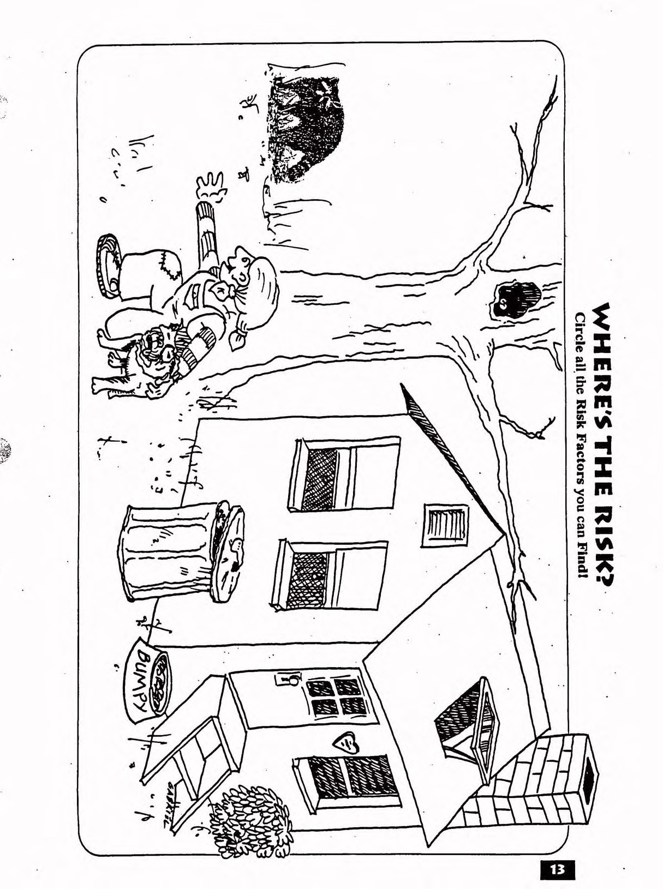

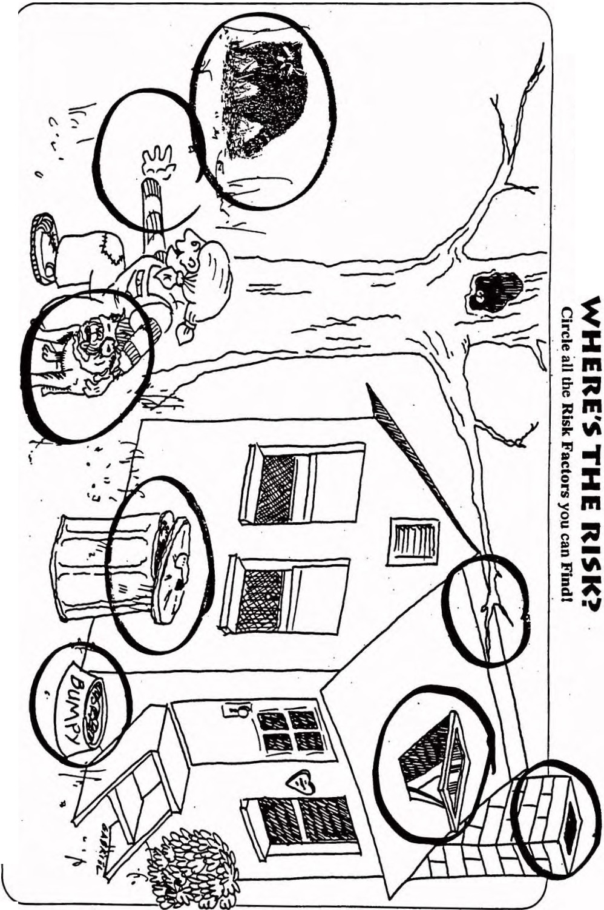

,0.
V\
c
-

-t ·
z0

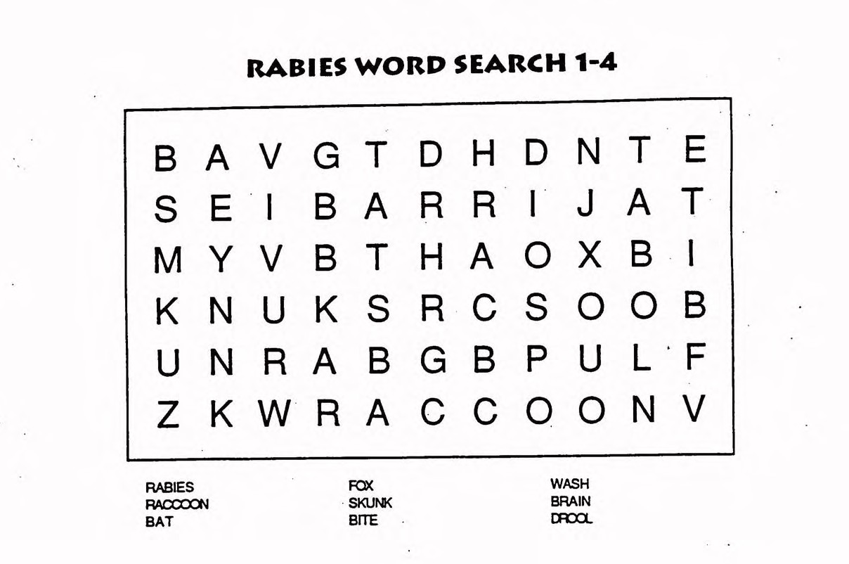

STAY AWAY FROM STRAYS

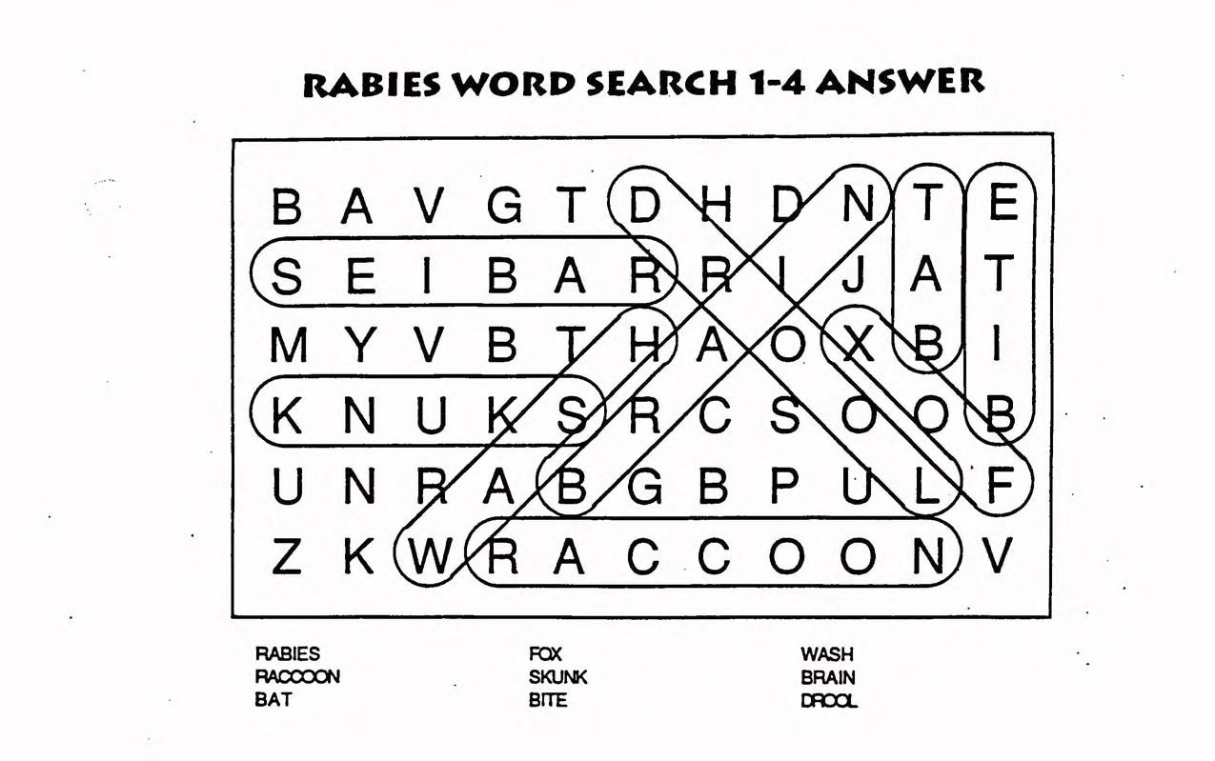

STAY AWAY FROM STRAYS

