MASSACHUSETTS DEPARTMENT OF PUBLIC HEALTH (MDPH)
The Top Six Animals Positive for Rabies in Massachusetts Since 1992

For Parents And Teachers

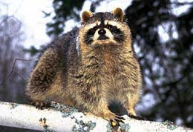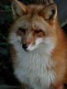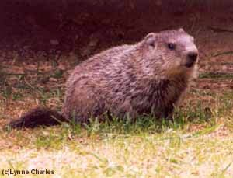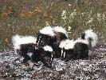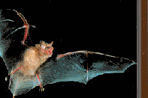1
2
3
4
5
6
May 2018

Over 3200 raccoons.
Stay away from wild animals!
Wild animals with rabies can appear tame or act aggressive.
Over 1800 skunks.
Rabies can affect all ages, even baby animals. It is against the law to adopt wild animals.

Over 675 bats.
Bats may have rabies. Do not release bats found in homes until potential exposures are carefully evaluated. Call the MDPH Division of Epidemiology and Immunization at 617-983-6800.

Over 190 cats.
Stay away from stray cats and dogs! Vaccinate your pets to protect them.
Over 210 foxes.
Call your local animal control officer if you see a wild animal acting strangely.

Over 110 woodchucks.
Seek medical attention if you or a family member are bitten or scratched by an animal.
Questions? Call the MDPH Division of Epidemiology and
Immunization at 617/983-6800.

