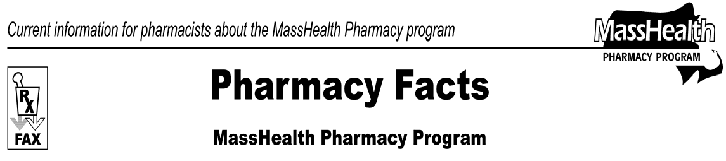Number 39
April 30, 2008

www.mass.gov/masshealth/pharmacy
- Editor: Vic Vangel • Contributors: Chris Burke, Gary Gilmore, Paul Jeffrey, James Monahan, Nancy Schiff, Chuck Young •

Prescriber NPI Requirements

The NPI identifier is mandated for compliance with the HIPAA standard transaction requirements. Effective May 20, 2008, the prescriber’s NPI must be placed in the Prescriber ID field (NCPDP field 411-DB) for all MassHealth pharmacy claim transactions. Other prescriber identifiers, such as the DEA number, will no longer be accepted. When submitting a claim with a prescriber NPI, the pharmacy will need to enter “01” in the prescriber ID qualifier field (NCPDP field 466-EZ).

Many prescribers are already providing their NPI on written prescriptions. If the prescriber’s NPI is not included with the prescription, the pharmacy can take one of the following steps to obtain it.

- The pharmacy may contact the prescriber by telephone to obtain the NPI. Consider asking for the prescriber’s NPI immediately during normal conversations with prescribers or their staff as you get ready to implement this process.
- The pharmacy can use the Centers for Medicare
& Medicaid Services (CMS) NPI lookup tool. This tool is available at https://nppes.cms.hhs.gov/NPPES/NPIRegistryH ome.do.

In order to ensure a smooth transition, we encourage pharmacies to begin integrating prescriber NPI data into existing prescriber records as soon as possible. The Pharmacy Online Processing System (POPS) will validate the prescriber NPI for all pharmacy claims.
Pharmacy claims for controlled substances (Schedules II-V) will be subject to additional verification to confirm that the prescriber’s NPI number corresponds to a valid DEA number.
It is extremely important that you submit only the actual NPI of the prescriber who issued the prescription, because this NPI ensures accurate prescriber identification which is essential for pharmacy claims processing, Drug Utilization Review (DUR) activity, and reporting. If MassHealth determines, upon inspection, that the pharmacy claim contains an incorrect prescriber NPI, MassHealth may recover payment for that claim.

If a pharmacist is not able to obtain a prescriber NPI at the time of dispensing the pharmacy may dispense an appropriate emergency supply. To indicate an emergency supply, the pharmacy must indicate a
level-of-service value of “3” (emergency service) in NCPDP field 418-DI.

Please direct any questions or comments (or to be taken off of this fax distribution) to
Victor Moquin of ACS at 617-423-9830.

