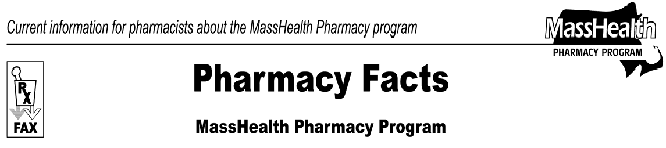Number 40
May 13, 2008

www.mass.gov/masshealth/pharmacy
Page 1 of 2

- Editor: Vic Vangel • Contributors: Chris Burke, Gary Gilmore, Paul Jeffrey, James Monahan, Nancy Schiff, Chuck Young •

MassHealth Prior Authorization (PA) Requests for Durable Medical Equipment and Medical Supplies (DME)
If, in addition to being a MassHealth pharmacy provider, you have been approved by MassHealth to provide DME or oxygen services, you must comply with DME regulations at 130 CMR 409.408 and with OXY regulations at 130 CMR 427.000, and submit prior authorization (PA) requests on behalf of MassHealth members in accordance with Subchapter 6 of the Durable Medical Equipment Manual. PA requests can be submitted to MassHealth electronically via the MassHealth Automated Prior Authorization System (APAS) or on paper in accordance with Appendix A of your All Provider Manual.
It has come to the attention of MassHealth that a large number of pharmacy providers who have also been approved to provide DME are not requesting prior authorization. The failure to submit prior authorization requests to MassHealth may be because pharmacies are not aware of the correct protocol. A provider may not turn away a MassHealth member who has a valid prescription for the sole reason that a PA request is necessary. In such circumstances, the provider must submit the PA request. MassHealth pharmacy providers who enter into a provider contract with MassHealth to provide DME or oxygen (equipment or supplies) are responsible for complying with all MassHealth regulations, including the regulations at 130 CMR 450.000, the DME regulations at 130 CMR 409.000 and the oxygen and respiratory therapy equipment regulations at 130 CMR 427.000.
Regulations that govern DME and oxygen can be found at www.mass.gov/masshealth. Go to MassHealth Regulations and Other Publications/ MassHealth Regulations/ MassHealth Provider Regulations/ 409: Durable Medical Equipment, and 427: Oxygen and Respiratory Therapy Equipment.

DME Prior Authorization Documentation
The MassHealth member (or caregiver) must obtain from their physician or nurse practitioner the prescription and written justification of medical necessity and forward this documentation to the DME or oxygen provider/pharmacy. The DME provider/pharmacy submits the prior authorization request to MassHealth on the member’s behalf along
with the prescription and written justification of medical necessity. Prescription requirements can be found in the DME regulations at 130 CMR 409.407 and in the oxygen regulations at 130 CMR 427.408.

Requesting Prior Authorization Electronically
For non-pharmacy medical services, MassHealth strongly encourages providers to request PA using the Web- based Automated Prior Authorization System (APAS) at www.masshealth-apas.com. Providers can use APAS to submit PA requests and all attachments electronically and review the status of PA requests almost immediately. If you have questions about APAS, please contact APAS Customer Services at 1-866-378-3789.

Requesting DME Prior Authorization on Paper
Providers may request PA for non-pharmacy DME services using the paper Prior Authorization Request form (PA-1). PA-1 forms and attachments should be sent to:
MassHealth
Attn: Prior Authorization Unit 600 Washington Street
Boston, MA 02111.

Prior Authorization Forms
You may also download forms from the MassHealth Web site. Go to www.mass.gov/masshealth Click on Information for MassHealth Providers / MassHealth Provider Forms. The PA form for DME is PA-1 (Prior Authorization Request). For additional supplies of this form use the Request for MassHealth Provider Forms, found under the “All Providers” subsection.

Rates for Payment of DME and Oxygen
The rates for DME and oxygen are established by the Division of Health Care Finance and Policy (DHCFP) and can be found at the DHCFP Web site at www.mass.gov/dhcfp; Click on DHCFP Regulations (under “What We Do”), and scroll to Regulation Number
114.3 CMR 22.00 to view rates. Pharmacies approved by MassHealth to provide DME or oxygen services must accept the rates of payment established by DHCFP.

Page 2 of 2

Submitting Claim for Payment
When submitting claims for DME or Oxygen to MassHealth on paper, providers, including pharmacy providers, must use claim form no. 9 (Request for Payment-Medical Services Claim). Providers may also submit claims electronically in accordance with the billing instructions in Subchapter 5 of the DME and oxygen provider manuals. Please refer to the Electronic Data Interchange (EDI) companion guide for information on electronic billing and HIPPA compliance. Go to www.mass.gov/masshealth. Click on Information for MassHealth Providers / MassHealth & HIPPA / EDI and HIPPA Information for Providers.
Subchapter 5 and Appendix A are both available on the Web. Go to www.mass.gov/masshealth, click on MassHealth Regulations and Other Publications
/Provider Library / Provider Manual / Durable Medical Equipment Manual (or Oxygen Manual). To begin to submit electronic claims, contact MassHealth Customer Service at 1-800-841-2900.

Obtaining Approval from MassHealth to Provide DME or Oxygen Services
If you are currently a pharmacy provider and have not been approved to provide durable medical equipment and medical supplies, or oxygen and respiratory therapy equipment and supplies, but would like to, you can contact MassHealth Customer Service at 1-800-841- 2900. Please identify yourself as a MassHealth- participating pharmacy.
We encourage you, before contacting MassHealth Customer service, to please review the eligibility regulations for durable medical equipment (130 CMR 409.404) and for oxygen (130 CMR 427.404) to ensure that you meet the eligibility requirements to provide DME or oxygen services. This information is available at www.mass.gov/masshealth in the "MassHealth Regulations and Other Publications" section.

Please direct any questions or comments (or to be taken off of this fax distribution) to
Victor Moquin of ACS at 617-423-9830.

