Instructions for Submitting Final Financial Reports

Introduction:

All Grantees must submit a Final Financial Report at the close of the grant period for each individual grant they have received for the current fiscal year. One report is to be submitted for each individual grant to EEC within sixty days of the close of the grant.

How to Complete the Final Financial Report Form:
Please log in to your online grant application to find the Final Financial Report button at the bottom of the home page.
Home Page:

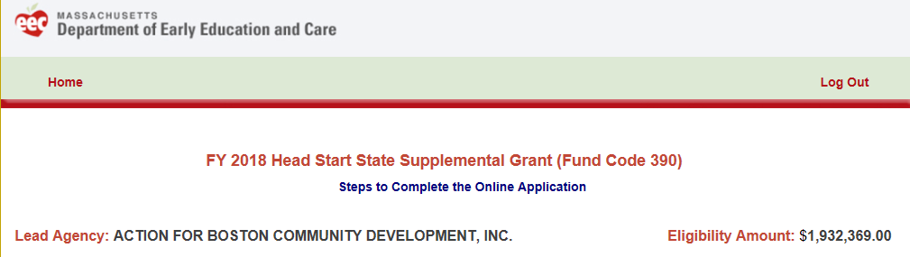
Click on box at Bottom of Home Page:

Final Financial Report:
- Fill in the Name of person completing this report.
- Fill in the Title of person completing this report.
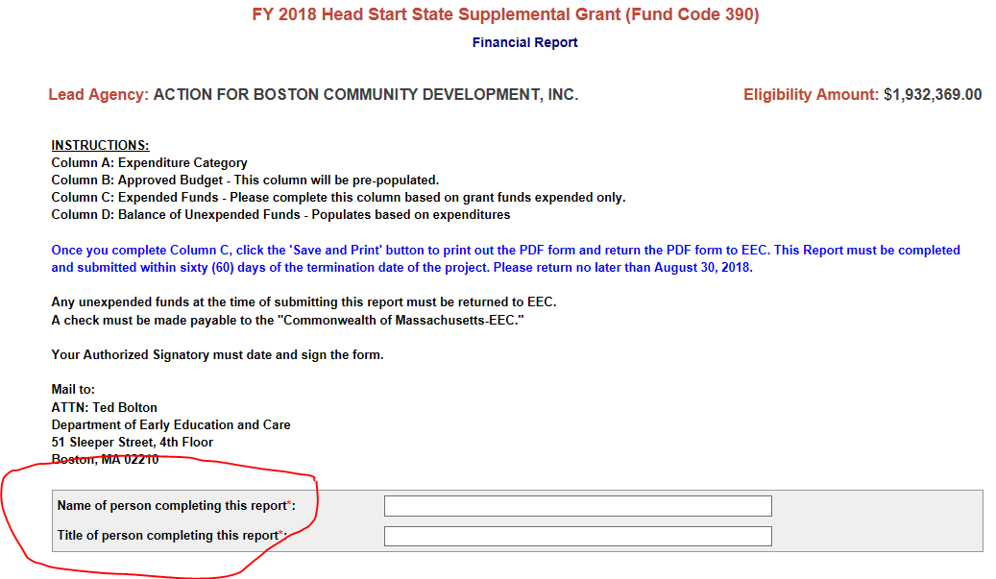

Then after that you will the columns for the Final Financial Reporting.

- Column A: Expenditure Category

- Column B: The most recently submitted approved budget will be pre-populated in Column B.

- Column C: Fill in the grant funds expended based on the approved budget line item expenditures.

- Column D: The balance unexpended (if applicable) will populate based on the expended amount in Column C.
This date is the Latest Submission of an Approved Budget or Budget Amendment

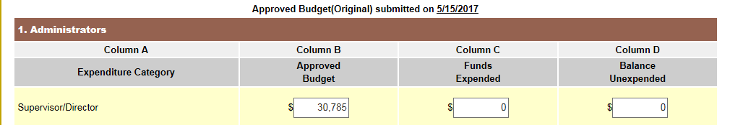

Once done completing Column C - at the bottom of the page Hit Save and Print for the PDF.
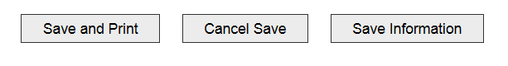
You will then print out the PDF of the Final Financial Report (see below):

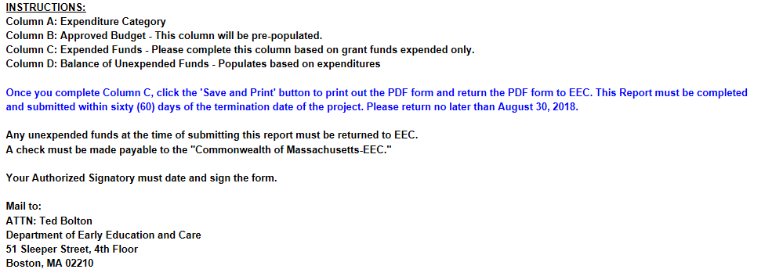

Unexpended Funds Checkbox:
- Please check off either Check Enclosed or Funds Not Requested if there is an unexpended balance.
- SIGNATURE: Include an original signature (in blue ink) of the authorized representative. Important: An unsigned Final Financial Report will NOT be approved and will have to be resubmitted to EEC.
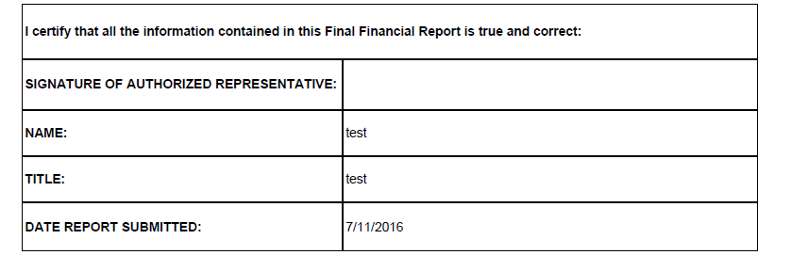

Grantees must submit the following documents when filing a Final Financial Report:
- One (1) original (the entire PDF of the report) with an original signature in blue ink.
- If applicable, a check for any unexpended funds.
Please mail the document(s) to:
ATTN: Ted Bolton
ATTN: Loida Marquez (391 and 262 only)
Department of Early Education and Care
51 Sleeper Street, 4th floor
Boston, MA 02210

Submission Instructions for grantees with any unexpended balance of funds

Grantee must return any unexpended funds to the Department of Early Education and Care via check. The check should be made payable to the “Commonwealth of Massachusetts-EEC” and submitted with their Final Financial Report.

