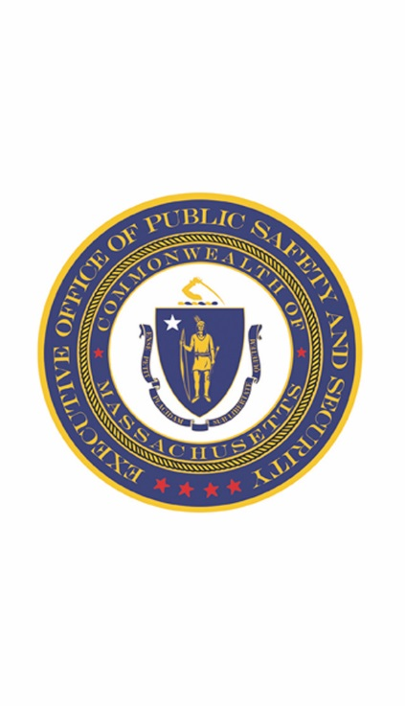
Office of Grants and Research
FFY17 VAWA STOP Programmatic Report

The Grantee must complete and submit a Semi-Annual Progress Report to OGR every six months following the calendar year. The progress report is to cover activities that occurred or were completed during the identified reporting period. This completed report is to be emailed to the assigned VAWA Grant Manager.

The due dates for the Semi-Annual Progress Reports are:
January 1 – June 30th Due: July 15th
July 1 – December 31st Due: January 15th

Note: The Grantee must also complete and submit an Annual Progress Report (APR) at the end of the reporting period. This report is to cover activities that occurred or were completed during the entire reporting period. The due date for the Annual Progress Report is 30 days after the project end date. Further information related to this report will be disseminated by your agency’s VAWA Grant Manager.

Award Number:
Reporting Period: |  | Report Date:
Subgrantee: |  | Report Completed By:
Email: |  | Phone:

- Is this a final report? (Please check one)
☐YES
☐NO

- What were your major accomplishments during this reporting period? Please describe.

- What goals and objectives were accomplished during this reporting period, as they relate to your grant application? Please list each goal and objective as stated in your application, and describe the progress made towards achieving each of them.

- Describe the project activities, as stated in your application that occurred during the reporting period.

- What problems/barriers did you encounter, if any, within the reporting period that prevented you from reaching your goals or milestones? Please include details on how these problems/barriers impacted the project and how they were resolved.

- Is there any assistance that OGR can provide to address and problems/barriers identified in question #6 above?

- Are you on track to fiscally and programmatically complete your project as outlined in your grant application? (Please answer YES or NO, if no, please explain.)
☐YES
☐NO

- What major activities are planned for the next 6 months?

In the chart below, indicate the requested statistical data for this reporting period in the applicable sections. Statistical data should be listed as number of victims served, calls responded to, cases prosecuted, trainings conducted, materials produced or distributed. (For categories that are not applicable, write “N/A.”). An agency is eligible for a category if they received VAWA funding for that specific category. Additionally, please attach a copy of ALL materials produced with VAWA STOP Grant funds during this reporting period.

Data Requested | 1st Reporting Period | 2nd Reporting Period
 | Contract Start – June 30th | July 1 – December 31st
Number of Victims Served (i.e. contacted, counseled, advocated for, etc.) (This is a cumulative number, please include victims that started service in one reporting period and carried over into another. Ex: if you served 10 victims in the 1st period and 5 of those victims carried over, plus 10 NEW victims were served in the 2nd period, the number in the 2nd period box would be 15.)
Number of Victim Service Referrals Made
Number of DV/SA/Stalking Cases Prosecuted
(# of arraignments completed by VAWA funded position(s)).
Number of DV/SA/Stalking Incident Calls Responded To
Number of Trainings Conducted
Number of Materials Produced* (please attach)
Number of Materials Distributed
Other (please describe)
Civilian Police Advocate Programs*

*For Civilian Police Advocate Programs Only – Please state the number of reports that your police department as a whole filed “concerning an incident, offense or alleged offense investigated, or any arrest made” that involved domestic abuse, as per MGL c 41 § 98G.

