Data Submission Dispenser Guide
Massachusetts Prescription Monitoring Program (MA PMP)
Version 4.0
Updated August 1, 2018

Table of Contents
1 Massachusetts Prescription Monitoring Program (MA PMP) Reporting Requirements 4
2 Guidelines for Data Submitters 6
Prescription Records and File Upload Specifications 6
3 Creating Your PMP Clearinghouse Account 6
4 Data Delivery Methods 9
4.1 Secure FTP 9
4.2 Web Portal Upload 9
4.3 Manual Entry – Universal Claim Form (UCF) 10
4.4 Zero Reports 11
5 Data Compliance 12
5.1 File Listing - sFTP 12
5.2 Claim Forms Listing - UCF 12
5.3 View Records 12
5.4 Error Correction 13
5.5 Error Correction in MassPAT 13
6 Email Reports 14
6.1 File Failed Report 14
6.2 File Status Report 14
6.3 Zero Report Confirmation 17
7 Password Management 18
7.1 Changing Your Password 18
7.2 Forgot Your Password 18
8 User Profile 18
8.1. Adding Users to Your Account 18
8.2. Adding States to Your Account 19
8.3. Adding sFTP to a Registered Account 19
8.4. Changing Administrator Account 20
If the Clearinghouse administrator account needs to be transferred from one user to another, contact the PMP Clearinghouse directly at 1-855-5MA-4PMP (1-855-562-4767). 20
9 Assistance and Support 21
9.1 Technical Assistance 21
9.2 Administrative Assistance 21
10 Appendix A - ASAP 4.2 Specifications 22
10 Appendix B - Data Entry Guidance 34
10.1 AIR03, AIR04, AIR05: ID of Person Picking up Prescription (i.e. Customer ID) 34
10.2 Exceptions to AIR03, AIR04 & AIR05 ID of Person Picking Up Rx (i.e. Customer ID) 35
10.3 Deliveries 35
10.4 AIR03- Jurisdiction Issuing Customer ID 36
10.5 AIR04- ID Qualifier of Person Picking Up Prescription 36
10.6 AIR06- Customer’s Relationship to Patient 36
10.7 DSP06 ─ Refill Number 36
10.8 Electronic Prescriptions -DSP18-21 36
10.9 PAT22 ─ Country of Non-U.S. Resident 37
10.10 PRE02 – Prescriber DEA Number (Including DEA "X" Numbers) 37
10.11 Guidance on Metric Quantity Reporting 37
10.12 Reporting Compounded Prescriptions 38
10.13 Reporting Gabapentin Prescriptions 38
11 Appendix C - ASAP Zero Report Specifications 39
12 Appendix D – sFTP Configuration 41
12.1 sFTP Connection Details: 41
12.2 State Subfolders 41
12.3 Public (SSH/RSA) Key Authentication 43
13 Appendix E – Data Submission Waivers 45
13.1 Annual Data Submission Waiver 45
13.2 Days of Operation Waiver 45
13.3 Temporary Waiver 45

Massachusetts Prescription Monitoring Program (MA PMP)
Reporting Requirements
The Massachusetts Prescription Monitoring Program (MA PMP), authorized by M.G.L. Chapter 94C §24A, collects dispensing information on Schedule II through V (M.G.L. Chapter 94C §3) controlled substances and DPH designated drugs (105 CMR 700.012(7)) dispensed pursuant to a prescription. The Massachusetts Department of Public Health (MA DPH) analyzes PMP data to:

- Determine prescribing and dispensing trends;
- Provide patient prescription history information to prescribers and dispensers;
- Provide educational information to health care providers and the public; and to
- Provide case information to regulatory and law enforcement agencies concerning drug distribution and diversion.

Pharmacies are required to submit dispensing information on federally controlled substances in Schedule II through V and Gabapentin, a Massachusetts Schedule VI substance, within 24-hours or the next business day, to the state of Massachusetts through the PMP Clearinghouse provided by Appriss Health, Inc. For more information on the reporting requirements, please visit the PMP website.

The MA PMP reporting requirements apply to all pharmacies registered with the Massachusetts Board of Pharmacy and to all pharmacies in health facilities registered with the MA DPH that dispense federally controlled substances in Schedules II - V and Gabapentin. In addition, MA PMP reporting requirements apply to any pharmacy located in another state, commonwealth, district or territory that delivers a prescription (via U.S.P.S. or common carrier) in Schedules II ─V and Gabapentin to a person who is located in Massachusetts. This includes, but is not limited to, mail-order pharmacies.

This Data Submission Guide provides the guidelines, specifications and instructions for submitting prescription data to the MA PMP. The Department is committed to working with pharmacies to comply with these requirements. Pharmacies are a critical partner in the accuracy of the data in the PMP and should ensure that their pharmacists are reporting the right information into the system.

At the micro-level, the PMP is a clinical tool that assists doctors, other prescribers and dispensers to safely care for their patients. Pain is subjective, and healthcare providers want to balance the real need for pain management with the potential risks of opioid misuse. The PMP helps them do that and it is important that they have accurate, timely information.

On the macro-level, the PMP is a powerful analytical tool that allows MA DPH to look at trends so that MA DPH can understand different patterns of prescribing and use. The MA DPH can then use that data to make evidence-based decisions on public health policies and interventions.

Without accurate and timely information, none of these objectives can be achieved. The MA DPH appreciates all of your assistance in meeting our shared goals of providing critical prescription information.

MA PMP Reporting Requirements
Drug Schedule | PMP Reporting Requirement | Frequency of Reporting Requirement
Schedule 1 | No | N/A
Schedule 2 | Yes | Within 24-hours or the next business day
Schedule 3 | Yes | Within 24-hours or the next business day
Schedule 4 | Yes | Within 24-hours or the next business day
Schedule 5 | Yes | Within 24-hours or the next business day
Schedule 6 | Gabapentin | Within 24-hours or the next business day

MA DPH and Appriss have made every effort to ensure the accuracy of the information in this document at the time of printing. However, information may change without notice. Recent changes include:

Version | Date | Changes
1.0 | 2/16/16 | - Original Document
1.1 | 02/26/16 | - Updates per Pharmacy Kick-Off Meeting feedback
1.2 | 04/05/16 | - DSP18-DSP21 are listed as optional not conditional  - Modified condition of AIR07/AIR08  - Added additional compliance language to section 6.2
2.0 | 06/21/16 | - Updated language under Deliveries regarding AIR06  - Added Appendix D
3.0 | 05/10/17 | - Requirement for pharmacies to submit Gabapentin (effective August 1, 2017). For details see 10 Appendix B 10.14  - AIR fields (Customer ID)  - AIR11 – Customer ID must be collected at pick-up only (effective August 1, 2017)  - AIR03, 04, 05 – Customer ID must be collected for refills (effective August 1, 2017)  - AIR03, 04, 05 – Customer ID must be collected for Gabapentin (effective August 1, 2018)  - Requirement for PRE 01 (Prescriber NPI) to be submitted in each record (effective August 1, 2017)  - PRE02 (Prescriber DEA) is conditionally required (effective August 1, 2017)  - PRE03 (DEA Suffix) will be optional (effective August 1, 2017)
4.0 | 8/1/18 | - Requirements for pharmacies to submit Customer ID information for Gabapentin (effective August 1st, 2018)  - Clarified error correction process  - Added Section 5.5 – Error Correction in MassPAT  - Added Appendix E – Data Submission Waivers

Guidelines for Data Submitters

Prescription Records and File Upload Specifications
- All data required within M.G.L. Chapter 94C §24A must be reported to the MA PMP through the PMP Clearinghouse within 24 hours, or the next business day following the most recent transmission.
- Files should be in ASAP 4.2 format.
- The primary email account in the User Profile must be monitored for communications from the Clearinghouse by the data submitter.
- Reports for multiple pharmacies can be in the same upload file in any order.
- If a pharmacy does not dispense any federally controlled Schedule II-V substances or Gabapentin for the preceding reporting period, it must file a “Zero Report” for that reporting period or it will be considered noncompliant. See Zero Reports for additional details.
- A Data Submission Waiver may be requested to avoid filing a Zero Report on days of the week the pharmacy is closed or for other specified reasons – see Appendix E.
- Prescription records that contain errors and are rejected by the PMP Clearinghouse must be corrected and resubmitted.

Creating Your PMP Clearinghouse Account
Prior to submitting data, you must create an account. If you are already registered with PMP Clearinghouse, you do not need to create a new account. A single account holder can submit to multiple states. If you have an existing PMP Clearinghouse account see section 8.2 Adding States to Your Account.
Note: Multiple pharmacies can be uploaded in the same file. For example, Wal-Mart, CVS, and other chain pharmacies can send in one file containing all their pharmacies from around the state. Therefore, chains with multiple stores only have to set up one account to upload a file.
Perform the following steps to create a PMP Clearinghouse account:
- Go to https://pmpclearinghouse.net and click the Create Account link in the center of the screen or go directly to https://pmpclearinghouse.net/registrations/new.

- Profile Section. Enter a current, valid email address and a password. This email address will act as your username when logging into the system.
- The password must contain at least 8 characters, including 1 capital letter, 1 lower case letter, and 1 special character (e.g. ! @ # $)

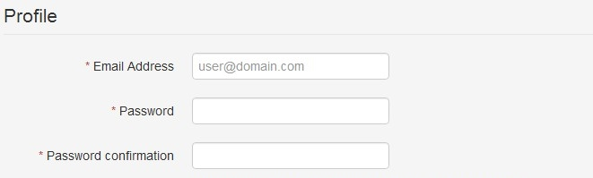
- Personal & Employer Section. Enter your personal and employer information.
- Required fields are marked with a red asterisk (*)
- Data fields may be auto populated by entering DEA, NCPDP, or NPI information in the appropriate search box located to the right of each section.
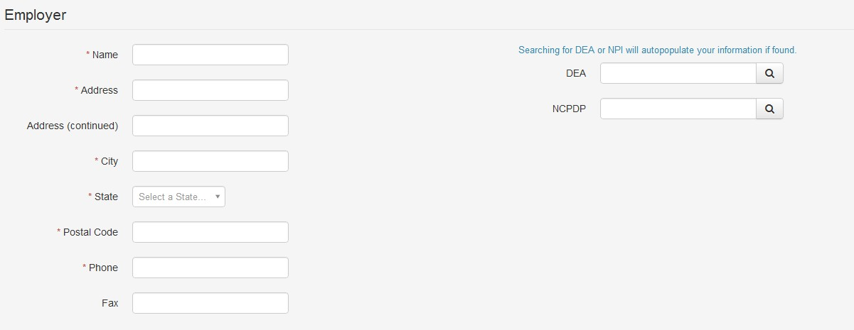

- sFTP Section. If the user would like to submit data via sFTP, sFTP access can be granted during account registration. See Adding sFTP to a Registered Account to add sFTP access to an existing PMP Clearinghouse account.
- Check the “Enable sFTP Access” box as seen below. The sFTP username is automatically generated using the first 5 characters of the employer name + the employer phone number + @prodpmpsftp. Example username: chain5025555555@prodpmpsftp
- Create a sFTP password that meets the following criteria: contain at least 8 characters, including 1 capital letter, 1 lower case letter, 1 number, and 1 special character (e.g. !,@,#,$)
NOTE: This will be the password that is entered into the pharmacy software so that submissions can be automated. This password can be the same as the one entered previously under Profile. Unlike the Profile password (i.e. user account password) the sFTP password does not expire.
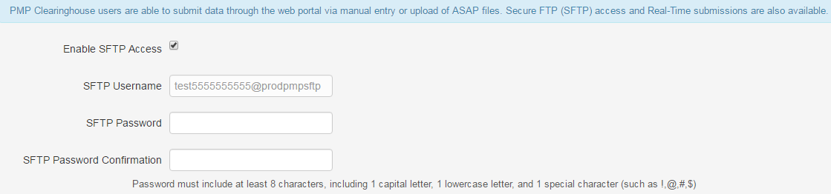
The URL to connect via sFTP is sftp://sftp.pmpclearinghouse.net
Additional details on sFTP configuration can be found in Appendix D – sFTP Configuration.

- The registering user must select which states they will be submitting data for. A list of available states using PMP AWAR_{X}E is selectable.
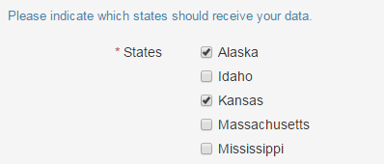

- The registering user clicks submit. The request is submitted to the PMP Administrator for each of the states the user selected for data submission.
- Once the State PMP Administrator has approved the request, the user will receive a welcome email and can begin submitting data to PMP AWAR_{X}E.

Data Delivery Methods
This section discusses the different options available to a user to submit controlled substance prescription data file(s) to PMP Clearinghouse. Users have the options of using 1) a sFTP account, 2) a web portal upload page, 3) using a manual entry UCF (Universal Claims Form) page, or 4) submitting a zero report.

Secure FTP
Data submitters who select to submit data to PMP Clearinghouse by sFTP must configure individual folders for the state PMP systems they will be submitting data to – see Appendix D for sFTP Configuration. The sub-folders should use state abbreviation for naming (ex. AK, KS, MA, etc.). The subfolder must be located in the homedir/ directory which is where you land once authenticated. Data files not submitted to a state subfolder will be required to have a manual state PMP assignment made on the File Listings screen. See State Subfolders for additional details on this process.
- If an account has not yet been created, perform the steps in Creating Your Account. If a Clearinghouse account already exists but needs sFTP access added, perform the steps in Adding sFTP to a Registered Account.
- Prepare the data file(s) for submission, using the ASAP 4.2 specifications described in Appendix B.
- SFTP the file to sftp://sftp.pmpclearinghouse.net.
- When prompted, use the username you received in an email when the SFTP account was created and the password you entered when requesting the SFTP account.
- Place the file in the desired directory.
- The user can view the results of the transfer/upload on the Submissions screen.
Note: If a data file was placed in the root directory and not a state sub-folder, the user will be prompted at the File Status screen to select a destination PMP to send the data to.

Web Portal Upload
- If an account has not yet been created, perform the steps in Creating Your Account.
- After logging into PMP Clearinghouse, navigate to File Upload in the menu bar.
- You must select a destination PMP from the available states listed in the drop-down.
- Click on the “Browse” button and select the file to upload.
- Click the “Upload” button to begin the process of transferring the file to PMP Clearinghouse.
- Files for upload should be named in a unique fashion, with a prefix constructed from the date (YYYYMMDD) and a suffix of “.dat”. An example file name would be “20110415.dat”.
- The results of the transfer/upload can be viewed on the File Submissions screen.
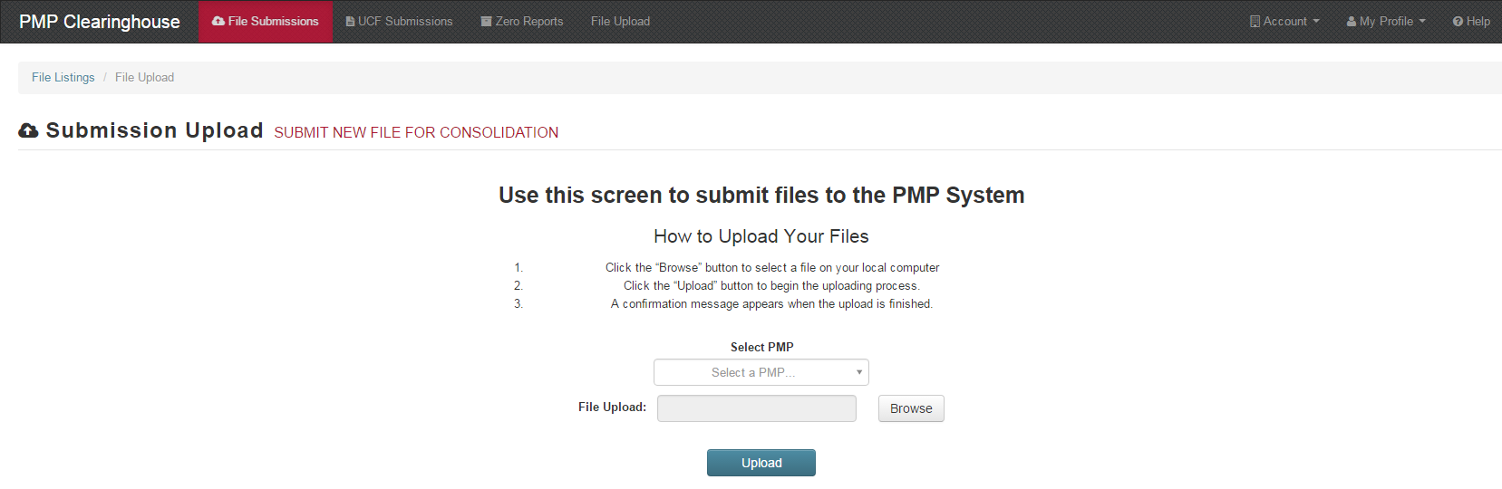

Manual Entry – Universal Claim Form (UCF)
Manual Entry is an option for data submitters to enter their prescription information into the PMP Clearinghouse system using a form derived from the Universal Claims Form. It allows the entry of patient, prescriber, pharmacy, and prescription information.
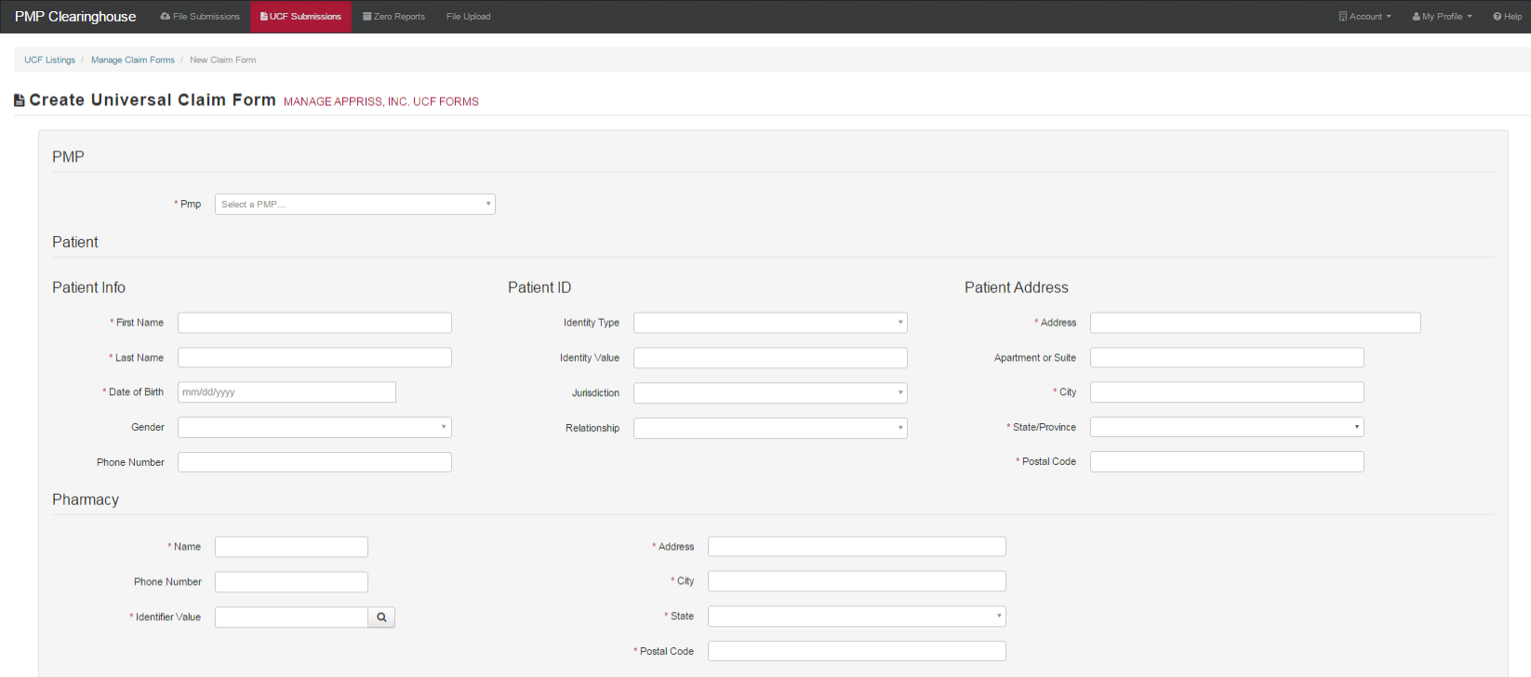
- If you do not have an account, perform the steps in Creating Your Account.
- After logging into PMP Clearinghouse, navigate to UCF Submissions in the menu bar.
- Choose New Claim Form to begin a submission.
- You must select a destination PMP from the available states listed in the drop-down.
- Complete all required fields as indicated by a red asterisks (*).
- Click Save.
- Then click Submit.
- The results can be viewed on the UCF Listing screen.

Zero Reports
If you have no dispensations to report, you must report this information to the MA PMP by performing the following steps:
- If you do not have an account, perform the steps in Creating Your Account.
- After logging into PMP Clearinghouse, navigate to Zero Reports in the menu bar.
- You must select a destination PMP from the available states listed in the drop-down.
- Enter the start date and end date for the report and click on the “Submit” button. (NCPDP and DEA number are optional)
- The request will be submitted to PMP Clearinghouse.
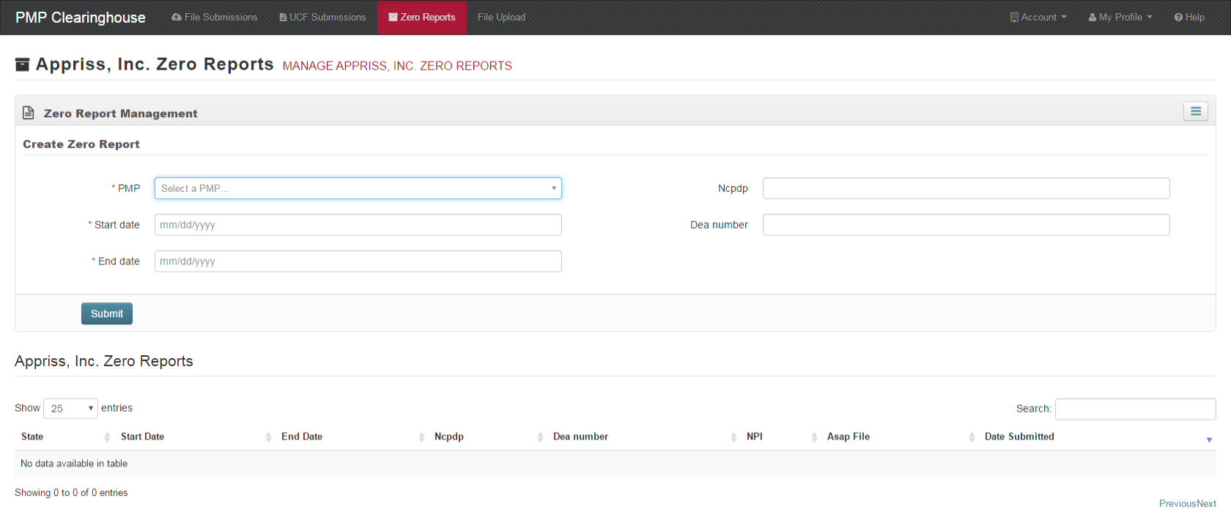
Zero Reports can also be submitted via sFTP using the ASAP Standard for Zero Reports. For additional details on this method, see Appendix C - ASAP Zero Report Specifications.

Data Compliance
Data Compliance allows users of PMP Clearinghouse to view the status of data files they have submitted.

File Listing - sFTP
The File Status screen displays information extracted from the data files submitted to PMP Clearinghouse. The screen displays the file name, the number of records identified within the data file, the number of records that contain warnings, the number of records that contain errors, and the date and time of submission. A status column is located at the end of each row displaying the status of the file. If there are errors, the status column will state “Pending Dispensation Error” and the text will be a hyperlink to the view records screen.

If a file is unable to be parsed into the Clearinghouse application, the appropriate message will display. A new file must be submitted to PMP Clearinghouse. It is not necessary to void a file that failed parsing since it was not successfully submitted to Clearinghouse.

If a file has been submitted by sFTP without using a state specific sub-folder, the file will be displayed and the user will be prompted to select a destination PMP for the data file to be transferred to.
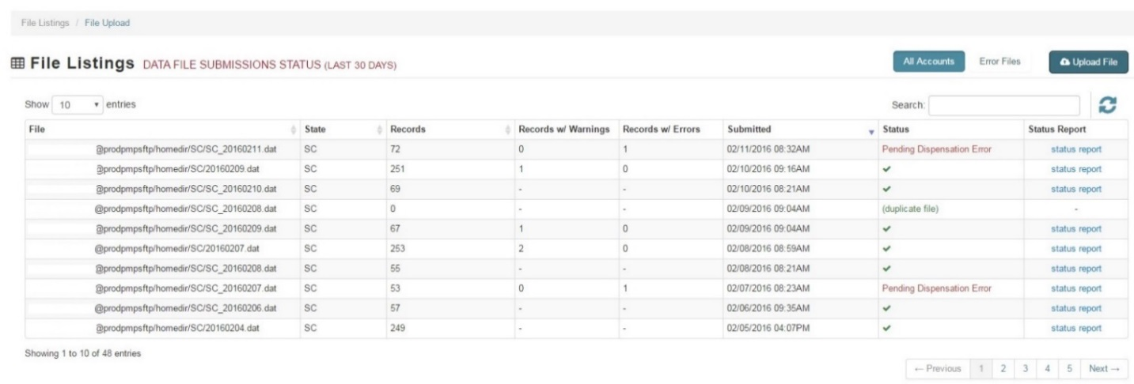

Claim Forms Listing - UCF
The Claim Forms Listing displays the UCF forms submitted to the PMP Clearinghouse. The screen displays number of warning and the number errors. A status column is located at the end of each row displaying the status of the file. If there are errors then the status column will state “Pending Dispensation Error” and the text will be a hyperlink to the view records screen.

View Records
The view records screen provides a deeper view of the records within a selected data file that need correcting. The screen displays Prescription Number, Segment Type, Warning Count, and Error Count. A “Correct” button is displayed at the end of each row that will allow the user to make corrections to the record.
To view the records that need correcting:
- Click on the “Pending Dispensation Error” hyperlink in the status column.
- The View Records screen is displayed.
- Click on the correct button at the end of the row for the record you want to correct.

Error Correction
The Error Correction screen allows a user to make corrections to data submitted that did not pass the validation rules. The screen displays all the fields contained within the record and the originally submitted value. A “Corrected Value” column displays the values the user enters to correct the error. The Message column displays the relevant error message for the field explaining why it did not pass the validation rules.
For files that failed to parse, the error identified is "best effort" and any information we could not parse is listed as "unparseable" in the file. A corrected file should be submitted.

To correct records:
- Identify the fields displayed that require corrections.
- Enter the new corrected value into the corrected value column.
- Click Submit.
- The error will be processed through the validation rules.
  - If the changes pass the validation rules, the record will be identified as valid and the File Status and View Records screen will be updated.
  - If the changes fail the validation rules, the record will continue to be identified as needing corrections. The error message will be updated to identify any new error message.
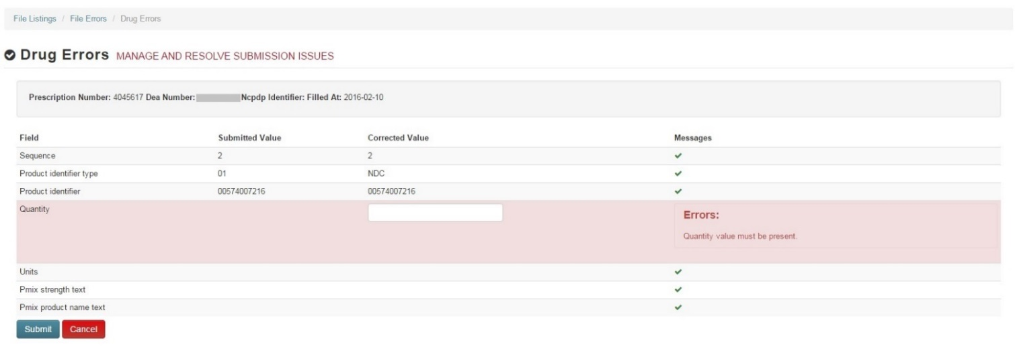

Error Correction in MassPAT
Pharmacists who are responsible for data submission for a pharmacy or pharmacies can request access to the Error Correction and Rx Maintenance features in their personal MassPAT account. These convenient features allow the pharmacist to view and correct records that have failed to parse and correct records that have been accepted into MassPAT but contain inaccuracies that need to be fixed. For more information contact the MA PMP at: mapmp.dph@MassMail.state.ma.us.

Email Reports
Email status reports will be automatically sent to the users associated with a data submitter account. The emailed reports are used to both identify errors in files that have been submitted and confirm a zero report submission. Please be sure that the primary email account in the User Profile will be monitored for communications from the Clearinghouse by the data submitter.

File Failed Report
The File Failed report identifies if the submitted file was not able to be parsed and was not processed into PMP Clearinghouse. The file contains a description of the error encountered within the file. In the event of a failed file, a new file should be submitted with the necessary corrections. Failed files are not parsed into Clearinghouse and do not require a Void ASAP file to remove it from the system. An example of a File Fail report is:

SUBJ: Massachusetts ASAP file: fake-test3.txt - Parse Failure

BODY:
Error Message
-----------------------------------------------------------------------------
Failed to decode the value '04' for the bean id 'transactionControlType'.

Summary:
* File Name: fake-test3.txt
* ASAP Version: 4.2
* Transaction Control Number: unparseable
* Transaction Control Type: unparseable
* Date of Submission: January 30, 2016

NOTE: This file could not be received into the system because the system could not recognize its content as a valid ASAP format. Action is required to resolve the issues and a subsequent file should be submitted. As such the information provided in this report is "best effort" and any information we could not parse is listed as "unparseable" in the fields above.

File Status Report
The File Status report is a report sent to notify the data submitter that a data file is currently being parsed by the state PMP system. The report notifies users of the following scenarios:
- Total Records: The total number of records contained in the submitted data file.
- Duplicate Records: The number of records that were identified as already existing within the PMP system. Duplicate records are not imported to prevent improper patient information.
- Records in Process: The number of records remaining to be processed into the system (usually only displays a number if the file has not finished loading at the time the report is sent out). Records remaining to be processed will continue to be processed even after the status report is sent.
- Records with Errors: Shows how many records contain errors. These errors will need to be corrected for the record to be imported into the system. If a zero (0) is displayed, there are no errors in the data.
- Records with Warnings: Shows how many records that contain warnings. These warnings do not need to be corrected for the record to be imported into the system. If a zero (0) is displayed, there are no warnings in the data.
- Records imported with warnings: Shows the number of records that were imported if they had warnings. Records with warning and errors must have the errors corrected to be submitted into the system.
- Records imported without warnings: Shows the number of records that were imported that had no warnings.
The initial report is sent out 2 hours after the file has been submitted to the system. Failure to correct the identified error(s) within the submitted data file after 7 days may result in notification to the Massachusetts Board of Registration in Pharmacy.
The report identifies specific records in the submitted data file and returns identifying information about the record and the specific error identified during the validation process. The report uses fixed width columns and contains a summary section after the error listings. Each column contains a blank 2 digit pad at the end of the data. The columns are set to the following lengths:
Column | Length
DEA | 11 (9+pad)
NCPDP | 9 (7+pad)
NPI | 12 (10+pad)
Prescription | 27 (25+pad)
Filled | 10 (8+pad)
Segment | 18 (16+pad)
Field | 18 (16+pad)
Type | 9 (7+pad)
Message | Arbitrary

An example of the report is:

SUBJ: Massachusetts ASAP file: fake-test3.txt - Status Report

BODY:
DEA NCPDP NPI Prescription Filled Segment Field Type Message
--------------------------------------------------------------------------------------------------------------------------------
BE1234567 1347347 9034618394 123486379596-0 20130808 Dispensation refill_number WARNING message example
DE9841394 3491849 4851947597 357199504833-345 20130808 Dispensation days_supply ERROR message example

Summary:
* File Name: fake-test3.txt
* ASAP Version: 4.2
* Transaction Control Number: 23489504823
* Transaction Control Type: send
* Date of Submission: January 30, 2016
* Total Record Count: ###
* Duplicate Records: ###
* Records in Process: ###
* Records with Errors: ###
* Records Imported with Warning(s): ###
* Records Imported without Warning(s): ###

Zero Report Confirmation
A Zero Report confirmation email is sent to a data submitter who successfully submits a zero report into PMP Clearinghouse. The report displays the PMP states the zero report was submitted to, the date range to be used in the zero report, the date the zero report was submitted to Clearinghouse, and the date the report was originally created by the data submitter. An example of the report is:

SUBJ: ASAP Zero Report: zero_reports_20160306KSMCPS.DAT

BODY:
Summary:
* File Name: zero_reports_20130301KSMCPS.DAT
* PMP Name: Mass
* Date Range: 2016-03-06 - 2016-03-06
* Submission Date: 2016-03-06
* Asap Creation Date: 2016-03-06

Password Management
Password management can be handled from within PMP Clearinghouse by the user. The user’s password will expire after 90 days. A user is able to proactively change their password before it expires within the application through their user profile. If a password has expired or if the user has forgotten the password, the user can use “Forgot your password” to change his password.

Changing Your Password
- When a user wants to change their current password, they navigate to their My Profile section.
- The user selects the navigation menu item for ‘Change Password’.
- The user must then enter their current password and enter a new password twice.
- The new password will take effect once the user has logged out of the application.
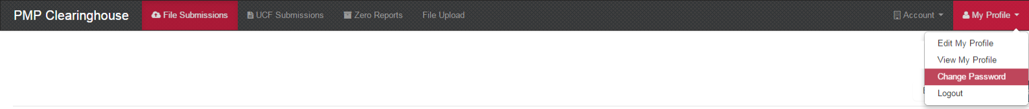

Forgot Your Password
- When a user has forgotten their password or their password has expired, the user should click on the link named “Forgot your password” located on the log in screen.
- The user must enter the email address they used to register with the application.
- The user will receive an email containing a link to reset the password for the user’s account.
- The user must enter the new password twice and then save the password.
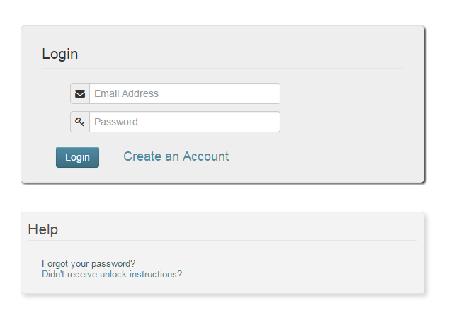

User Profile

Adding Users to Your Account
PMP Clearinghouse allows data submitters to add new users to the system that will have the same rights and access to submitting and viewing file status. This practice will allow a data submitter to create an account to be used for a backup individual.
- In “Account” in the menu bar, the user can select to add users under the section titled, “Users”.
- Click the “New User” button and enter the first name, last name, and email address for the new user.
- Once saved, the new user will be able to log into PMP Clearinghouse.
- The new user will use the email address used when creating their account.
- The new user must use the “Forgot your password” link to create a password for their account.
- The new user can now log in and view all data files that have been submitted under the account.
- Please be sure that the primary email account in the User Profile will be monitored for communications from the Clearinghouse by the data submitter.

Adding States to Your Account
If a registered user of PMP Clearinghouse needs to submit data files to an additional state using PMP AWAR_{X}E, the user can submit the request through their “Account” settings page.
    - Navigate to “Account” in the main menu and select “Multi State Approval” from the dropdown.
    - This page lists the current states the account has requested to submit data to and the current approval from that state.
    - To submit to a new state using PMP AWAR_{X}E, check the state on the list. This will send the data submission request to the desired state’s PMP Administrator for approval.
    - After approval has been granted, the status will change from “Pending” to “Approved”. The account may begin submitting data to the new state.
Note: If submitting by sFTP, data must be located in the proper sub-folder to ensure proper delivery to the desired state PMP.
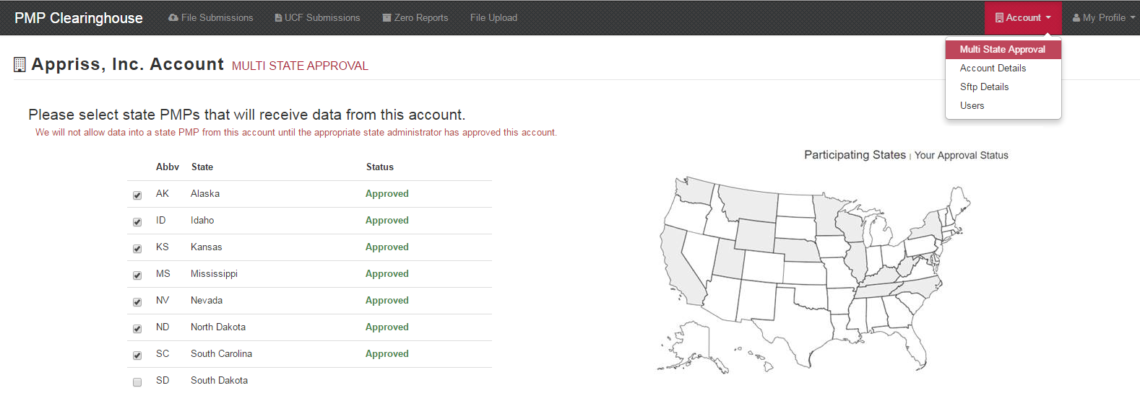

Adding sFTP to a Registered Account
If a registered account did not request a sFTP account during the registration process, a user of the account can request one in the “Account” options.
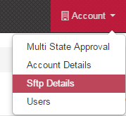
    - Navigate to the “Account” drop down menu and select sFTP Details.
    - Select the button to request a sFTP account.
Note: If an sFTP account already exists, the username will be displayed on this screen.
    - Enter the desired password for the sFTP account.
    - The sFTP username will be displayed on the screen after the sFTP account has been created.

Changing Administrator Account

If the Clearinghouse administrator account needs to be transferred from one user to another, contact the PMP Clearinghouse directly at 1-855-5MA-4PMP (1-855-562-4767).

Assistance and Support

Technical Assistance
If you need additional help with any of the procedures outlined in this guide, you can:
Contact Appriss at
1-855-5MA-4PMP (1-855-562-4767)
Technical assistance is available 24 hours, 7 days a week, 365 days a year.

Administrative Assistance
If you have non-technical questions regarding the MA PMP, please contact:
617-753-7310
mapmp.dph@MassMail.State.MA.US
http://www.mass.gov/dph/dcp/pmp

10 Appendix A - ASAP 4.2 Specifications
For additional details or examples please consult the Implementation Guide ASAP Standard For Prescription Monitoring Programs, Version 4 Release 2. This document is available from American Society for Automation in Pharmacy (www.asapnet.org) or phone (610) 825-7783.
The following table lists the required definitions for submitting ASAP 4.2 records to MA PMP. Please see Appendix B- Data Entry Guidance for more information.
The Requirement column uses the following codes:
- R = Required submission
- C = Conditional submission, please refer to notes
- O = Optional submission, please submit if available
Element ID | Element Name | Requirement | Notes
TH – Transaction Header - Required
To indicate the start of a transaction. It also assigns the segment terminator, data element separator, and control number.
TH01 | Version/Release Number  Code uniquely identifying the transaction.  Format = x.x | R
TH02 | Transaction Control Number  Sender assigned code uniquely identifying a transaction. | R
TH03 | Transaction Type  Identifies the purpose of initiating the transaction.  - 01 Send/Request Transaction  - 02 Acknowledgement (used in Response only)  - 03 Error Receiving (used in Response only)  - 04 Void (used to void a specific Rx in a real-time transmission or an entire batch that has been transmitted) | R
TH04 | Response ID  Contains the Transaction Control Number of a transaction that initiated the transaction. Required in response transaction only. | O
TH05 | Creation Date  Date the transaction was created. Format: CCYYMMDD. | R
TH06 | Creation Time  Time the transaction was created. Format: HHMMSS or HHMM. | R
TH07 | File Type  - P = Production  - T = Test | R
TH08 | Routing Number  Reserved for real-time transmissions that go through a network switch to indicate, if necessary, the specific state PMP the transaction should be routed to. | O
TH09 | Segment Terminator Character  This terminates the TH segment and sets the actual value of the data segment terminator for the entire transaction. | R
IS – Information Source – Required
To convey the name and identification numbers of the entity supplying the information.
IS01 | Unique Information Source ID  Reference number or identification number.  (Example: phone number) | R
IS02 | Information Source Entity Name  Entity name of the Information Source. | R
IS03 | Message  Free-form text message. | O
PHA – Pharmacy Header – Required
To identify the pharmacy or the dispensing prescriber.
PHA01 | National Provider Identifier (NPI)  Identifier assigned to the pharmacy by CMS. | O
PHA02 | NCPDP/NABP Provider ID  Identifier assigned to pharmacy by the National Council for Prescription Drug Programs. | R
PHA03 | DEA Number  Identifier assigned to the pharmacy by the Drug Enforcement Administration. | R | See Appendix B 10.13 for exception information.
PHA04 | Pharmacy Name  Freeform name of the pharmacy. | R
PHA05 | Address Information – 1  Freeform text for address information. | C | PHA05 – 07 are Required if the DEA in PHA02 cannot be verified in DEA database.
PHA06 | Address Information – 2  Freeform text for address information. | C
PHA07 | City Address  Freeform text for city name. | C
PHA08 | State Address  U.S. Postal Service state code. | R
PHA09 | ZIP Code Address  U.S. Postal Service ZIP Code. | O
PHA10 | Phone Number  Complete phone number including area code. Do not include hyphens. | R
PHA11 | Contact Name  Free-form name. | O
PHA12 | Chain Site ID  Store number assigned by the chain to the pharmacy location. This is used when PMP needs to identify the specific pharmacy from which information is required. | C | If the pharmacy has multiple locations, please submit the chain site ID (location ID).
PAT – Patient Information – Required
Used to report the patient’s name and basic information as contained in the pharmacy record.
PAT01 | ID Qualifier of Patient Identifier  Code identifying the jurisdiction that issues the ID in PAT02. | O
PAT02 | ID Qualifier  Code to identify the type of ID in PAT03. If PAT02 is used, PAT03 is required.  - 01 Military ID  - 02 State Issued ID  - 04 Permanent Resident Card (Green Card)  - 05 Passport ID  - 06 Driver’s License ID  - 08 Tribal ID  - 99 Other (agreed upon ID) | O | Please do not submit 03 Unique System ID or 07 Social Security Number.
PAT03 | ID of Patient  Identification number for the patient as indicated in PAT02. An example would be the driver’s license number. | O
PAT04 | ID Qualifier of Additional Patient Identifier  Code identifying the jurisdiction that issues the ID in PAT06. Used if the PMP requires such identification. | O
PAT05 | Additional Patient ID Qualifier  Code to identify the type of ID in PAT06 if the PMP requires a second identifier. If PAT05 is used, PAT06 is required.  - 01 Military ID  - 02 State Issued ID  - 04 Permanent Resident Card (Green Card)  - 05 Passport ID  - 06 Driver’s License ID  - 08 Tribal ID  - 99 Other (agreed upon ID) | O | Please do not submit 03 Unique System ID or 07 Social Security Number.
PAT06 | Additional ID  Identification that might be required by the PMP to further identify the individual. An example might be in that PAT03 driver’s license is required. | O
PAT07 | Last Name  Patient’s last name. | R
PAT08 | First Name  Patient’s first name. | R
PAT09 | Middle Name  Patient’s middle name or initial if available. | O
PAT10 | Name Prefix  Patient’s name prefix such as Mr. or Dr. | O
PAT11 | Name Suffix  Patient’s name suffix such as Jr. or the III. | O
PAT12 | Address Information – 1  Free-form text for street address information. | R
PAT13 | Address Information – 2  Free-form text for additional address information. | O
PAT14 | City Address  Free-form text for city name. | R
PAT15 | State Address  U.S. Postal Service state code  Note: Field has been sized to handle international patients not residing in the U.S. | R
PAT16 | ZIP Code Address  U.S. Postal Service ZIP code.  Populate with zeros if patient address is outside the U.S. | R
PAT17 | Phone Number  Complete phone number including area code. Do not include hyphens. For situations in which the patient does not have a phone number, submit ten 9’s. | R
PAT18 | Date of Birth  Date patient was born.  Format: CCYYMMDD. | R
PAT19 | Gender Code  Code indicating the sex of the patient.  - F Female  - M Male  - U Unknown | R
PAT20 | Species Code  Used if required by the PMP to differentiate a prescription for an individual from one prescribed for an animal.  - 01 Human  - 02 Veterinary Patient | R
PAT21 | Patient Location Code  Code indicating where patient is located when receiving pharmacy services.  - 01 Home  - 02 Intermediary Care  - 03 Nursing Home  - 04 Long-Term/Extended Care  - 05 Rest Home  - 06 Boarding Home  - 07 Skilled-Care Facility  - 08 Sub-Acute Care Facility  - 09 Acute Care Facility  - 10 Outpatient  - 11 Hospice  - 98 Unknown  - 99 Other | R
PAT22 | Country of Non-U.S. Resident  Used when the patient’s address is a foreign country and PAT12 through PAT16 are left blank. | C | If the patient is not a U.S. Resident, please submit.
PAT23 | Name of Animal  Used if required by the PMP for prescriptions written by a veterinarian and the pharmacist has access to this information at the time of dispensing the prescription. | C | If PAT20 = 02 (veterinary patient), please submit the name of the animal.
DSP – Dispensing Record – Required
To identify the basic components of a dispensing of a given prescription order including the date and quantity.
DSP01 | Reporting Status  DSP01 requires one of the following codes, and an empty or blank field no longer indicates a new prescription transaction:  - 00 New Record (indicates a new prescription dispensing transaction)  - 01 Revise (indicates that one or more data element values in a previously submitted transaction are being revised)  - 02 Void (message to the PMP to remove the original prescription transaction from its data, or to mark the record as invalid or to be ignored). | R
DSP02 | Prescription Number  Serial number assigned to the prescription by the pharmacy. | R
DSP03 | Date Written  Date the prescription was written (authorized). Format: CCYYMMDD | R
DSP04 | Refills Authorized  The number of refills authorized by the prescriber. | R
DSP05 | Date Filled  Date prescription was filled. Format: CCYYMMDD | R
DSP06 | Refill Number  Number of the fill of the prescription.  0 indicates New Rx; 01-99 is the refill number. | R
DSP07 | Product ID Qualifier  Used to identify the type of product ID contained in DSP08.  - 01 NDC  - 06 Compound | R
DSP08 | Product ID  Full product identification as indicated in DSP07, including leading zeros without punctuation. If Compound is indicated in DSP07 then use 99999 as the first 5 characters; CDI then becomes required. | R
DSP09 | Quantity Dispensed  Number of metric units dispensed in metric decimal format. Example: 2.5  Note: For compounds show the first quantity in CDI04. | R
DSP10 | Days Supply  Estimated number of days the medication will last. | R
DSP11 | Drug Dosage Units Code  Identifies the unit of measure for the quantity dispensed in DSP09.  - 01 Each  - 02 Milliliters (ml)  - 03 Grams (gm) | R
DSP12 | Transmission Form of Rx Origin Code  Code indicating how the pharmacy received the prescription.  - 01 Written Prescription  - 02 Telephone Prescription  - 03 Telephone Emergency Prescription  - 04 Fax Prescription  - 05 Electronic Prescription  - 99 Other | R
DSP13 | Partial Fill Indicator  To indicate whether it is a partial fill.  - 00 Not a partial fill  - 01 First partial fill  Note: For additional fills per prescription, increment by 1. So the second partial fill would be reported as 02, up to a maximum of 99. | R
DSP14 | Pharmacist National Provider Identifier (NPI)  Identifier assigned to the pharmacist by CMS. This number can be used to identify the pharmacist dispensing the medication. | O
DSP15 | Pharmacist State License Number  This data element can be used to identify the pharmacist dispensing the medication.  Assigned to the pharmacist by the State Licensing Board. | O
DSP16 | Classification Code for Payment Type  Code identifying the type of payment, i.e. how it was paid for.  - 01 Private Pay (cash, check, credit, debit)  - 02 Medicaid  - 03 Medicare  - 04 Commercial Insurance  - 05 Military Installations and VA  - 06 Workers’ Compensation  - 07 Indian Nations  - 99 Other | R
DSP17 | Date Sold  Usage of this field depends on the pharmacy having a point-of-sale system that is integrated with the pharmacy management system to allow a bidirectional flow of information. | O
DSP18 | RxNorm Code Qualifier  RXNorm Code that is populated in the DRU-010-09 field in the SCRIPT transaction.  - 01 Sematic Clinical Drug (SCD)  - 02 Semantic Branded Drug (SBD)  - 03 Generic Package (GPCK)  - 04 Branded Package (BPCK) | O | If DSP12 = 05 (electronic), then please provide DSP18-21.
DSP19 | RxNorm Code  Used for electronic prescriptions to capture the prescribed drug product identification. | O
DSP20 | Electronic Prescription Reference Number  This field should be populated with the Initiator Reference Number from field UIB-030-01 in the SCRIPT transaction. | O
DSP21 | Electronic Prescription Order Number  This field will be populated with the Initiator Control Reference from field UIH-030-01 in the SCRIPT standard. | O
PRE – Prescriber Information – Required
To identify the prescriber of the prescription.
PRE01 | National Provider Identifier (NPI)  Identifier assigned to the prescriber by CMS. | R | See Appendix B 10.13 for guidance on veterinarians
PRE02 | DEA Number  Identifying number assigned to a prescriber or a facility by the Drug Enforcement Administration (DEA). | C | Required for all Schedule II-V prescriptions. Required for Schedule VI prescriptions when the prescriber has a DEA number.  Please see Appendix B for information on xDEA numbers.
PRE03 | DEA Number Suffix  Identifying number assigned to a prescriber by an institution when the institution’s number is used as the DEA number. | O
PRE04 | Prescriber State License Number  Identification assigned to the Prescriber by the State Licensing Board. | O
PRE05 | Last Name  Prescriber’s last name. | O
PRE06 | First Name  Prescriber’s first name. | O
PRE07 | Middle Name  Prescriber’s middle name or initial. | O
PRE08 | Phone Number  Complete phone number including area code. Do not include hyphens. | O
CDI – Compound Drug Ingredient Detail – Conditional
To identify the individual ingredients that make up a compound.
CDI01 | Compound Drug Ingredient Sequence Number  First reportable ingredient is 1; each additional reportable Ingredient is increment by 1. | C | If DSP07 = 06 (compound), then all elements of CDI segment are Required.
CDI02 | Product ID Qualifier  Code to identify the type of product ID contained in CDI03.  - 01 NDC | C
CDI03 | Product ID  Full product identification as indicated in CDI02, including leading zeros without punctuation. | C
CDI04 | Compound Ingredient Quantity  Metric decimal quantity of the ingredient identified in CDI03.  - Example: 2.5 | C
CDI05 | Compound Drug Dosage Units Code  Identifies the unit of measure for the quantity dispensed in CDI04.  - 01 Each (used to report as package)  - 02 Milliliters (ml) (for liters; adjust to the decimal milliliter equivalent)  - 03 Grams (gm) (for milligrams; adjust to the decimal gram equivalent) | C
AIR – Additional Information Reporting - Required
To report other information if required by the state.
AIR01 | State Issuing Rx Serial Number  U.S.P.S. state code of state that issued serialized prescription blank. | C | This is required if AIR02 is used.
AIR02 | State Issued Rx Serial Number  - Number assigned to state issued serialized prescription blank. | O
AIR03 | Issuing Jurisdiction  Code identifying the jurisdiction that issues the ID in AIR04. Used if required by the PMP and AIR04 is equal to 02 or 06. | C | Please note that the code for “Other” in the List of Jurisdictions is now “99”.  For exceptions to AIR03, AIR04, and AIR05 please see Appendix B.
AIR04 | ID Qualifier of Picking Up Rx  Used to identify the type of ID contained in AIR05 for person picking up the prescription.  - 01 Military ID  - 02 State Issued ID  - 04 Permanent Resident Card (Green Card)  - 05 Passport ID  - 06 Driver’s License ID  - 08 Tribal ID  - 99 Other (agreed upon ID) | C | Please do not submit 03 Unique System ID or 07 Social Security Number.
AIR05 | ID of Person Picking Up Rx  ID number of patient or person picking up the prescription. | C | For exceptions, please see 10.1. For deliveries, please see 10.3.
AIR06 | Relationship of Person Picking Up Rx  Code indicating the relationship of the person.  - 01 Patient  - 99 Other | R
AIR07 | Last Name of Person Picking Up Rx  - Last name of person picking up the prescription. | C | If the person picking up the RX is not the patient (AIR06 = 99) please submit.
AIR08 | First Name of Person Picking Up Rx  - First name of person picking up the prescription. | C
AIR09 | Last Name or Initials of Pharmacist  Last name or initials of pharmacist dispensing the medication. | O
AIR10 | First Name of Pharmacist  First name of pharmacist dispensing the medication. | O
AIR11 | Picking Up Identifier Qualifier  Additional qualifier for the ID contained in AIR05  - 02 Person Picking Up  - 03 Unknown/Not Applicable | R | MA requires that the Customer ID be collected and entered into the pharmacy management system at pick-up. Please do not submit 01 (person dropping off).
TP – Pharmacy Trailer – Required
To identify the end of the data for a given pharmacy and to provide a count of the total number of detail segments included for the pharmacy.
TP01 | Detail Segment Count  Number of detail segments included for the pharmacy including the pharmacy header (PHA) including the pharmacy trailer (TP) segments. | R
TT – Transaction Trailer – Required
To identify the end of the transaction and to provide the count of the total number of segments included in the transaction.
TT01 | Transaction Control Number  Identifying control number that must be unique.  Assigned by the originator of the transaction.  Must match the number in TH02. | R
TT02 | Segment Count  - Total number of segments included in the transaction including the header and trailer segments. | R

Appendix B - Data Entry Guidance
This section is designed to address those fields that may require extra guidance for proper data entry.
Please note: The names used for data fields in this section may differ from the labels assigned by software providers programming pharmacy systems.
The comprehensive list of specific data elements that pharmacies are required to collect and submit to the MA PMP is listed in Appendix A of this document.
Pharmacies and pharmacy corporations are advised to consult their software providers regarding the alphanumeric code values, dropdown list choices, and terminology to use for data entry screens.

10.1 AIR03, AIR04, AIR05: ID of Person Picking up Prescription (i.e. Customer ID)
The pharmacy is required to obtain and submit to the MA PMP the information from the customer’s government issued ID for all federally controlled Schedule II-V drugs and Gabapentin (Schedule VI), including refill prescriptions for these medications. The pharmacy is required to check that the photo ID matches the customer taking possession of the prescription and that the ID is valid and not out of date. Obtaining and reporting the customer ID is mandatory except in the limited circumstances described below in Section 10.2.
The customer and patient may or may not be the same person. For example, the customer may be a parent picking up a prescription for a child, a relative picking up a prescription for a housebound family member, or the customer may be a pet owner.
Important Note: A previously stored ID should never be automatically entered. With each new prescription, the pharmacy must inspect and data enter the specific valid ID information of the customer who receives the filled prescription. A Social Security Number is not an acceptable form of Customer ID and therefore should not be submitted.

Currently acceptable forms of customer ID are:
- Military ID
- State Issued ID
  - Motor Vehicles Identification
- Permanent Resident Card (Green Card)
- Passport ID
- Driver’s License ID
- Tribal ID
- Other (agreed upon ID)
  - MA Commission for the Blind Identification Card

The customer ID field must contain only the alphanumeric characters of the ID number that has been issued by the governmental agency. Do not add punctuation marks (e.g., dashes, question marks) or additional information (e.g., MA, NO CHECKS, MOTHER, LIC#, NH LIC, or any text other than the ID number itself).
For Massachusetts Registry of Motor Vehicles license numbers that begin with the letter “S”, please be careful when entering the “S.” Transcription errors have caused the “S” to be mistakenly entered as a “3,” “5,” or an “8”.
For Permanent Resident Card ID numbers, enter the Alien number. Include the leading letter “A” as part of the number if it is printed as part of or preprinted in front of the Alien number. Permanent Resident Cards are typically composed of nine characters. However, some have been issued with eight characters and some with ten characters. Enter the exact number as it appears on the card.

10.2 Exceptions to AIR03, AIR04 & AIR05 ID of Person Picking Up Rx (i.e. Customer ID)

The exceptions to the collecting and reporting requirements for customer ID information are:
- On a case-by-case basis, a pharmacist is permitted to dispense a controlled substance in Schedules II through V and Gabapentin without obtaining positive ID provided that:

- The pharmacist has reason to believe that the failure to dispense the Schedule II-V substance or Gabapentin at this time would result in a serious hardship for the ultimate user or agent of the ultimate user; and
- The pharmacist documents the reason; and
- The ultimate user or agent of the ultimate user prints his or her name and address on the reverse side of the prescription and signs his or her name thereto or in the case of an electronic prescription, provides an electronic signature; and
- The pharmacist enters “cust signed rx” in the customer ID field (AIR05) rather than leaving the field blank.

- MA DPH does not require the collection of customer ID requirement for deliveries under the circumstance described below. The term “delivery” should be entered in the customer ID field.

10.3 Deliveries
When a pharmacy delivers in person or through a common carrier to a private residence or to a facility where the patient is located, MA PMP does not require the pharmacy to collect and report a customer ID. The pharmacy will use its internal procedures for tracking deliveries.
When submitting data utilizing the “deliveries exception,” pharmacies should populate the relevant ASAP fields as follows:
- PAT21 [Patient Location Code] – The pharmacist should use his/her professional judgment to determine which of the available ASAP location codes applies. Be as accurate as possible in selecting the code. Do not leave the field blank.
- AIR03 [Issuing Jurisdiction of the Customer ID] – Leave blank.
- AIR04 [ID Qualifier] – Leave blank.
- AIR05 [Customer ID] - Enter “delivery”
- AIR06 [Relationship of the customer to the patient] – Enter ‘99’.
- AIR11 [Picking Up Identifier Qualifier] – Enter 03
However, if an individual delivers a written prescription or prescription container for dispensing and subsequent delivery to the patient, the pharmacy is required to collect and report the customer ID information of the individual to MA PMP.

10.4 AIR03- Jurisdiction Issuing Customer ID
The AIR03 field is used to identify the jurisdiction issuing the customer ID. For example, “MA” will be entered into this field to indicate a Massachusetts issued ID, or “US” will be entered to indicate a federally issued ID. Pharmacy software providers should distribute the full list of the approved ASAP jurisdiction codes for states, Canadian provinces, and other jurisdictions. When the specific jurisdiction is not on the list (for example, most foreign countries are not listed) use the code “99” for “Other”.

10.5 AIR04- ID Qualifier of Person Picking Up Prescription
The AIR04 field identifies the type of identification the individual delivering or receiving the prescription presents to the pharmacy. Use code “99” to indicate “other” for the MA Commission for the Blind ID, since ASAP 4.2 does not provide a more specific code.

10.6 AIR06- Customer’s Relationship to Patient
The MA PMP does not require the pharmacist to choose from all of the available ASAP relationship codes. Just enter “01” if the customer is the patient, or enter “99” if the customer is not the patient.

10.7 DSP06 ─ Refill Number
An original prescription is a prescription that upon dispensing is issued/assigned a new prescription number by the dispensing pharmacy. Prescriptions that constitute continuation of drug therapy and that are issued/assigned a new prescription number are original prescriptions. The code for an original prescription is “0,” zero.
Refills of prescriptions are those prescriptions dispensed in accordance with the refill indication on a prescription having a previously issued/assigned prescription number. The codes indicating the refill number correspond to that dispensing, e.g. ‘01’ for first refill, ‘02’ for second refill, etc. PRN is not an acceptable code to indicate a refill.
Partial fills are entered in DSP13.

10.8 Electronic Prescriptions -DSP18-21
DSP18-21 are the fields that must be populated from the NCPDP script transmission for electronic prescriptions. It is anticipated that the pharmacy software will be constructed such that these fields will be automatically populated behind the scenes without the pharmacy personnel performing the data entry. For electronic prescriptions, DSP12 (Transmission Form of Rx Origin Code) must be coded as “05.”
When any of this information comes across in the NCPDP SCRIPT transmission from the prescriber, the pharmacy software needs to insert the information into the respective data elements for the data submission to the MA PMP. The electronic prescription fields are:
- DSP18 RxNorm Qualifier: (See the comment to DSP19 below.)
- DSP19 RxNorm: ASAP 4.2 specifies that DSP18 and DSP19 should not be required until RxNorm becomes an industry standard. Therefore, until greater than 50% of the electronic prescriptions begin coming across in the NCPDP feed as actual RxNorm values, the MA PMP is permitting pharmacies to either omit or include DSP18 and DSP19 values. When greater than 50% of the NCPDP feeds begin coming across as actual RxNorm values, pharmacies must populate those fields.

10.9 PAT22 ─ Country of Non-U.S. Resident
If the patient does not have a US address enter the country name in PAT22. If the patient has a U.S. address, leave this field blank. If your pharmacy software is set up for you to enter non-U.S. country information in a different address field that is submitted to the MA PMP (for example in the zip code field), it is permissible to continue using that field instead.

10.10 PRE02 – Prescriber DEA Number (Including DEA "X" Numbers)
The pharmacy is required to submit the prescriber’s personal DEA number, if the prescriber has a DEA number. There are only a few prescribers of Gabapentin (Schedule VI) that do not have a DEA number. For guidance on how to report these please see Section 10.13.
For prescription drug products containing buprenorphine, when both the physician’s primary DEA number and the DATA 2000 waiver ID (“X”) number appear on the prescription, the MA PMP requires the “X” number to be submitted to the MA PMP rather than the physician’s primary DEA number.

10.11 Guidance on Metric Quantity Reporting
Accurate reporting of metric quantities is essential for providers who review patient records and MA PMP staff who perform data analyses. To aid in accurate and consistent reporting of metric quantities, the following guidance has been developed using information from the commercial databases most frequently used in pharmacy data entry:
- Use “each” when referring to the following dosage forms: capsule, diaphragm, disc, patch, plaster, suppository, suture, tablet, troche, and wafer.
- Use “mL” when referring to the following dosage forms: aerosol liquids (note: some formulations are powders, use “gm”), elixirs, emulsions, extracts, mouthwash, oils, shampoos, liquid soaps, solutions, sprays, suspensions, syrups, tinctures.
Example: For 1 package of 10 morphine sulfate syringes, each syringe containing 2 mL of 10 mg/mL morphine, the total volume dispensed is 20 mL and the metric quantity reported will be “20.”
- Use “gm” when referring to the following dosage forms: aerosol powders (note: some formulations are liquids, use “mL”), creams, crystals, gels, jellies, granules, ointments, powders.
In cases where NCPDP Billing Unit standard offers specific guidance on particular product formulations, the MA PMP will accept such guidance as an acceptable basis of metric quantity calculation and will not consider it to be a conflict with the ASAP or the instructions above.

10.12 Reporting Compounded Prescriptions
Enter code “06” in DSP07. In the DSP08 field where the National Drug Code [NDC] number is normally entered for the prescription, the pharmacy will either enter (a) the number “9” eleven times i.e.,“99999999999” or (b) an in house assigned eleven character compound code, provided the first five characters are nines. Also, enter code “06” in DSP07. The specific NDC number, the metric quantity and the unit of measure (gm, mL, or each) of each reportable ingredient must also be submitted to the MA PMP. Pharmacies and pharmacy corporations are advised to consult with their software providers for guidance on how to enter this data.

10.13 Reporting Gabapentin Prescriptions
Typically records submitted to the MA PMP require a dispenser/pharmacy DEA and prescriber DEA. Gabapentin is a Schedule VI drug and as such may be obtained from prescribers or dispensers that do not have a DEA registration and from veterinarians who have neither a DEA registration nor NPI. Refer to these scenarios below for guidance.
Scenario 1: A pharmacy that does not dispense Sch. II-V controlled substances but does dispense gabapentin. The pharmacy does not have DEA number but does have an NPI number.
Guideline: Leave the dispenser/pharmacy DEA number section blank. Input the dispenser/pharmacy NPI number in the appropriate data submission field.
Scenario 2: Prescriber does not prescribe Sch. II-V controlled substances but does prescribe gabapentin. Prescriber does not have a DEA number.
Guideline: Leave the prescriber DEA number field blank and input the prescriber NPI number in the appropriate data submission field.
Scenario 3: Prescriber is a veterinarian who does not prescribe drugs in Schedules II – V, but does prescribe gabapentin. Because CMS will not issue an NPI to a veterinarian, the prescriber does not have an NPI.
Guideline: Leave the prescriber DEA number field blank and insert “1234567893” in the prescriber NPI field and “02” in the species code field.

Appendix C - ASAP Zero Report Specifications

The following information table contains the required definitions for submitting Zero Reports via sFTP or manual upload to MA PMP. The table below lists the Segment and Element ID with prepopulated data to be used as an example for constructing a Zero Report. For more details regarding these Segment or Elements IDs or for the purposes of reporting actual dispensations please refer to the previous section, Appendix B – ASAP 4.2 Specifications
Element ID | Element Name | Requirement
TH – Transaction Header - Required
TH01 | 4.2 | R
TH02 | 123456 | R
TH05 | 20150101 | R
TH06 | 223000 | R
TH07 | P | R
TH09 | \\ | R
IS – Information Source – Required
IS01 | 6175555555 | R
IS02 | PHARMACY NAME | R
IS03 | #20160101#-#20160107# | O
PHA – Pharmacy Header – Required
PHA03 | ZZ1234567 | R
PAT – Patient Information – Required
PAT07 | REPORT | R
PAT08 | ZERO | R
DSP – Dispensing Record – Required
DSP05 | 20150101 | R
PRE – Prescriber Information
CDI – Compound Drug Ingredient Detail
AIR – Additional Information Reporting
TP – Pharmacy Trailer – Required
TP01 | 7 | R
TT – Transaction Trailer – Required
TT01 | 123456 | R
TT02 | 10 | R

The following is an example, using the above values, of how a Zero Report would look.

TH*4.2*123456*01**20160107*223000*P**\\
IS*9075555555*PHARMACY NAME*#20160101#-#20160107#\
PHA*** ZZ1234567\
PAT*******REPORT*ZERO************\
DSP*****20160107******\
PRE*\
CDI*\
AIR*\
TP*7\
TT*1234

Appendix D – sFTP Configuration
If submitting data via sFTP, a Clearinghouse account with sFTP access needs to already exist.
See Creating Your Account to register with PMP Clearinghouse.
See Adding sFTP to a Registered Account to add sFTP access to an existing PMP Clearinghouse account.

sFTP Connection Details:
Hostname: sftp.pmpclearinghouse.net
It is recommended to use the hostname when configuring the connection rather than the IP Address as the IP Address is subject to change.
Port: 22
The port will always be 22
Credentials – Account credentials (username and password) can be found within the PMP Clearinghouse website. Login to PMP Clearinghouse > click Account > sFTP Details > Edit
The username cannot be modified, however, the password can be updated. The current sFTP password cannot be seen or recovered. If it is unknown/lost the user will need to create a new one.
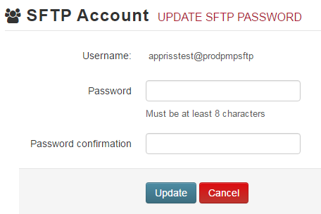
Users can test the sFTP connection but will not be able to submit data to a PMP until their account has been approved by the state administrator.

State Subfolders
PMP Clearinghouse is the data repository for several states. As such, data submitted via sFTP must be placed in a state abbreviated folder so that it can be properly imported to the correct state. The creation of subfolders must be done outside of the PMP Clearinghouse website using 3rd party software such as a SSH Client or a command line utility. Files placed in the root/home directory of the sFTP server will not be imported. This will cause the dispensing entity to appear as non-compliant/delinquent.
The following are two methods by which to create state subfolders for sFTP submissions.
- Via SSH client (ex: WinSCP/FileZilla)
    - Log into sFTP Account and create the directories needed under /homedir.
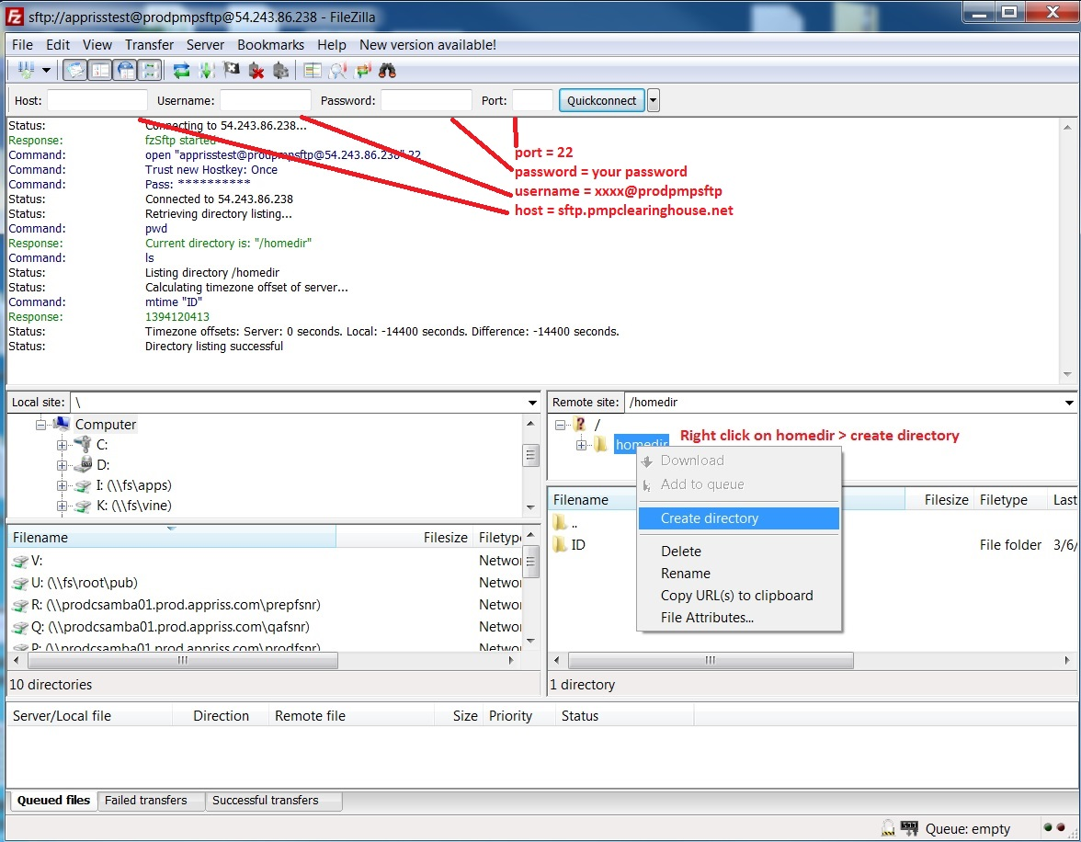
- Via command prompt
- Log into sFTP Account using command prompt. Once logged in, type:
“mkdir” (then the directory name you wish to create)
Example: mkdir KS
NOTE: The state folder must be titled as above, with the two-letter Abbreviation.
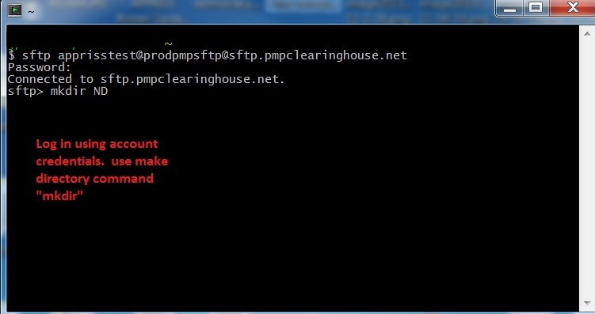
Pharmacy software will need to be configured to place files in the appropriate state folder when submitting. The software vendor may need to be contacted for additional assistance on this process. NOTE: Capitalization of the abbreviated state folders names have no bearing on whether or not Clearinghouse processes the files, however, some pharmacy systems, especially *nix based systems, will require the exact case be used when specifying the target folder.

Public (SSH/RSA) Key Authentication
SSH key authentication is supported by PMP Clearinghouse. The generation of the key is outside the scope of this document, however, general guidelines about the key along with how to import/load the key is provided.

*PGP Encryption is not supported

Supported Key Types:
  - SSH-2 RSA 2048 bit length

Unsupported Key Types:
  - SSH-1 RSA and SSH-2 DSA keys are not supported.

Correct Public Key Format – If opened in a text editor, key should look like the following:
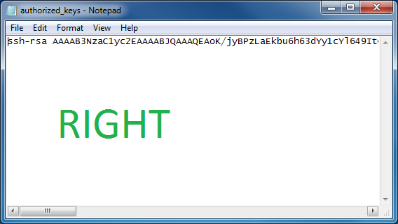

Incorrect Public Key Format – If opened in a text editor, key SHOULD NOT look like the following:
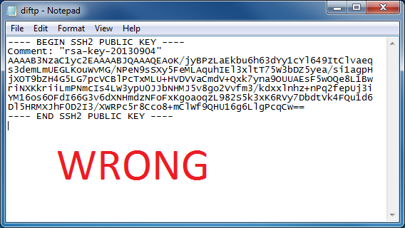

Once the key has been generated it should be named “authorized_keys”
NOTE: There is no file extension and an underscore between the words authorized and keys.

A .ssh subfolder needs to be created in the home directory of the of the sFTP account. The “authorized_keys” file must be placed in the .ssh folder. The creation of this folder follows the same process as creating a state subfolder. Refer to the State Subfolders section for steps on creating subfolders.

Appendix E – Data Submission Waivers
The MA PMP has three types of Data Submission Waivers available to pharmacies to waive them of their requirement to report to the PMP. These waivers are available on the Pharmacy Reporting and Data Submission section of the MA PMP website and must be returned via email to mapmp.dph@State.MA.US.

Annual Data Submission Waiver
Pharmacies that do not dispense Controlled Substances in Schedules II-V, Gabapentin, or any additional drugs that the Department has determined must be reported to the PMP, may complete an Annual Reporting Waiver Request Form to request a waiver of the requirement that pharmacies must report to the PMP. If a pharmacy receiving this waiver nevertheless dispenses from Schedules II-V or any additional drug required for submission to the PMP by the Department, the waiver will not apply to such activity. The pharmacy will be required to report such dispensing to the PMP.

Days of Operation Waiver
Pharmacies that are not open 7 days a week to dispense Controlled Substances in Schedules II-V, Gabapentin, or any additional drugs that the Department has determined must be reported to the PMP, may complete a Days of Operation Waiver Request Form to waive the requirement that pharmacies must report to the PMP every day.

Temporary Waiver
Pharmacies that experience unforeseen circumstances preventing them from submitting to the PMP for an extended period of time can submit a Temporary Pharmacy Waiver Request Form from daily submissions.

