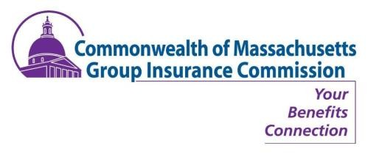
GROUP INSURANCE COMMISSION (GIC),
PUBLIC HEARINGS - 2018

GIC Public Hearings
Based on feedback we heard last year, please join the GIC for a series of public hearings.
Our goal for the sessions is to collect your feedback in advance of our official decision making.
Please be sure to RSVP to secure your attendance.
RSVP (required) to: gic.events@massmail.state.ma.us
JANUARY 2018
FRIDAY, JANUARY 19 | THURSDAY, JANUARY 25
3:00 – 4:30 PM  WORCESTER | CENTRAL  Worcester State University  May Street Building, Banquet Hall  260 May Street  Worcester, MA 01602  Parking: Lot D – May Street; Lot Q – Chandler Street Lot | 11:30 AM – 1:00 PM  BOSTON | EAST  Charles Hurley Building  Minihan Hall  19 Staniford Street, 6th Floor  Boston, MA 02114
MONDAY, JANUARY 22 | THURSDAY, JANUARY 25
10:00 – 11:30 AM  SPRINGFIELD| SOUTHWEST  Springfield State Office Building  Conference Room, B42  436 Dwight Street  Springfield, MA 01103  Parking: Metered street parking around state building | 5:00 – 6:30 PM  LOWELL |NORTHEAST  UMass Lowell  O’Leary Library*, Room 222 (South Campus)  61 Wilder Street  Lowell, MA 01854  Parking: Wilder Lot/Visitor Metered Parking Lot
TUESDAY, JANUARY 23 | FRIDAY, JANUARY 26
4:30 – 6:00 PM  GREENFIELD | NORTHWEST  Greenfield Middle School  Auditorium  195 Federal Street, STE 100  Greenfield, MA 01301  Parking: open lots around school | 10:00 – 11:30 AM  DARTMOUTH | SOUTHEAST  UMass Dartmouth  Woodland Commons, Conference Room #1-3  285 Old Westport Road  North Dartmouth, MA 02747  Parking: Lot #7 | 2:30 – 4:00 PM  CAPE & ISLANDS | SOUTHEAST  Hyannis Youth & Community Center  Shepley Community Room  141 Bassett Lane  Hyannis, MA 02601
WEDNESDAY, JANUARY 24 | MONDAY, JANUARY 29
10:00 – 11:30 AM  PITTSFIELD | WEST  Berkshire Athenaeum: Pittsfield’s Public Library  Library Auditorium, Basement  One Wendell Avenue  Pittsfield, MA 01201  Parking: Limited parking in lot; street parking | 12:00 – 1:30 PM  BOSTON | EAST  Charles Hurley Building  Minihan Hall  19 Staniford Street, 6th Floor  Boston, MA 02114
Check for updated event information: mass.gov/gic-news-and-announcements
If you need a reasonable accommodation to attend or participate in these events
please email your request to the GIC’s ADA Coordinator, GIC.ADA.Requests@MassMail.State.MA.US, no later than 1/12/18.
(An accommodation will not be assured if a request is not made in a timely manner.)

