BRC Manager – Agency Users Guide

Step 1 – Create an EEC Single Sign In Account (if you already have an EEC Single Sign In Account, skip to Step 2)

- Go to the following link:
https://www.eec.state.ma.us/SSI_V2/ProfileSetup/LoginUN.aspx

- Click on “Do not have an EEC SSI account? Enroll here”.

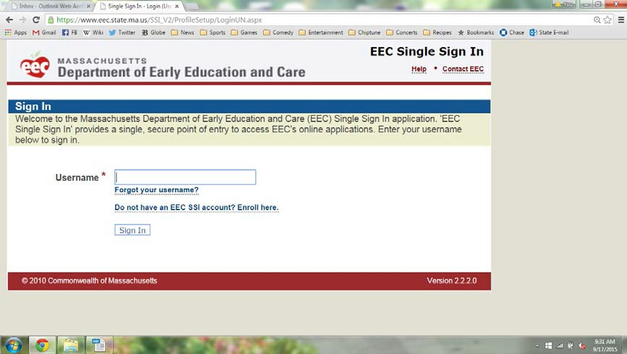

- Create a Username and Password.

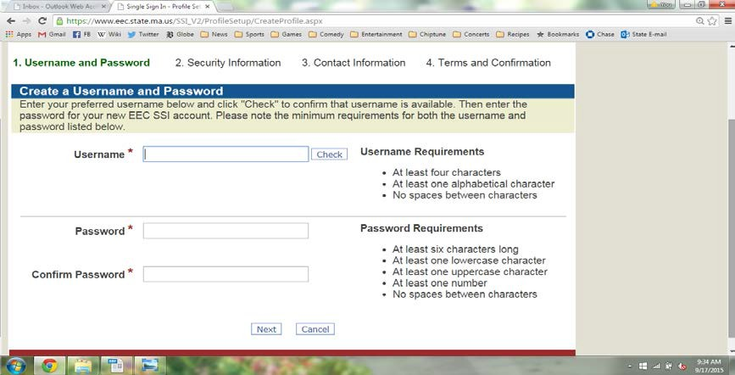

- Complete security information.

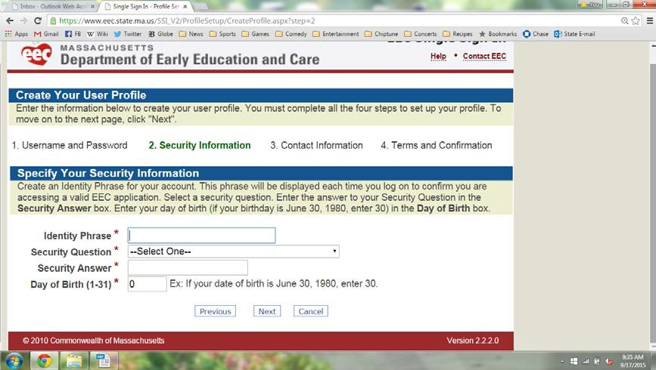

- Complete the contact information screen and accept the terms of use on the next screen.

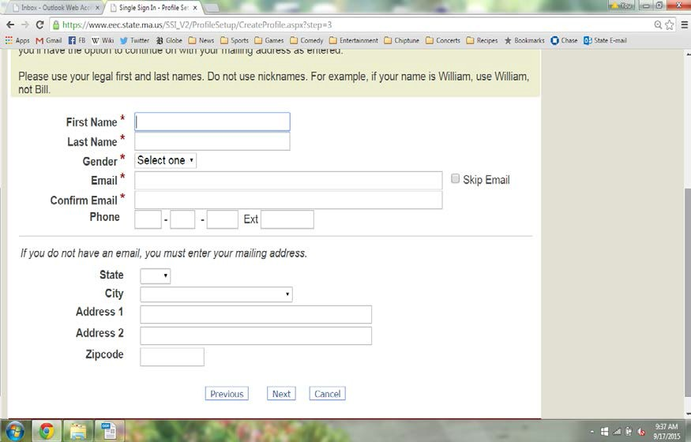

Step 2 – Add BRC Manager as an Application and Register
- If you already have access to and are registered to use BRC Manager as a Licensee Provider or CCR&R, you will need to create a new EEC Single Sign In Account for BRC Manager and register as an Agency.

If you already have access to and are registered to use BRC Manager as an Agency, skip to Step 3)

          - Select “Background Record Check (BRC) Manager” from the list of EEC Applications.

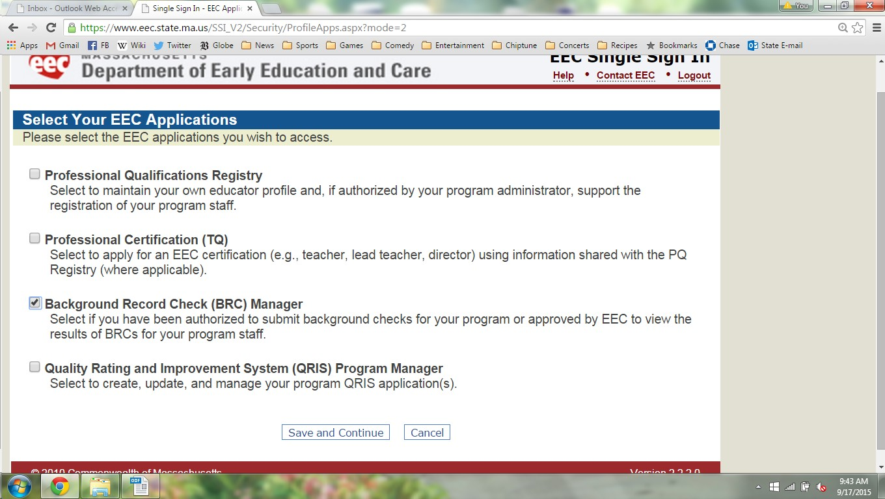

          - Once added, click on the "Background Record Check (BRC) Manager" link. This will
bring you to BRC Manager.
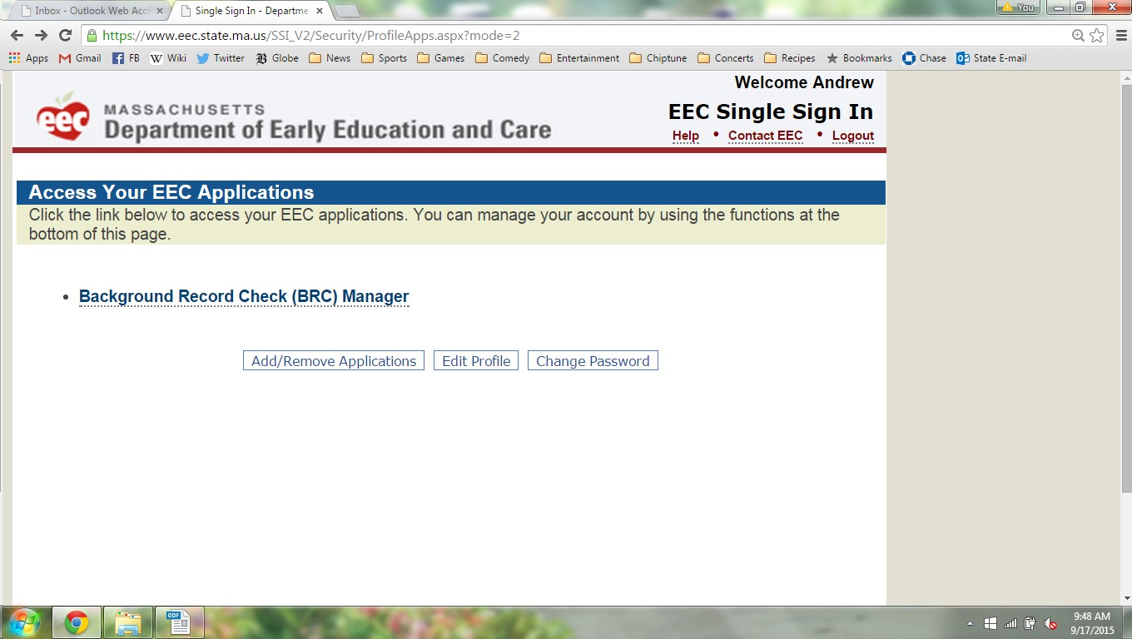

          - If you have never registered for BRC Manager before, you will see the page for New
BRC Account Registration Page.
- If you are an independent agency that is exempt from EEC licensure, but provide services and/or have the potential for unsupervised contact with children in EEC licensed programs, then click on "Agency".

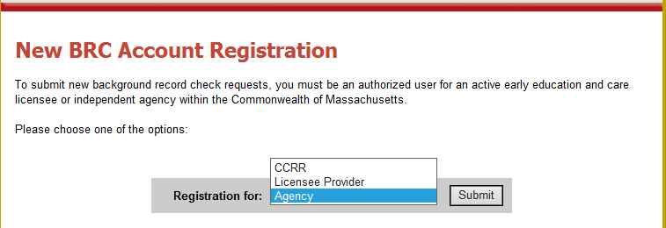

          - On the next screen, from the drop-down menu you will need to select your agency’s
name. Next, input your Agency Number provided to you via email upon approval by
EEC’s BRC Unit.

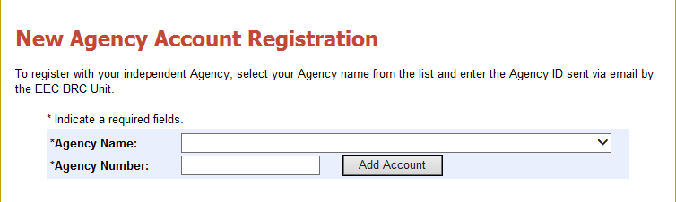

Step 3 – Activating your administrator status (each administrator must activate their own status when they are logged into their individual account)

BRC Manager has two different types of user accounts: "agency administrator" and “agency data entry”.

- If you have been authorized as an administrator you will need to verify your administrator access.

Please note:
  - You are authorized as an administrator if you have completed the Agency Administrator BRC form to EEC and EEC has reviewed your BRC and approved you as an Agency Administrator within the past three years, and that approval has not been revoked or rescinded. The Agency Administrator BRC form must be completed by the person responsible for the administration of the agency or facility and who is a duly authorized agent of the EEC licensed agency (ex. Executive Director, CEO, owner, etc.).

The Agency Administrator BRC form is located under:
User Administration -> Request Access as an Agency Administrator -> Download the Applicant-Agency Administrator BRC form

  - Your agency must have at least one person approved as the administrator, otherwise, no one in your agency will be able to submit new BRC requests or access previous BRC results through BRC Manager.

  - To activate the administrator access, input your date of birth and last 4 digits of your social security number.

  - Once successful, you will need to agree to the User Agreement and Privacy Policy.

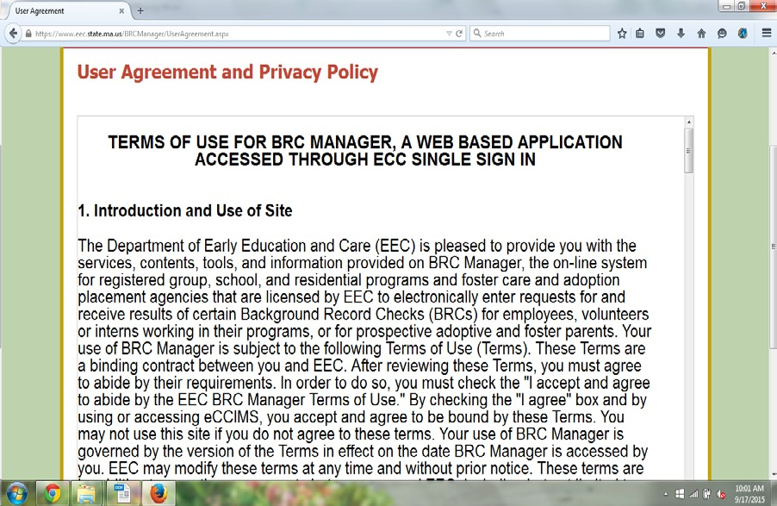

  - After you agree, you will get “agency account confirmation page” and will now have access to the BRC Manager System.
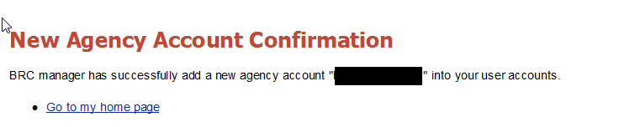

  - You will now be an active Agency Administrator. Below is the home page.

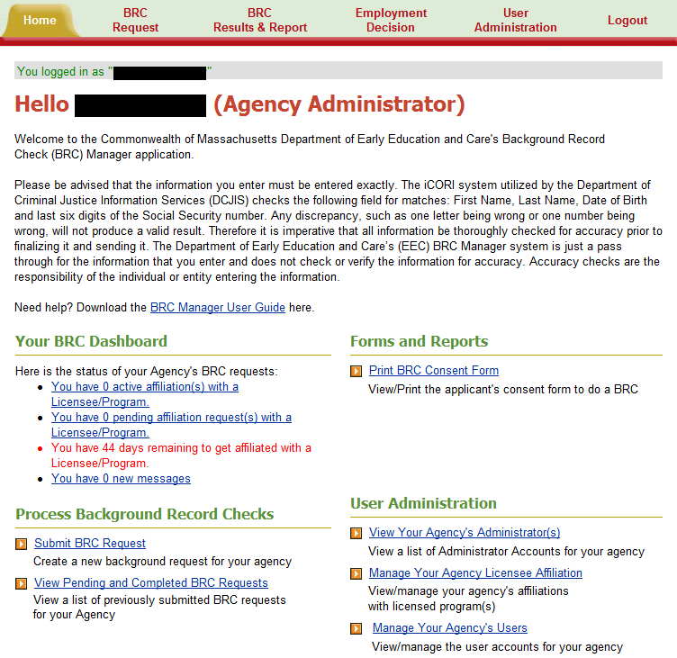

Step 4 - Using the System as an Administrator

- Agency Administrators can submit applicants for BRC checks, and have access to BRC information.
- To submit an applicant for BRC processing, click on the "Submit BRC Request" link from home page or go to “BRC Request” tab.
- On the next screen, you must confirm that the applicant has completed and signed the Background Record Check consent form. Once completed, click the "Continue Background Record Check" button.
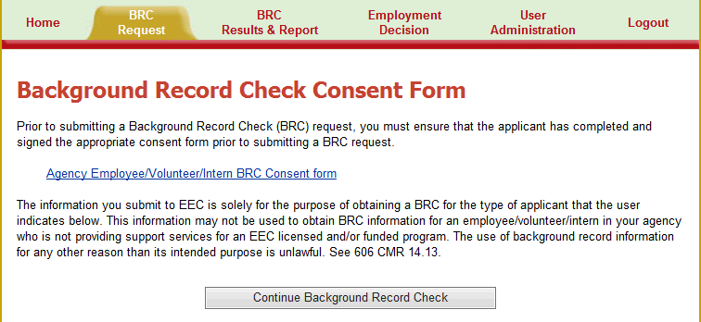

- Complete all of the information requested and submit. MAKE SURE TO SPELL THE APPLICANT'S NAME CORRECTLY AND CORRECTLY TYPE IN ALL KNOWN INFORMATION ABOUT THE APPLICANT!
If you type the information incorrectly, the BRC will be inaccurate and the applicant's BRC will be delayed.

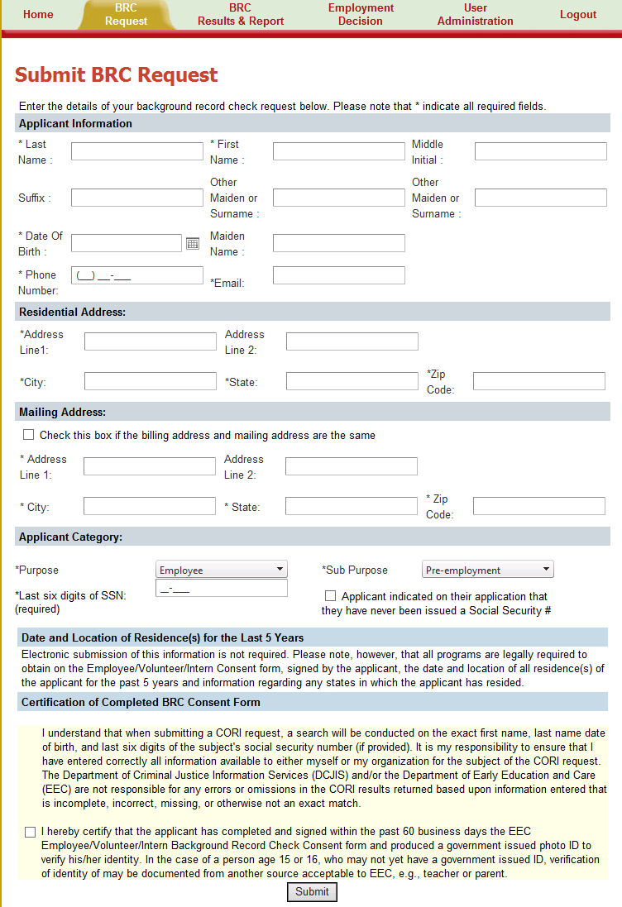
- Administrator can view the status of submitted BRC Requests. On the main screen, click on "View Pending and Completed BRC Requests" page.

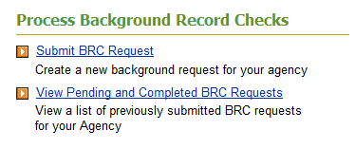

- Administrator can select the date range and can go back up to 3 years to view the status of all submitted requests.

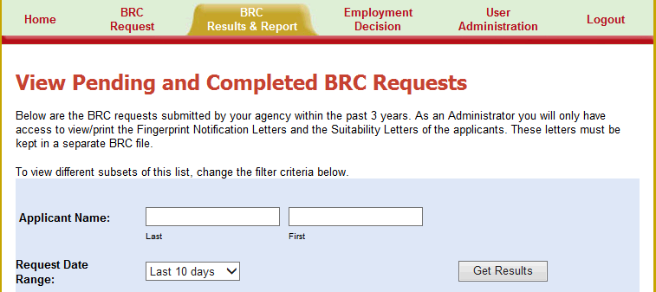

- Administrator can only print "Fingerprint Notification Letters” and “Suitability Letters” of the applicants submitted by the agency. The user can see a Status "Not Yet Available", or “Completed”, or “Suitable” / “Not Suitable” etc.

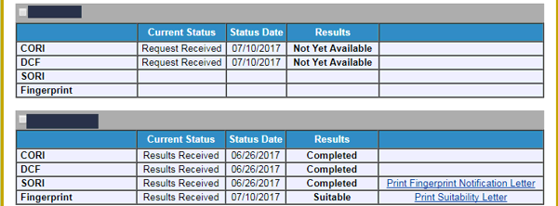

- The “View Pending and Completed BRC Requests” Screen shows the applicant's name and the status of the 4 checks -- CORI, DCF, SORI, and Fingerprint.

5A: CORI Results
  - Not Yet Available - The BRC request has been received and the CORI results are not yet available.
  - Completed - The CORI was completed for the applicant entered
In order to proceed with the BRC process the final CORI results should be “Completed”.

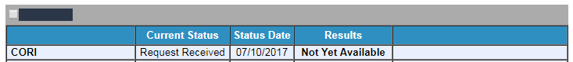
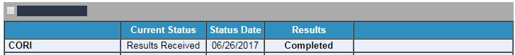

5B: DCF Results
  - Not Yet Available - The BRC request has been received and the DCF results are not yet available.
  - Completed - The DCF was completed for the applicant entered
In order to proceed with the BRC process the final CORI results should be “Completed”.

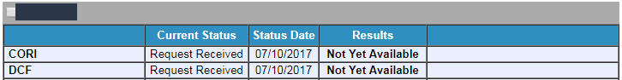

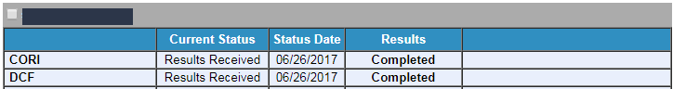

5C: SORI Results
  - Not Yet Available - The BRC request has been received and the SORI results are not yet available
  - Completed - The SORI was completed for the applicant entered and the agency can print the fingerprint notification letter by clicking on the link. This link will allow the agency to print the fingerprint notification letter that advises them that the CORI, DCF and SORI was approved, the applicant can be conditionally hired and be fingerprinted. EEC will not mail this letter to the agency. You must print and keep a hard copy of the notification letter in your BRC secure file.

In order for there to be a link to print the fingerprint notification letter, the CORI, DCF, and SORI must all be completed. FP Notification Letter will be displayed after 2 days from the SORI completion date. If there is no link after 2 days from SORI completion then you may contact the BRC Unit.
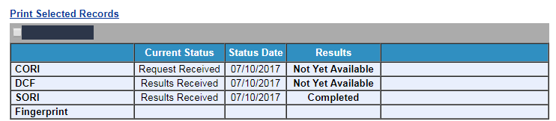

*Example of notification letter not available:
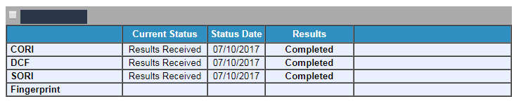

This example illustrates the situation where an applicant cannot be conditionally hired because there is no link to a notification letter. The link does not appear because the CORI is not completed yet. All three checks (CORI, DCF & SORI) must be completed before the applicant may be conditionally hired and sent for fingerprinting.

5D: Fingerprint Results
  - If there is no information provided (blank) this means the applicant has not registered or had a fingerprint appointment. The agency must ensure applicants are scheduling fingerprinting appointments.
  - Not yet available - The applicant has registered for fingerprinting but the appointment has not occurred or the results are still in process. The status date is the date the notification letter was sent.
  - BRC to be resubmitted - The applicant's name, previous names, DOB, or SSN does not match what the applicant provided for fingerprinting. If this information is inaccurate, then the agency should obtain a new consent form and the agency should resubmit a BRC request. The applicant does not have a valid/completed BRC if there are discrepancies with information. An applicant cannot be conditionally hired until a new BRC request is completed with accurate information and a new fingerprint notification letter is received.
  - Suitable - the applicant has been deemed suitable by EEC and the BRC is complete. The agency can print the suitability letter by clicking on the link.
  - Not Suitable - EEC deemed the applicant not suitable and should be removed from the agency within 14 days unless EEC requires removal sooner. The agency can print the suitability letter by clicking on the link.

The agency should record when the applicant was fingerprinted and encourage all applicants to keep a copy of the receipt received after fingerprinting.

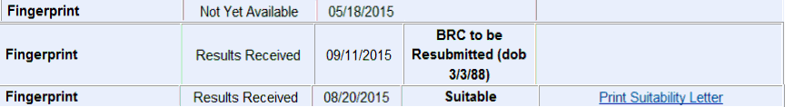

- Agency Administrators will not have access to view the "Employment Decision page". This functionality is not available yet.

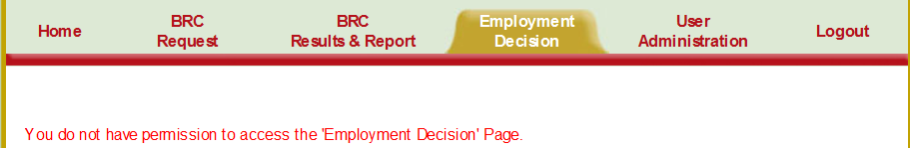

Step 5 - Manage Agency-Licensee Affiliation (Only Administrator)

- Apart from BRC Submission and View Results, Agency Administrators can also access and manage Agency-Licensee Affiliation.

- Agency Administrator can click on the link “Manage Your Agency Licensee Affiliation” from home page or
Go to “User Administration” tab and click on “Manage Your Agency Licensee Affiliation” link.
- If the Agency does not have any affiliation with other Licensee, then the administrator will see below error.

- As soon as the Agency Administrator account has been created, administrator can contact the EEC Licensed Program and ask for an affiliation request from that program.
- Licensee/Reviewer of the EEC licensed program can send an affiliation request to the agency from BRC Manager.
- Agency Administrator will get a notification and can accept the affiliation request by clicking on link “You have 1 pending affiliation request(s) with a Licensee/Program.” or going to “Manage Your Agency Licensee Affiliation”

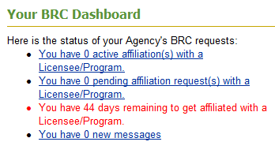

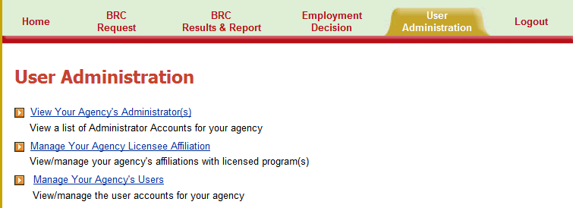

- Agency Administrator can either accept or reject the affiliation request from the licensed program.
  - If the user accepts the affiliation request, then the program will get a notification of acceptance and the agency will have an “Active” affiliation at this point.
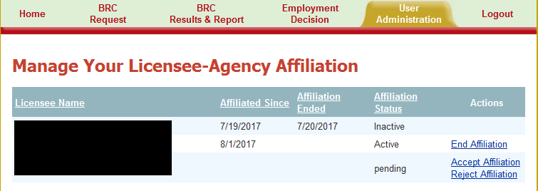

  - If the user rejects the affiliation request, then the program will get a notification of rejection and the agency will have “no” affiliation at this point.
    - The request will be removed from the list. If there are no other affiliation requests then user will get the error message.

  - Agency administrator can end an active affiliation at any time and the affiliated program will get a notification. The agency will have an “Inactive” affiliation at this point.
    - The request will be marked inactive under affiliation list.

- An Agency needs to have at least one affiliation (active/inactive) with a Licensed Program to continue submitting new BRC requests for applicants working for Agency and providing services to a licensed program.
  - The agency has 45 days to get affiliated with a licensed program. Administrator will see a reminder message (in Red) on Dashboard “XX days remaining to get affiliated with Licensee/Program.
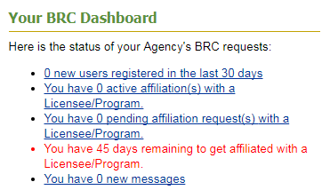

  - After 45 days, if the Agency has zero (0) affiliation(s) with another Licensee/Program then the agency will no longer be able to submit new requests for applicants.
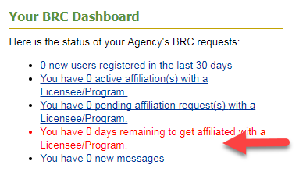
  - After 45 days, if the Agency has zero (0) affiliation(s) with another Licensee/Program then the program will no longer be able to view the requests submitted by that Agency.

Step 6 – Using the System as an Agency Data Entry User

- If you register for BRC manager under an agency, by default, you will have agency data-entry operator access.

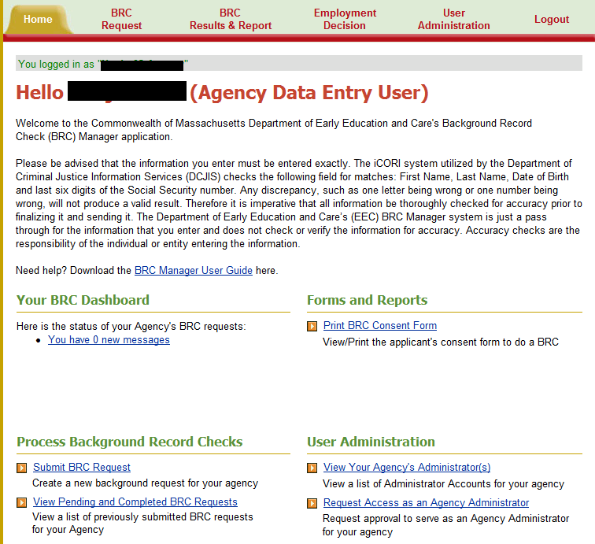

- To submit an applicant for BRC processing, click on the "Submit BRC Request" link.

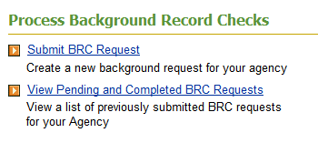

- Agency Data Entry users are limited to submitting applicants for BRC checks, and do not have access to BRC Results.
  - Agency Data Entry users will only see “Not Yet Available” or “Completed” status.
  - Agency Data Entry users will not have access to “Fingerprint Notification Letter” or “Suitability Letter” of any applicant submitted by the agency.

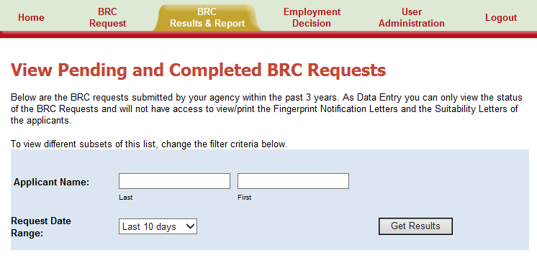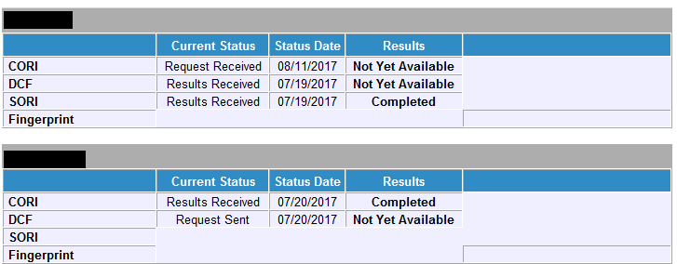

- Agency Data Entry user will not have access to “Employment Decision” page

Step 7 – Requesting access as an Agency Administrator
- An agency data entry user can request access as an administrator by any of the below ways:
  - Click on “Request Access as administrator” link on the main screen.
  - Go to User Administration page Tab and then click on “Request Access as administrator” link.

- Download the Agency Administrator BRC form and submit it to BRC Unit via email (eec.brc@state.ma.us) or mail (51 Sleeper Street, 4th Floor Boston, MA 02210).
- Once you receive the Agency account creation confirmation email from EEC’s BRC Unit you must update your online account by providing your date of birth, last 4 digits of your social security number below and click the "Verify Access" button.

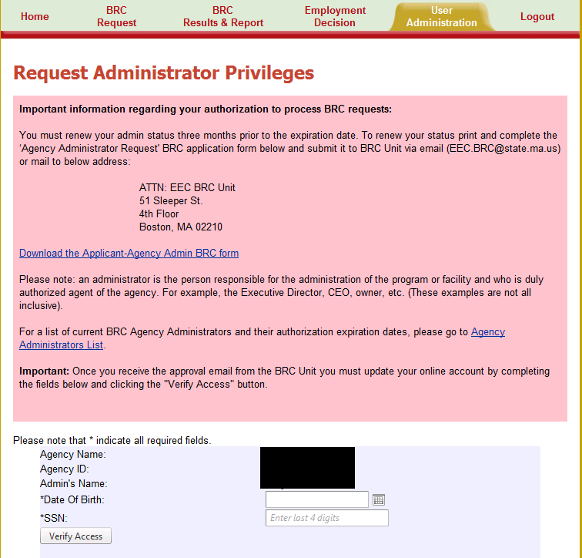

Step 8 - Contacting EEC for any questions

Click on “Contact Us” link at the bottom right of the page.

