INTERESTED IN BECOMING A BROCKTON POLICE OFFICER?

JOIN THE BROCKTON POLICE & THE MASSACHUSETTS HUMAN RESOURCES DIVISION FOR INFORMATION ABOUT
2019 POLICE OFFICER EXAM

SATURDAY, JANUARY 12, 2019 10 AM-12 PM
ARNONE SCHOOL AUDITORIUM
135 Belmont Street Brockton,
MA 02301

Police Officer Written Examination: Saturday, March 23, 2019

Application Deadline: February 5, 2019* Fee Waivers Available
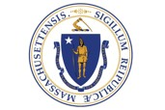
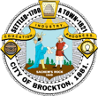
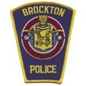
Office of Mayor Bill Carpenter

Apply online at www.MASS.GOV/CivilService

