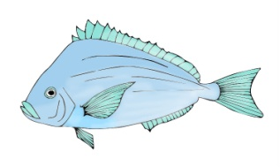
Fort Taber
Youth Fishing Clinic

Saturday, June 22, 2019
10am - Noon
Or
12:30pm-2:30pm
Sponsored by
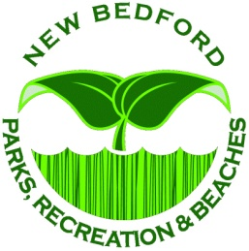
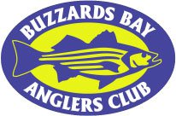
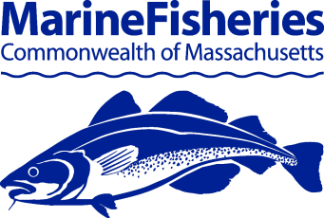

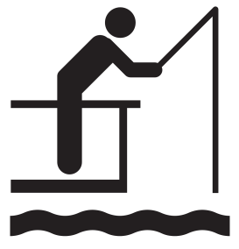
Sign up for a youth fishing clinic at the Fort Taber pier in New Bedford! MarineFisheries biologists will be joined by New Bedford’s Parks and Recreation Department and the Buzzards Bay Anglers Club to teach basic saltwater angling skills. This is a FREE event! Fishing equipment and bait will be provided. The Fort Taber pier is located at 1000 S. Rodney French Blvd in New Bedford, MA. Parking, restrooms, and concessions are available on site.

Fishing Clinic Activities

Learn how to cast with spinning reels |  | Gyotaku fish prints with paint
Test your knot tying skills |  | Learn how to measure fish
Fun and educational handouts |  | Catch and release fishing!!

Space is limited for this event, so be sure to reserve your spot early by sending in the required forms (see below). Registration and Media Release forms must be filled out prior to participation in the Youth Fishing Clinic.
Youth Fishing Clinic Registration Form
Fort Taber: June 22, 2019

Registered youth’s name:
Registered youth’s age:
Preferred Time Slot: 10am-Noon ☐or 12:30pm-2:30pm☐
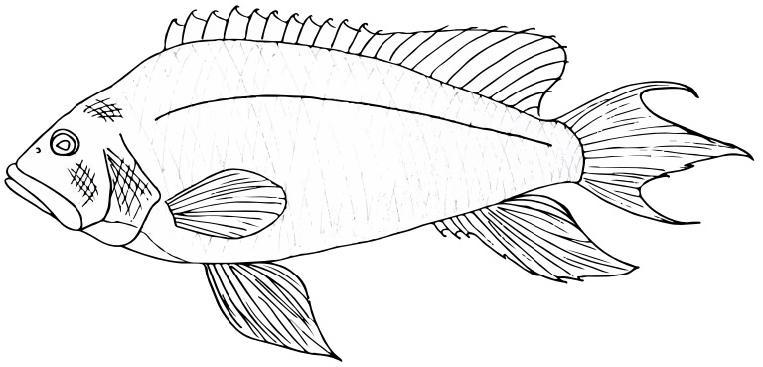
How many family members will be joining the participating youth?

By signing below, I understand that:
- The youth I am registering is between the ages of 7 and 15 years.
- I MUST stay with my registered youth, even when visiting concessions or restrooms.
- Only the youth I am registering may fish, however everyone is welcome to participate in other clinic activities.
- I am responsible for providing weather-appropriate items, including attire, sunscreen, sunglasses, etc. for myself and my family.
- I release Massachusetts Division of Marine Fisheries and co-sponsors from liability and understand I am responsible for my and my angler’s wellbeing.
Parent/Guardian name:
Parent/Guardian signature: Date:
Parent/Guardian phone number (day of the event):
Parent/Guardian email:
To submit forms, or if you have any questions, please contact Kimberly Fine, MarineFisheries Angler Education Program Coordinator, at (978) 282-0308 ext. 130; or via email at kimberly.trull@mass.gov . Forms can also be mailed to Massachusetts Division of Marine Fisheries, 30 Emerson Ave, Gloucester, MA 01930. Your reservation will be confirmed when all forms are received.
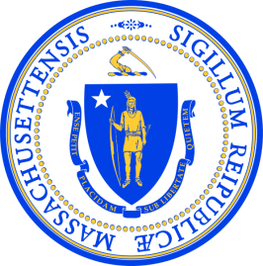
Division of Marine Fisheries
251 Causeway Street, Suite 400
Boston, Massachusetts 02114
Media Release

The Massachusetts Division of Marine Fisheries often documents research and public outreach events to convey the importance of what we do and share it with the public. We respectfully use photo, video, and audio documentation to engage the public and promote more public involvement in our Division’s mission and outreach events.

By signing below, I hereby:

- Grant to the Division of Marine Fisheries (MarineFisheries), the right and permission to use, reuse, and/or broadcast, publish, and distribute in any form whatsoever, including print, photograph, or by electronic means such as the World Wide Web, the media (images, video, and/or audio) that is the subject of this release.

- Waive any right to inspect or approve of the original or any copies of the media that is subject to this agreement.

I hereby certify that I am over eighteen years of age, and competent to contract in my own name.

I understand that I will not be compensated in any way for the use by MarineFisheries of any media subject to this agreement.

Any use by MarineFisheries of an image(s), video(s), or audio clip(s) that is subject to this agreement shall not constitute an unreasonable, substantial, or serious interference with my privacy.

I have read and understood the foregoing.

Signed: Dated:

Name: Address:

City/State/Zip:
Minor Release:

I hereby certify that I am the parent and/or guardian of ,
who is under the age of eighteen years. By signing above, I hereby consent to the terms of the foregoing agreement in connection with the Commonwealth’s use of the image(s) that is subject to this agreement.

MarineFisheries Media Release Form

