

**IZOLASYON**

**An plis de Prekosyon Estanda yo**

**Anplwaye ak Doktè yo DWE:**

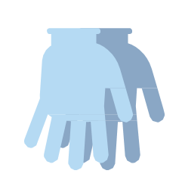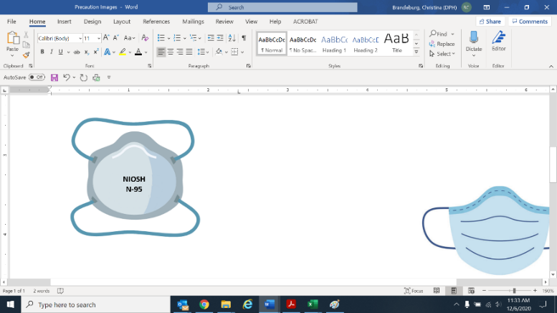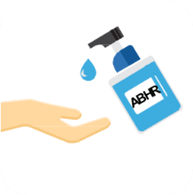

**Itilize ekipman pasyan oswa ekipman jetab.**

**Netwaye epi dezenfekte ekipman ki pataje yo.**

**KITE PÒT FÈMEN**

(Sof pwoblèm sekirite oswa si inite a pa fizikman separe)

**✓**

**✓**

**✓**

**✓**

Aktyalize: 9 March. 2023

**✓**

**Pwoteksyon Je**

(Pwoteksyon figi oswa gwo linèt)

**Respiratè N95**

(Mask akseptab si N95 pa disponib; N-95 oswa siperyè teste pou AGP)

**Gan -** Chanjman ant chak rezidan

**Netwaye men yo:** lè y’ap antre ak sòti

**Blouz -** Chanjman ant chak rezidan