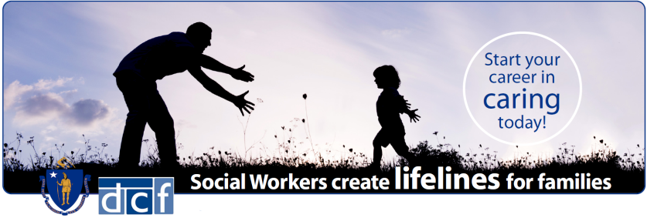
SOCIAL WORKERS IN-PERSON HIRING EVENT
YOU MUST SUBMITT ELECTRONIC COPIES OF
- Updated Resume
- College or University Transcript (Unofficial or Official)
- MA Social Work Licensure (preferred)
- 3 professional references (at least 1 must be supervisor or manager)
WE OFFER
- Starting Annual Salary at $54,281.24
- Health Insurance – 75% employer paid
- Basic Life Insurance
- Optional Life Insurance - up to 8x your annual salary
- Dental and Vision coverage plans
- Twelve Paid Holidays per year
- Tuition Benefit- for employee and their spouse
- Exceptional Retirement Savings Plan
- Vacation, Sick Time Accrual and Personal Days
- Long and Short-term Disability insurances
- Professional Development and Continuing Education
- Educational and Bilingual incentives
- Employee Assistance Program (EAP)

Become part of a hardworking, compassionate staff dedicated to the safety and protection of children. As a DCF Social Worker, you have the ability to profoundly impact lives of children and families across the Commonwealth.

Interested candidates
We are seeking dedicated and passionate individuals for these Exclusive One Day Hiring Events to be interviewed virtually.
A bachelor’s degree is required in any of the following disciplines:
Social Work | Psychology | Human Services | Sociology |
Counseling | Counseling Education | Criminal Justice
Bachelor’s degree in other closely related fields may be considered:
Social / Child Welfare | Human Development | Family / Urban Studies |
Marriage Counseling | Family Therapy | Forensic Psychology

CAPE & ISLANDS AREA OFFICES
COME IN WITH A PASSION…
LEAVE WITH A CAREER

Saturday 12/4/2021 – 10:00 a.m. to 2:00 p.m.
Department of Children and Families
Hiring for Cape & Islands Area Offices ONLY
500 Main Street, Hyannis, MA 02601
In-Person interviews! Pre-registration is required by Wednesday, December 1, 2021 at 12:00 noon:
To register for the hiring event, go to: https://rb.gy/r5vsqs

In addition to registering for this Hiring Event please be sure you apply to Social Worker I – Southern Region PIPELINE - (210000HU) on MassCareers. Please use this link: https://bit.ly/35Q7eza
For more information on additional EOHHS Career Opportunities go to: https://www.mass.gov/EOHHSCAREERS DCF is an Equal Opportunity / Affirmative Action Employer. Females, minorities, veterans, and persons with disabilities are strongly encouraged to apply. Reasonable Accommodation: If you require an ADA accommodation, please contact Alisha Queen, (857) 321-1097 TTY (617) 348-5193 or email at alisha.queen@mass.gov Ms. Queen must receive your request for an accommodation no later than two weeks prior to the date of this event. For those who request an accommodation after this date, every effort will be made to provide a reasonable accommodation; however, we may not be able to do so given potential time constraints.
Executive Order #595 requires Executive Department employees to have received COVID-19 vaccination or to have been approved for exemption as a condition of employment. Finalists will be given details about how to demonstrate receipt of vaccination or request an exemption due to a sincerely held religious belief or if the vaccine is medically contraindicated.

