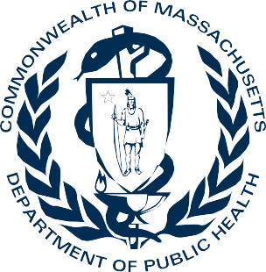
DPH Office of Problem Gambling Services:
Leading a Public Health Response to Problem Gambling

Our Values
The Office of Problem Gambling Services is guided by the public health principles of engagement, empowerment, and equity. The Office works by allocating significant resources to prevention, intervention, treatment, evaluation, and recovery support services in order to mitigate the harmful effects of problem gambling and related issues through a variety of community-level strategies.

Why a Public Health Approach?

Mitigating harms associated with gambling must go beyond the promotion of individual responsibility and be centered on broader effective strategies and principles of public health. Problem gambling is governed by a complex set of interrelating factors, causes, and determinants ranging from biology and family history to social norms and existing statutes. Research indicates
that gambling is interrelated with various health issues and disproportionately impacts individuals with mental health disorders, substance misuse disorders, and communities of color. Historically, community-level experiences of gambling and communities of color are often not the focus of problem gambling research, services and efforts.

Equity in Action!
Surveillance and Community Engagement
Programs and Services
Workforce Training and Supports
Public Awareness
Technical
Assistance and Evaluation
1

Surveillance and Community Engagement:
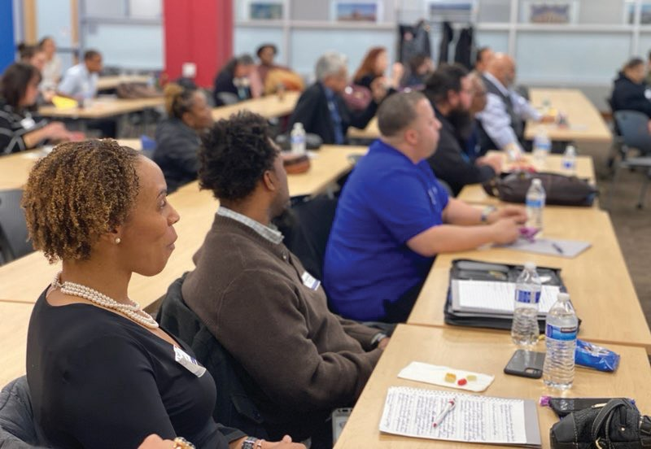Central to OPGS’ work, surveillance and community engagement activities are ongoing and inform the Office’s programs and services. Guided by the public health principles of engagement, empowerment, and equity, the OPGS Data to Action Framework was developed to illustrate the process through which public health data and community experience can be leveraged to inform and support each other in a mutually reinforcing feedback loop and ensuring effective response to
community need. The OPGS Data to

Action Framework consists of:
- Monitoring and Surveillance
- Contextualizing Data
- Comprehensive and Responsive Services
- Evaluation and Quality Improvement
- Community Engagement and Feedback

Program and Services
An example of our community engagement work is the annual Stakeholder Listening Sessions, where we elicit input from the community – especially those disproportionately impacted by gambling – on programmatic priorities, which informs programs and services.

OPGS directly contracts with community organizations to provide services to individuals and families throughout Massachusetts to prevent and mitigate gambling-related harms, especially for communities disproportionately impacted by
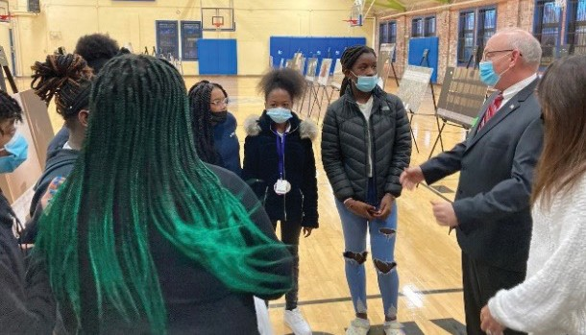gambling. Programs are implemented across the continuum of care and have a consistent focus on the social determinants of health and equity. OPGS programs and services span from awareness and prevention to treatment and recovery support. Some examples of these programs include PhotoVoice and the Ambassador project.

2

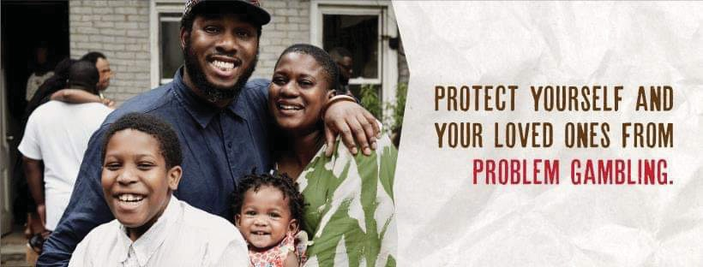The PhotoVoice project trains and empowers young people to use photography to catalyze change in their communities. The Ambassador Project is a peer-based, community-centered, participatory, and culturally responsive approach to reaching a
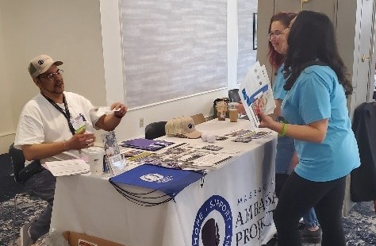population at higher risk for problem gambling and to engage them in prevention discussions through individual, group, and community-level interactions. You can learn more about the Ambassador project by reading Our Voices Matter: Using Lived Experience to Promote Equity in Problem Gambling Prevention.

Workforce and Training Supports
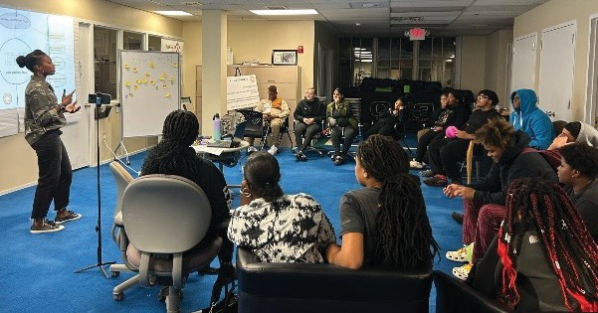OPGS contracts with vendors to provide workforce support and leadership development through various training activities. Training and leadership development efforts also seek to enhance capacity within priority populations such as Veterans, Men of Color, Asian Americans, and Youth in addition to building the capacity of the workforce of outpatient substance use treatment programs to offer and promote gambling treatment services.

Public Awareness
OPGS leads a comprehensive communication strategy centered on our platform: Let’s Get Real about Gambling. The campaigns aim to increase education and awareness of gambling, especially for
priority populations. They also direct viewers to resources such as the Problem Gambling Helpline and the OPGS website. The various campaigns are shared via billboards, digital bulletins, on YouTube, Facebook,
3

Instagram and other platforms. To date, communication campaigns include Youth and Parents, Older Adults, and Men of Color that have resulted in over 100 million impressions! Be on the lookout for new campaigns in the future.

Technical Assistance and Evaluation
OPGS is committed to leading with data and building capacity across problem gambling programs and services. Our evaluation framework measures the progress of programming while informing continuous quality improvement. Our two technical assistance centers build community capacity in the prevention and treatment of problem gambling and related issues.

The Massachusetts Center of Excellence on Problem Gambling Prevention (MCOE PGP) provides capacity building, training and resource development services to address the prevention of problem gambling and related health issues.

The Massachusetts Technical Assistance Center for Problem Gambling Treatment (M-TAC) provides a range of services that build the capacity of outpatient treatment programs to address problem gambling and co-occurring substance use and mental health disorders.

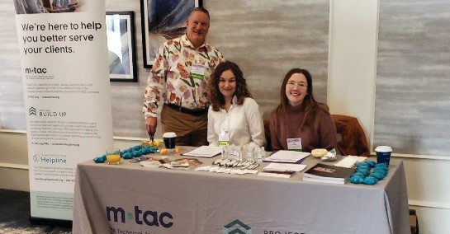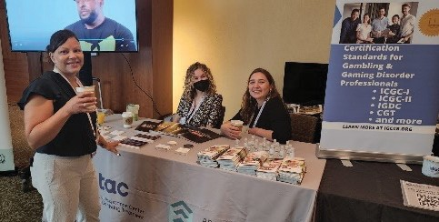

To learn more about the Office of Problem Gambling Services please visit mass.gov/opgs

4

