Adverse and Positive Childhood Experiences (ACEs & PCEs) in Massachusetts:
Interactive Dashboard User Guide
[Version 1.2: August 2023]
Contents
Description of the Dashboard 2
Who is this dashboard for? 2
Quick-Start Navigation 3
Dashboard Features Overview 4
Topic Navigation 5
Topic Dashboard Filters 6
Chart Features Overview 11
Dashboard Display Options 16
View Topic Questions 21
Downloading the Data 23
About the Data 24
Technical Data Notes 24
Data Dictionary 28
Using the Data 29
Interpreting and Sharing the Data 30
Using Racial Justice Reframing and Data-to-Action 32
Topic-Specific Information 36
Reflection Questions 39

Description of the Dashboard

Who is this dashboard for?
This dashboard was published on Mass.gov, in coordination with the Population Health Information Tool (PHIT) team. The “user” is meant to be anyone in the public interested in childhood experiences. The user can be a parent or caregiver, youth, community member, community organization employee, community advocate, local board of health staff, state government staff, etc. The purpose of the dashboard is for any user to be able use these data to create action to make a change. Guiding resources to support data-to-action can be found in the Using the Data section. For more help with this dashboard, send an e-mail to the PHIT Team: DPH.PHIT@state.ma.us.

Quick-Start Navigation
This section provides a quick-start list of how to navigate the dashboard. For more detailed instructions, see Dashboard Features Overview.
- To view information on different types of experiences, select a topic of interest to you from the ten topic tabs at the top of the dashboard page (for example, ‘Positive Childhood Experiences’, ‘Bullying’).
- Within a topic page, to view the prevalence of experiences, first select a Year, a Survey, and a Population Group. Then, select the Experience(s) you are interested in.
- The surveys have different options available for population groups and experiences. To change your view to a different Year, Survey, and/or Population Group, first select 'Overall' Population Group, then select '(All)' Experience. Then, select the Year, Survey, Population Group, and Experience.
- Use the Show or Hide Confidence Interval Option drop-down menu, to show or hide the Confidence Interval in the displayed chart on the dashboard.
- Use the Show Information About the Experiences button to display more information about the selected data to the right of the chart.
- Use the View Topic Questions button at the bottom of the dashboard topic page to download a document that includes information about the selected population group and experiences and the survey questions for the experiences and populations.

Dashboard Features Overview
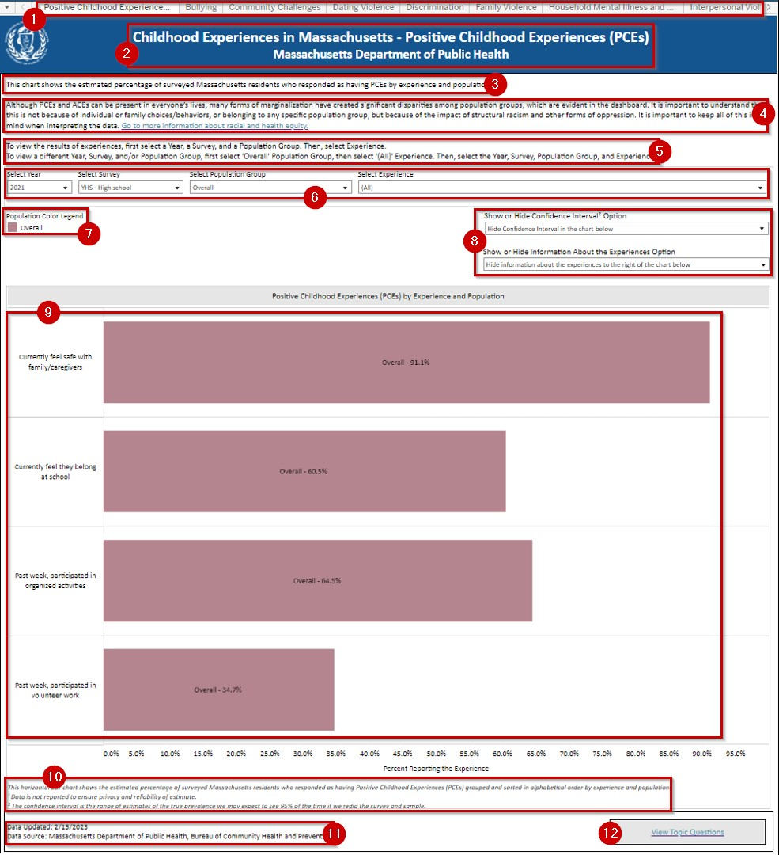

- At the top of the dashboard application are tabs. Each tab contains a dashboard for each of the ACEs and PCEs topic. Each topic dashboard contains:
  - a title that includes the ACEs and PCEs topic.
  - a description of the topic dashboard.
  - information about race and health equity data interpretation.
  - quick instructions for using the topic dashboard.
  - a set of drop-down menus for filtering the data on the chart.
  - a color legend for the chart.
  - a set of drop-down menus for display options on the dashboard.
  - a bar chart of the topic data.
  - a section for the bar chart data notes.
  - a section for the topic dashboard footnotes with date the data was updated and the data source.
  - a button to view the topic questions.

Topic Navigation
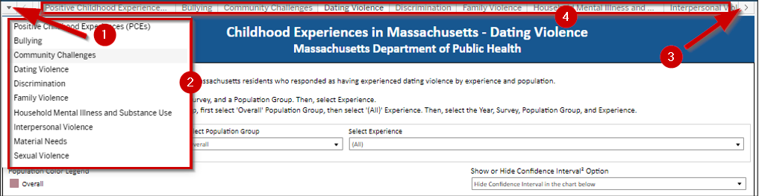
There are two ways to select and view a topic dashboard.
One way is to:
- Select the drop-down arrow on the top left corner of the dashboard.
- Then select the topic from the drop-down list.
The other way is to:
- Select the greater sign on the top right corner of the dashboard.
- Then select the tab for the topic at the top of the dashboard.
The following are the topic options available to users:
- Positive Childhood Experiences
- Bullying
- Community Challenges
- Dating Violence
- Discrimination
- Family Violence
- Household Mental Illness and Substance Use
- Interpersonal Violence
- Material Needs
- Sexual Violence

Topic Dashboard Filters
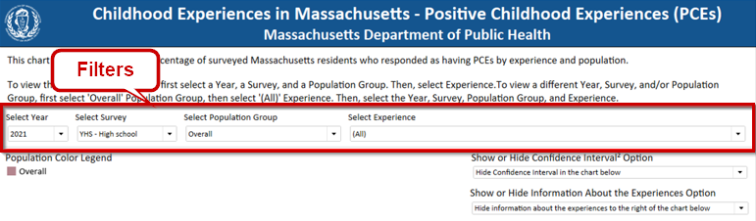 To change the survey year, survey, population group, and experiences to display on the dashboard use the filter drop-down options. The available population groups and experiences are based on the data available for the selected survey year and survey. Important: Not all population groups and experiences are available on all surveys.

Default Filter Selections
The default filter selections when first accessing the topic dashboard page are:
- Survey Year is the latest available survey year
- Survey is the first survey based on alphabetical ascending order of the survey name
- Population Group is the overall population
- Experiences are all the available experiences

Filtering the Data on a Topic Dashboard

Filtering for Survey Year, Survey, and Population Group Data
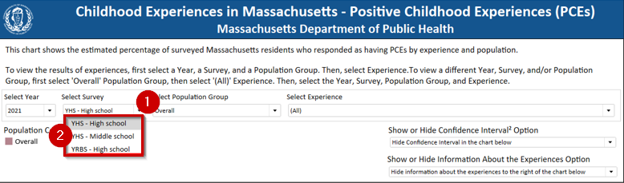
To filter the survey year, survey, and population group of a topic dashboard:
- At the Select Year, Select Survey, or Selection Population Group prompt, click the drop-down arrow to the right of the filter. A list of filter values is displayed.
- Select a filter value from the list. The chart on the dashboard is filtered for the selected filter values.

Filtering for Experiences Data
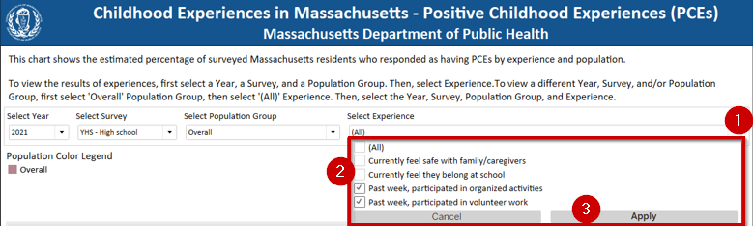 To filter one or more experiences of a topic dashboard:
- At the Select Experience prompt, click the drop-down arrow to the right of the filter. A list of filter values is displayed.
- Check one or more filter values from the list. Optionally, check the “(All)” filter value to select all experiences.
- Click the Apply button. The chart on the dashboard is filtered for the selected filter values.

Clearing Filters
You have the option to clear a single filter or resetting all filter values by resetting the view of the topic dashboard. To clear a filter:
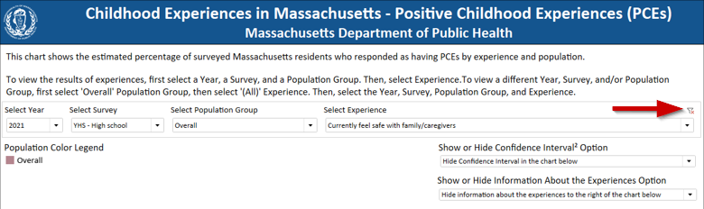Hover to right of the filter label when a clear filter icon is displayed. Click on the clear filter icon. The filter is set to the ‘(All)’ value and the chart data is updated to include all values of the filter.
Note the only filter that can be cleared on the dashboard is the Experience filter.

Reset All Filters
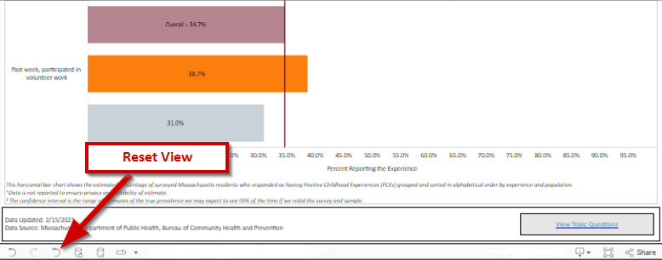To reset the topic dashboard view, use the Reset View button at the bottom of the dashboard application. The page will be updated to display the initial view of the topic dashboard.
Note that resetting the view will also reset the display options.

Viewing a Different Survey
The population groups and experiences differ across the surveys reported for each topic dashboard. If a combination of experiences, or one experience, is selected for a survey that is not available in a different survey, then the survey is not included in the list available of surveys to choose from in the Select Survey filter. So, to view a different survey than the one already selected and select the available population groups and experiences for the survey:
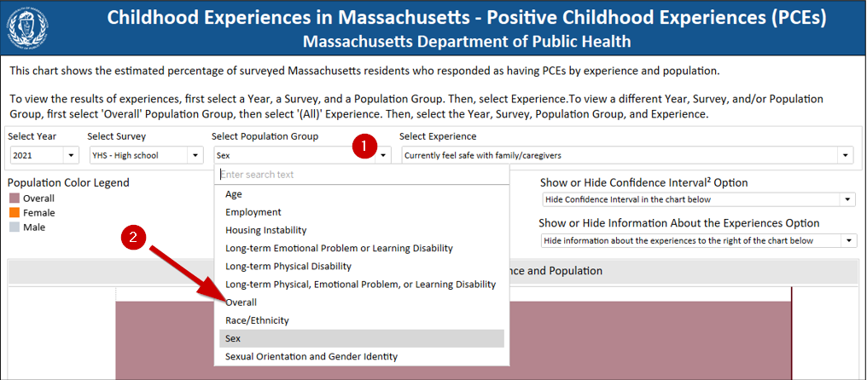
- At the Population Group filter prompt, click the drop-down arrow to the right of the filter. A list of filter values is displayed.
- Select the “Overall” population from the list. The chart on the dashboard is updated to show the overall population.
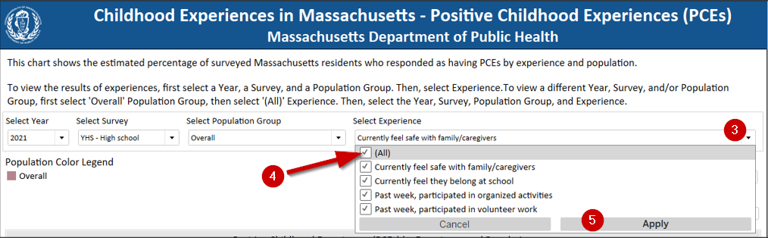
- At the Select Experience prompt, click the drop-down arrow to the right of the filter. A list of filter values is displayed.
- Check the “(All)” filter value to select all experiences.
- Click the Apply button. The chart on the dashboard is updated to include all experiences.

Viewing Different Survey Continued
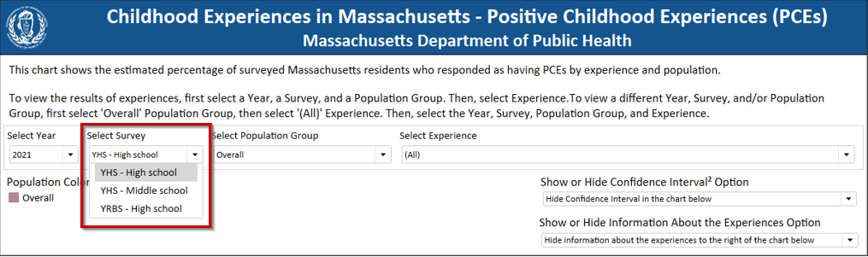The Select Survey filter prompt list of values now include all available surveys. Proceed with making the selections for the Select Survey, Select Population Group and Select Experience filters, see the sections Filtering for Survey Year, Survey, and Population Group Data and Filtering for Experiences Data for instructions to filter these data.

Chart Features Overview
The following image is an example of selecting the “2021” survey year, the “YHS – High School” survey, the “Sex” population group, and two of the four available experiences.
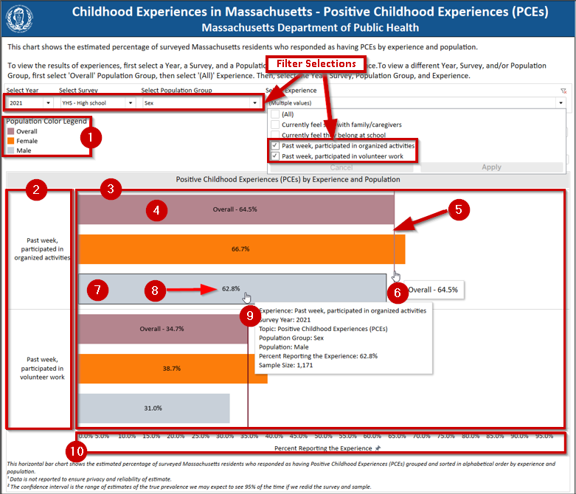The chart in each topic dashboard include:
- a color legend for the populations reported in the chart.
- an experiences row label area.
- a plot area.
- an overall bar.
- an overall reference line for each experience.
- overall reference line tooltips.
- an experience population bar for each population of the selected experience.
- a label in each bar that displays the estimated percent reporting the experience for the population.
- an experience population bar tooltip.
- chart axis of the estimated percent reporting the experience.

Population Color Legend
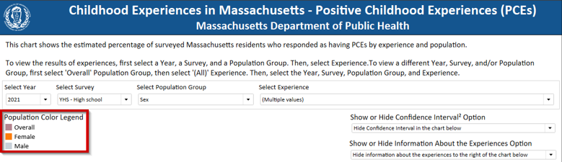
The Population Color Legend updates to show the color keys for each population in the bar chart of the selected Population Group. The populations are listed in ascending alphabetical order.

Experiences Row Label Area
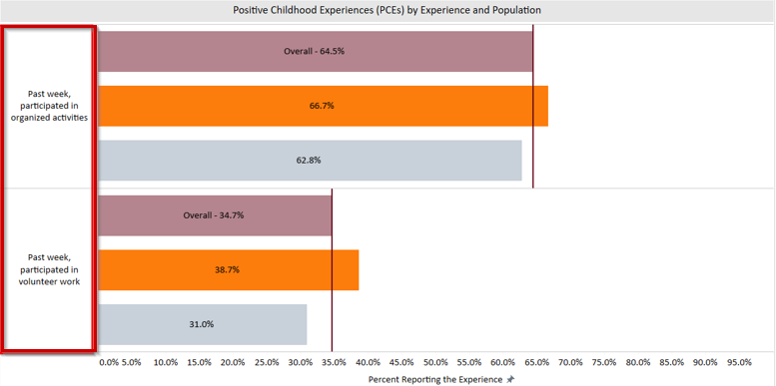
The experience row label area displays each selected experience from the Experience filter. The experiences are listed in ascending alphabetical order.

Plot Area
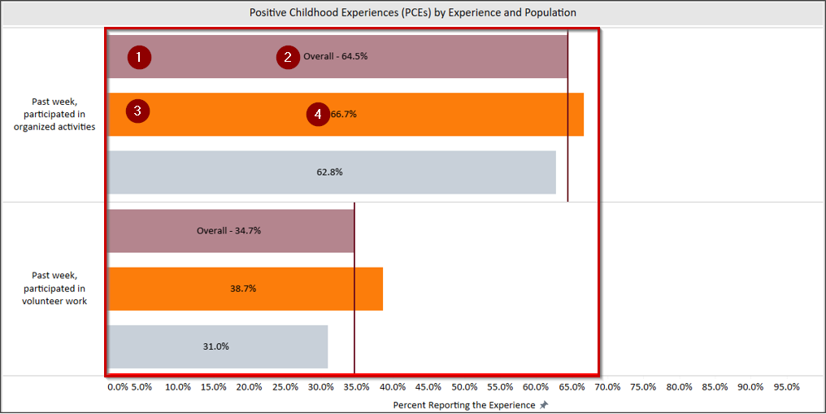
The plot area displays a bar representing the estimated percent reporting the experience. For each experience selected from the Experience filter, there is:
- an overall bar
- a label that displays the estimated percent reporting the experience for the overall population.
- a bar for each experience population representing the population’s estimated percent reporting the experience.
- a label in each bar that displays the estimated percent reporting the experience for the population.

Overall Bar
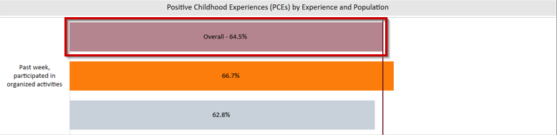
The overall bar represents the estimated percent reporting the experience for the overall population. There is an overall bar for each experience in the bar chart. The label in the middle of the bar shows the estimated percent reporting the experience for the overall population.

Overall Reference Line
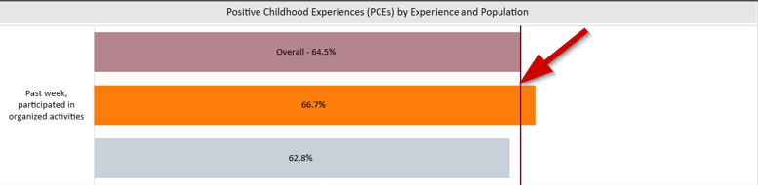
When a population group other than “Overall” is selected, an “Overall” vertical reference line is displayed across each set of experience bars. The line allows a user to compare the overall estimated percent reporting the experience to the population group to see if some groups of residents have the experience more or less often than the whole group.

Overall Reference Line Tooltip
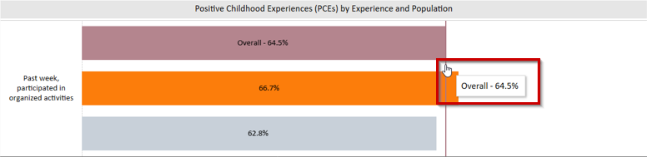
Hover over the Overall Reference line to show the estimated percent reporting the experience for the overall population.

Experience Population Bar
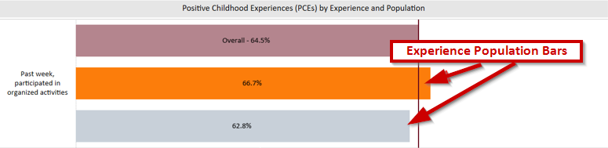
The experience population bar represents the population’s estimated percent reporting the experience. The label in the middle of the bar is the estimated percent reporting the experience for the population.

Experience Population Bar Tooltip
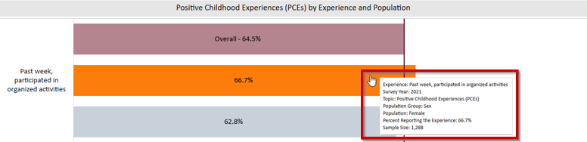
Hover over a bar to view more detailed survey data information about the experience population. It provides information about the experience, survey year, topic, population group, population, percent reporting the experience and sample size. This information can be helpful when interpreting the data

Chart Axis
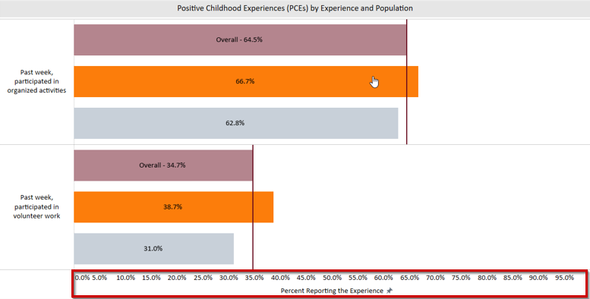The chart axis displays the range of the estimated percent representing the experience from 0% to 100%.

Dashboard Display Options
There are options to show or hide additional data on the topic dashboard, confidence interval data, and information about the survey population groups and experiences. The option selected for these display options is applied across all topic dashboards in the application.

Show or Hide Confidence Interval Option
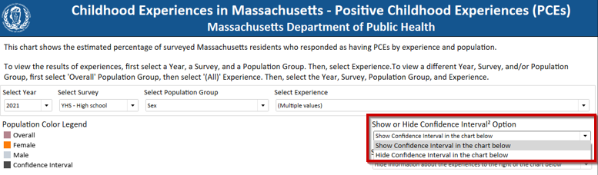Use the Show or Hide Confidence Interval Option to show or hide a confidence interval reference line on the chart for each experience population. The option selected is applied to all topic dashboards in the application. The default selection is to hide the confidence interval on the chart.

Changing the Show or Hide Confidence Interval Option
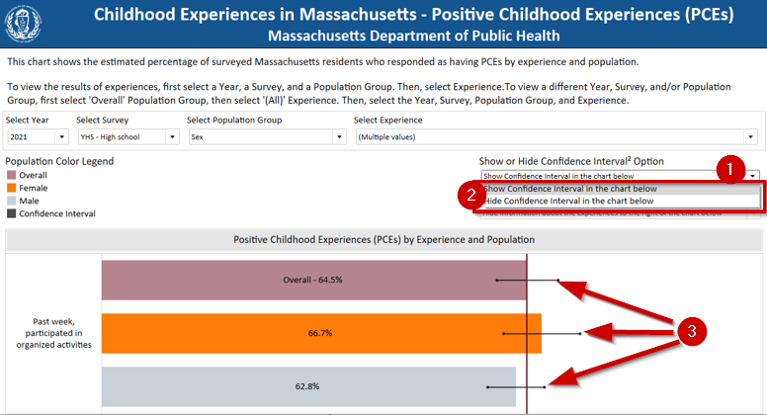
- At the Show or Hide Confidence Interval Option prompt, click the drop-down arrow to the right of the filter. A list of filter values is displayed.
- Select the show or hide option. The chart is updated to show or hide the confidence interval reference line based on your selection.
- When the option to show the confidence interval is selected, a horizontal reference line representing the confidence interval is displayed for each experience population bar.

Confidence Interval Reference Line
The confidence interval is the range of estimates of the true prevalence we may expect to see 95% of the time if we redid the survey sample. This can be an important statistic when interpreting our confidence in the data, based on how this information was collected through surveys from a sample of the population. More about survey sampling and confidence intervals can be found in the About the Data section below of this guide.

Confidence Interval Tooltip
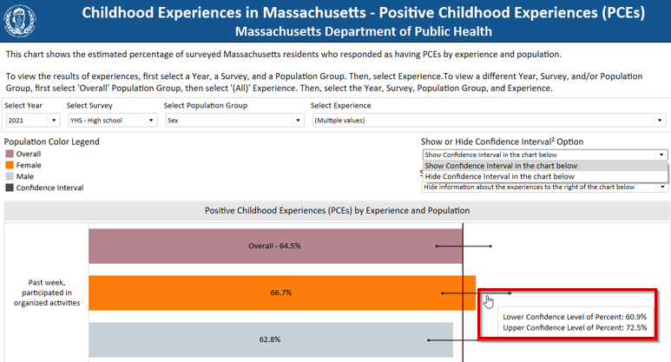Hover over a confidence interval reference line to view the information about the lower confidence level of percent and the upper confidence level of percent.

Show or Hide Information About the Experiences
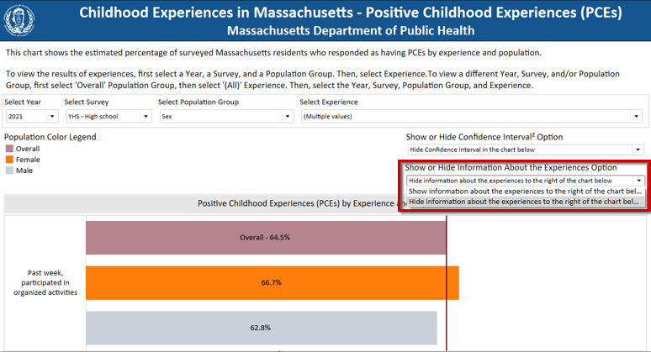Use the Show or Hide Information About the Experiences to show or hide additional information about the population groups and experiences to the right of the chart. The option selected is applied to all topic dashboards in the application. The default selection is to hide the information about the experiences on the topic dashboard.

Changing the Show or Hide Information About the Experiences Option
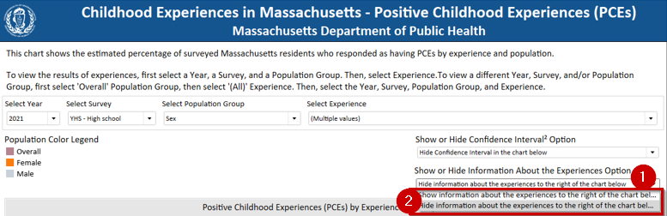
- At the Show or Hide Information About the Experiences Option prompt, click the drop-down arrow to the right of the filter. A list of filter values is displayed.
- Select the show or hide option. The chart is updated to show or hide the Information About the Experiences panel to the right of the bar chart based on your selection.

Information About the Experiences Panel
The Information About the Experiences panel displays additional information about the selected population group and experiences.
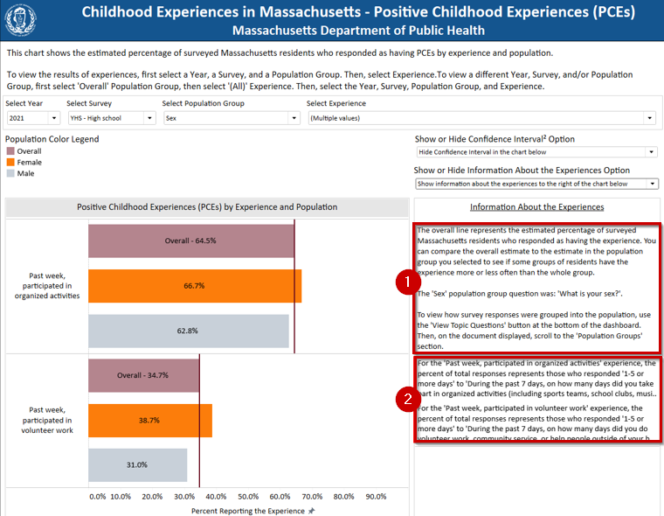
- Information About the Experiences Panel - Population
At the top of the Information About the Experiences panel is information about the selected population group. The information states what question was asked of the survey respondents that determined the population they were categorized as on the topic dashboard. Additionally, users can use the View Topic Questions button at the bottom right of the topic dashboard. Refer to View Topic Questions.
- Information About the Experiences Panel – Experiences
Below the information of the selected population group in the Information About the Experiences panel is information about the selected experiences. The information states what question was asked of the survey respondents that determined how their experience was categorized and which responses were included on the topic dashboard. The information is listed in ascending alphabetical order of the experience label on the chart.

Information About the Experiences Tooltip
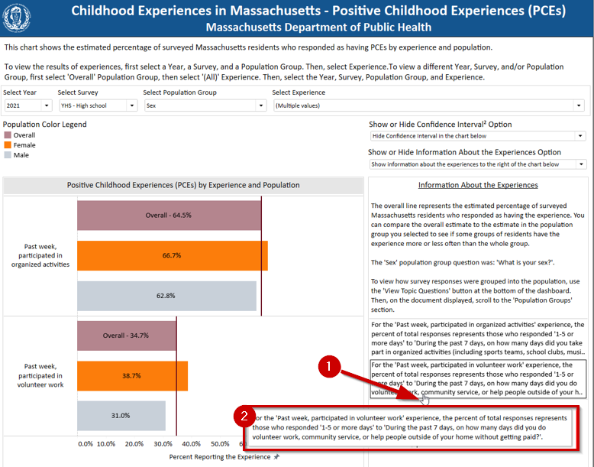
- Hover over a cell in the Information About the Experiences pane
- to display the full text of the cell.

View Topic Questions
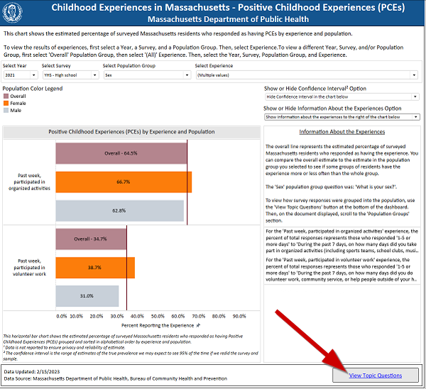
Use the View Topic Questions link, to display a Microsoft Word document in a new Web browser window with information specific to the dashboard topic you are viewing. This document provides the survey questions, by survey, for the experience topic selected. After the experience questions are displayed, subsequent pages provide the survey questions, by survey, for the population groups available in those surveys. All images include alternative text.

Example: Topic Questions Document
The following is an example abbreviated topic questions document that starts with the survey questions, by survey, for the experiences of the PCE topic.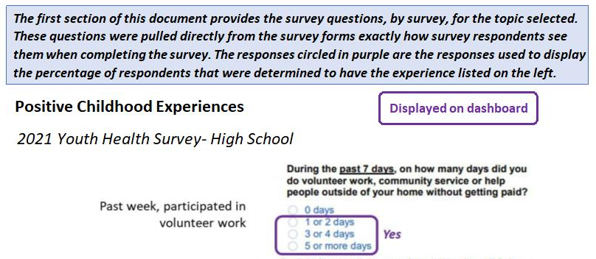
The following is an example abbreviated topic questions document showing the survey questions, by survey, for the population groups available in the surveys for the PCE topic.
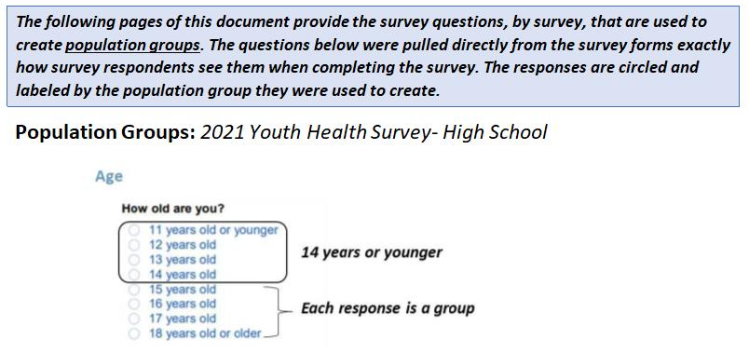

Downloading the Data
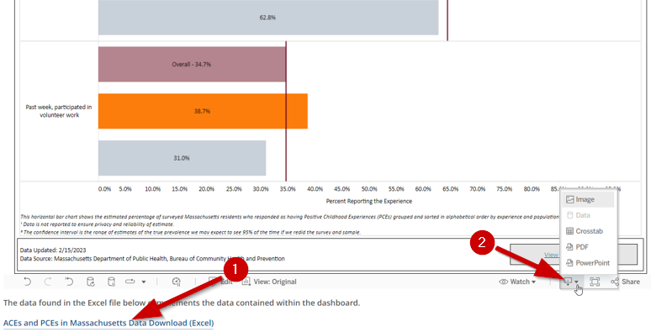
- A Microsoft Excel file containing all the similar data available on the dashboard can be downloaded from the main ACEs and PCEs of Massachusetts Residents webpage below the dashboard. The file contains data for all surveys included on the current version of the dashboard. Columns include dataset, year, domain, population group, population, construct, sample size, percent, and lower and upper confidence levels.
- Tableau also has options to allow users to download images, data, crosstabs, PDFs, and PowerPoint slides of the data being viewed in the dashboard (the drop-down menu for these options is in the bottom right corner of the embedded dashboard). For crosstabs, you have options to download the data on the bar chart and information about the population groups and experiences for your selections on the dashboard.

About the Data
The following section provides more detailed information about the data included in the dashboard. It includes technical notes about the sample and methodology used to collect the data from Massachusetts residents. This section also includes a data dictionary.

Technical Data Notes

MA Youth Survey Methodology
In Massachusetts, the MA Department of Public Health Survey Program collaborates with the MA Department of Elementary and Secondary Education (DESE) to administer the MA Youth Health Survey (YHS) and MA Youth Risk Behavior Survey (YRBS). The YHS and YRBS are both conducted in randomly sampled high schools (9-12th grades; YHS-HS) every odd-numbered year. The YHS is also conducted in randomly sampled middle schools (schools with at least one grade 6-8).
The sampling methodology, how schools are randomly selected to be part of the survey, is determined by Centers for Disease Control (CDC) procedures. More information about the methodology can be found here. Based on this sampling process, not every youth in the state completes the survey. Because not every youth completes the survey, the initial data cannot definitively determine the percentage of all youth with certain experiences across the state. Although youth were included in the sample based on random school and classroom selection, there are additional processes that make the data more representative of all public high school or middle school students that could have been included in the survey.
A statistical technique called weighting is used to adjust the survey results to increase how the results represent the whole public school population. Weighting accounts for the unequal probability of selection into the sample. The base weight reflects the inverse probability of selection for each participating student. Adjustments are then applied to the base weight to adjust for school-level non-response, student-level non-response, and a post-stratification adjustment for grade, sex, and race/ethnicity.

Limitations
There are limitations to consider about the survey methodology and process to collect the data. The following are important limitations to know for the YHS and YRBS surveys:
- Youth self-report to complete these surveys. There may be under- or over-reporting of behaviors based on social desirability bias (knowing what the more desirable behavior/response is when it is not true for the youth). There may also be recall bias if youth do not remember experiences accurately when completing the survey. There also are times when people have their own ideas about what a term means that is not what researchers and people who provide services mean, which can lead a person answering a question to inaccurately answer “No” to a question for which the answer for them actually is “Yes.” We try to minimize this problem with the way that questions are asked, but we cannot eliminate it.
- Only youth who attend school on the day of survey collection are included in the report. There is no effort to survey students who were absent.
  - Students who are more often absent from school, such as those experiencing housing instability or having health needs that require medical care, are more likely to be missing from the sample because they were absent on the day of data collection.
- Only youth who attend public schools are included in the survey collection. This data is not representative of all youth in the middle school or high school age groups across Massachusetts.
  - Youth who have dropped out, are enrolled in alternative school (such as in a Department of Youth Services, Department of Mental Health, or other setting), are home-schooled, or enrolled in private or religious school, are not surveyed.
- The surveys are currently only available in Massachusetts in English, which may limit comprehension and ability for English Language Learners, or youth more comfortable reading and comprehending in a language besides English, to complete the survey.
- Historically, the surveys were conducted on paper. In 2019, the high schools YHS and YRBS moved to web-based, with a paper option. In 2021, the survey moved to web-based for middle schools, with a paper survey option.
- Youth are expected to complete the survey on their own. The experiences of youth who would need support from another person to complete the survey are not included.
- Boston conducts a separate YRBS survey from the MA state YRBS. Students in Boston classes selected into the state sample are given the Boston YRBS and their responses are also included in the state data. While most questions overlap, there are a few differences between the surveys including those that are not asked on Boston YRBS. This may affect the generalizability of results from these questions if students in Boston have different experiences with these indicators than students in the rest of the state.

Suppression
Suppression is a technique in presenting data to withhold or remove information in order to protect identities, privacy, personal information, or because the data is not sufficient to develop a reliable estimate. Specific surveys, datasets, or entities have suppression rules to determine when data needs to be withheld. For the youth surveys mentioned above, suppression rules are applied to ensure reliability of the estimate. If the standard error is greater than 30% and/or there are less than 100 survey respondents in the specific subpopulation of interest that answered the question, the information will be suppressed.
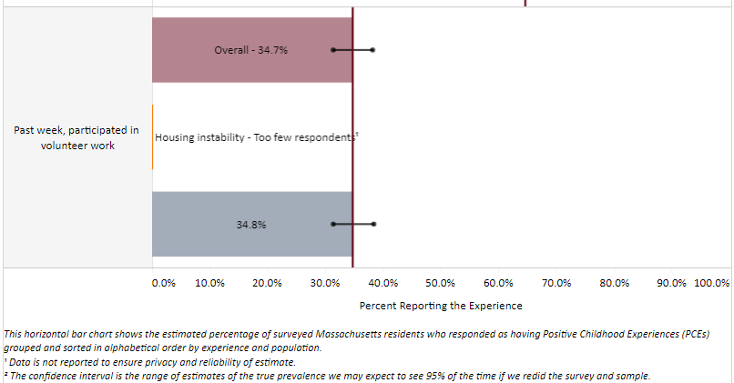
In some instances, complimentary suppression is necessary. This is an additional data suppression step when it is possible for users to subtract to figure out the suppressed counts. For the youth surveys, this is not required because the dataset population size does not include those that did not respond to the survey question(s). Additionally, the percent of survey responses is weighted, so for any experience on the dashboard, users cannot determine the number of respondents who indicated they had this particular experience from the weighted percent (i.e., the weighted percent is not equal to the percent of respondents who reported the experience). Therefore, a user cannot identify an actual individual or small group using a population’s weighted percent of total responses, sample size, and/or comparing against the overall population weight percent of total responses and sample size.

Confidence Intervals
Including a confidence interval (CI) when calculating an estimate provides a range of values you would expect the estimate to fall between if you had many samples of the same size from the same overall group of people. For these CIs, a 95% confidence was used to determine this range. If we re-sampled MA public schools and classrooms using the YRBS or YHS surveys many times, 95% of the time the estimates we calculated for each experience and within each population group would fall in the range provided.
The CI for an estimate can tell the user how stable and reliable an estimate is. If the CI is very wide, it is less stable and less reliable. A narrower range would describe a more stable and reliable estimate compared to a wider range. The width of the CI can be impacted by the size of the sample (larger samples produce narrower CIs), the confidence level selected (here all CIs are 95%), and the variability in the sample (when the data points differ a lot from each other or the average of the data points, a wider range is produced).
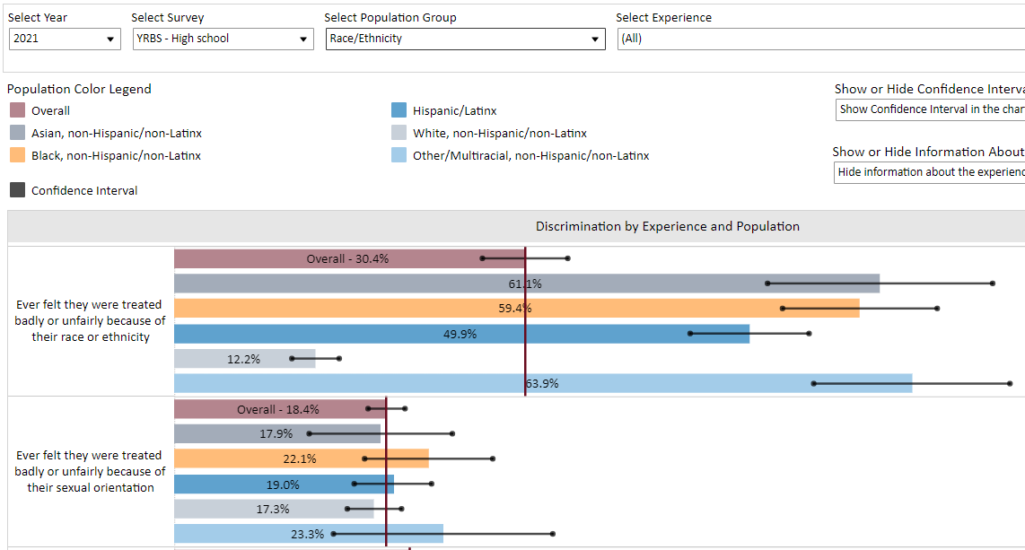

In the above example (example 1), the overall bar for “Ever felt they were treated badly or unfairly because of their sexual orientation” sample size is 3,140 and the CI ranges from 16.8% to 20.0% (specific numbers are available in the tooltip). The overall CI is narrow compared to the “Other/Multiracial, non-Hispanic/non-Latinx” bar (light blue) with a sample size of 150 and a range of 13.8% to 32.8%.
A user can also compare the overlap of related CIs (CIs of related estimates, such as between two or more population estimates of the same experience) to understand the difference between two or more groups. Using hypothesis testing in a statistical program is the ideal way to compare statistical differences between two or more groups, but the visual provided in the dashboard can assist in visually identifying the potential for differences between the reports of some groups to be of a size that is statistically significant, given the sample size and amount of variability in the groups. In the first example above, the lack of overlap between the CIs for White youth and the CIs for youth of other race-ethnicities, and the degree of those differences, suggests that a stronger statistical test is likely to give us confidence that these differences are sufficiently great, given the sample size and variability in the sample responses, to conclude that this type of experience is more common among these groups than among White youth in the MA youth population. In the second example, the overlapping CIs suggest that the differences in the sample estimates will not prove to be great enough (given the sample size and variability in responses) to conclude with confidence that there is a difference based on race-ethnicity in this experience in the MA youth population. However, in both cases, we would want to do additional statistical testing before reaching a conclusion.
To be more specific, in the above example (example 2), the population bar “White, non-Hispanic/non-Latinx” for “Ever felt they were treated badly or unfairly because of their race or ethnicity” has a CI range from 10.2% to 14.3%. This range does not overlap with the “Other/Multiracial, non-Hispanic/non-Latinx” bar for this experience which has a range of 55.4% to 72.4%. Therefore, it is likely that there is a statistically significant difference between these two groups related to this experience.

Data Dictionary
The following table provides additional information about common terms used in the dashboard, including the dashboard data element name, definition, and example values.
Dashboard Data Element | Definition | Example Values
Survey | Survey administered | YHS - High School  YHS - Middle School  YRBS - High School
Survey Year | Calendar year survey was administered | 2021
Topic | Category of childhood experience | Bullying  Community Challenges  Dating Violence  Material needs
Population Group | The characteristic youth are grouped by to determine differences- such as age, disability, or sex. | Age  Any Long-term Disability  Employment  Housing instability  Overall
Population | The specific population within a population group that a prevalence estimate will be determined for (such as 15 years old within the age population group stratification). | 15 years old  16 years old  Asian, non-Hispanic/Latinx  Female  Employed
Experience | The specific experience, including timeframe (e.g. "ever", "within the past month", "within the past year"), within a topic of childhood experiences. | Past year, bullied at school  Currently consider neighborhood unsafe  Past week, participated in organized activities
Experience Group | Only applicable to some questions, this group is the sub-group of the total respondent sample that identified they had had a life experience that could expose them to a particular ACE or PCE, allowing researchers to exclude youth who could not experience the ACE or PCE because they did not have that life experience. This data element is only applicable to the Dating Violence topic on the dashboard. | Those who have ever dated
Sample Size | The number of students who responded to the particular question or questions used to define the experience. | 132  577  1,324  Too few respondents
Percent Reporting the Experience | A weighted estimate that provides the prevalence estimate for a specific experience based on survey responses in the selected survey sample that can be generalized to the state population of a specific group. This estimate may be determined for a specific population within a population group. Youth Surveys: Percent of public school students who reported the childhood experience | 53.7%  85.5%  91.0%  Too few respondents
Overall Percent Reporting the Experience | A weighted overall estimate that provides the prevalence estimate for a specific experience based on survey responses in the selected survey sample. This is the estimate of how common the experience is in the overall MA state population of youth. Youth surveys: Overall percent of public school students who reported the childhood experience | 53.7%  85.5%  91.0%  Too few respondents
Lower Confidence Level of Percent | The lower bound of a 95% confidence interval (a range of values in which we may expect to see the estimate of true prevalence 95% of the time if we redid the sample and survey many times) for the estimated prevalence of a specific experience in the state population. Like the prevalence estimate itself, this number is based on survey responses in the selected survey sample and is weighted. Youth Surveys: Lower confidence level for the percent of public school students who reported the childhood experience | 53.7%  85.5%  91.0%  Too few respondents
Upper Confidence Level of Percent | The upper bound of a 95% confidence interval (a range of values in which we may expect to see the estimate of true prevalence 95% of the time if we redid the sample and survey many times) for the estimated prevalence of a specific experience in the state population. Like the prevalence estimate itself, this number is based on survey responses in the selected survey sample and is weighted. Youth Surveys: Upper confidence level for the percent of public school students who reported the childhood experience | 53.7%  85.5%  91.0%  Too few respondents

Using the Data
The following section provides information about how users can take information from the dashboard and apply it to their understanding and work. This section aims to provide resources for interpreting the data accurately with a racial and health equity lens, and with important background information about each of the topic areas related to PCEs and ACEs. Lastly, this section includes reflection questions to guide critical thinking about prevention and intervention strategies we can implement to ensure healthy outcomes for all Massachusetts (MA) residents.

Interpreting and Sharing the Data
The goal of this dashboard is to allow users to view and interpret the data about PCEs and ACEs to better understand how Social Determinants of Health (SDoH) and systemic inequities create conditions that unfairly increase ACEs and prevent PCEs among MA residents. Additionally, users of the dashboard can share the data with others to inform action, funding, and policies to reduce inequalities across the Commonwealth. As previously mentioned in the About the Data section, most of the data presented in this dashboard are collected from samples of Massachusetts residents and weighted to make statements about population experiences in the Commonwealth.
The following components of the data should be included when sharing data from the dashboard:
- Survey year and survey (e.g. 2021 Youth Health Survey- High School)
  - When reporting data from the Youth Risk Behavior Survey, it is helpful to mention it collects data from high school students
  - When reporting data from the MA Youth Health Survey (YHS), be careful to identify if it is YHS high school or middle school data
  - The year and survey information can be included in the body of a report or as a footnote, end note, or citation
- Population group/population for the estimate you are using or reporting (e.g. overall, female, housing unstable, etc.)
- The experience measured
  - Can change wording to fit tense/sentence structure
  - Be sure to include the time frame of the experience (ever, past year, past month, past week, etc.)
- The prevalence estimate (that is, the estimated percentage of people reporting the experience, written as XX%)
- The confidence interval (95% CI [lower] – [upper]) of the prevalence estimate
- A racial justice and health equity lens (see Using Racial Justice Reframing and Data-to-Action section)
Most of this information will be found in the drop-down options, the bar chart, and the tooltip of the dashboard. Supplemental information about how the responses were captured in the survey can be found in the Information about the experiences sidebar and should be included in interpretations as well. For interpretations involving more than one data point, such as to compare between populations or experiences, be sure to include all data components for each point. See Using Racial Justice Reframing and Data-to-Action to support using a racial justice and health equity lens to interpret this data and inform action.

Example Interpretations
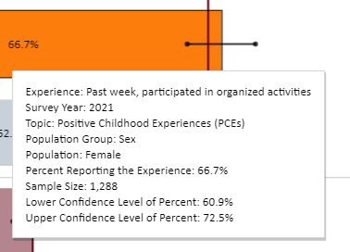

Example 1: Single Interpretation Options
- Among female high school students, 66.7% (95% CI: 60.9% - 72.5%) participated in organized activities within the past week (2021 MA Youth Health Survey- High School).
- Sixty-seven percent of female high school students reported participating in organized activities within the past week (95% CI: 60.9% - 72.5%; survey source: 2021 MA Youth Health Survey- High School).
- In 2021, 66.7% of Massachusetts female high school students reported participating in organized activities within the past week (95% CI 60.9%-72.5%).
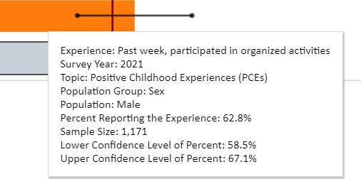

Example 2: Comparison Interpretation (same experience) Options
- Among Massachusetts female high school students, 66.7% (95% CI: 60.9% - 72.5%) participated in organized activities within the past week, while 62.8% (95% CI 58.5% - 67.1%) of male high school students participated in organized activities within the past week (survey source: 2021 Youth Health Survey- High School).
- In 2021, 66.7% and 62.8% of female and male high school students, respectively, reported participating in organized activities within the past week (Female: 95% CI 60.9%-72.5%, Male: 95% CI 58.5% - 67.1%).
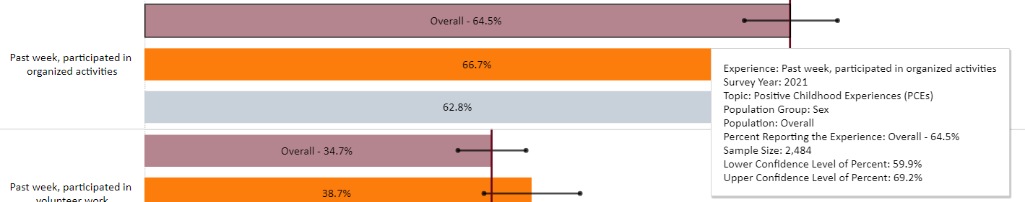

Example 3: Comparison Interpretation (same experience + overall) Options
- Overall, in 2021, 64.5% of high school students reported participating in organized activities in the past week. Grouped by reported sex, 66.7% of females and 62.5% of males reported this experience (Female: 95% CI 60.9%-72.5%, Male: 95% CI 58.5% - 67.1%; MA Youth Health Survey- High School).
  - Due to the overlapping confidence intervals, it cannot be assumed that female high school students participate in organized activities in the past week more than male high school students

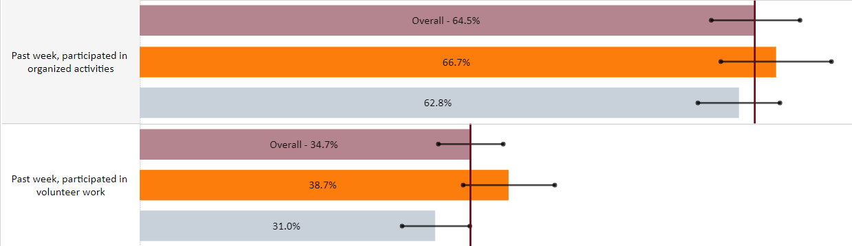

Example 4: Comparison Interpretation (different experiences) Options
- In 2021, 64.5% (95% CI 59.9% - 69.2%) and 34.7% (95% CI 31.3% - 38.1%) of Massachusetts high school students reported past week participation in organized activities and volunteer work, respectively. Also, 66.7% (95% CI 60.9% - 72.5%) and 38.7% (95% CI 33.9% - 43.5%) of female high school students reported past week participation in organized activities and volunteer work. For male high school students, 62.8% (95% 58.5% - 67.1%) and 31.0% (95% CI 27.5% - 34.5%) of students participated in organized activities and volunteer work, respectively.
The examples provided above are not inclusive of every way to report this data and do not include additional racial and health equity context, but they do incorporate important components necessary to contextualize the data points. The following section will support users in interpreting and using this data to inform action with a racial and health equity lens.

Using Racial Justice Reframing and Data-to-Action
The following section is adapted from materials developed by the COVID Community Impact Survey team at Massachusetts Department of Public Health (link to abbreviated slides).

What is racial justice reframing?
“Frames are mental structures that shape the way we see the world. As a result, they shape the goals we seek, the plans we make, the way we act, and what counts as a good or bad outcome of our actions… frames shape our social policies and the institutions we form to carry out policies.” – George Lakoff
In society, dominant frames are ideas, attitudes, and beliefs that are shared collectively and evoke certain standards, values, and morals that are reinforced and continued throughout society and across time. Framing is important to how we perceive information and make meaning, and it is used in different aspects of communication- such as media, marketing, news reporting, and campaigns. Frames influence our own implicit or unconscious biases- the stereotypes and attitudes we hold that we are not fully aware of (see examples of frames on slides 29 and 30 of the CCIS resource).
A common example of a dominant and commonly used frame and resulting implicit bias is the “bootstrapping theory.” This theory comes from the phrase “pull yourself up by your bootstraps” which implies that someone can only improve an individual situation through hard work without outside support. Our history of systemic racism and other institutionalized forms of injustice still actively harm members of some population groups and make it more difficult for them to help themselves compared to others. Bootstrapping theory takes the focus away from unfair laws and policies and blames their victims. This contributes to unfair judgements, or “implicit biases” against those facing discrimination and in need of outside support as being not working hard, lazy, or too dependent. Using this theory actively takes away from an individual, family, or community’s agency to help themselves, and instead actively disadvantages them.
When we use racial justice and health equity reframing, we work to focus our attention on the root causes of health disparities instead of focusing on individual behavior, lifestyle, and personal responsibility. Root causes of health disparities can come from systemic racism and other SDoH- which are defined as the “non-medical factors that influence health outcomes… the conditions in which people are born, grow, work, live, and age, and the wider set of forces and systems shaping the conditions of daily life” (WHO). By reframing our interpretations and health communications by considering the conditions in which we live, we can create more sustainable and equitable plans to change the conditions and improve health outcomes for everyone.
When interpreting findings, consider the problem, the cause (what/who’s responsible), the solution, the actions needed, and the value highlighted in the frames of your interpretation. The following exercise compares an approach to interpreting data with a dominant lens of bootstrapping theory with a racial justice approach that looks at systems-level factors that influence health outcomes. This example uses 2021 YHS-High School data for past month food insecurity and stratifies the results by race/ethnicity.
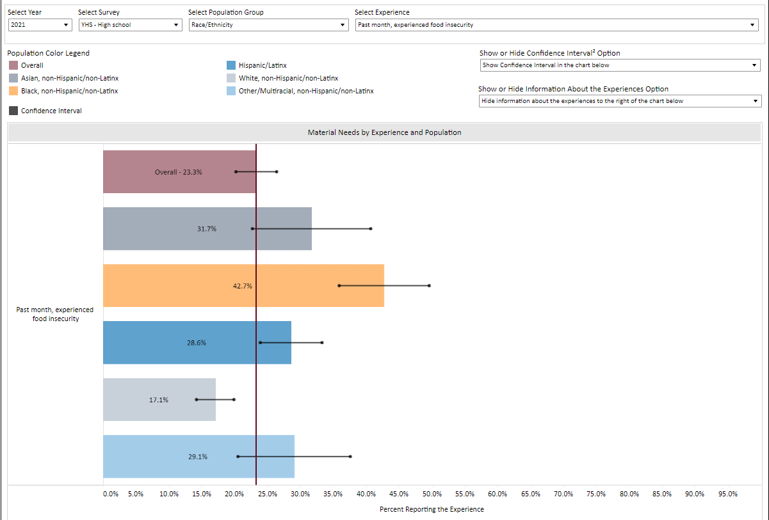
Framing Elements | Individual-Focused Approach* | Racial Justice Approach
1. What’s the problem? | Black nh/l youth experience the highest prevalence of food insecurity because they do not have enough food in the home | There are racial inequities in food security
2. What’s the cause? What/Who’s Responsible? | Parents of black nh/l youth are unable to/ do not provide youth with enough food (neglect) | Food deserts; income inequality; racial redlining in transit in communities of color; disinvestment in communities of color; residential segregation, low wages, lack of economic opportunity/job opportunities
3. What’s the solution? | Parents of black nh/l youth need to work more and not rely on food stamps | Food security in all communities; economic investment in low-income communities/communities of color; livable wages; accessible and affordable healthy foods in all communities, particularly communities of color
4. What action is needed? | DCF involvement (neglect), more employment | Food access policies that target roots of inequities; economic policies that invest in communities of color; partnerships across sectors and with community residents
5. What values are highlighted? | Bootstrapping, hard work, personal responsibility, individual choice | Equity, justice, fairness, shared responsibility
*Blaming someone’s behavior instead of looking at the systems and policies in which people live
An interpretation rooted in the bootstrapping theory and framing incorrectly places blame on individual and family choices for the different outcomes in food security by race and ethnicity. When using a racial justice lens, we consider the historical and society level factors that influence environments and opportunities and lead to these inequitable outcomes. These interpretations also help us use the data to inform our actions and consider sustainable and community and society-level changes to improve the health and well-being of MA residents. Follow the steps outlined below for a racial and health equity informed data-to-action approach, and also visit the Racial Equity Data Road Map | Mass.gov for more guidance.

Steps from Data to Action
- Get the data
  - PCEs & ACEs Data Dashboard & other published data resources on the website (coming soon)
  - Think about multiple formats of data available- webinars, sides, raw data in tables, talking points with statements of findings and using all of the context available to support the data
  - Other data sources: American Community Survey, PHIT SDoH, PHIT Community Health Data Tool (add in links)
- Identify your partners
With racial justice reframing at every step. Consider:
- Who benefits?
- Who is harmed?
- Who influences/who decides?
- What might be unintended consequences?
  - Who are the partners that can help you take action?
  - Which voices have you heard from?
  - Who has been left out of the conversation so far?
  - Whose lived experiences are represented?
  - Consider the reframing questions
  - These are your data to action partners!
- Identify actions with partners
  - What are some possible causes for the issues this data highlights?
  - What are possible solutions?
  - What is the underlying system issue(s)?
  - Are there actions you are already taking or could take that relate to this finding?
  - Are there actions you can take right now? Actions you can take soon? When?
  - Are there actions someone else can take? Who?
  - How can you engage others in data-to-action conversations?
  - Who should see the data?
- Make a plan and keep checking with partners
Ask the Racial Justice Reframing questions every time you revisit your work plan
  - Turn your answers into a work plan and share it
  - Follow the plan – act with partners now and later
  - Include the actions in funding opportunities to increase capacity
  - Check in with partners about progress on the work plan
  - Relate short-term change to long-term solutions
- Repeat
  - Find more data, check back for updates, and repeat the steps!

Topic-Specific Information
This section provides additional topic-specific information that can aid users’ understanding of specific PCEs & ACEs topics, and provides context for interpretations users might develop from the dashboard.

Positive Childhood Experiences (PCEs)
PCEs are things that promote safe, stable, and nurturing relationships or environments in a child’s life, such as having an adult to talk to, or feeling safe within their home environment. These experiences buffer, or mitigate, the impact of toxic stress from ACEs by increasing the development of children’s physical, social, behavioral, and intellectual capacities. Reducing the impact of toxic stress reduces the likelihood of risk-taking behaviors and negative health outcomes. Research also has established that as the number of PCEs increases, the risk of negative health outcomes decreases in a dose-response relationship.
DPH has worked with Tufts University’s Healthy Outcomes from Positive Experiences researchers to think about PCEs to include in this dashboard. HOPE’s Building Blocks of HOPE framework supports thinking about experiences that promote positive relationships, positive engagement, positive environments, and opportunities for social-emotional development. When viewing PCEs in the dashboard, it’s important to know that higher percentages of the specific PCE is desirable. The more residents have PCEs, the more residents can thrive and reduce the impact of ACEs and grow into healthy adults and respond to adversity in the future. Seeing disparities in PCEs among populations within a population group identifies opportunities to promote specific PCEs for those groups.
More information about how parents, caregivers, and community members can support positive experiences for children in the Commonwealth can be found here: The Power of Positive Childhood Experiences | Mass.gov. This website provides information for families and community members about PCEs and resources and services available to families across the State.

Adverse Childhood Experiences (ACEs)
ACEs are things that happen in childhood (0-17 years old) that cause toxic stress throughout a person’s life. Toxic stress from these experiences affects the brain, how it develops, and how someone’s body will respond to stress in the future. Previous research has linked toxic stress to risk-taking behaviors (like substance misuse) and negative health outcomes in adulthood (like chronic health conditions or mental illness). Also, research has identified that a larger number of ACEs increase the risk of negative health outcomes in a dose-response relationship. Similar to PCEs, seeing disparities in ACEs among populations within a population group identifies opportunities to employ specific prevention or intervention strategies and approaches for those ACEs in those groups. For this dashboard, ACEs are grouped into the topics areas listed below:

Bullying
Bullying, which can occur in-person or through various media, such as via the internet, is defined by the CDC as “any unwanted aggressive behaviors(s) [toward a youth] by another youth or groups of youths, who are not siblings or current dating partners, that involves an observed or perceived power imbalance, and is repeated multiple times or is highly likely to be repeated.” Physical, verbal, relational/social, and victim property damage, are types of bullying. These experiences may result in a variety of physical, psychological, social, and educational harms for youth who are bullied. This dashboard measures experiences of bullying and cyberbullying. Information about bullying prevention can be found here. Bullying prevention tips can also be found here.

Community Challenges
Community challenge ACEs are adverse experiences youth may be exposed to within the community. These experiences can impact one’s sense of safety and ability to make community connections and engage outside of one’s home. In this dashboard, community challenges include witnessing neighborhood violence or skipping school due to feeling unsafe traveling to, from, or at school. Community violence is defined by the CDC as a critical public health problem, as it creates physical, emotional, and financial pain in communities, families, and individuals. Information about community violence prevention can be found here.

Dating Violence
Teen dating violence is intimate partner violence experienced in adolescence, in-person, online, or through other forms of technology. This includes sexual and physical violence by a dating partner, as well as experiencing psychological aggression, emotional abuse, threats to kill or harm a partner or someone the partner cares about, stalking, monitoring, or controlling behavior during or after a relationship with a dating partner. Experiencing unhealthy relationships in adolescence increases the risk of experiencing other types of violence and IPV in adulthood. This dashboard is careful to only share estimates of youth who experience dating violence out of youth who have experienced dating. Information about preventing intimate partner violence can be found here. Information about preventing teen dating violence can be found here.

Discrimination
Youth experience discrimination when they are unjustly or prejudicially treated based on a characteristic of their identity. This dashboard includes experiences of discrimination based on race/ethnicity and sexual orientation. Experiencing discrimination causes stress and is a traumatic experience. Discrimination also can negatively impact the ability to receive appropriate services and access to opportunities. Systematic racism, systemic barriers, and historical trauma are the result of years of discrimination and impact the communities in which youth and families live and their exposure to adverse experiences. Experiencing discrimination at school, based on race/ethnicity or sexual orientation/gender identity can decrease school connectedness. Information about racism and health can be found here. Information about supporting LGBTQ youth can be found here.

Family Violence
Family violence is a topic area for this dashboard that encompasses experiences of violence within the household. For youth, this can include witnessing intimate partner violence or violence among household members. It can also include youth experiencing physical violence in the home against them. These experiences can impact one’s sense of safety within their home and impact relationships with members of the household. Information about preventing child abuse and neglect can be found here. Information about preventing domestic violence can be found here.

Household Mental Illness and Substance Use
Sharing a household with someone with mental illness or substance use are two traditional ACEs from the original CDC-Kaiser study. This dashboard includes if youth have ever lived with someone who was “…depressed, mentally ill, or suicidal” and “…having a problem with alcohol or drug use.” It is important to note that although these indicators are traditional ACEs, they often are interpreted with an ableist view that individuals (such as caregivers) that fall into these categories are unable to properly care for youth, which may not be the case. Additional questions, such as those related to household members’ access to treatment or care related to these conditions, often result from interpreting and viewing this data for household members experiencing mental illness or substance use. Unfortunately, it is beyond the scope of the indicators we have available to address these important nuances. Dashboard users are encouraged to consider these ACEs in light of consideration of the availability and access to resources in their communities and how these can be addressed.

Interpersonal Violence
Interpersonal Violence refers to violence between persons. As a topic area for this dashboard, it captures experiences that are not included in more specific types of interpersonal violence topics (like sexual violence, dating violence, or bullying). This dashboard includes interpersonal violence experiences of being involved in a physical fight or being threatened or injured with a weapon. Experiencing interpersonal violence as a youth, per the CDC, can “harm development and contribute to impaired decision-making, learning challenges, decreased connections to peers and adults, and trouble coping with stress.” Information about preventing youth violence can be found here. Information about preventing firearm violence can be found here.

Material Needs
The lack of basic physical human needs is also known as having material needs or hardships. These include things such as food, shelter, clothing, and health care. This dashboard includes food insecurity and lack of access to stable housing (also referred to as unstable housing) as material needs ACEs for youth. Lack of resources to fulfill basic needs is a traumatic experience for youth, as lack of these items such as food or stable housing can negatively impact development and contribute to feelings of stress and uncertainty of where the next meal will come from or where they will sleep. These experiences can also reflect greater community or socio-economic needs youth and their families are experiencing. Information on Massachusetts resources to address some of these needs can be found here.

Sexual Violence
Sexual violence is defined as sexual activity that occurs “when consent is not obtained or freely given” and includes experiences that happen in-person, online, or through other technology. Experiencing and perpetrating sexual violence is not confined to one gender, sexual orientation, or age, and experiencing it as a victim can be physically and psychologically harmful and relate to experiencing other forms of violence, like intimate partner violence. This dashboard measures experiences with unwanted sexual contact in high schoolers. Information about preventing sexual violence can be found here. Information about preventing child sexual abuse can be found here.

Reflection Questions
Below are some questions to think about as you explore the data and consider the problems it raises and identify appropriate solutions. These are adapted from the COVID-19 Community Impact Survey Data Dashboard.
- What do the data tell you about specific issues related to PCEs and ACEs in Massachusetts?
- Who are the populations within the state who are most impacted?
  - Although the dashboard does NOT show inequities by race, ethnicity, and other identity groups that are specific to communities, towns, or cities, users can compare what they know about their community/town/city to statewide survey results for these groups.
  - Comparing the statewide survey results with what you know about your community's demographics, are there groups living in your community that are most impacted or disproportionately impacted by certain ACEs or lack of PCEs?
- Does the data tell you something new about youth experiences?
- What are some possible causes for the issues you’re seeing?
- What do you know from other data and experiences that help you understand youth experiences?
- Which voices have you heard from? Who has been left out of the conversation so far?
  - Are youth voices adequately included when talking about ACEs prevention or PCEs promotion?
- What are possible solutions/goals?
- Are there things that can be done right away to address issues related to PCEs/ACEs?
- Are there things that you can work on long-term to address these issues?
- What action is needed?
- Who are partners that can help you take action? Think about partners that are already engaged, as well as those who have been left out of the conversation. What are possible barriers to action? How can you overcome them?
- What else do you need to know to take action?

2021 Youth Health Survey- High School
2021 Youth Health Survey- High School
2021 Youth Health Survey- High School

