The Commonwealth of Massachusetts
Executive Office of Health and Human Services
Department of Public Health
Bureau of Infectious Disease and Laboratory Sciences
305 South Street, Jamaica Plain, MA 02130

MARYLOU SUDDERS
Secretary
MONICA BHAREL, MD, MPH Commissioner

Tel: 617-624-6000
www.mass.gov/dph

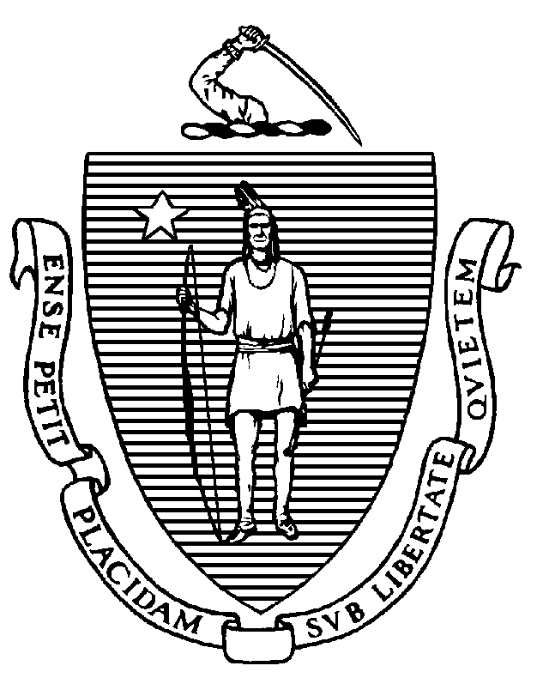

CHARLES D. BAKER
Governor
KARYN E. POLITO
Lieutenant Governor

MOLD and LEGIONELLA REOPENING GUIDANCE
MAY 21, 2020
_______________________________________________________________________________________

The temporary shutdown or reduced operation of a building and reductions in normal water use can create hazards for returning occupants; these hazards can include mold and Legionella. After a prolonged shutdown, building owners and employers should ensure that their building does not have mold and that the water system is safe to use to minimize the risk of Legionnaires’ disease. Guidance on how to do this is available from the CDC https://www.cdc.gov/coronavirus/2019-ncov/php/building-water-system.html.

