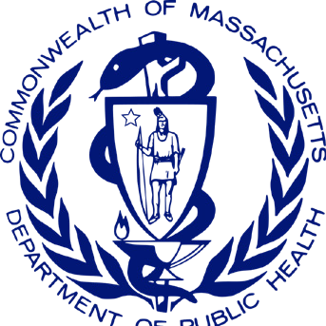
The MA Department of Public Health’s Office of Problem Gambling Services’ Response to the COVID-19 Pandemic
Lessons learned from successful collaborations with vendors to ensure that quality services were provided to those who needed them the most — July 2021

Project Methodology

1

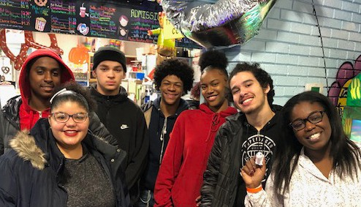
*Photographs in this report were taken prior to the COVID-19 pandemic.
Project Overview

This brief documents how the Massachusetts Department of Public Health’s (DPH) Office of Problem Gambling Services (OPGS) - together with vendors providing services to those most at risk of problem gambling disorders - rose to the challenge in its response to the COVID-19 pandemic to provide essential services to MA
communities most impacted by problem gambling. The research presented in this brief was prepared to understand the dynamic between OPGS and
its vendors more closely as well as to lift up the voices of vendors who worked with OPGS so thoughtfully and strategically throughout this challenging time. OPGS sought to be flexible, empathetic, and collaborative in its work with vendors to acknowledge the overwhelming pressures the pandemic brought. In short, OPGS engaged vendors as close partners, not distant administrators, and helped vendors navigate and pivot practices to continue providing successful services despite the method in which services were provided. This allowed for a pandemic response that was consistently praised by those who worked most closely with OPGS.
“… everyone at OPGS – they’re all phenomenal and passionate and a thrill to work with.”

- Gandara Mental Health Center, Youth
Gambling Prevention Ambassador Project
Public Consulting Group (PCG) conducted a series of interviews with OPGS vendors and staff to learn more about the Office’s response to the COVID-19 pandemic. PCG spoke with 11 vendor organizations, completing a total of 9 interviews, some with multiple staff members. All vendor organizations contacted for an interview agreed to participate and answer questions about challenges they had faced during the pandemic, adaptions made, the successes OPGS had helped them achieve during that time, and lessons learned throughout. Surveys were also conducted with this audience on similar themes. A total of 14 surveys were collected.

Spoke with
11
19
14
11 Vendors

Completed
19 Interviews

14 Surveys collected

Key Themes
Focus groups, interviews and survey results all yielded that OPGS has done an impressive job responding to the conditions resulting from the pandemic. Through the research, four key themes emerged which highlight OPGS’ strengths. They include Social Determinants of Health and Equity, Transparent and Continuous Communication, Adaptability and Resilience, and Relationship Building.

Social Determinants of Health and Equity
OPGS is a leader in the field in incorporating the social determinants of health with addressing problem gambling. Not only is OPGS successful in working with vendors to mitigate the negative impacts related to problem gambling for individuals, families, and communities, but the Office recognizes how social and cultural inequities and lack of resources for high-risk communities can exacerbate problem gambling disorders. Interviews and surveys show that OPGS works to prevent and treat problem gambling disorders by addressing these inequities. OPGS helped vendors focus their resources on a wider array of issues than pure problem gambling and maintained a focus on equitable services throughout the pandemic. Their aim was to provide individuals and communities with access to basic needs resources so they can thrive.
“During the pandemic, a lot of these students lost access to their school clubs and their parents were lost their jobs, we were able to help with both by providing a safe social space

Project Finding - Almost all vendors stated social determinants of health and equity were always a priority for their organization but working with OPGS helped to heighten efforts to meet the unique needs of high- risk groups.
with PhotoVoice and able to give the families direct financial assistance
by sending gift cards and snack vouchers.”

- High Point Treatment Center, PhotoVoice Project

“As an outside vendor, we truly appreciate that OPGS brings the topic of social determinants of health to every conversation. The team’s focus on equity has helped us
develop campaigns that always focus on providing resources and never blame individuals for their illnesses. Although we have extensive
experience in public health and viewing projects through an equity lens, the OPGS team brings a deeper understanding of social determinants of health than almost any of our other clients.”

- Argus Communications, Inc.

“Our team has always sought to focus on social determinants of health and equity. It looked different this past year because individual and social needs became far more visible
and out in the open. Therefore, we have become more intentional about talking about issues that impact the communities we serve with other providers in the region.”

- High Point Treatment Center, PhotoVoice Project

Transparent and Continuous Communication
OPGS is praised for excellent communication with their vendors throughout the pandemic. Vendors commented on the clarity of communication from OPGS and the opportunity for responsive two-way engagement with OPGS. Vendors described how OPGS staff proactively worked with vendors to find answers to questions and solutions to problems, and vendors always felt “in the loop” on how to proceed with providing programs and services during the pandemic.

“Frequent open and honest conversations with OPGS allowed us to not be hindered from implementing our project and
OPGS understood why it was more difficult to recruit individuals and provide services. I was transparent on what I thought our organization could pull off and we spoke frequently with OPGS and we set up virtual engagement check-ins and they set up a reporting system for us to easily use so we could continue reaching students.”

- Gandara Mental Health Center, Photovoice Project
“The pandemic has made it difficult for our community and our organization is under a lot of stress. OPGS has helped us a lot
in navigating how to respond to racism towards our community. They have provided emotional support both directly and indirectly. The racism, it’s systemic, so there’s a lot of organizations who need be in support of changing the narrative. OPGS is a model for the community on how to communicate as a bureaucratic organization and show respect and understanding for the community - which makes a big difference in our success as an organization.”

- Boston Chinatown Neighborhood Center, Community Level Health Project

Project Finding - All vendors who were interviewed discussed transparent and continuous communication as one of the three most important attributes organizations should have to support problem gambling work in communities across the state.
Adaptivity and Resilience

The pandemic necessitated immediate adaption of procedure and policy, deviating from the norm. OPGS was able to effectively develop new procedures and update existing policies to navigate the pandemic,

Project Finding - Vendors highlighted throughout most interviews and surveys OPGS’ unique ability to create effective solutions to complex
problems. Some stated this was an attribute that set OPGS apart from other government entities.
including supporting program adaptation and providing accommodations to internal staff such as the opportunity to work remotely. For example, vendors pointed out that OPGS waived all course training fees throughout the pandemic, allowing their vendors and other professionals to take classes to become better educated on problem gambling disorders and treatment free of charge. OPGS swiftly evolved its infrastructure to ensure vendors could continue serving communities to provide essential services, and that internal staff could still provide the management and oversight required.

“I think along with a lot of other things in this pandemic, the priority of creating a safe space was heightened because you don’t know what everyone else is bringing to the table. Safe
space to be vulnerable, learn, and just feel safe and exist - that was a big priority. This is not something new. It’s always existed, especially for minority or high-risk communities. But now we have the criteria or the justification to discuss creating these safe spaces - and that was important.”

- Gandara Mental Health Center,Photovoice Project

Relationship Building

One of OPGS’s guiding principles is to have a high degree of visibility in high-risk communities, and this certainly held true during the pandemic. Vendors described how OPGS took the time to not only understand the barriers faced by vendors, but also to connect directly with the communities served.
This relationship building provides the opportunity for vendors and people receiving services alike to foster connections in the community that go above and beyond the provision of services. This type of relationship building and communication supports OPGS’ mission to develop programs and services
based on the unique needs of the community. Vendors described how OPGS supported them to reach individuals within the community by conducting surveys, focus groups and interviews to better understand community needs and better tailor services for those who need them the most.
OPGS has also worked to establish connections and relationships with other state departments in
Massachusetts, other offices within the Department of Public Health, and community organizations who are
also funded to address problem gambling and provide mental health services. This allows OPGS’ programming to align with existing programs and strategically enhance efforts instead of duplicating them. This type of collaboration has become increasingly important as vendors work with limited resources during and beyond the pandemic. Seven out of nine vendor organizations interviewed by PCG stated OPGS was unique, in comparison to other state agencies, in supporting
the alignment of different organizations and fostering connections.
“OPGS is unique because they support aligning different organizations and help to make connections; they are really working
on breaking down silos. It’s refreshing and it’s been wonderful to work with them.”

- Public Health Institute of Western Massachusetts,
Community Level Health Project

Project Finding - All survey respondents agreed they would continue maintaining the new and existing collaborations they have developed or fostered throughout the pandemic.
*Photographs in this report were taken prior to the COVID-19 pandemic.
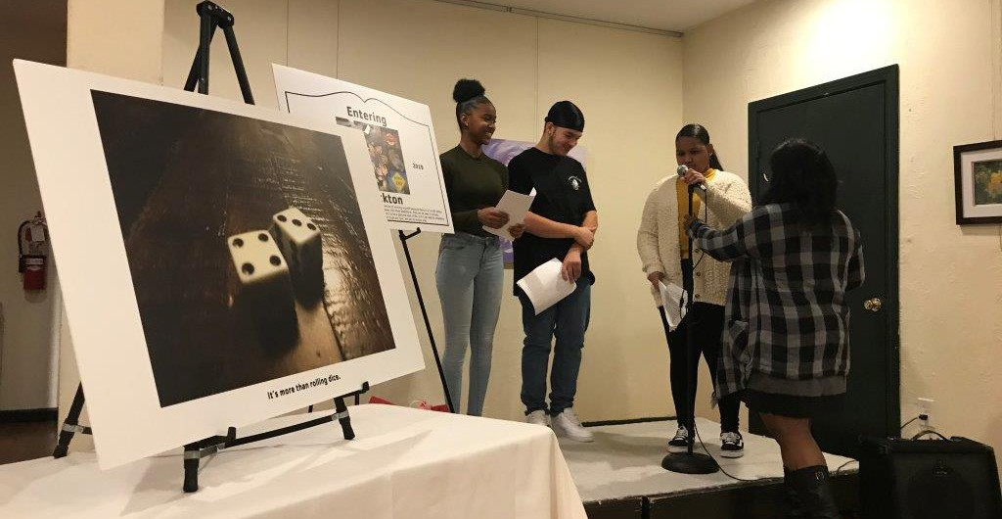

For more information, contact the OPGS Director, Victor Ortiz at victor.ortiz@mass.gov

